
The ODeS

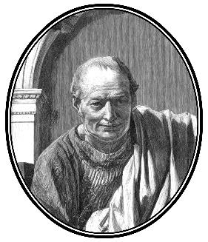
Horace
(Quintus Horatius Flaccus)

Translated into English by
- S. Kline

Published with Selected Illustrations

POETRY IN TRANSLATION
www.poetryintranslation.com

© Copyright 2003 A. S. Kline

Cover design by Poetry in Translation

Digital scans or photographs of the images in the main text have been released into the public domain by various institutions. Identifications and attributions are provided beneath each image. All related image rights are at the discretion of the copyright holders of the original images and/or the referenced institutions.

All rights reserved under International and Pan American Copyright Conventions. Textual content of this work may be freely reproduced, stored and transmitted, electronically or otherwise, for any non-commercial purpose. Restrictions apply to adaptation of the work. Usage of any material for commercial purposes resulting in direct, indirect or incidental commercial gain requires permission to be sought and granted in writing from the copyright holder. Refer to the Poetry in Translation copyright statement (www.poetryintranslation.com/Admin/Copyright.php)

Any statements or opinions expressed in this book reflect the views of the author alone. Although the author has made every effort to ensure that the information in this book was correct at the time of going to press, the author does not assume and hereby disclaims any liability to any party for any loss, damage, or disruption caused by errors or omissions, whether such errors or omissions result from negligence, accident, or any other cause

Please direct sales or editorial enquiries to:
tonykline@poetryintranslation.com



This digital edition is published by
Poetry In Translation (www.poetryintranslation.com),

Contents

Translator’s Introduction 9
Book I 12
BkI:I The Dedication: To Maecenas 12
BkI:II To Augustus 13
BkI:III Virgil: Off to Greece 16
BkI:IV Spring 18
BkI:V Treacherous Girl 19
BkI:VI A Tribute to Agrippa 20
BkI:VII Tibur (the modern Tivoli) 21
BkI:VIII : To Lydia: Stop Ruining Sybaris! 23
BkI:IX Winter 24
BkI:X To Mercury 26
BkI:XI Carpe Diem 27
BkI:XII Praising Augustus 28
BkI:XIII His Jealousy 31
BkI:XIV The Ship of State 32
BkI:XV Nereus’ Prophecy of Troy 33
BkI:XVI He Repents 34
BkI:XVII The Delights of the Country 36
BkI:XVIII Wine 37
BkI:XIX Glycera’s Beauty 38
BkI:XX To Maecenas 39
BkI:XXI Hymn to Diana 39
BkI:XXII Singing of Lalage (Integer Vitae) 40
BkI:XXIII Chloë, Don’t Run 41
BkI:XXIV A Lament For Quintilius 42
BkI:XXV A Prophecy of Age 43
BkI:XXVI A Garland For Lamia 44
BkI:XXVII Entanglement 44
BkI:XXVIII Three Handfuls of Earth 46
BkI:XXIX Off To The Wars 47
BkI:XXX Ode To Venus 48
BkI:XXXI A Prayer to Apollo 49
BkI:XXXII To the Lyre 50
BkI:XXXIII Tibullus, Don’t Grieve 50
BkI:XXXIV Fortune’s Changes 51
BkI:XXXV To Fortune 52
BkI:XXXVI Numida’s Back Again 54
BkI:XXXVII Cleopatra 55
BkI:XXXVIII The Simple Myrtle 57
Index of First Lines in Book I 59
Metres Used in Book I 61
Book II 63
BkII:I To Pollio, Writing His History of the Civil Wars 63
BkII:II Money 65
BkII:III One Ending 66
BkII:IV Loving A Servant Girl 68
BkII:V Be Patient 69
BkII:VI Tibur and Tarentum 70
BkII:VII A Friend Home From the Wars 71
BkII:VIII Faithless Barine 73
BkII:IX Stop Weeping 74
BkII:X The Golden Mean 75
BkII:XI Don’t Ask 76
BkII:XII Terentia’s Singing 77
BkII:XIII Nearly, Tree 79
BkII:XIV Eheu Fugaces 81
BkII:XV Excess 83
BkII:XVI Contentment 84
BkII:XVII We’ll Go Together 86
BkII:XVIII Vain Riches 87
BkII:XIX To Bacchus 89
BkII:XX Poetic Immortality 91
Index of First Lines in Book II 93
Metres Used in Book II 94
Book III 96
BkIII:I Odi Profanum 96
BkIII:II Dulce Et Decorum Est 98
BkIII:III Stand Firm 101
BkIII:IV Temper Power With Wisdom 104
BkIII:V No Surrender 108
BkIII:VI Moral Decadence 111
BkIII:VII Be True 113
BkIII:VIII Celebration 115
BkIII:IX A Dialogue 116
BkIII:X Cruel One 117
BkIII:XI Remember the Danaids 118
BkIII:XII Neobule, to Herself 121
BkIII:XIII O Fons Bandusiae 122
BkIII:XIV Augustus Returns 123
BkIII:XV Too Old 125
BkIII:XVI Just Enough 125
BkIII:XVII The Approaching Storm 127
BkIII:XVIII To Faunus 128
BkIII:XIX Let’s Drink 129
BkIII:XX The Conflict 130
BkIII:XXI Praise Of Wine 131
BkIII:XXII To Diana 132
BkIII:XXIII Pure Hands 133
BkIII:XXIV Destructive Wealth 134
BkIII:XXV Bacchanalian Song 137
BkIII:XXVI Enough 138
BkIII:XXVII Europa 138
BkIII:XXVIII For Neptune 142
BkIII:XXIX Fortune 142
BkIII:XXX Aere Perennius 145
Index of First Lines in Book III 147
Metres Used in Book III 149
Book IV 151
BkIV:I Venus, be Merciful 151
BkIV:II Augustus’s Return 153
BkIV:III To The Muse 156
BkIV:IV Drusus and the Claudians 157
BkIV:V To Augustus 161
BkIV:VI To Apollo 163
BkIV:VII Diffugere Nives 165
BkIV:VIII Poetry 167
BkIV:IX Lollius 168
BkIV:X Age 171
BkIV:XI Maecenas’ Birthday 171
BkIV:XII Spring 173
BkIV:XIII You too, Lyce 174
BkIV:XIV Drusus and Tiberius 176
BkIV:XV To Augustus 179
Index of First Lines in Book IV 181
Metres Used in Book IV 182
About the Author 184
About the Translator 185

Translator’s Introduction

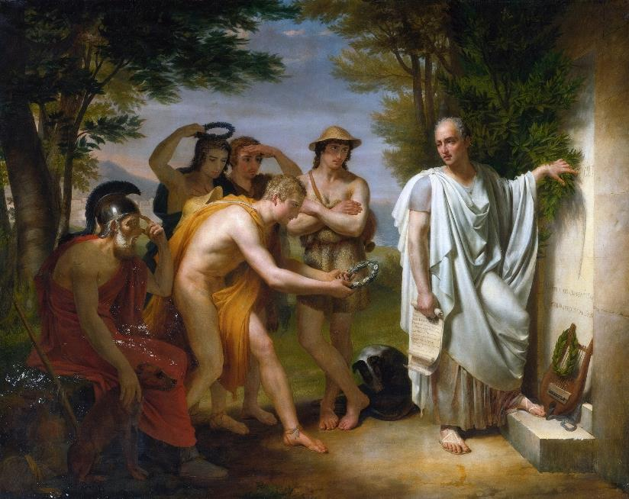
‘Horace at the Tomb of Virgil’
Jean-Bruno Gassies (1786 - 1832)
Artvee
Q
uintus Horatius Flaccus (65–8 BC) was born at Venusia, on the border of Lucania and Apulia. His father, a freed slave and coactor (auctioneer and financier), invested heavily in his son’s education, accompanying him to Rome to oversee his schooling. Horace subsequently enrolled at the Academy in Athens, where he studied Greek lyric poetry alongside Epicurean and Stoic philosophy.
The civil wars that followed Julius Caesar’s assassination brought his education to an untimely close. Brutus recruited him in Athens, and Horace served as a military tribune at the Battle of Philippi in 42 BC. After the republican defeat, he accepted Octavian’s amnesty and returned to Italy, where his father’s estate had been confiscated for veteran settlements. He obtained a civil service post at the Treasury and began writing verse.
Through Virgil, Horace gained an introduction to Maecenas, Octavian’s political lieutenant. Maecenas became his patron and gave him the Sabine farm that features prominently in his poetry. This relationship aligned Horace with the emerging Augustan regime - which scholars argue may have influenced the independence of his writing.
His works appeared over a period of roughly twenty-five years: two books of Satires (c. 35–30 BC), the Epodes (30 BC), Odes 1–3 (23 BC), Epistles 1 (c. 21 BC), the Carmen Saeculare (17 BC), Epistles 2, Odes 4 (c. 11 BC), and the Ars Poetica (c. 10–8 BC). Each collection adapted Greek and Roman models, including Archilochus, Lucilius, Alcaeus, and Sappho, to Roman conditions.
He died on 27 November 8 BC, shortly after Maecenas, and was buried near his patron’s tomb. Both men bequeathed their property to Augustus.
Horace’s Odes (Carmina) is a collection of 103 Latin lyric poems across four books. Books 1–3 were published in 23 BC; Book 4, comprising 15 poems, followed in 13 BC. The work draws on Greek lyric models, principally Pindar, Sappho, and Alcaeus, adapting their forms and metres to Roman social and political life under Augustus.
The poems address a wide range of subjects: love, friendship, wine, religion, morality, patriotism, and the praise of Augustus and his circle. Philosophical themes recur throughout, particularly the brevity of life, the value of moderation (the “golden mean”), and contentment with one’s lot. Several widely cited Latin phrases originate here, including carpe diem (“seize the day”), nunc est bibendum (“now’s the time for drinking”), and dulce et decorum est pro patria mori (“it’s sweet and fitting to die for one’s country”).
The collection displays careful structural arrangement. Books 1–3 exhibit a chiastic symmetry, with thematically or verbally linked poems positioned at corresponding distances from the beginning and end. The six “Roman Odes” opening Book 3 form an independent sequence unified by the Alcaic metre and themes of civic virtue. Book 4, composed after a gap of several years, centres on mortality and poetic immortality.
Metrically, the Odes employ Alcaic, Sapphic, and several Asclepiad stanza forms, along with rarer metres. Horace claimed priority in adapting Aeolic lyric metres to Latin verse. Stylistic analysis of the Alcaic stanzas across the four books suggests the poems were composed roughly in the order of their arrangement, with progressive metrical refinement over time.
Horace fully exploited the metrical possibilities offered to him by Greek lyric verse. I have followed the original Latin metre in all cases, giving a reasonably close English version of Horace’s strict forms. Rhythm not rhyme is the essence. Please try reading slowly to identify the rhythm of the first verse of each poem, before reading the whole poem through. Counting syllables, and noting the natural rhythm of individual phrases, may help. Those wishing to understand the precise scansion of Latin lyric verse should consult a specialist text. The Collins Latin Dictionary, for example, includes a good summary. The metres used by Horace in each of the Odes, giving the standard number of syllables per line only, are listed at the end of each book of the text.

Book I

BkI:I The Dedication: To Maecenas

Maecenas, descendant of royal ancestors,
O my protector, and my sweet glory,
some are delighted by showers of dust,
Olympic dust, over their chariots, they
are raised to the gods, as Earth’s masters, by posts
clipping the red-hot wheels, by noble palms:
this man, if the fickle crowd of Citizens
compete to lift him to triple honours:
that one, if he’s stored away in his granary
whatever he gleaned from the Libyan threshing.
The peasant who loves to break clods in his native
fields, won’t be tempted, by living like Attalus,
to sail the seas, in fear, in a Cyprian boat.
The merchant afraid of the African winds as
they fight the Icarian waves, loves the peace
and the soil near his town, but quickly rebuilds
his shattered ships, unsuited to poverty.
There’s one who won’t scorn cups of old Massic,
nor to lose the best part of a whole day lying
under the greenwood tree, or softly
close to the head of sacred waters.
Many love camp, and the sound of trumpets
mixed with the horns, and the warfare hated
by mothers. The hunter, sweet wife forgotten,
stays out under frozen skies, if his faithful
hounds catch sight of a deer, or a Marsian
wild boar rampages, through his close meshes.
But the ivy, the glory of learned brows,
joins me to the gods on high: cool groves,
and the gathering of light nymphs and satyrs,
draw me from the throng, if Euterpe the Muse
won’t deny me her flute, and Polyhymnia
won’t refuse to exert herself on her Lesbian lyre.
And if you enter me among all the lyric poets,
my head too will be raised to touch the stars.

BkI:II To Augustus

The Father’s sent enough dread hail
and snow to earth already, striking
sacred hills with fiery hand,
to scare the city,

and scare the people, lest again
we know Pyrrha’s age of pain
when Proteus his sea-herds drove
across high mountains,

and fishes lodged in all the elms,
that used to be the haunt of doves,
and the trembling roe-deer swam
the whelming waters.

We saw the yellow Tiber’s waves
hurled backwards from the Tuscan shore,
toppling Numa’s Regia and
the shrine of Vesta,

far too fierce now, the fond river,
in his revenge of wronged Ilia,
drowning the whole left bank, deep,
without permission.

Our children, fewer for their father’s
vices, will hear metal sharpened
that’s better destined for the Persians,
and of battles too.

Which gods shall the people call on
when the Empire falls in ruins?
With what prayer shall the virgins
tire heedless Vesta?

Whom will Jupiter assign to
expiate our sins? We pray you,
come, cloud veiling your bright shoulders,
far-sighted Apollo:
or laughing Venus Erycina,
if you will, whom Cupid circles,
or you, if you see your children
neglected, Leader,

you sated from the long campaign,
who love the war-shouts and the helmets,
and the Moor’s cruel face among his
blood-stained enemies.

Or you, winged son of kindly Maia,
changing shape on earth to human
form, and ready to be named as
Caesar’s avenger:

Don’t rush back to the sky, stay long
among the people of Quirinus,
no swifter breeze take you away,
unhappy with our

sins: here to delight in triumphs,
in being called our prince and father,
making sure the Medes are punished,
lead us, O Caesar.

BkI:III Virgil: Off to Greece

May the goddess, queen of Cyprus,
and Helen’s brothers, the brightest of stars,
and father of the winds, Aeolus,
confining all except Iapyga, guide you,

ship, that owes us Virgil, given
to your care, guide you to Attica’s shores,
bring him safely there I beg you,
and there watch over half of my spirit.

Triple bronze and oak encircled
the breast of the man who first committed
his fragile bark to the cruel sea,
without fearing the fierce south-westerlies

fighting with the winds from the north,
the sad Hyades, or the raging south,
master of the Adriatic,
whether he stirs or he calms the ocean.

What form of death could he have feared,
who gazed, dry-eyed, on swimming monsters,
saw the waves of the sea boiling,
and Acroceraunia’s infamous cliffs?

Useless for a wise god to part
the lands, with a far-severing Ocean,
if impious ships, in spite of him,
travel the depths he wished inviolable.

Daring enough for anything,
the human race deals in forbidden sin.
That daring son of Iapetus
brought fire, by impious cunning, to men.

When fire was stolen from heaven
its home, wasting disease and a strange crowd
of fevers covered the whole earth,
and death’s powers, that had been slow before

and far away, quickened their step.
Daedalus tried the empty air on wings
that were never granted to men:
Hercules’ labours shattered Acheron.

Nothing’s too high for mortal men:
like fools, we aim at the heavens themselves,
sinful, we won’t let Jupiter
set aside his lightning bolts of anger.

BkI:IV Spring

Fierce winter slackens its grip: it’s spring and the west wind’s sweet change:
the ropes are hauling dry hulls towards the shore,
The flock no longer enjoys the fold, or the ploughman the fire,
no more are the meadows white with hoary frost.

Now Cytherean Venus leads out her dancers, under the pendant moon,
and the lovely Graces have joined with the Nymphs,
treading the earth on tripping feet, while Vulcan, all on fire, visits
the tremendous Cyclopean forges.

Now its right to garland our gleaming heads, with green myrtle or flowers,
whatever the unfrozen earth now bears:
now it’s right to sacrifice to Faunus, in groves that are filled with shadow,
whether he asks a lamb, or prefers a kid.

Pale death knocks with impartial foot, at the door of the poor man’s cottage,
and at the prince’s gate. O Sestus, my friend,
the span of brief life prevents us from ever depending on distant hope.
Soon the night will crush you, the fabled spirits,

and Pluto’s bodiless halls: where once you’ve passed inside you’ll no longer
be allotted the lordship of wine by dice,
or marvel at Lycidas, so tender, for whom, already, the boys
are burning, and soon the girls will grow hotter.

BkI:V Treacherous Girl

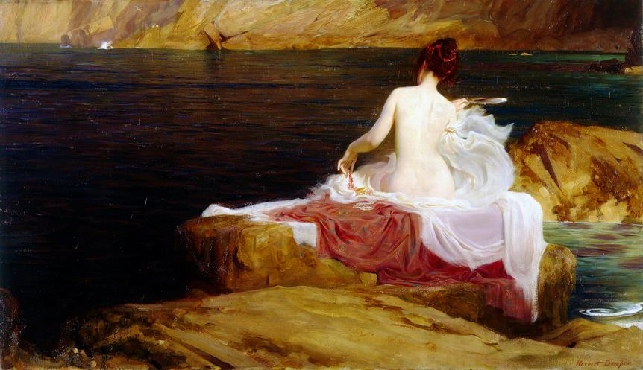
‘Calypso's Isle’
Herbert James Draper (1863 – 1920)
Wikimedia Commons
What slender boy, Pyrrha, drowned in liquid perfume,
urges you on, there, among showers of roses,
deep down in some pleasant cave?
For whom did you tie up your hair,

with simple elegance? How often he’ll cry at
the changes of faith and of gods, ah, he’ll wonder,
surprised by roughening water,
surprised by the darkening storms,

who enjoys you now and believes you’re golden,
who thinks you’ll always be single and lovely,
ignoring the treacherous
breeze. Wretched are those you dazzle

while still untried. As for me the votive tablet
that hangs on the temple wall reveals, suspended,
my dripping clothes, for the god,
who holds power over the sea.

BkI:VI A Tribute to Agrippa

You should be penned as brave, and a conqueror
by Varius, winged with his Homeric poetry,
whatever fierce soldiers, with vessels or horses,
have carried out, at your command.

Agrippa, I don’t try to speak of such things,
not Achilles’ anger, ever unyielding,
nor crafty Ulysses’ long sea-wanderings,
nor the cruel house of Pelops,

I’m too slight for grandeur, since shame and the Muse,
who’s the power of the peaceful lyre, forbids me
to lessen the praise of great Caesar and you,
by my defective artistry.

Who could write worthily of Mars in his armour
Meriones the Cretan, dark with Troy’s dust,
or Tydides, who with the help of Athene,
was the equal of all the gods?

I sing of banquets, of girls fierce in battle
with closely-trimmed nails, attacking young men:
idly, as I’m accustomed to do, whether
fancy free or burning with love.

BkI:VII Tibur (the modern Tivoli)

Let others sing in praise of Rhodes, or Mytilene,
or Ephesus, or Corinth on the Isthmus,
or Thebes that’s known for Bacchus, or Apollo’s isle
of Delphi, or Thessalian Tempe.

There’s some whose only purpose is to celebrate
virgin Athene’s city forever,
and set indiscriminately gathered olive on their heads.
Many a poet in honour of Juno

will speak fittingly of horses, Argos, rich Mycenae.
As for me not even stubborn Sparta
or the fields of lush Larisa are quite as striking,
as Albunea’s echoing cavern,

her headlong Anio, and the groves of Tiburnus,
and Tibur’s orchards, white with flowing streams.
Bright Notus from the south often blows away the clouds
from dark skies, without bringing endless rain,

so Plancus, my friend, remember to end a sad life
and your troubles, wisely, with sweet wine,
whether it’s the camp, and gleaming standards, that hold you
or the deep shadows of your own Tibur.

They say that Teucer, fleeing from Salamis and his
father, still wreathed the garlands, leaves of poplar,
round his forehead, flushed with wine, and in speech to his friends
said these words to them as they sorrowed:

‘Wherever fortune carries us, kinder than my father,
there, O friends and comrades, we’ll adventure!
Never despair, if Teucer leads, of Teucer’s omens!
Unerring Apollo surely promised,
in the uncertain future, a second Salamis
on a fresh soil. O you brave heroes, you
who suffered worse with me often, drown your cares with wine:
tomorrow we’ll sail the wide seas again.’

BkI:VIII : To Lydia: Stop Ruining Sybaris!

Lydia, by all the gods,
say why you’re set on ruining poor Sybaris, with passion:
why he suddenly can’t stand
the sunny Campus, he, once tolerant of the dust and sun:

why he’s no longer riding
with his soldier friends, nor holds back the Gallic mouth, any longer,
with his sharp restraining bit.
Why does he fear to touch the yellow Tiber? Why does he keep

away from the wrestler’s oil
like the viper’s blood: he won’t appear with arms bruised by weapons,
he who was often noted
for hurling the discus, throwing the javelin out of bounds?

Why does he hide, as they say
Achilles, sea-born Thetis’ son, hid, before sad Troy was ruined,
lest his male clothing
had him dragged away to the slaughter, among the Lycian troops?

BkI:IX Winter

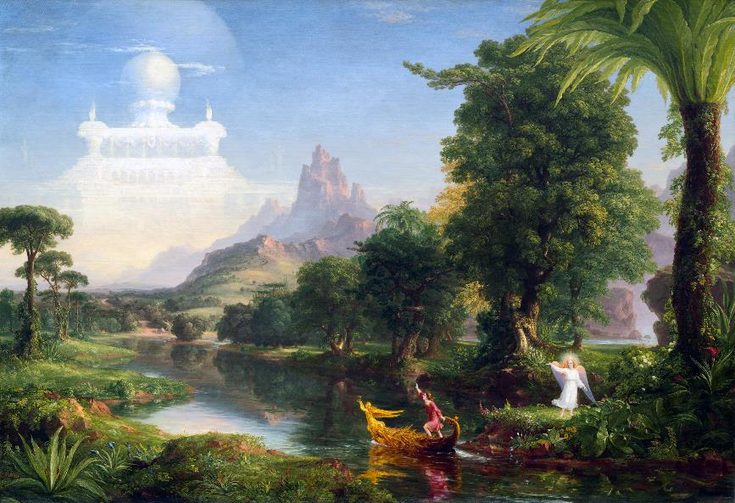
‘The Voyage of Life: Youth’
Thomas Cole (1801 – 1848)
Wikimedia Commons
See how Soracte stands glistening with snowfall,
and the labouring woods bend under the weight:
see how the mountain streams are frozen,
cased in the ice by the shuddering cold?

Drive away bitterness, and pile on the logs,
bury the hearthstones, and, with generous heart,
out of the four-year old Sabine jars,
O Thaliarchus, bring on the true wine.

Leave the rest to the gods: when they’ve stilled the winds
that struggle, far away, over raging seas,
you’ll see that neither the cypress trees
nor the old ash will be able to stir.

Don’t ask what tomorrow brings, call them your gain
whatever days Fortune gives, don’t spurn sweet love,
my child, and don’t you be neglectful
of the choir of love, or the dancing feet,

while life is still green, and your white-haired old age
is far away with all its moroseness. Now,
find the Campus again, and the squares,
soft whispers at night, at the hour agreed,

and the pleasing laugh that betrays her, the girl
who’s hiding away in the darkest corner,
and the pledge that’s retrieved from her arm,
or from a lightly resisting finger.

BkI:X To Mercury

Mercury, eloquent grandson of Atlas,
I’ll sing of you, who wise with your training, shaped
the uncivilised ways of our new-born race,
with language, and grace

in the ways of wrestling, you the messenger
of Jove and the gods, and the curved lyre’s father,
skilful in hiding whatever pleases you,
with playful deceit.

While he tried to scare you, with his threatening voice,
unless you returned the cattle you’d stolen,
and so craftily, Apollo was laughing
missing his quiver.

And indeed, with your guidance, Priam carrying
rich gifts left Troy, escaped the proud Atridae,
Thessalian fires, and the menacing camp
threatening Ilium.

You bring virtuous souls to the happy shores,
controlling the bodiless crowds with your wand
of gold, pleasing to the gods of the heavens
and the gods below.

BkI:XI Carpe Diem

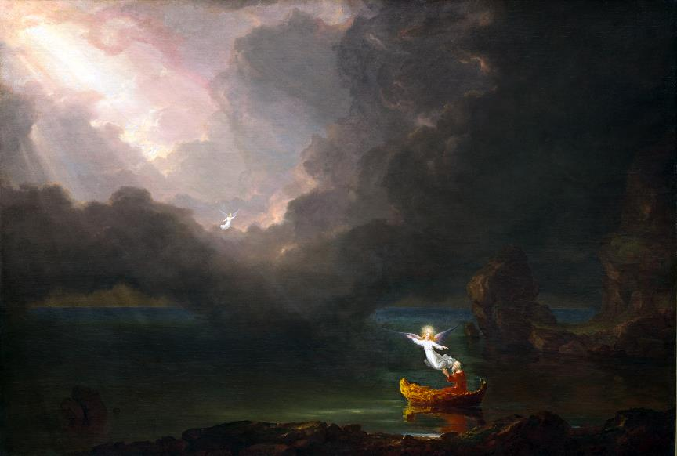
‘The Voyage of Life: Old Age’
Thomas Cole (1801 – 1848)
Wikimedia Commons
Leuconoë , don’t ask, we never know, what fate the gods grant us,
whether your fate or mine, don’t waste your time on Babylonian,
futile, calculations. How much better to suffer what happens,
whether Jupiter gives us more winters or this is the last one,
one debilitating the Tyrrhenian Sea on opposing cliffs.
Be wise, and mix the wine, since time is short: limit that far-reaching hope.
The envious moment is flying now, now, while we’re speaking:
Seize the day, place in the hours that come as little faith as you can.

BkI:XII Praising Augustus

What god, man, or hero do you choose to praise
on the high pitched flute or the lyre, Clio?
Whose name will it be that joyfully resounds
in playful echoes,

either on shadowed slopes of Mount Helicon,
or on Pindus’s crest, or on cool Haemus,
where the trees followed thoughtlessly after
Orpheus’s call,

that held back the swift-running streams and the rush
of the breeze, by his mother the Muse’s art,
and seductively drew the listening oaks
with enchaining song?

Which shall I sing first of the praises reserved
for the Father, who commands mortals and gods,
who controls the seas, and the land, and the world’s
various seasons?

From whom nothing’s born that’s greater than he is,
and there’s nothing that’s like him or near him,
though Athene has honour approaching his,
she’s bravest in war:

I won’t be silent about you, O Bacchus,
or you Diana, virgin inimical
to wild creatures, or you Apollo, so feared
for your sure arrows.

I’ll sing Hercules, too, and Leda’s twin boys,
one famed for winning with horses, the other
in boxing. When their clear stars are shining bright
for those on the sea,

the storm-tossed water streams down from the headland,
the high winds die down, and the clouds disappear,
and, because they wish it, the menacing waves
repose in the deep.

I don’t know whether to speak next, after those,
of Romulus, or of Numa’s peaceful reign,
of Tarquin’s proud axes, or of that younger
Cato’s noble death.
Gratefully, I speak in distinguished verses
of Regulus: and the Scauri: and Paulus
careless of his life, when Hannibal conquered:
of Fabricius.

Of him, and of Curius with uncut hair,
and Camillus too, whom their harsh poverty
and their ancestral gods, and their ancient farms,
inured to struggle.

Marcellus’ glory grows like a tree, quietly
with time: the Julian constellation shines,
among the other stars, as the Moon among
the lesser fires.

Father, and guardian of the human race,
son of Saturn, the care of mighty Caesar
was given you by fate: may you reign forever
with Caesar below.

Whether its the conquered Persians, menacing
Latium , that he leads, in well-earned triumph,
or the Seres and the Indians who lie
beneath Eastern skies,

under you, he’ll rule the wide earth with justice:
you’ll shake Olympus with your heavy chariot,
you’ll send your hostile lightning down to shatter
once-pure sacred groves.

BkI:XIII His Jealousy

When you, Lydia, start to praise
Telephus’ rosy neck, Telephus’ waxen arms,
alas, my burning passion starts
to mount deep inside me, with troubling anger.

Neither my feelings, nor my hue
stay as they were before, and on my cheek a tear
slides down, secretly, proving how
I’m consumed inwardly with lingering fires.

I burn, whether it’s madhouse
quarrels that have, drunkenly, marked your gleaming
shoulders, or whether the crazed boy
has placed a love-bite, in memory, on your lips.

If you’d just listen to me now,
you’d not bother to hope for constancy from him
who wounds that sweet mouth, savagely,
that Venus has imbued with her own pure nectar.

Three times happy are they, and more,
held by unbroken pledge, one which no destruction
of love, by evil quarrels,
will ever dissolve, before life’s final day.

BkI:XIV The Ship of State

O ship the fresh tide carries back to sea again.
Where are you going! Quickly, run for harbour.
Can’t you see how your sides
have been stripped bare of oars,

how your shattered masts and yards are groaning loudly
in the swift south-westerly, and bare of rigging,
your hull can scarce tolerate
the overpowering waters?

You haven’t a single sail that’s still intact now,
no gods, that people call to when they’re in trouble.
Though you’re built of Pontic pine,
a child of those famous forests,

though you can boast of your race, and an idle name:
the fearful sailor puts no faith in gaudy keels.
You must beware of being
merely a plaything of the winds.

You, who not long ago were troubling weariness
to me, and now are my passion and anxious care,
avoid the glistening seas
between the shining Cyclades.

BkI:XV Nereus’ Prophecy of Troy

While Paris, the traitorous shepherd, her guest,
bore Helen over the waves, in a ship from Troy,
Nereus , the sea-god, checked the swift breeze
with an unwelcome calm, to tell

their harsh fate: ‘You’re taking a bird of ill-omen,
back home, whom the Greeks, new armed, will look for again,
having sworn to destroy the marriage your planning
and the empire of old Priam.

Ah, what sweated labour for men and for horses
draws near! What disaster you bring for the Trojan
people! Athene’s already prepared her helm,
breastplate, chariot, and fury.

Uselessly daring, through Venus’ protection,
you’ll comb your hair and pluck at the peace-loving lyre,
make the music for songs that please girls: uselessly
you’ll hide, in the depths of your room,

from the heavy spears, from the arrows of Cretan
reeds, and the noise of the battle, and swift-footed
Ajax quick to follow: yet, ah too late, you’ll bathe
your adulterous hair in the dust!

Have you thought of Ulysses, the bane of your race,
have you even considered Pylian Nestor?
Teucer of Salamis presses you fearlessly,
Sthenelus , skilful in warfare,

and if it’s a question of handling the horses
he’s no mean charioteer. And Meriones
you’ll know him too. See fierce Tydides, his father’s
braver, he’s raging to find you.

As the deer sees the wolf there, over the valley,
and forgets its pastures, a coward, you’ll flee him,
breathing hard, as you run, with your head thrown high,
not as you promised your mistress.

The anger of Achilles’ armies may delay
the day of destruction for Troy and its women:
but after so many winters the fires of Greece
will burn the Dardanian houses.’

BkI:XVI He Repents

O lovelier child of a lovely mother,
end as you will, then, my guilty iambics
whether in flames or whether instead
deep down in the Adriatic’s waters.

Neither Cybele, nor Apollo, who troubles
the priestess’s mind in the Pythian shrine,
nor Bacchus, nor the Corybants who
clash their shrill, ringing cymbals together,

pain us like anger, that’s undefeated by
swords out of Noricum, or sea, the wrecker,
or cruel fire, or mighty Jupiter
when he sweeps down in terrible fury.

They say when Prometheus was forced to add
something from every creature to our first clay
he chose to set in each of our hearts
the violence of the irascible lion.

Anger brought Thyestes down, to utter ruin,
and it’s the prime reason powerful cities
vanished in their utter destruction,
and armies, in scorn, sent the hostile plough

over the levelled spoil of their shattered walls.
Calm your mind: the passions of the heart have made
their attempt on me, in my sweet youth,
and drove me, maddened, as well, to swift verse:

I wish to change the bitter lines to sweet, now,
since I’ve charmed away all of my hostile words,
if you might become my friend, again,
and if you, again, might give me your heart.

BkI:XVII The Delights of the Country

Swift Faunus, the god, will quite often exchange
Arcady for my sweet Mount Lucretilis,
and while he stays he protects my goats
from the midday heat and the driving rain.

The wandering wives of the rank he-goats search,
with impunity, through the safe woodland groves,
for the hidden arbutus, and thyme,
and their kids don’t fear green poisonous snakes,

or the wolf of Mars, my lovely Tyndaris,
once my Mount Ustica’s long sloping valleys,
and its smooth worn rocks, have re-echoed
to the music of sweet divine piping.

The gods protect me: my love and devotion,
and my Muse, are dear to the gods. Here the rich
wealth of the countryside’s beauties will
flow for you, now, from the horn of plenty.

Here you’ll escape from the heat of the dog-star,
in secluded valleys, sing of bright Circe,
labouring over the Teian lyre,
and of Penelope: both loved one man.

Here you’ll bring cups of innocent Lesbian
wine, under the shade, nor will Semele’s son,
that Bacchus, battle it out with Mars,
nor shall you fear the intemperate hands

of insolent Cyrus, jealously watching,
to possess you, girl, unequal to evil,
to tear off the garland that clings to
your hair, or tear off your innocent clothes.

BkI:XVIII Wine

Cultivate no plant, my Varus, before the rows of sacred vines,
set in Tibur’s gentle soil, and by the walls Catilus founded:
because the god decreed all things are hard for those who never drink,
and he gave us no better way to lessen our anxieties.
Deep in wine, who rattles on, about harsh campaigns or poverty?
Who doesn’t rather speak of you, Bacchus, and you, lovely Venus?
And lest the gifts of Liber pass the bounds of moderation set,
we’ve the battle over wine, between the Lapiths and the Centaurs,
as a warning to us all, and the frenzied Thracians, whom Bacchus
hates, when they split right from wrong, by too fine a line of passion.
Lovely Bacchus, I’ll not be the one to stir you, against your will,
nor bring to open light of day what’s hidden under all those leaves.
Hold back the savagery of drums, and the Berecyntian horns,
and those deeds that, afterwards, are followed by a blind self-love,
by pride that lifts its empty head too high, above itself, once more,
and wasted faith in mysteries much more transparent than the glass.

BkI:XIX Glycera’s Beauty

Cruel Venus, Cupid’s mother,
Bacchus, too, commands me, Theban Semele’s son,
and you, lustful Licentiousness,
to recall to mind that love I thought long-finished.

I burn for Glycera’s beauty,
who gleams much more brightly than Parian marble:
I burn for her lovely boldness
and her face too dangerous to ever behold.

Venus bears down on me, wholly,
deserting her Cyprus, not letting me sing of
the Scythians, or Parthians
eager at wheeling their horses, nor anything else.

Here set up the green turf altar,
boys, and the sacred boughs of vervain, and incense,
place here a bowl of last year’s wine:
if a victim’s sacrificed, she’ll come more gently.

BkI:XX To Maecenas

Come and drink with me, rough Sabine in cheap cups,
yet wine that I sealed myself, and laid up
in a Grecian jar, when you dear Maecenas,
flower of knighthood,

received the theatre’s applause, so your native
river-banks, and, also, the Vatican Hill,
together returned that praise again, to you,
in playful echoes.

Then, drink Caecubum, and the juice of the grape
crushed in Campania’s presses, my cups are
unmixed with what grows on Falernian vines,
or Formian hills.

BkI:XXI Hymn to Diana

O tender virgins sing, in praise of Diana,
and, you boys, sing in praise, of long-haired Apollo,
and of Latona, deeply
loved by all-conquering Jove.

You girls, she who enjoys the streams and the green leaves
of the groves that clothe the cool slopes of Algidus,
or dark Erymanthian
trees, or the woods of green Cragus.
You boys, sounding as many praises, of Tempe
and Apollo’s native isle Delos, his shoulder
distinguished by his quiver,
and his brother Mercury’s lyre.

He’ll drive away sad war, and miserable famine,
the plague too, from our people and Caesar our prince,
and, moved by all your prayers,
send them to Persians and Britons.

BkI:XXII Singing of Lalage (Integer Vitae)

The man who is pure of life, and free of sin,
has no need, dear Fuscus, for Moorish javelins,
nor a bow and a quiver, fully loaded
with poisoned arrows,

whether his path’s through the sweltering Syrtes,
or through the inhospitable Caucasus,
or makes its way through those fabulous regions
Hydaspes waters.

While I was wandering, beyond the boundaries
of my farm, in the Sabine woods, and singing
free from care, lightly-defended, of my Lalage,
a wolf fled from me:

a monster not even warlike Apulia
nourishes deep in its far-flung oak forests,
or that Juba’s parched Numidian land breeds,
nursery of lions.

Set me down on the lifeless plains, where no trees
spring to life in the burning midsummer wind,
that wide stretch of the world that’s burdened by mists
and a gloomy sky:

set me down in a land denied habitation,
where the sun’s chariot rumbles too near the earth:
I’ll still be in love with my sweetly laughing,
sweet talking Lalage.

BkI:XXIII Chloë, Don’t Run

You run away from me as a fawn does, Chloë,
searching the trackless hills for its frightened mother,
not without aimless terror
of the pathless winds, and the woods.

For if the coming of spring begins to rustle
among the trembling leaves, or if a green lizard
pushes the brambles aside,
then it trembles in heart and limb.

And yet I’m not chasing after you to crush you
like a fierce tiger, or a Gaetulian lion:
stop following your mother,
now, you’re prepared for a mate.

BkI:XXIV A Lament For Quintilius

What limit, or restraint, should we show at the loss
of so dear a life? Melpomene, teach me, Muse,
a song of mourning, you, whom the Father granted
a clear voice, the sound of the lyre.

Does endless sleep lie heavy on Quintilius,
now? When will Honour, and unswerving Loyalty,
that is sister to Justice, and our naked Truth,
ever discover his equal?

Many are the good men who weep for his dying,
none of them, Virgil, weep more profusely than you.
Piously, you ask the gods for him, alas, in vain:
not so was he given to us.

Even if you played on the Thracian lyre, listened
to by the trees, more sweetly than Orpheus could,
would life then return, to that empty phantom,
once Mercury, with fearsome wand,

who won’t simply re-open the gates of Fate
at our bidding, has gathered him to the dark throng?
It is hard: but patience makes more tolerable
whatever wrong’s to be righted.

BkI:XXV A Prophecy of Age

Now the young men come less often, violently
beating your shutters, with blow after blow, or
stealing away your sleep, while the door sits tight,
hugging the threshold,

yet was once known to move its hinges, more than
readily. You’ll hear, less and less often now:
‘Are you sleeping, Lydia, while your lover
dies in the long night?’

Old, in your turn, you’ll bemoan coarse adulterers,
as you tremble in some deserted alley,
while the Thracian wind rages, furiously,
through the moonless nights,

while flagrant desire, libidinous passion,
those powers that will spur on a mare in heat,
will storm all around your corrupted heart, ah,
and you’ll complain,

that the youths, filled with laughter, take more delight
in the green ivy, the dark of the myrtle,
leaving the withering leaves to this East wind,
winter’s accomplice.

BkI:XXVI A Garland For Lamia

Friend of the Muses, I’ll throw sadness and fear
to the winds, to blow over the Cretan Sea,
untroubled by whoever he is, that king
of the icy Arctic shores we’re afraid of,

or whatever might terrify the Armenians.
O Sweet Muse, that joys in fresh fountains,
weave them together all the bright flowers,
weave me a garland for my Lamia.

Without you there’s no worth in my tributes:
it’s fitting that you, that all of your sisters,
should immortalise him with new strains
of the lyre, with the Lesbian plectrum.

BkI:XXVII Entanglement

To fight with wine-cups intended for pleasure
only suits Thracians: forget those barbarous
games, and keep modest Bacchus away
from all those bloodthirsty quarrels of yours.

The Persian scimitar’s quite out of keeping
with the wine and the lamplight: my friends restrain
all that impious clamour, and rest
on the couches, lean back on your elbows.

So you want me to drink up my share, as well,
of the heavy Falernian? Then let’s hear
Opuntian Megylla’s brother tell
by what wound, and what arrow, blessed, he dies.

Does your will waver? I’ll drink on no other
terms. Whatever the passion rules over you,
it’s not with a shameful fire it burns,
and you always sin with the noblest

of lovers. Whoever it is, ah, come now,
let it be heard by faithful ears – oh, you wretch!
What a Charybdis you’re swimming in,
my boy, you deserve a far better flame!

What magician, with Thessalian potions,
what enchantress, or what god could release you?
Caught by the triple-formed Chimaera,
even Pegasus could barely free you.

BkI:XXVIII Three Handfuls of Earth

You, my Archytas, philosopher, and measurer of land,
of the sea, of wide sands, are entombed
in a small mound of meagre earth near the Matinian shore,
and it’s of no use to you in the least,

that you, born to die, have explored the celestial houses
crossed, in spirit, the rounds of the sky.
Tantalus, Pelop’s father, died too, a guest of the gods,
and Tithonus took off to the heavens,

Minos gained entry to great Jupiter’s secrets, Tartarus
holds Euphorbus, twice sent to Orcus,
though he bore witness, carrying his shield there, to Trojan times,
and left nothing more behind, for black Death,

but his skin and his bones, and that certainly made him, Archytas,
to your mind, no trivial example
of Nature and truth. But there’s still one night that awaits us all,
and each, in turn, makes the journey of death.

The Furies deliver some as a spectacle for cruel Mars,
the greedy sea’s the sailor’s ruin:
the funerals of the old, and the young, close ranks together,
and no one’s spared by cruel Proserpine.

Me too, the south wind, Notus, swift friend of setting Orion,
drowned deep in Illyrian waters.
O, sailor, don’t hesitate, from spite, to grant a little treacherous
sand, to my unburied bones and skull.

So that, however the east wind might threaten the Italian
waves, thrashing the Venusian woods,
you’ll be safe, yourself, and rich rewards will flow from the source,
from even-handed Jupiter, and from

Neptune, who is the protector of holy Tarentum. Are you
indifferent to committing a wrong
that will harm your innocent children hereafter? Perhaps
a need for justice, and arrogant

disdain, await you, too: don’t let me be abandoned here
my prayers unanswered: no offering
will absolve you. Though you hurry away, it’s a brief delay:
three scattered handfuls of earth will free you.

BkI:XXIX Off To The Wars

Iccius, are you gazing with envy, now,
at Arabian riches, and preparing
for bitter war on unbeaten kings
of Saba, weaving bonds for those dreadful

Medes? What barbaric virgin
will be your slave, when you’ve murdered her lover?
What boy, from the palace, with scented
hair, will handle your wine-cups, one taught

by his father’s bow how to manage eastern
arrows? Who’ll deny, now, that rivers can flow
backwards, to the summits of mountains,
and Tiber reverse the course of his streams,

when you, who gave promise of much better things,
are intent on changing Panaetius’s
noble books, the school of Socrates,
for a suit of Iberian armour?

BkI:XXX Ode To Venus

O Venus, the queen of Cnidos and Paphos,
spurn your beloved Cyprus, and summoned
by copious incense, come to the lovely shrine
of my Glycera.

And let that passionate boy of yours, Cupid,
and the Graces with loosened zones, and the Nymphs,
and Youth, less lovely without you, hasten here,
and Mercury too.

BkI:XXXI A Prayer to Apollo

What is the poet’s request to Apollo?
What does he pray for as he pours out the wine
from the bowl? Not for the rich harvests
of fertile Sardinia, nor the herds,

(they’re delightful), of sunlit Calabria,
not for India’s gold or its ivory,
nor fields our silent Liris’s stream
carries away in the calm of its flow.

Let those that Fortune allows prune the vines,
with a Calenian knife, so rich merchants
can drink their wine from a golden cup,
wine they’ve purchased with Syrian goods,

who, dear to the gods, three or four times yearly,
revisit the briny Atlantic, unscathed.
I browse on olives, and chicory
and simple mallow. Apollo, the son

of Latona, let me enjoy what I have,
and, healthy in body and mind, as I ask,
live an old age not without honour,
and one not lacking the art of the lyre.

BkI:XXXII To the Lyre

I’m called on. O Lyre, if I’ve ever played
idle things with you in the shade, that will live,
for a year or more, come and utter a song
now, of Italy:

you were first tuned by Alcaeus of Lesbos,
a man daring in war, yet still, amongst arms,
or after he’d moored his storm-driven boat
on a watery shore,

he sang of the Muses, Bacchus, and Venus
that boy of hers, Cupid, that hangs around her,
and that beautiful Lycus, with his dark eyes
and lovely dark hair.

O tortoiseshell, Phoebus’s glory, welcome
at the feasts of Jupiter, the almighty,
O sweet comfort and balm of our troubles, heal,
if I call you true!

BkI:XXXIII Tibullus, Don’t Grieve

Tibullus, don’t grieve too much, when you remember
your cruel Glycera, and don’t keep on singing
those wretched elegies, or ask why, trust broken,
you’re outshone by a younger man.
Lovely Lycoris, the narrow-browed one, is on fire
with love for Cyrus, Cyrus leans towards bitter
Pholoë, but does in the wood are more likely
to mate with Apulian wolves,

than Pholoë to sin with some low-down lover.
So Venus has it, who delights in the cruel
game of mating unsuitable bodies and minds,
under her heavy yoke of bronze.

I, myself, when a nobler passion was called for,
was held in the charming bonds of Myrtale,
that freed slave, more bitter than Hadria’s waves
that break in Calabria’s bay.

BkI:XXXIV Fortune’s Changes

Once I wandered, an expert in crazy wisdom,
a scant and infrequent adorer of gods,
now I’m forced to set sail and return,
to go back to the paths I abandoned.

For Jupiter, Father of all of the gods,
who generally splits the clouds with his lightning,
flashing away, drove thundering horses,
and his swift chariot, through the clear sky,

till the dull earth, and the wandering rivers,
and Styx, and dread Taenarus’ hateful headland,
and Atlas’s mountain-summits shook.
The god has the power to replace the highest

with the lowest, bring down the famous, and raise
the obscure to the heights. And greedy Fortune
with her shrill whirring, carries away
the crown and delights in setting it, there.

BkI:XXXV To Fortune

O goddess, who rules our lovely Antium,
always ready to lift up our mortal selves,
from humble position, or alter
proud triumphs to funeral processions,

the poor farmer, in the fields, courts your favour
with anxious prayers: you, mistress of ocean,
the sailor who cuts the Carpathian
Sea, in a Bithynian sailing boat:

you, the fierce Dacian, wandering Scythian,
cities, and peoples, and warlike Latium,
mothers of barbarous kings, tyrants,
clothed in their royal purple, all fear you,

in case you demolish the standing pillar
with a careless foot, or the tumultuous crowd
incite the peaceful: ‘To arms, to arms’,
and shatter the supreme authority.

Grim Necessity always treads before you,
and she’s carrying the spikes and the wedges
in her bronze hand, and the harsh irons
and the molten lead aren’t absent either.

Hope cultivates you, and rarest Loyalty,
her hands bound in sacred white, will not refuse
her friendship when you, their enemy,
desert the great houses plunged in mourning.

But the disloyal mob, and the perjured whores
vanish, and friends scatter when they’ve drunk our wine
to the lees, unequal to bearing
the heavy yoke of all our misfortunes.

Guard our Caesar who’s soon setting off again
against the earth’s far-off Britons, and guard
the fresh young levies, who’ll scare the East
in those regions along the Red Sea’s shores.

Alas, the shame of our scars and wickedness,
and our dead brothers. What has our harsh age spared?
What sinfulness have we left untried?
What have the young men held their hands back from,
in fear of the gods? Where are the altars they’ve left
alone? O may you remake our blunt weapons
on fresh anvils so we can turn them
against the Scythians and the Arabs.

BkI:XXXVI Numida’s Back Again

With music, and incense, and blood
of a bullock, delight in placating the gods
that guarded our Numida well,
who’s returned safe and sound, from the farthest West, now,

showering a host of kisses
on every dear friend, but on none of us more than
lovely Lamia, remembering
their boyhood spent under the self-same master,

their togas exchanged together.
Don’t allow this sweet day to lack a white marker,
no end to the wine jars at hand,
no rest for our feet in the Salian fashion,

Don’t let wine-heavy Damalis
conquer our Bassus in downing the Thracian draughts.
Don’t let our feast lack for roses,
or the long-lasting parsley, or the brief lilies:

we’ll all cast our decadent eyes
on Damalis, but Damalis won’t be parted
from that new lover of hers she’s
clasping, more tightly than the wandering ivy.

BkI:XXXVII Cleopatra

Now’s the time for drinking deep, and now’s the time
to beat the earth with unfettered feet, the time
to set out the gods’ sacred couches,
my friends, and prepare a Salian feast.

It would have been wrong, before today, to broach
the Caecuban wines from out the ancient bins,
while a maddened queen was still plotting
the Capitol’s and the empire’s ruin,

with her crowd of deeply-corrupted creatures
sick with turpitude, she, violent with hope
of all kinds, and intoxicated
by Fortune’s favour. But it calmed her frenzy

that scarcely a single ship escaped the flames,
and Caesar reduced the distracted thoughts, bred
by Mareotic wine, to true fear,
pursuing her close as she fled from Rome,

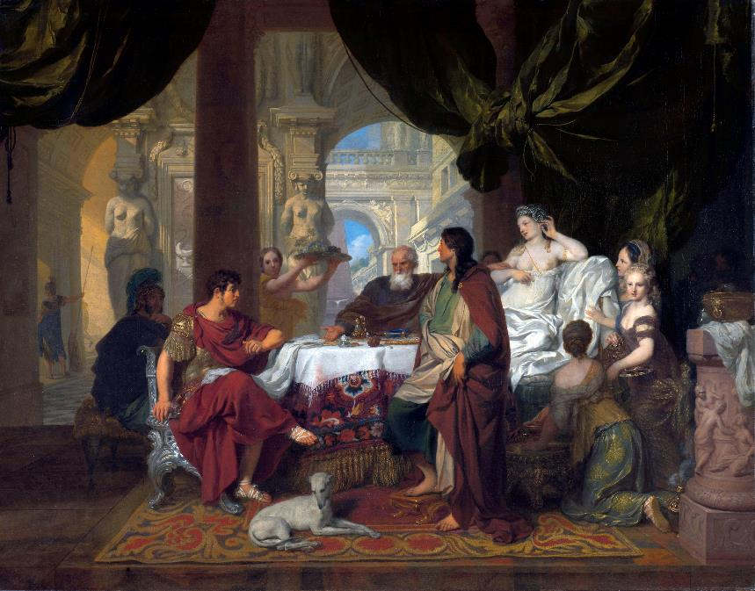
‘Cleopatra’s Banquet’
Gerard de Lairesse (1641–1711)
The Rijksmuseum
out to capture that deadly monster, bind her,
as the sparrow-hawk follows the gentle dove
or the swift hunter chases the hare,
over the snowy plains of Thessaly.

But she, intending to perish more nobly,
showed no sign of womanish fear at the sword,
nor did she even attempt to win
with her speedy ships to some hidden shore.

And she dared to gaze at her fallen kingdom
with a calm face, and touch the poisonous asps
with courage, so that she might drink down
their dark venom, to the depths of her heart,

growing fiercer still, and resolving to die:
scorning to be taken by hostile galleys,
and, no ordinary woman, yet queen
no longer, be led along in proud triumph.

BkI:XXXVIII The Simple Myrtle

My child, how I hate Persian ostentation,
garlands twined around lime-tree bark displease me:
forget your chasing, to find all the places
where late roses fade.

You’re eager, take care, that nothing enhances
the simple myrtle: it’s not only you that
it graces, the servant, but me as I drink,
beneath the dark vine.

Index of First Lines in Book I

Maecenas, descendant of royal ancestors, 12
The Father’s sent enough dread hail 13
May the goddess, queen of Cyprus, 16
Fierce winter slackens its grip: it’s spring and the west wind’s sweet …… 18
What slender boy, Pyrrha, drowned in liquid perfume, 20
You should be penned as brave, and a conqueror 20
Let others sing in praise of Rhodes, or Mytilene, 21
Lydia, by all the gods, 23
See how Soracte stands glistening with snowfall, 25
Mercury, eloquent grandson of Atlas, 26
Leuconoë, don’t ask, we never know, what fate the gods grant us, 28
What god, man, or hero do you choose to praise 28
When you, Lydia, start to praise 31
O ship the fresh tide carries back to sea again. 32
While Paris, the traitorous shepherd, her guest, 33
O lovelier child of a lovely mother, 34
Swift Faunus, the god, will quite often exchange 36
Cultivate no plant, my Varus, before the rows of sacred vines, 37
Cruel Venus, Cupid’s mother, 38
Come and drink with me, rough Sabine in cheap cups, 39
O tender virgins sing, in praise of Diana, 39
The man who is pure of life, and free of sin, 40
You run away from me as a fawn does, Chloë, 41
What limit, or restraint, should we show at the loss 42
Now the young men come less often, violently 43
Friend of the Muses, I’ll throw sadness and fear 44
To fight with wine-cups intended for pleasure 44
You, my Archytas, philosopher, and measurer of land, 46
of the sea, of wide sands, are entombed 46
Iccius, are you gazing with envy, now, 47
O Venus, the queen of Cnidos and Paphos, 48
What is the poet’s request to Apollo? 49
I’m called on. O Lyre, if I’ve ever played 50
Tibullus, don’t grieve too much, when you remember 50
Once I wandered, an expert in crazy wisdom, 51
O goddess, who rules our lovely Antium, 52
Now’s the time for drinking deep, and now’s the time 55
My child, how I hate Persian ostentation, 57

Metres Used in Book I

T
he number of syllables most commonly employed in each standard line of the verse is given. This may vary slightly for effect (two beats substituted for three etc.) in a given line.

Alcaic Strophe: 11 (5+6) twice, 9, 10
Used in Odes: 9, 16, 17, 26, 27, 29, 31, 34, 35, 37

Sapphic and Adonic: 11(5+6) three times, 5
Odes: 2, 10, 12, 20, 22, 25, 30, 32, 38

First Asclepiadean: 12 (6+6) all lines
Ode: 1

Second Asclepiadean:8, 12 (6+6), alternating
Odes: 3, 13, 19, 36

Third Asclepiadean: 12 (6+6) three times, 8
Odes: 6, 15, 24, 33

Fourth Asclepiadean: 12 (6+6) twice, 7, 8
Odes: 5, 14, 21, 23

Fifth Asclepiadean: 16 (6+4+6) all lines
Ode: 11, 18

Alcmanic Strophe: 17 (7+10) or less, 11 or less, alternating
Odes: 7, 28

First Archilochian: 17 (7+10) or less, 7 alternating
Odes: None in Book I

Fourth Archilochian Strophe: 18 (7+11) or less, 11 (5+6) alternating
Ode: 4

Second Sapphic Strophe: 7, 15 (5+10) alternating
Ode: 8

Trochaic Strophe: 7, 11 alternating
Odes: None in Book I

Ionic a Minore: 16 twice, 8
Odes: None in Book I

Book II

BkII:I To Pollio, Writing His History
of the Civil Wars

You’re handling the Civil Wars, since Metellus
was Consul, the causes, errors, and stages,
Fortune’s game, and the heavy friendships
of princes, and the un-expiated

stain of blood over various weapons,
a task that’s filled with dangerous pitfalls,
so that you’re walking over embers
hidden under the treacherous ashes.

Don’t let the Muse of dark actions be long away
from the theatre: soon, when you’ve finished writing
public events, reveal your great gifts
again in Athenian tragedy,

you famous defendant of troubled clients,
Pollio , support of the Senate’s councils,
whom the laurel gave lasting glory
in the form of your Dalmatian triumph.

Already you’re striking our ears with the sounds,
the menace of blaring horns, and the trumpets,
already the glitter of weapons
terrifies horses, and riders’ faces.

Now I seem to hear magnificent leaders,
heads darkened, but not with inglorious dust,
and all the lands of earth are subdued,
but not implacable Cato’s spirit.

Juno, and those gods friendly to Africa,
who, powerless to avenge the land, withdrew,
make funeral offerings to Jugurtha,
of the grandchildren of his conquerors.

What fields are not enriched with the blood of Rome,
to bear witness with their graves to this impious
struggle of ours, and the sound, even heard
by the Persians, of Italy’s ruin?

What river or pool is ignorant of these
wretched wars? What sea has Roman slaughter failed
to discolour, and show me the shores
that are, as yet, still unstained by our blood.

But Muse, lest you dare to leave happy themes,
and take up Simonides’ dirges again,
search out a lighter plectrum’s measures,
with me, in some deep cavern of Venus.

BkII:II Money

Crispus , silver concealed in the greedy earth
has no colour, and you are an enemy
to all such metal unless, indeed, it gleams
from sensible use.

Proculeius will be famous in distant
ages for his generous feelings towards
his brothers: enduring fame will carry him
on its tireless wings.

You may rule a wider kingdom by taming
a greedy spirit, than by joining Spain
to far-off Libya, while Carthaginians
on both sides, serve one.

A fatal dropsy grows worse with indulgence,
the patient can’t rid himself of thirst unless
his veins are free of illness, and his pale flesh
of watery languor.

Though Phraates is back on the Armenian
throne, Virtue, differing from the rabble, excludes
him from the blessed, and instructs the people
not to misuse words,

instead conferring power, and security
of rule, and lasting laurels, on him alone
who can pass by enormous piles of treasure
without looking back.

BkII:III One Ending

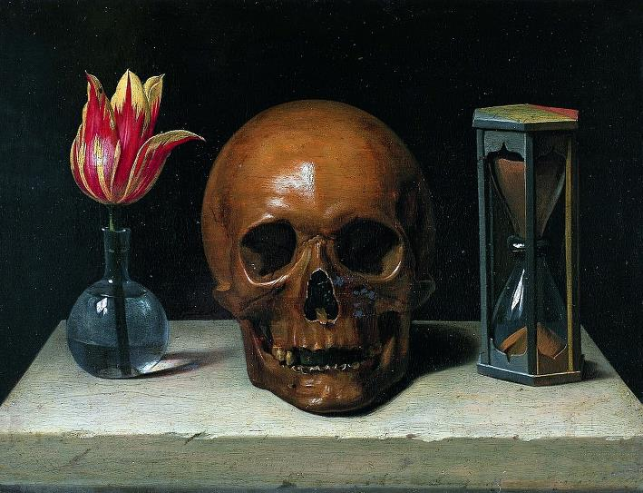
‘Vanitas’
Philippe de Champaigne (1602 – 1674)
Wikimedia Commons
When things are troublesome, always remember,
keep an even mind, and in prosperity
be careful of too much happiness:
since my Dellius, you’re destined to die,

whether you live a life that’s always sad,
or reclining, privately, on distant lawns,
in one long holiday, take delight
in drinking your vintage Falernian.

Why do tall pines, and white poplars, love to merge
their branches in the hospitable shadows?
Why do the rushing waters labour
to hurry along down the winding rivers?

Tell them to bring us the wine, and the perfume,
and all-too-brief petals of lovely roses,
while the world, and the years, and the dark
threads of the three fatal sisters allow.

You’ll leave behind all those meadows you purchased,
your house, your estate, yellow Tiber washes,
you’ll leave them behind, your heir will own
those towering riches you’ve piled so high.

Whether you’re rich, of old Inachus’s line,
or live beneath the sky, a pauper, blessed with
humble birth, it makes no difference:
you’ll be pitiless Orcus’s victim.
We’re all being driven to a single end,
all our lots are tossed in the urn, and, sooner
or later, they’ll emerge, and seat us
in Charon’s boat for eternal exile.

BkII:IV Loving A Servant Girl

Phocian Xanthis, don’t be ashamed of love
for your serving-girl. Once before, Briseis
the Trojan slave with her snow-white skin stirred
angry Achilles:

and captive Tecmessa’s loveliness troubled
her master Ajax, the son of Telamon:
and Agamemnon, in his mid-triumph, burned
for a stolen girl,

while the barbarian armies, defeated
in Greek victory, and the loss of Hector,
handed Troy to the weary Thessalians,
an easier prey.

You don’t know your blond Phyllis hasn’t parents
who are wealthy, and might grace their son-in-law.
Surely she’s royally born, and grieves at her
cruel household gods.

Believe that the girl you love’s not one who comes
from the wicked masses, that one so faithful
so averse to gain, couldn’t be the child of
a shameful mother.

I’m unbiased in praising her arms and face,
and shapely ankles: reject all suspicion
of one whose swiftly vanishing life has known
its fortieth year.

BkII:V Be Patient

She’s not ready to bear a yoke on her bowed
neck yet, she’s not yet equal to the duty
of coupling, or bearing the heavy
weight of a charging bull in the mating act.

The thoughts of your heifer are on green pastures,
on easing her burning heat in the river,
and sporting with the eager calves
in the depths of moist willow plantations.

Forget this passion of yours for the unripe
grape: autumn, the season of many-colours,
will soon be dyeing bluish clusters
a darker purple, on the vine, for you.

Soon she’ll pursue you, since fierce time rushes on
and will add to her the years it takes from you,
soon Lalage herself will be eager
to search you out as a husband, Lalage,

beloved as shy Pholoë was not, nor your
Chloris , with shoulders gleaming white, like a clear
moon shining over a midnight sea,
nor Cnidian Gyges, that lovely boy,

whom you could insert in a choir of girls,
and the wisest of strangers would fail to tell
the difference, with him hidden behind
his flowing hair, and ambiguous looks.

BkII:VI Tibur and Tarentum

Septimus , you, who are prepared to visit
Cadiz with me, and its tribes (they’re not used
to bearing our yoke) and barbarous Syrtes,
by the Moors’ fierce Sea,

I’d rather Tibur, founded by men of Greece,
were my home when I’m old, let it be my goal,
when I’m tired of the seas, and the roads, and all
this endless fighting.

But if the cruel Fates deny me that place,
I’ll head for the river Galaesus, sweet
with its precious sheep, on Spartan fields, once ruled
by King Phalanthus.

That corner of earth is the brightest to me,
where the honey gives nothing away to that
of Hymettus, and its olives compete with
green Venafrum:

where Jupiter grants a lengthy spring, and mild
winters, and Aulon’s hill-slopes, dear to fertile
Bacchus, are filled with least envy for those rich
grapes of Falernum.

That place, and its lovely heights, call out to me,
to you: and there’ll you’ll scatter your debt of sad
tears, over the still-glowing ashes of this,
the poet, your friend.

BkII:VII A Friend Home From the Wars

O Pompey, often led, with me, by Brutus,
the head of our army, into great danger,
who’s sent you back, as a citizen,
to your country’s gods and Italy’s sky,

Pompey, the very dearest of my comrades,
with whom I’ve often drawn out the lingering
day in wine, my hair wreathed, and glistening
with perfumed balsam, of Syrian nard?

I was there at Philippi, with you, in that
headlong flight, sadly leaving my shield behind,
when shattered Virtue, and what threatened
from an ignoble purpose, fell to earth.

While in my fear Mercury dragged me, swiftly,
through the hostile ranks in a thickening cloud:
the wave was drawing you back to war,
carried once more by the troubled waters.

So grant Jupiter the feast he’s owed, and stretch
your limbs, wearied by long campaigning, under
my laurel boughs, and don’t spare the jars
that were destined to be opened by you.

Fill the smooth cups with Massic oblivion,
pour out the perfume from generous dishes,
Who’ll hurry to weave the wreathes for us
of dew-wet parsley or pliant myrtle?

Who’ll throw high Venus at dice and so become
the master of drink? I’ll rage as insanely
as any Thracian: It’s sweet to me
to revel when a friend is home again.

BkII:VIII Faithless Barine

If any punishment ever visited
you, Barine, for all your perjuries, if you
were ever harmed at all by a darkened tooth,
a spoilt fingernail,

I’d trust you. But no sooner have you bound your
faithless soul by promises, than you appear
much lovelier, and shine out, as everyone’s
dearest young thing.

It helps you to swear by your mother’s buried
ashes, by all night’s silent constellations,
by the heavens, and the gods, who are free from
the icy chill of death.

Venus herself smiles at it all, yes she does:
the artless Nymphs, smile too, and cruel Cupid,
who’s always sharpening his burning arrows
on a blood-stained stone.

Add that all our youths are being groomed for you,
groomed as fresh slaves, while none of your old lovers
leave the house of their impious mistress, as
they often threatened.

All the mothers fear you, because of their sons,
and the thrifty old fathers, and wretched brides,
who once were virgins, in case your radiance
makes husbands linger.

BkII:IX Stop Weeping

The rain doesn’t fall from the clouds forever
on the sodden fields, and capricious storm-winds
don’t always trouble the Caspian
waters, nor does the solid ice linger,

Valgius , dear friend of mine, through all twelve months,
and the oak woods of Garganus aren’t always
trembling, because of the northern gales,
or the ash trees stripped of their foliage:

But you’re always pursuing in tearful ways
the loss of your Mystes, and your endearments
don’t ebb with the evening star’s rising
or when it sinks before the swift sunrise.

Yet Nestor, who lived for three generations,
didn’t mourn his beloved Antilochus,
every moment, nor were the youthful
Troilus’s Trojan parents and sisters,

always weeping. Stop your unmanly grieving
now, and let’s sing about Augustus Caesar’s
new trophies instead, the ice-bound Mount
Niphates , and the Persian waters,

with its flow reduced, now the Medes are added
to the subject nations, and then the Thracians,
riding over their meagre landscape,
within the bounds that we’ve now set for them.

BkII:X The Golden Mean

You’ll live more virtuously, my Murena,
by not setting out to sea, while you’re in dread
of the storm, or hugging fatal shores
too closely, either.

Whoever takes delight in the golden mean,
safely avoids the squalor of a shabby house,
and, soberly, avoids the regal palace
that incites envy.

The tall pine’s more often shaken by the wind,
and it’s a high tower that falls with a louder
crash, while the mountainous summits are places
where lightning strikes.

The heart that is well prepared for any fate
hopes in adversity, fears prosperity.
Though Jupiter brings us all the unlovely
winters: he also

takes them away again. If there’s trouble now
it won’t always be so: sometimes Apollo
rouses the sleeping Muse with his lyre, when he’s
not flexing his bow.

Appear brave and resolute in difficult
times: and yet be wise and take in all your sails
when they’re swollen by too powerful
a following wind.

BkII:XI Don’t Ask

Don’t ask what the warlike Spaniards are plotting,
or those Scythians, Quinctius Hirpinus,
the intervening Adriatic
keeps off, don’t be anxious about the needs

of life: it asks little: sweet youth and beauty
are vanishing behind us, and dry old age
is driving away all our playful
affections, and all our untroubled sleep.

And the glory of spring flowers won’t last forever,
and the blushing moon won’t always shine, with that
selfsame face: why weary your little
mind with eternal deliberations?

Why not drink while we can, lying, thoughtlessly,
under this towering pine, or this plane-tree,
our greying hair scented with roses,
and perfumed with nard from Assyria?

Bacchus dispels all those cares that feed on us.
Where’s the boy now, who’ll swiftly dilute for us
these cups of fiery Falernian,
with clear water drawn from the passing stream?

Who’ll lure Lyde, that fickle jade, from the house?
Go, tell her to hurry, with her ivory lyre,
her hair done in an elegant knot,
tied up, as if she were a Spartan girl.

BkII:XII Terentia’s Singing

You’d not wish the theme of Numantia’s fierce wars
matched to the lyre’s soft tones, nor cruel Hannibal,
nor the Sicilian Sea turned to dark crimson
by the Carthaginians’ blood,

nor the savage Lapiths, and drunken Hylaeus
filled with excess wine, nor Hercules with his hand
taming the sons of earth, at the danger of which
ancient Saturn’s glittering house

was shaken: you’d be better yourself, Maecenas,
at writing prose histories of Caesar’s battles,
and telling us about all those menacing kings,
now led by the neck through the streets.

The Muse wishes me to speak of the sweet singing
of your lady Terentia, and speak of her bright
flashing eyes, and speak of that heart of hers, that is
so faithful in mutual love:

she to whom it’s not unbecoming to adopt
the lead among the dancers, or compete in wit,
or, that holy day that honours Diana, give
her arm in play to shining girls.

Would you exchange now, one hair of Terentia’s
for what rich Achaemenes owned, Mygdonian
wealth of fertile Phrygia, or
the Arabians’ well-stocked homes,

while she bends her neck for those passionate kisses,
or in gentle cruelty refuses to yield them,
more than he who asks likes having them taken: then
at times surprises by taking?

BkII:XIII Nearly, Tree

Tree, whoever planted you first it was done
on an evil day, and, with sacrilegious
hands, he raised you for utter ruin
of posterity, and this region’s shame.

He’ll have broken his father’s neck, I guess:
he’ll have sprinkled the blood of a guest around,
in an inner room, in deepest night:
he’ll have dabbled with Colchian poisons,

and whatever, wherever, evil’s conceived,
that man who once planted you there in my field,
you, sad trunk, who were destined to fall
on the head of your innocent master.

Men are never quite careful enough about
what they should avoid: the Carthaginian
sailor’s afraid of the Bosphorus,
but not the hidden dangers, beyond, elsewhere:

Soldiers fear the Persians’ arrows and rapid
flight, the Persians fear Italian power, and chains:
but they don’t expect the forces of death,
that have snatched away the races of men.

How close I was, now, to seeing the kingdom
of dark Proserpine, and Aeacus judging,
and the seats set aside for the good,
and Sappho still complaining about

the local girls, on her Aeolian lyre,
and you, Alcaeus, with a golden plectrum,
sounding more fully the sailor’s woe,
the woe of harsh exile, the woe of war.

The spirits wonder at both of them, singing,
they’re worth a reverent silence, but the crowd,
packed shoulder to shoulder, drinks deeper
of tales of warfare and banished tyrants.

No wonder that, lulled by the songs, the monster
with a hundred heads lowers his jet-black ears,
and the snakes that wriggle in the hair
of the Furies take time out for a rest.

Even Prometheus, even Tantalus,
are seduced in their torments by the sweet sound:
Orion doesn’t even bother
to chase the lions, or wary lynxes.

BkII:XIV Eheu Fugaces

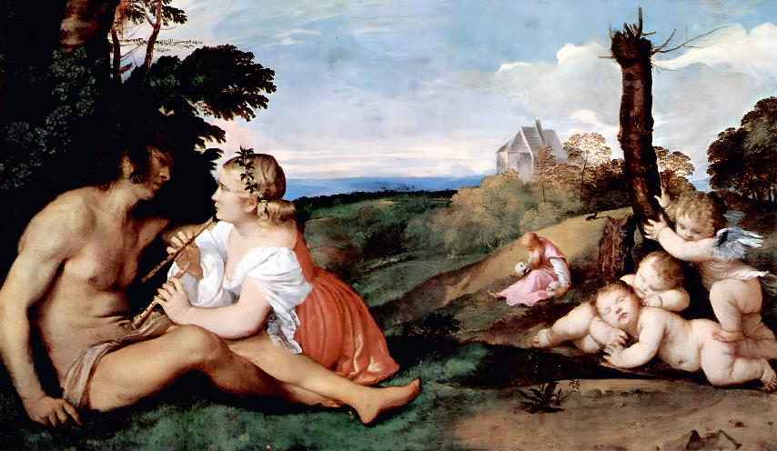
‘The Three Ages of Man’
Titian (1490 – 1576)
Wikimedia Commons
Oh how the years fly, Postumus, Postumus,
they’re slipping away, virtue brings no respite
from the wrinkles that furrow our brow,
impending old age, Death the invincible:

not even, my friend, if with three hundred bulls
every day, you appease pitiless Pluto,
jailor of three-bodied Geryon,
who imprisons Tityos by the sad

stream, that every one of us must sail over,
whoever we are that enjoy earth’s riches,
whether we’re wealthy, or whether we are
the most destitute of humble farmers.

In vain we’ll escape from bloodiest warfare,
from the breakers’ roar in the Adriatic,
in vain, on the autumn seas, we’ll fear
the southerly that shatters our bodies:

We’re destined to gaze at Cocytus, winding,
dark languid river: the infamous daughters
of Danaus: and at Sisyphus,
son of Aeolus, condemned to long toil.

We’re destined to leave earth, home, our loving wife,
nor will a single tree, that you planted here,
follow you, it’s briefly-known master,
except for the much-detested cypress.
A worthier heir will drink your Caecuban,
that cellar a hundred keys are protecting,
and stain the street with a vintage wine,
finer than those at the Pontiff’s table.

BkII:XV Excess

Not long now and our princely buildings will leave
few acres under the plough, ornamental
waters appearing everywhere, spread
wider than the Lucrine Lake is, plane trees,

without vines, will drive out the elms: and violet
beds, and myrtles, and all the wealth of perfumes
will scatter their scent through olive groves
that gave their crops for a former owner.

Then thick laurel branches will shut out the sun’s
raging. It wasn’t the case under Romulus,
or long-haired Cato, it wasn’t the rule,
that our ancient predecessors ordained.

Private property was modest in their day,
the common lands vast: no private citizen
had a portico, measuring tens
of feet, laid out facing the shady north,

nor did the laws allow ordinary turf
to be scorned for altars, ordering cities
and the gods’ temples, to be adorned,
at public expense, with rarest marbles.

BkII:XVI Contentment

It’s peace the sailor asks of the gods, when he’s
caught out on the open Aegean, when dark clouds
have hidden the moon, and the constellations
shine uncertainly:

It’s peace for Thrace, so furious in battle,
peace for the Parthians, adorned with quivers,
and, Grosphus, it can’t be purchased with jewels,
or purple or gold.

No treasure, no consular attendants,
can remove the miserable mind’s disorders,
and all of the cares that go flying around
our panelled ceilings.

He lives well on little, whose meagre table
gleams with his father’s salt-cellar, whose soft sleep
isn’t driven away by anxiety,
or by sordid greed

Why do we struggle so hard in our brief lives
for possessions? Why do we exchange our land
for a burning foreign soil? What exile flees
from himself as well?

Corrupting care climbs aboard the bronze-clad ship,
and never falls behind the troops of horses,
swifter than deer, swifter than easterly winds
that drive on the clouds.

Let the spirit be happy today, and hate
the worry of what’s beyond, let bitterness
be tempered by a gentle smile. Nothing is
altogether blessed.

Bright Achilles was snatched away by swift death,
Tithonus was wasted by lingering old age:
perhaps the passing hour will offer to me
what it denies you.

A hundred herds of Sicilian cattle
low around you, mares fit for the chariot
bring you their neighing, you’re dressed in wool:
African purple

has stained it twice: truthful Fates, ‘the Sparing Ones’,
the Parcae, gave me a little estate, and
the purified breath of Greek song, and my scorn
for the spiteful crowd.

BkII:XVII We’ll Go Together

Why do you stifle me with your complaining?
It’s neither the gods’ idea nor mine to die
before you, Maecenas, you’re the great
glory, and pillar of my existence.

Ah, if some premature blow snatches away
half of my spirit, why should the rest remain,
no longer as loved, nor surviving
entire? That day shall lead us to ruin

together. I’m not making some treacherous
promise: whenever you lead the way, let’s go,
let’s go, prepared as friends to set out,
you and I, to try the final journey.

No Chimaera’s fiery breath will ever tear
me from you, or if he should rise against me
hundred handed Gyas: that’s the will
of all-powerful Justice and the Fates.

Whether Libra or fearful Scorpio shone
more powerfully on me at my natal hour,
or Capricorn, which is the ruler
of the waters that flow round Italy,

our stars were mutually aspected in their
marvellous way. Jupiter’s protection shone,
brighter for you than baleful Saturn,
and rescued you, and held back the rapid

wings of Fate, that day when the people crowding
the theatre, three times broke into wild applause:
I’d have received the trunk of a tree
on my head, if Faunus, the guardian

of Mercurial poets, hadn’t warded off
the blow with his hand. So remember to make
due offering: you build a votive shrine:
I’ll come and sacrifice a humble lamb.

BkII:XVIII Vain Riches

There’s no ivory, there’s no
gilded panelling, gleaming here in my house,
no beams of Hymettian
marble rest on pillars quarried in deepest

Africa, I’ve not, as heir
to Attalus, become unwitting owner
of some palace, no noble
ladies trail robes of Spartan purple for me.

But I’ve honour, and a vein
of kindly wit, and though I’m poor the rich man
seeks me out: I don’t demand
anything more of the gods, or my powerful

friend, I’m contented enough
blessed with my one and only Sabine Farm.
Day treads on the heels of day,
and new moons still continue to wane away.

Yet you contract on the edge
of the grave itself for cut marble, forget
the tomb and raise a palace,
pushing hard to extend the shore of Baiae’s

roaring seas, not rich enough
in mainland coast. What’s the point of tearing down
every neighbouring boundary
edging your fields, leaping over, in your greed,

the limits of your tenants? Both the husband
and wife, and their miserable
children, are driven out, and they’re left clutching
their household gods to their breast.

Yet there’s no royal courtyard
that more surely waits for a wealthy owner,
than greedy Orcus’ fateful
limits. Why stretch for more? Earth’s equally open
to the poorest of men and
the sons of kings: and Orcus’s ferryman
couldn’t be seduced by gold
to row back and return crafty Prometheus.

Proud Tantalus, and Pelops
his son, he holds fast, and whether he’s summoned,
or whether he’s not, he lends
an ear, and frees the poor man, his labours done.

BkII:XIX To Bacchus

I saw Bacchus on distant cliffs - believe me,
O posterity - he was teaching songs there,
and the Nymphs were learning them, and all
the goat-footed Satyrs with pointed ears.

Evoe ! My mind fills with fresh fear, my heart
filled with Bacchus, is troubled, and violently
rejoices. Evoe! Spare me, Liber,
dreaded for your mighty thyrsus, spare me.

It’s right to sing of the wilful Bacchantes,
the fountain of wine, and the rivers of milk,
to sing of the honey that’s welling,
and sliding down from the hollow tree-trunks:

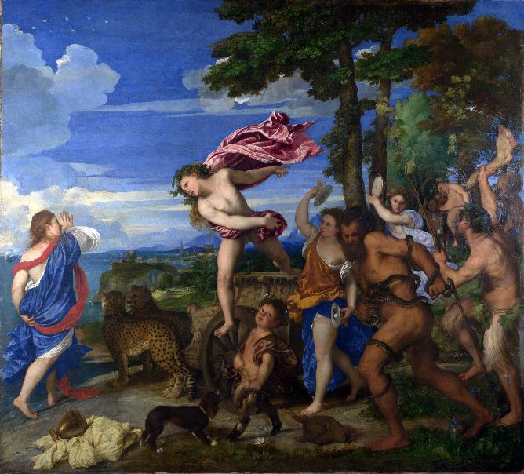
‘Bacchus and Ariadne’
Titian (1490 – 1576)
Wikimedia Commons

It’s right to sing of your bride turned goddess, your
Ariadne, crowned among stars: the palace
of Pentheus, shattered in ruins,
and the ending of Thracian Lycurgus.

You direct the streams, and the barbarous sea,
and on distant summits, you drunkenly tie
the hair of the Bistonian women,
with harmless knots made of venomous snakes.
When the impious army of Giants tried
to climb through the sky to Jupiter’s kingdom,
you hurled back Rhoetus, with the claws
and teeth of the terrifying lion.

Though you’re said to be more suited to dancing,
laughter, and games, and not equipped to suffer
the fighting, nevertheless you shared
the thick of battle as well as the peace.

Cerberus saw you, unharmed, and adorned
with your golden horn, and, stroking you gently,
with his tail, as you departed, licked
your ankles and feet with his triple tongue.

BkII:XX Poetic Immortality

A poet of dual form, I won’t be carried
through the flowing air on weak or mundane wings,
nor will I linger down here on earth,
for any length of time: beyond envy,

I’ll leave the cities behind. It’s not I, born
of poor parents, it’s not I, who hear your voice,
beloved Maecenas, I who’ll die,
or be encircled by Stygian waters.

Even now the rough skin is settling around
my ankles, and now above them I’ve become
a snow-white swan, and soft feathers are
emerging over my arms and shoulders.

Soon, a melodious bird, and more famous
than Icarus, Daedalus’ son, I’ll visit
Bosphorus’ loud shores, Gaetulian
Syrtes, and the Hyperborean plains.

Colchis will know me, so will the Scythians,
who pretend to show no fear of Italian
troops, and the Geloni: Spain will learn
from me, the expert, and those who drink Rhone.

No dirges at my insubstantial funeral,
no elegies, and no unseemly grieving:
suppress all the clamour, not for me
the superfluous honour of a tomb.

Index of First Lines in Book II

You’re handling the Civil Wars, since Metellus 63
Crispus, silver concealed in the greedy earth 65
When things are troublesome, always remember, 67
Phocian Xanthis, don’t be ashamed of love 68
She’s not ready to bear a yoke on her bowed 69
Septimus, you, who are prepared to visit 70
O Pompey, often led, with me, by Brutus, 71
If any punishment ever visited 73
The rain doesn’t fall from the clouds forever 74
You’ll live more virtuously, my Murena, 75
Don’t ask what the warlike Spaniards are plotting, 76
You’d not wish the theme of Numantia’s fierce wars 77
Tree, whoever planted you first it was done 79
Oh how the years fly, Postumus, Postumus, 82
Not long now and our princely buildings will leave 83
It’s peace the sailor asks of the gods, when he’s 84
Why do you stifle me with your complaining? 86
There’s no ivory, there’s no 87
I saw Bacchus on distant cliffs - believe me, 89
A poet of dual form, I won’t be carried 91

Metres Used in Book II

T
he number of syllables most commonly employed in each standard line of the verse is given. This may vary slightly for effect (two beats substituted for three etc.) in a given line.

Alcaic Strophe: 11 (5+6) twice, 9, 10
Used in Odes: 1, 3, 5, 7, 9, 11, 13, 14, 15, 17, 19, 20

Sapphic and Adonic: 11(5+6) three times, 5
Odes: 2, 4, 6, 8, 10, 16

First Asclepiadean: 12 (6+6) all lines
Odes: None in Book II

Second Asclepiadean: 8, 12 (6+6), alternating
Odes: None in Book II

Third Asclepiadean: 12 (6+6) three times, 8
Ode: 12

Fourth Asclepiadean: 12 (6+6) twice, 7, 8
Odes: None in Book II

Fifth Asclepiadean: 16 (6+4+6) all lines
Odes: None in Book II

Alcmanic Strophe: 17 (7+10) or less, 11 or less, alternating
Odes: None in Book II

First Archilochian: 17 (7+10) or less, 7 alternating
Odes: None in Book II

Fourth Archilochian Strophe: 18 (7+11) or less, 11 (5+6) alternating
Odes: None in Book II

Second Sapphic Strophe: 7, 15 (5+10) alternating
Odes: None in Book II

Trochaic Strophe: 7, 11 alternating
Ode: 18

Ionic a Minore: 16 twice, 8
Odes: None in Book II

Book III

BkIII:I Odi Profanum

I hate the vulgar crowd, and keep them away:
grant me your silence. A priest of the Muses,
I sing a song never heard before,
I sing a song for young women and boys.

The power of dread kings over their peoples,
is the power Jove has over those kings themselves,
famed for his defeat of the Giants,
controlling all with a nod of his head.

It’s true that one man will lay out his vineyards
over wider acres than will his neighbour,
that one candidate who descends to
the Campus, will maintain that he’s nobler,

another’s more famous, or has a larger
crowd of followers: but Necessity sorts
the fates of high and low with equal
justice: the roomy urn holds every name.

Sicilian feasts won’t supply sweet flavours
to the man above whose impious head hangs
a naked sword, nor will the singing
of birds or the playing of zithers bring back

soft sleep. But gentle slumber doesn’t despise
the humble house of a rural labourer,
or a riverbank deep in the shade,
or the vale of Tempe, stirred by the breeze.

He who only longs for what is sufficient,
is never disturbed by tumultuous seas,
nor the savage power of Arcturus
setting, nor the strength of the Kids rising,

nor his vineyards being lashed by the hailstones,
nor his treacherous farmland, rain being blamed
for the state of the trees, the dog-star
parching the fields, or the cruel winter.

The fish can feel that the channel’s narrowing,
when piles are driven deep: the builder, his team
of workers, the lord who scorns the land
pour the rubble down into the waters.

But Fear and Menace climb up to the same place
where the lord climbs up, and dark Care will not leave
the bronze-clad trireme, and even sits
behind the horseman when he’s out riding.
So if neither Phrygian stone, nor purple,
brighter than the constellations, can solace
the grieving man, nor Falernian
wine, nor the perfumes purchased from Persia,

why should I build a regal hall in modern
style, with lofty columns to stir up envy?
Why should I change my Sabine valley,
for the heavier burden of excess wealth?

BkIII:II Dulce Et Decorum Est

Let the boy toughened by military service
learn how to make bitterest hardship his friend,
and as a horseman, with fearful lance,
go to vex the insolent Parthians,

spending his life in the open, in the heart
of dangerous action. And seeing him, from
the enemy’s walls, let the warring
tyrant’s wife, and her grown-up daughter, sigh:

‘Ah, don’t let the inexperienced lover
provoke the lion that’s dangerous to touch,
whom a desire for blood sends raging
so swiftly through the core of destruction.’

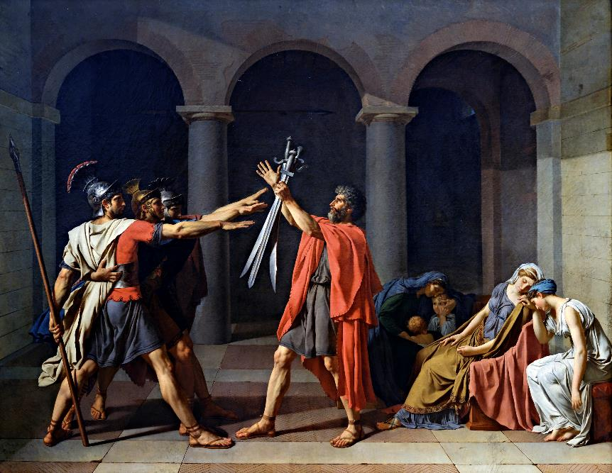
‘The Oath of the Horatii’
Jacques-Louis David (1748 – 1825)
Wikimedia Commons

It’s sweet and fitting to die for one’s country.
Yet death chases after the soldier who runs,
and it won’t spare the cowardly back
or the limbs, of peace-loving young men.

Virtue, that’s ignorant of sordid defeat,
shines out with its honour unstained, and never
takes up the axes or puts them down
at the request of a changeable mob.

Virtue, that opens the heavens for those who
did not deserve to die, takes a road denied
to others, and scorns the vulgar crowd
and the bloodied earth, on ascending wings.

And there’s a true reward for loyal silence:
I forbid the man who divulged those secret
rites of Ceres, to exist beneath
the same roof as I, or untie with me

the fragile boat: often careless Jupiter
included the innocent with the guilty,
but lame-footed Punishment rarely
forgets the wicked man, despite his start.

BkIII:III Stand Firm

The passion of the public, demanding what
is wrong, never shakes the man of just and firm
intention, from his settled purpose,
nor the tyrant’s threatening face, nor the winds

the stormy masters of the troubled Adriatic,
nor Jupiter’s mighty hand with its lightning:
if the heavens fractured in their fall,
still their ruin would strike him, unafraid.

By these means Pollux, and wandering Hercules,
in their effort, reached the fiery citadels,
where Augustus shall recline one day,
drinking nectar to stain his rosy lips.

Bacchus, for such virtues your tigers drew you,
pulling at the yoke holding their untamed necks:
for these virtues, Romulus, escaped
with horses that were Mars’, from Acheron,

while Juno, in the council of the gods, spoke
welcome words: ‘Ilium, Ilium is in
the dust, through both Paris’s fatal,
sinful judgement, and that foreign woman:

Ilium was mine, and virgin Minerva’s,
and its citizens, and its treacherous king,
from the time when Laomedon robbed
the gods, withholding the payment agreed.

The infamous guest no longer shines for his
Spartan adulteress, nor does Priam’s house,
betrayed, hold back the fierce Achaeans,
with Hector’s help: now the ten-year battle,

which our quarrels long extended, is ended.
From this moment on I’ll abandon my fierce
anger, and I’ll restore my hated
grandson, he who was born of a priestess

of Troy, to Mars: I’ll allow him to enter
the regions of light, and to drink sweet nectar,
and to be enrolled, and take his place,
here, among the quiet ranks of the gods.

Let the exiles rule happily in any
place they choose, so long as there’s a width of sea,
roaring, between Ilium and Rome,
so long as the cattle trample over

the tombs of Paris and of Priam, and wild
beasts hide their offspring there with impunity:
and let their Capitol stand gleaming,
let warlike Rome make laws for conquered Medes.
Let her extend her dreaded name to farthest
shores, there where the straits separate Africa
and Europe, there where the swollen Nile
irrigates the lands beside the river,

firm in ignoring gold still undiscovered,
that’s better where it is while earth conceals it,
than mining it for our human use,
with hands that grasp everything that’s sacred.

Whatever marks the boundaries of the world,
let Rome’s might reach it, eager to see regions
where solar fires perform their revels,
or places where the mists and rain pour down.

But I prophesy such fate for her warlike citizens,
with this proviso: that they show no excess
of piety, or faith in their powers,
wishing to rebuild Troy’s ancestral roofs.

Troy’s fortunes would revive with evil
omens, and they’d repeat their sad disaster,
while I, who am Jove’s wife and sister,
would lead the victorious armies.

If her bronze walls were to rise again three times
with Apollo’s help, three times they’d be destroyed,
shattered by my Argives, and, three times,
the captive wife would mourn sons and husband.’
What are you saying, Muse? This theme doesn’t suit
the happy lyre. Stop wilfully repeating
divine conversations, and weakening
great matters with these trivial metres.

BkIII:IV Temper Power With Wisdom

O royal Calliope, come from heaven,
and play a lengthy melody on the flute,
or, if you prefer, use your clear voice,
or pluck at the strings of Apollo’s lute.

Do you hear her, or does some lovely fancy
toy with me? I hear, and seem to wander, now,
through the sacred groves, where delightful
waters steal, where delightful breezes stray.

In my childhood, once, on pathless Vultur’s slopes,
beyond the bounds of nurturing Apulia,
exhausted with my play and weariness,
the fabled doves covered me with new leaves,

which was a wonder to everyone who holds
Acherontia’s high nest, and Bantia’s
woodland pastures, and the rich meadows
of low-lying Forentum, since I slept

safe from the bears and from the dark vipers,
the sacred laurel and the gathered myrtle
spread above me, a courageous child,
though it was thanks to the power of the gods.

Yours Muses, yours, I climb the high Sabine Hills,
or I’m carried off to my cool Praeneste,
to the slopes of Tibur, if I please,
or the cloudless loveliness of Baiae.

A friend of your sacred fountains and your
choirs, the rout of the army at Philippi
failed to kill me, and that accursed
tree, and Palinurus’ Sicilian Sea.

Whenever you are with me, as a sailor
I’ll attempt the raging Bosphorus, or be
a traveller in the burning sands
of the Syrian shore: as a stranger

I’ll see the fierce inhospitable Britons,
the Spaniards that love drinking horses’ blood,
I’ll see the quiver-bearing Thracians,
and, unharmed, visit the Scythian stream.

It’s you then who refresh our noble Caesar,
in your Pierian caves, when he’s settled
his weary troops in all the cities,
and he’s ready to complete his labours.
You give calm advice, and you delight in that
giving, kindly ones. We know how the evil
Titans, how their savage supporters
were struck down by the lightning from above,

by him who rules the silent earth, the stormy
sea, the cities, and the kingdoms of darkness,
alone, in imperial justice,
commanding the gods and the mortal crowd.

Great terror was visited on Jupiter
by all those bold warriors bristling with hands,
and by the brothers who tried to set
Pelion on shadowy Olympus.

But what power could Giant Typhoeus have,
or mighty Mimas, or that Porphyrion
with his menacing stance, Rhoetus,
or Enceladus, audacious hurler

of uprooted trees, against the bronze breastplate,
Minerva’s aegis? On one side stood eager
Vulcan, on the other maternal
Juno, and Apollo of Patera

and Delos, who is never without the bow
on his shoulder, who bathes his flowing hair
in Castalia’s pure dew, who holds
the forests, and thickets of Lycia.
Power without wisdom falls by its own weight:
The gods themselves advance temperate power:
and likewise hate force that, with its whole
consciousness, is intent on wickedness.

Let hundred-handed Gyas be the witness
to my statement: Orion too, well-known as
chaste Dian’s attacker, and tamed
by the arrows of the virgin goddess.

Earth, heaped above her monstrous children, laments
and grieves for her offspring, hurled down to murky
Orcus by the lightning bolt: The swift
fires have not yet eaten Aetna, set there,

nor the vultures ceased tearing at the liver
of intemperate Tityus, those guardians placed
over his sin: and three hundred chains
hold the amorous Pirithous fast.

BkIII:V No Surrender

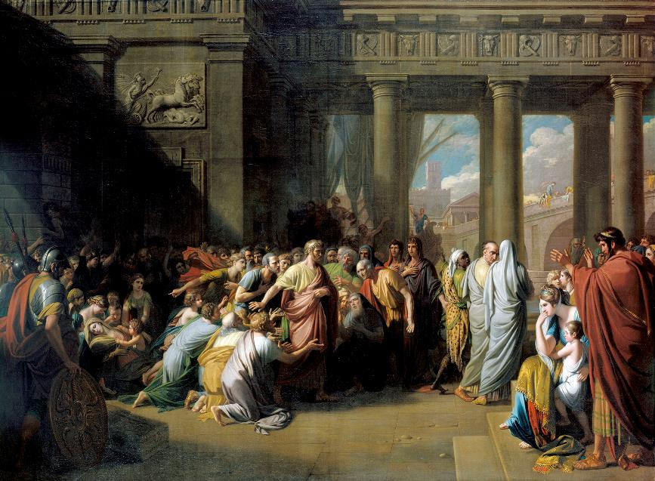
‘The Departure of Regulus’
Benjamin West (1738 - 1820)
Wikimedia Commons
We believe thunderous Jupiter rules the sky:
Augustus is considered a god on earth,
for adding the Britons, and likewise
the weight of the Persians to our empire.

Didn’t Crassus’ soldiers live in vile marriage
with barbarian wives, and (because of our
Senate and its perverse ways!) grow old,
in the service of their hostile fathers.

Marsians , Apulians ruled by a Mede,
forgetting their shields, Roman names, and togas,
and eternal Vesta, though Jove’s shrines
and the city of Rome remained unharmed?

Regulus’s far-seeing mind warned of this,
when he objected to shameful surrender,
and considered from its example
harm would come to the following age,

unless captured men were killed without pity.
‘I’ve seen standards and weapons,’ he said,
‘taken bloodlessly from our soldiers,
hung there in the Carthaginian shrines,

I’ve seen the arms of our freemen twisted
behind their backs, enemy gates wide open,
and the fields that our warfare ravaged
being freely cultivated again.
Do you think that our soldiers ransomed for gold,
will fight more fiercely next time! You’ll add
harm to shame: the wool that’s dyed purple
never regains the colour that vanished,

and true courage, when once departed, never
cares to return to an inferior heart.
When a doe that’s set free, from the thick
hunting nets, turns to fight, then he’ll be brave

who trusts himself to treacherous enemies
and he’ll crush Carthage, in a second battle,
who’s felt the chains on his fettered wrists,
without a struggle, afraid of dying.

He’s one who, not knowing how life should be lived,
confuses war with peace. O, shame! O mighty
Carthage, made mightier now because
of Italy’s disgraceful decadence.’

It’s said he set aside his wife’s chaste kisses,
and his little ones, as of less importance,
and, grimly, he set his manly face
to the soil, until he might be able

to strengthen the Senate’s wavering purpose,
by making of himself an example no
other man had made, and hurrying,
among grieving friends, to noble exile.
Yet he knew what the barbarous torturer
was preparing for him. Still he pushed aside
the kinsmen who were blocking his way,
and the people who delayed his going,

as if, with some case decided, and leaving
all that tedious business of his clients,
he headed for Venafrum’s meadows,
or Lacedaemonian Tarentum.

BkIII:VI Moral Decadence

Romans, though you’re guiltless, you’ll still expiate
your fathers’ sins, till you’ve restored the temples,
and the tumbling shrines of all the gods,
and their images, soiled with black smoke.

You rule because you are lower than the gods
you worship: all things begin with them: credit
them with the outcome. Neglected gods
have made many woes for sad Italy.

Already Parthians, and Monaeses
and Pacorus, have crushed our inauspicious
assaults, and laugh now to have added
our spoils to their meagre treasures.

Dacians and Ethiopians almost toppled
the City, mired in civil war, the last feared
for their fleet of ships, and the others
who are best known for their flying arrows.

Our age, fertile in its wickedness, has first
defiled the marriage bed, our offspring, and homes:
disaster’s stream has flowed from this source
through the people and the fatherland.

The young girl early takes delight in learning
Greek dances, in being dressed with all the arts,
and soon meditates sinful affairs,
with every fibre of her new being:

later at her husband’s dinners she searches
for younger lovers, doesn’t mind to whom she
grants all her swift illicit pleasures
when the lights are far removed, but she rises,

openly, when ordered to do so, and not
without her husband’s knowledge, whether it’s for
some peddler, or Spanish ship’s captain,
an extravagant buyer of her shame.

The young men who stained the Punic Sea with blood
they were not born of such parentage, those who
struck at Pyrrhus, and struck at great
Antiochus, and fearful Hannibal:
they were a virile crowd of rustic soldiers,
taught to turn the furrow with a Sabine hoe,
to bring in the firewood they had cut
at the instruction of their strict mothers.

when the sun had lengthened the mountain shadows,
and lifted the yokes from the weary bullocks,
bringing a welcome time of rest,
with the departure of his chariot.

What do the harmful days not render less?
Worse than our grandparents’ generation, our
parents’ then produced us, even worse,
and soon to bear still more sinful children.

BkIII:VII Be True

Why weep, Asterie, for Gyges, whom west winds
will bring back to you at the first breath of springtime,
your lover constant in faith,
blessed with goods, from Bithynia?

Driven by easterlies as far as Epirus,
now, after Capella’s wild rising, he passes
chill nights of insomnia,
and not without many a tear.

Yet messages from his solicitous hostess,
telling how wretched Chloë sighs for your lover,
and burns with desire, tempts him
subtly and in a thousand ways.

She tells how a treacherous woman, making
false accusations, drove credulous Proteus
to bring a too-hasty death
to a too-chaste Bellerophon:

she tells of Peleus, nearly doomed to Hades,
fleeing Magnesian Hippolyte in abstinence:
and deceitfully teaches
tales that encourage wrongdoing.

All in vain: still untouched, he hears her voice, as deaf
as the Icarian cliffs. But take care yourself
lest Enipeus, next door,
pleases you more than is proper:

even though no one else is considered as fine
at controlling his horse, on the Campus’s turf,
and no one else swims as fast
as him, down the Tiber’s channel.

Close your doors when it’s dark, and don’t you go gazing
into the street, at the sound of his plaintive flute,
and when he keeps calling you
cruel, you still play hard to get.

BkIII:VIII Celebration

You, an expert in prose in either language,
wonder what I, a bachelor, am doing
on the Kalends of March, what do the flowers mean,
the box of incense,

and the embers laid out on the fresh cut turf.
I vowed sweet meats to Bacchus, vowed a pure white
goat, at that time when I was so nearly killed
by a falling tree.

When this festive day returns again I’ll draw
a tight-fitting cork, sealed with pitch, from a jar
laid down to gather the dust in that year when
Tullus was Consul.

So drink a whole gallon of wine, Maecenas,
celebrating your friend’s escape, and we’ll quench
the flickering lamps at dawn: keep far away
the noise and anger.

Leave the cares of state behind in the City:
Cotiso’s Dacian army’s been destroyed,
the dangerous Medes are fighting each other,
in grievous battle,

our old Cantabrian enemies are slaves,
subdued, in chains, at last, on the Spanish coast,
and now the Scythians, their bows unstrung, plan
to give up their plains.

A private citizen for now, don’t worry
yourself, overmuch, what troubles the people,
and gladly accept the gifts of the moment,
and forget dark things.

BkIII:IX A Dialogue

‘While I was the man, dear to you,
while no young man, you loved more dearly, was clasping
his arms around your snow-white neck,
I lived in greater blessedness than Persia’s king.’

‘While you were on fire for no one
else, and Lydia was not placed after Chloë,
I, Lydia, of great renown,
lived more gloriously than Roman Ilia.’

‘Thracian Chloe commands me now,
she’s skilled in sweet verses, she’s the queen of the lyre,
for her I’m not afraid to die,
if the Fates spare her, and her spirit survives me.’

‘I’m burnt with a mutual flame
by Calais, Thurian Ornytus’s son,
for whom I would die twice over
if the Fates spare him, and his spirit survives me.’

‘What if that former love returned,
and forced two who are estranged under her bronze yoke:
if golden Chloë was banished,
and the door opened to rejected Lydia?’

‘Though he’s lovelier than the stars,
and you’re lighter than cork, and more irascible
than the cruel Adriatic,
I’d love to live with you, with you I’d gladly die!’

BkIII:X Cruel One

If you drank the water of furthest Don, Lyce,
married to some fierce husband, you’d still expose me
to the wailing winds of your native North country,
stretched out here by your cruel door.

Hear how the frame creaks, how the trees that are planted
inside your beautiful garden moan in the wind,
and how Jupiter’s pure power and divinity
ices over the fallen snow.

Set aside your disdain, it’s hateful to Venus,
lest the rope fly off, while the wheel is still turning:
you’re no Penelope, resistant to suitors,
nor born of Etruscan parents.

O, spare your suppliants, though nothing moves you,
not gifts, not my prayers, not your lover’s pallor,
that’s tinged with violet, nor your husband smitten
with a Pierian mistress,

you, no more pliant than an unbending oak-tree,
no gentler in spirit than a Moorish serpent.
My body won’t always put up with your threshold,
or the rain that falls from the sky.

BkIII:XI Remember the Danaids

Mercury (since, taught by you, his master,
Amphion could move the stones, with his singing),
and you, tortoise shell, clever at making your
seven strings echo,

you, who were neither eloquent nor lovely,
but welcomed, now, by rich tables and temples,
play melodies to which Lyde might apply
a reluctant ear,

who gambols friskily, like a three year old
filly, over the widening plain, fears being
touched, a stranger to marriage, who’s not yet ripe
for a forceful mate.

You’ve the power to lead tigers and forests as
attendants, and hold back the swift-running streams:
Cerberus, the frightful doorkeeper of Hell,
yielded to your charms,

though a hundred snakes guarded his fearful head,
and a hideous breath flowed out of his mouth
and poisoned venom was frothing around
his triple-tongued jaws.

Even Ixion and Tityos smiled, with
unwilling faces, and, for a little while,
the urns were dry, as your sweet song delighted
Danaus’ daughters.

Lyde should listen to those girls’ wickedness
and their punishment, it’s well known: their wine jars
empty, water vanishing through the bottom:
that fate long-delayed

that still waits for wrongdoers down in Orcus.
Impious (what worse could they have committed?)
impious, they had the power to destroy their
lovers with cruel steel.
Hypermnestra alone of the many was
worthy of marriage, splendidly deceiving
her lying father, a girl rendered noble
for ages to come,

‘Up, up,’ she cried to her young husband, ‘lest sleep,
that lasts forever, comes, to you, from a source
you wouldn’t expect: escape from my father,
my wicked sisters,

ah, they’re like lionesses who each has seized
a young bullock, and tears at it: I, gentler
than them, will never strike you, or hold you
under lock and key.

Let my father weigh me down with cruel chains,
because in mercy I spared my wretched man:
let him banish me in a ship to the far
Numidian lands.

Go, wherever your feet and the winds take you,
while Venus, and Night, both favour you: luck be
with you: and carve an epitaph on my tomb,
in fond memory.

BkIII:XII Neobule, to Herself

Girls are wretched who can’t allow free play to love, or drown their cares
with sweet wine, those who, terrified, go around in fear of a tongue
lashing from one of their uncles.

Neobule, Cytherea’s winged boy snatches your wool stuff away
and your work, your devotion to busy Minerva, whenever
shining Liparean Hebrus,

that lover of yours, has bathed his oiled shoulders in Tiber’s waters,
even better a horseman than Bellerephon, never beaten
through slowness of fists or of feet,

clever too at spearing the deer, as they pour, in a startled herd,
across the wide open spaces, and quick to come at the wild boar
as it lurks in the dense thicket.

BkIII:XIII O Fons Bandusiae

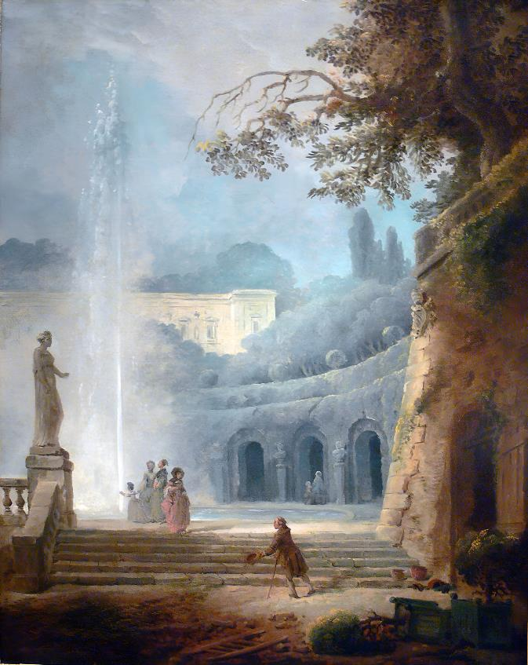
‘The Fountain’
Hubert Robert (1733 – 1808)
Wikimedia Commons
O Bandusian fountain, brighter than crystal,
worthy of sweet wine, not lacking in flowers,
tomorrow we’ll honour you
with a kid, whose brow is budding

with those horns that are destined for love and battle.
All in vain: since this child of the playful herd will
darken your ice-cool waters,
with the stain of its crimson blood.

The implacable hour of the blazing dog-star
knows no way to touch you, you offer your lovely
coolness to bullocks, weary
of ploughing, and to wandering flocks.

And you too will be one of the famous fountains,
now I write of the holm oak that’s rooted above
the cave in the rock where your
clear babbling waters run down.

BkIII:XIV Augustus Returns

O citizens, conquering Caesar is home
from the Spanish shores, who, like Hercules, now
was said to be seeking that laurel, that’s bought
at the price of death.

May his wife rejoice in a matchless husband,
having sacrificed to true gods, appear now
with our famous leader’s sister, and, all dressed
in holy ribbons,

the mothers of virgins and youths, now safe and
sound. And you, O you boys and you young girls who
are still without husbands, spare us any of
your ill-omened words

This day will be a true holiday for me,
and banish dark care: I’ll not fear civil war,
nor sudden death by violence, while Caesar has
command of the earth.

Go, now, you boys, seek out perfumes and garlands
and a jar that’s old as the Marsian War,
if any of them have managed to escape
Spartacus’s eyes.

And tell that graceful Neaera to hurry
and fasten all her perfumed hair in a knot:
if her hateful doorkeeper causes
delay, come away.

My greying hair softens a spirit eager
for arguments and passionate fights:
I’d not have endured it in my hot youth, while
Plancus was Consul.

BkIII:XV Too Old

O, dear wife of poor Ibycus,
put an end to your wickedness, at last, and all
of your infamous goings-on:
now you are nearer the season for dying,

stop playing about with the girls,
and scattering a mist over shining stars.
What fits Pholoe is not quite
fitting for you, Chloris: while your daughter’s more

suited to storming the houses of lovers,
like a Bacchante stirred by the beating drum.
Her love for Nothus forces her
to gambol like a lascivious she-goat:

the wool that’s shorn near to noble
Luceria’s fitting for you, sad old thing,
not the dark red flower of the rose,
nor the lyre, nor the wine-jars drained to their dregs.

BkIII:XVI Just Enough

The towers made of bronze, and the doors made of oak,
and the watch-dogs sombre vigil, would, surely, have
been enough, to protect imprisoned Danaë,
from adulterers in the night,
if Jupiter, and then Venus, hadn’t been laughing
at Acrisius, the girl’s anxious guardian:
since they knew that the path would be safe and open,
with the god as a shower of gold.

Gold loves to travel in the midst of fine servants,
and break through the rocks, since it’s far more powerful
than lightning bolts: didn’t the Greek prophet’s house fall
because of his riches, and sink

to ruin: and with gifts, the Macedonian
burst the gates of the cities, brought rival kingdoms
to destruction: and gifts of gold, too, are able
to snare fierce naval commanders.

Anxiety, and the hunger for more, pursues
growing wealth. It’s right, then, that I shrank from raising
my head to be seen far and wide, dear Maecenas,
glory of the Equestrians.

The more that a man denies himself, then the more
will flow from the gods: so naked, I seek the camp
of those who ask for nothing, I’m a deserter,
eager to abandon the rich,

a more glorious lord of the wealth that I spurn,
than if it were said I conceal, deep in my barns,
whatever the busy Apulians harvest:
destitute among great riches.
A stream of pure water, a few woodland acres,
and a confident faith in the crops from my fields,
are more blessed than the fate that deceives the shining
master of fertile Africa.

Though it’s true the Calabrian bees don’t bring me
their honey, and no Laestrygonian wine-jar
mellows for me, with no glossy fleece thickening
for me in the pastures of Gaul:

yet there’s still no presence of grinding poverty,
nor if I wished for more would you deny it me.
I can eke out my income more effectively
by constraining what I desire,

than if I were to join the Mygdonian plains
to the Lydian kingdom. To those who want much,
much is lacking: he’s happy to whom the god grants
just enough, from a careful hand.

BkIII:XVII The Approaching Storm

Aelius, noble descendant of ancient
Lamus (and they say the Lamiae of old
were named from him, the ancestral line,
through all of our recorded history):

you come from him, the original founder,
who, it’s said, first held the walls of Formiae
and Latium’s River Liris where
it floods the shores of the nymph, Marica,

he the lord, far and wide. Tomorrow a storm
sent from the East, will fill all the woodland grove
with leaves, and the sands with useless weed,
unless the raven, old prophet of rain,

is wrong. Pile up the dry firewood while you can:
tomorrow, with your servants, released from their
labours, cheer your spirit with neat wine,
and a little pig, only two months old.

BkIII:XVIII To Faunus

Faunus, the lover of Nymphs who are fleeing,
may you pass gently over my boundaries,
my sunny fields, and, as you go by, be kind
to all my new-born,

if at the end of the year a tender kid
is sacrificed to you: if the full bowls of wine,
aren’t lacking, friend of Venus: the old altar
smoking with incense.

All the flock gambols over the grassy plain,
when the fifth of December returns for you:
the festive village empties into the fields,
and the idle herd:

the wolf wanders among the audacious lambs:
for you the woods, wildly, scatter their leaves:
the ditcher delights in striking the soil he
hates, in triple time.

BkIII:XIX Let’s Drink

You can tell me the years between
Inachus and Codrus, who wasn’t afraid to
die for his country, Aeacus’
line, and the fights by the walls at sacred Troy:

but you can’t say what price we’ll pay
for a jar of Chian wine, who’ll heat the water,
or under whose roof, at what time,
I can escape at last from Paelignian cold.

Don’t wait: drink to the new moon, boy,
to the midnight hour, to the augur, Murena:
the wine is mixed in three measures,
or nine, depending which of the two is fitting.

The poet, inspired, who’s in love
with the odd-numbered Muses, will ask for three times
three: fearing our quarrels, the Grace,
who ’ s hand in hand with her naked sisters, forbids

more than triple. I like to rave:
why have the blasts of the Berecyntian flute
fallen silent? Why is the pipe
hanging there speechless, next door to the speechless lyre?

I dislike those hands that refrain:
scatter rose petals: and let envious Lycus
hear our demented noise-making,
and the girl who’s next door, who won’t suit old Lycus.

Ripe Rhode is searching for you,
Telephus, you with the glistening hair, oh you,
who are like the pure evening star:
while a slow love, for Glycera, has me on fire.

BkIII:XX The Conflict

Pyrrhus, you can’t see how dangerous it is
to touch the Gaetulian lioness’ cub?
Soon you’ll be running from all that hard fighting,
a spiritless thief,

while she goes searching for lovely Nearchus,
through obstructive crowds of young men: ah, surely
the fight will be great, whether the prize is yours,
or, more likely, hers.

Meanwhile, as you produce your swift arrows, as
she is sharpening her fearsome teeth, the battle’s
fine judge is said to have trampled the palm leaf,
beneath his bare foot,

and he’s cooling his shoulders, draped in perfumed
hair, in the gentle breeze, just like Nireus,
or like Ganymede, who was snatched away from
Ida rich in streams.

BkIII:XXI Praise Of Wine

Faithful wine-jar, born, with me, in Manlius’
Consulship, whether you bring moans or laughter,
whether you bring mad love, and quarrels,
or whether you bring us gentle slumber,

whatever the end of the vintage Massic
you guard, that’s worthy of some auspicious day,
be emptied, Corvinus orders us
to bring out a much less powerful wine.

Though he’s steeped in Socratic dialogue,
He’ll not shiver with the cold, and reject you,
For they say that even old Cato
Was often warmed by a powerful vintage.

You apply gentle torture to wits that are
mostly dull: you reveal the cares of the wise,
and you uncover their secret thoughts,
by means of Bacchus’ happy pleasantries:

you bring fresh hope to those minds that are distressed,
and grant the poor man strength and courage, through you
he no longer trembles at the crowns
of angry kings, nor at soldiers’ weapons.

You, Bacchus, and delightful Venus, if she
would come, the Graces, reluctant to dissolve
their knot, and the bright lamps, will be here,
till Phoebus puts the stars to flight again.

BkIII:XXII To Diana

Virgin protectress of the mountain and the grove,
who, called on three times, hears young girls, labouring
through childbirth, and rescues them from dying, O
triple formed goddess,

may it be yours, this pine-tree above my farm,
so that I may, happily, through passing years,
offer it the blood of a boar, that’s trying
its first sidelong thrusts.

BkIII:XXIII Pure Hands

Phidyle, my country girl, if you raise your
upturned palms to heaven, at the new-born moon,
if you placate the Lares with corn
from this year’s harvest, with a greedy pig:

your fruiting vines won’t suffer the destructive
southerlies, nor your crops the killing mildew,
nor will the young of the flock be born
in that sickly season, heavy with fruit.

Since the destined victim, grazing, on snowy
Algidus, amongst the oak and ilex trees,
or fattening in the Alban meadows,
will stain the axes of the priest with blood:

there’s no need for you to try and influence
the gods, with repeated sacrifice of sheep
while you crown their tiny images
with rosemary, and the brittle myrtle.

If pure hands have touched the altar, even though
they’ve not gratified with lavish sacrifice,
they’ll mollify hostile Penates,
with the sacred corn, and the dancing grain.

BkIII:XXIV Destructive Wealth

Though you’re richer than the untouched
riches of Araby, than wealthy India,
and you fill the land, and inshore
waters, with your deposits of builders’ rubble:

if dread Necessity fixes
her adamantine nails in your highest rooftops,
you’ll not free your spirit from fear,
nor free your very being from the noose of death.

Better to live like Scythians
in the Steppes, whose wagons haul their movable homes,
that’s custom, or the fierce Getae,
whose unallocated acres produce their fruits,

their harvests of rye, in common,
where cultivation’s not decided for more than
a year, and when one turn is done,
it’s carried on by other hands, as a duty.

There, as their own, the unselfish
women raise those children who have lost their mothers:
and the richly dowered wife never
rules her husband, or believes in shining lovers.

Their greatest dowry’s their parents’
virtue, and their own chastity, which is careful
of another’s husband, in pure
loyalty, sin is wrong and death’s its penalty.

O whoever would end impious
killing, and civil disorder, and would desire
to have ‘City Father’ inscribed
on their statues, let them be braver, and rein in

unbridled licence, and win fame
among posterity: since we, alas, for shame,
filled with envy, hate chaste virtue,
and only seek it when it’s hidden from our eyes.

What use are sad lamentations,
if crime is never suppressed by its punishment?
What use are all these empty laws
without the behaviour that should accompany them?

if neither those parts of the Earth
enclosed by heat, nor those far confines of the North,
snow frozen solid on the ground,
deter the trader, if cunning sailors conquer
the stormy seas, if poverty,
is considered a great disgrace, and directs us
to do and to bear everything,
and abandon the arduous paths of virtue?

Let’s send our jewels, our precious
stones, our destructive gold, to the Capitol, while
the crowd applauds, and raises its strident clamour,
or ship them to the nearest sea,

as causes of our deepest ills,
if we truly repent of all our wickedness.
Let the source of our perverted
greed be lost, and then let our inadequate minds

be trained in more serious things.
The inexperienced noble youth is unskilled
at staying in the saddle, he
fears to hunt, and he’s much better at playing games,

whether you order him to fool
with a Greek hoop, or you prefer forbidden dice,
while his father’s perjured trust cheats
his partner and his friends, hurrying to amass

money for his unworthy heir.
While it’s true that in this way his ill-gotten gains
increase, yet there’s always something
lacking in a fortune forever incomplete.

BkIII:XXV Bacchanalian Song

Where are you taking me, Bacchus,
now I’m full of you? To what caves or groves, driven,
swiftly, by new inspiration?
In what caverns will I be heard planning to set

illustrious Caesar’s lasting
glory among the stars, in the councils of Jove?
I’ll sing a recent achievement,
not yet sung by other lips. So does the sleepless

Bacchante, stand in amazement
on a mountain-ridge, gazing at Hebrus, at Thrace,
shining with snow, at Rhodope,
trodden by barbarous feet, even as I like

to wander gazing, at river
banks, and echoing groves. O master of Naiads,
of Bacchae owning the power
to uproot the tallest ash-trees, with their bare hands,

I’ll sing nothing trivial, no
humble measure, nothing that dies. O, Lenaeus,
the danger of following a god
is sweet, wreathing my brow with green leaves of the vine.

BkIII:XXVI Enough

I was suited to sweethearts till now, and performed
my service, not without glory: but now this wall
that protects the left flank of Venus,
the girl from the sea, shall have my weapons,

and hold up the lyre that has finished with warfare.
Here, O here, place the shining torches, and set up
the crowbars, and set up the axes,
so that they menace opposite doorways.

O goddess, you who possess rich Cyprus, O queen,
who holds Memphis, that’s free of Sithonian snows,
touch, just for once, arrogant Chloë,
touch her, just once, with your whip, lifted high.

BkIII:XXVII Europa

Let the wicked be led by omens of screeching
from owls, by pregnant dogs, or a grey-she wolf,
hurrying down from Lanuvian meadows,
or a fox with young:

May a snake disturb the journey they’ve started,
terrifying the ponies like an arrow
flashing across the road: but I far-seeing
augur, with prayer
for him whom I’m fearful for, out of the east
I’ll call up the ominous raven, before
the bird that divines the imminent showers
seeks standing water.

Galatea, wherever you choose to live
may you be happy, and live in thought of me:
no woodpecker on your left, or errant crow
to bar your going.

But see, with what storms flickering Orion
is setting. I know how the Adriatic’s
black gulf can be, and how the bright westerly
wind commits its sins.

Let the wives and children of our enemy
feel the blind force of the rising southerly,
and the thunder of the dark waters, the shores
trembling at the blow.

So, Europa entrusted her snow-white form
to the bull’s deceit, and the brave girl grew pale,
at the sea alive with monsters, the dangers
of the deep ocean.

Leaving the meadow, where, lost among flowers,
she was weaving a garland owed to the Nymphs,
now, in the luminous night, she saw nothing
but water and stars.
As soon as she reached the shores of Crete, mighty
with its hundred cities, she cried: ‘O father,
I’ve lost the name of daughter, my piety
conquered by fury.

Where have I come from, where am I going? One
death is too few for a virgin’s sin. Am I
awake, weeping a vile act, or free from guilt,
mocked by a phantom,

that fleeing, false, from the ivory gate brings
only a dream? Is it not better to pick
fresh flowers than to go travelling over
the breadths of the sea?

If anyone now could deliver that foul
beast to my anger, I’d attempt to wound it
with steel, and shatter the horns of that monster,
the one I once loved.

I’m shameless, I’ve abandoned my country’s gods,
I’m shameless, I keep Orcus waiting. O if
one of the gods can hear, I wish I might walk
naked with lions!

Before vile leanness hollows my lovely cheeks,
and the juices ebb in this tender victim,
while I am still beautiful, I’ll seek to be
food for the tigers.
My absent father urges me on: ‘Why wait
to die, worthless Europa? Happily you
can hang by the neck from this ash-tree: use
the sash that’s with you.

Or if cliffs and the sharpened rocks attract you,
as a means of death, put your trust in the speed
of the wind, unless you’d rather be carding
some mistress’s wool,

you, of royal blood, be handed over, as
concubine to a barbarous queen.’ She moaned:
Venus was laughing, treacherously, with her
son, his bow unstrung.

When she’d toyed enough with her, she said: ‘Refrain
from anger and burning passion, when the bull,
you hate, yields you his horns again, so that you
can start to wound them.

Don’t you know you’re invincible Jupiter’s
wife. Stop your sobbing, and learn to carry your
good fortune well: a continent of the Earth
will be named for you.

BkIII:XXVIII For Neptune

What better thing is there to do,
on Neptune’s festive day? Lyde, brisk now, bring up
Caecuban wine, from my reserve,
and apply some pressure to wisdom’s defences.

You can see the day is dying,
and yet, as if the flying hours were standing still,
you’re slow to fetch from the cellar
that wine-jar put down in Bibulus’ Consulship.

We’ll sing, one after the other,
I, of Neptune, I, the Nereids’ sea-green hair:
you reply on the curving lyre
with Latona, and Cynthia’s speeding arrows:

we’ll end the song with she who holds
Cnidos, the shining Cyclades, she who visits
Paphos: Venus, drawn by her swans:
and we’ll celebrate night too, with a fitting song.

BkIII:XXIX Fortune

Maecenas, son of Etruscan kings, a jar
of mellow wine, that nobody’s touched, awaits
you, at my house, and with rose-petals,
and balsam, for your hair, squeezed from the press.
Escape from what delays you: don’t always be
thinking of moist Tibur, and of Aefula’s
sloping fields, and of the towering heights
of Telegonus, who killed his father.

Forget the fastidiousness of riches,
and those efforts to climb to the lofty clouds,
stop being so amazed by the smoke,
and the wealth, and the noise, of thriving Rome.

A change usually pleases the rich: a meal
that’s simple beneath a poor man’s humble roof,
without the tapestries and purple,
smooths the furrows on a wrinkled forehead.

Already Cepheus, Andromeda’s bright
father, shows his hidden fires, and now Procyon
rages, and Leo’s furious stars,
as the sun returns with his parching days:

Now the shepherd, with his listless flock, searches
for the shade, and the stream and the thickets
of shaggy Silvanus, the silent banks
lack even the breath of a wandering breeze.

You’re worrying about state politics,
and, anxious about the City, you’re fretting
what the Seres, and Bactra, Cyrus
once ruled, and troublesome Don, are plotting.
The wise god buries the future’s outcome deep
in shadowy night, and smiles at those mortals
who are agitated far beyond
what’s sensible. Remember, with calmness,

reconcile yourself to what is: the rest is
carried along like a river, gliding now,
peacefully, in mid-stream, and down
to the Tuscan Sea, now rolling around

polished stones, uprooted trees, the flocks, and homes
together, with the echoes from the mountains,
and the neighbouring woods, while the wild
deluge stirs the peaceful tributaries.

He’s happy, he’s his own master, who can say
each day: ‘I’ve lived: tomorrow, the Father may
fill the heavens with darkening cloud,
or fill the sky with radiant sunshine:

yet he can’t render whatever is past as
null and void, he can never seek to alter,
or return and undo, whatever
the fleeting moment tosses behind it.

Fortune takes delight in her cruel business,
determined to play her extravagant games,
and she alters her fickle esteem,
now kind to me, and, now, to some other.
I praise her while she’s here: but if she flutters
her swift wings, I resign the gifts she gave, wrap
myself in virtue, and woo honest
Poverty, even though she’s no dowry.

When the masts are groaning in African gales,
it’s not for me to ask in wretched prayer,
that my Cyprian and Tyrian
wares should be saved entire not add new wealth

to the greedy sea: and then the light breezes,
Pollux, and Castor his brother, carry me
safely through the stormy Aegean,
all with the aid of my double-oared skiff.

BkIII:XXX Aere Perennius

I’ve raised a monument, more durable than bronze,
one higher than the Pyramids’ royal towers,
that no devouring rain, or fierce northerly gale,
has power to destroy: nor the immeasurable
succession of years, and the swift passage of time.
I’ll not utterly die, but a rich part of me,
will escape Persephone: and fresh with the praise
of posterity, I’ll rise, beyond. While the High
Priest, and the silent Virgin, climb the Capitol,
I’ll be famous, I, born of humble origin,
(from where wild Aufidus roars, and where Daunus once,
lacking in streams, ruled over a rural people)
as the first to re-create Aeolian song
in Italian verse. Melpomene, take pride,
in what has been earned by your merit, and, Muse,
willingly, crown my hair, with the Delphic laurel.

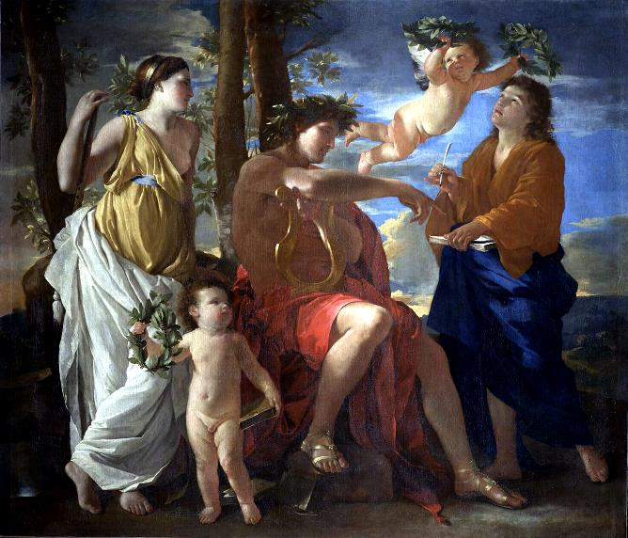
‘The Inspiration of the Poet’
Nicolas Poussin (1594 – 1665)
Wikimedia Commons

Index of First Lines in Book III

I hate the vulgar crowd, and keep them away: 96
Let the boy toughened by military service 98
The passion of the public, demanding what 101
O royal Calliope, come from heaven, 104
We believe thunderous Jupiter rules the sky: 109
Romans, though you’re guiltless, you’ll still expiate 111
Why weep, Asterie, for Gyges, whom west winds 113
You, an expert in prose in either language, 115
‘While I was the man, dear to you, 116
If you drank the water of furthest Don, Lyce, 117
Mercury (since, taught by you, his master, 118
Girls are wretched who can’t allow free play to love, or drown their cares 121
O Bandusian fountain, brighter than crystal, 123
O citizens, conquering Caesar is home 123
O, dear wife of poor Ibycus, 125
The towers made of bronze, and the doors made of oak, 125
Aelius, noble descendant of ancient 127
Faunus, the lover of Nymphs who are fleeing, 128
You can tell me the years between 129
Pyrrhus, you can’t see how dangerous it is 130
Faithful wine-jar, born, with me, in Manlius’ 131
Virgin protectress of the mountain and the grove, 132
Phidyle, my country girl, if you raise your 133
Though you’re richer than the untouched 134
Where are you taking me, Bacchus, 137
I was suited to sweethearts till now, and performed 138
Let the wicked be led by omens of screeching 138
What better thing is there to do, 142
Maecenas, son of Etruscan kings, a jar 142
I’ve raised a monument, more durable than bronze, 145

Metres Used in Book III

T
he number of syllables most commonly employed in each standard line of the verse is given. This may vary slightly for effect (two beats substituted for three etc.) in a given line.

Alcaic Strophe: 11 (5+6) twice, 9, 10
used in Odes: 1-6, 17, 21, 23, 26, 29

Sapphic and Adonic: 11(5+6) three times, 5
Odes: 8, 11, 14, 18, 20, 22, 27

First Asclepiadean: 12 (6+6) all lines
Ode: 30

Second Asclepiadean: 8, 12 (6+6), alternating
Odes: 9, 15, 19, 24, 25, 28

Third Asclepiadean: 12 (6+6) three times, 8
Odes 10, 16

Fourth Asclepiadean: 12 (6+6) twice, 7, 8
Odes: 7, 13

Fifth Asclepiadean: 16 (6+4+6) all lines
Odes: None in Book III

Alcmanic Strophe: 17 (7+10) or less, 11 or less, alternating
Odes: None in Book III

First Archilochian: 17 (7+10) or less, 7 alternating
Odes: None in Book III

Fourth Archilochian Strophe: 18 (7+11) or less, 11 (5+6) alternating
Odes: None in Book III

Second Sapphic Strophe: 7, 15 (5+10) alternating
Odes: None in Book III

Trochaic Strophe: 7, 11 alternating
Odes: None in Book III

Ionic a Minore: 16 twice, 8
Ode: 12

Book IV

BkIV:I Venus, be Merciful

‘Venus and Mars’
Sandro Botticelli (1445 – 1510)
Wikimedia Commons
Venus now you’ve returned again
to battles long neglected. Please, oh please, spare me.
I’m not prey to the power of kind
Cinara , as once I was. After fifty years,

cruel mother of sweet Cupids,
leave one now who’s hardened to your soft commands:
take yourself there, where seductive
prayers, from the young men, invite you to return.

It would be better still for you,
lifted by wings of gleaming swans, to adventure
to Paulus Maximus’s house,
if you want a worthy heart to set on fire.

Since he’s noble and he’s handsome,
and he’s not un-eloquent, for anxious clients:
he’s a lad of a hundred skills,
and he’ll carry your army’s standard far and wide:

and he’ll laugh when he’s successful
despite his rival’s expensive gifts, and he’ll raise,
just for you, by the Alban Lake,
a statue in marble, under a wooden roof.

You’ll smell rich incense, and you’ll take
delight in the notes of the lyre, when they’re mingled
with the Berecyntian flute’s,
and the sound of the reed pipes won’t be absent, there:
while sweet, virgin girls celebrate
your power, there, twice every day, see the young boys
beat the ground with their snow-white feet,
in a triple measure, like Salian dancers.

Women and boys can’t please me now,
nor those innocent hopes of mutual feeling,
nor wine-drinking competitions,
nor foreheads circled by freshly-gathered flowers.

But why, ah Ligurinus, why
should tears gather here on my cheeks, from time to time?
Why does my tongue, once eloquent,
fall indecorously silent while I’m speaking?

In dreams, at night, hard-hearted one,
I hold you prisoner, or follow you in flight,
over the grassy Fields of Mars,
or wing with you above the inconstant waters.

BkIV:II Augustus’s Return

Iulus , whoever tries to rival Pindar,
flies on waxen wings, with Daedalean art,
and is doomed, like Icarus, to give a name
to glassy waters.

Like a river, rushing down from the mountains,
that the rain has filled above its usual banks,
so Pindar’s deep voice seethes, immeasurably,
and goes on flowing,

Pindar , deserving Apollo’s laurel crown,
whether he coins new phrases in audacious
dithyrambs, and is carried along in verse
that’s free of rules,

or whether he sings gods, and kings, the children
of gods, at whose hands the Centaurs, rightly, died,
and by whom the fearful Chimaera’s fires
were all extinguished,

or speaks of those godlike ones an Elean
palm, for boxing or riding, leads home again,
granting a tribute much more powerful than
a hundred statues,

or weeps for the young man snatched from his tearful
bride, praises his powers, to the stars, his spirit,
his golden virtue, begrudging all of them
to gloomy Orcus.

Son of Antony, a powerful breeze raises
the Dircean swan, whenever it’s carried
to cloudy heights. While I create my verses,
in the manner
of a humble Matinian bee, that goes
gathering pollen from all the pleasant thyme,
and labours among the many groves, on the banks
of flowing Tiber.

You, a poet of much greater power, will sing
Caesar, honoured with well-earned wreaths, as he climbs
the sacred slopes, drawing along in his wake
the savage Germans:

he, whom no greater and no better ruler
has Fate, and the true gods, given to the world,
nor ever will, though the centuries roll back
to that first age of gold.

You’ll sing of those happy days, and the City’s
public games, when our brave Augustus returns,
in answer to our prayers: you’ll sing the Forum
free of all quarrels.

Then, if what I utter’s worth hearing, the best
strains of my voice, thrilled by Caesar’s return,
will rise, and I will sing: ‘O lovely sun, O
worthy to be praised!’

While you lead us along: ‘Hail, God of Triumph!’
not once but many times: ‘Hail, God of Triumph!’
all the city will shout, and offer incense
to the kindly gods.
Ten bulls will acquit you, and as many cows:
me, a tender calf that has left its mother,
one that’s been fattened on wide pastures, one that
can fulfil my vow,

echoing, with its brow, those returning fires
of the crescent moon, at the third night’s rising,
appearing snow-white where it carries a mark,
and the rest tawny.

BkIV:III To The Muse

Melpomene , Muse, one whom you
have looked on with favourable eyes at his birth
Ismian toil will never grant
fame as a boxer: while no straining horses

will draw him along, triumphant
in a Greek chariot, nor will his acts of war
show him to the high Capitol,
wreathed with the Delian laurel crown, who’s crushed

the bloated menaces of kings:
but the waters that run beneath fertile Tibur,
and the thick leafage of the groves,
will make him of note in Aeolian song.

It’s thought that I’m worthy by Rome’s
children, the first of cities, to rank there among
the choir of delightful poets,
and already envy’s teeth savage me less.

O Pierian girl, you who
command the golden tortoise shell’s sweet melodies,
O you, who could, if you wished,
lend a swan’s singing, too, to the silent fishes,

all of this is a gift of yours:
that I’m pointed out by the passer-by as one
who’s a poet of the Roman lyre:
that I’m inspired, and please as I please: is yours.

BkIV:IV Drusus and the Claudians

Like the winged agent of the bright lightning-bolt,
to whom Jove granted power over wandering
birds, once the divine king had found him
faithful in snatching blond Ganymede:

youth and his native vigour first launching him
fresh to his labours, out from the nest: spring winds,
despite his fears, when the storms were past,
teaching him, then, unaccustomed effort:

now with a fierce, hostile assault sweeping down
on the sheepfold, and love of spoils, and the fight,
hurling him at writhing snakes: or like
a lion-cub newly weaned from rich milk

and its tawny mother, seeing a roe deer
intent on its browsing, that’s fated to die
in his inexperienced jaws, such
was Drusus, as the Vindelici found

waging war beneath the Rhaetian Alps:
(where the custom’s derived from that, as long as
is known, has forced them to arm themselves,
clutch, in their right hands, Amazonian

battle-axes, I’ve not tried to ascertain,
it’s not right to know everything) but those hordes,
triumphant everywhere, for so long,
were conquered by the young man’s strategies:

they came to realise what mind, and character
nurtured, with care, in a fortunate household,
by Augustus’ fatherly feelings
towards his stepsons, the Neros, could do.

By the brave and good, are the brave created:
their sire’s virtues exist in horses and men,
while the ferocious golden eagles
don’t produce shy doves, but education
improves inborn qualities, and its proper
cultivation strengthens the mind: whenever
moral behaviour falls short, its faults
dishonour whatever was good at birth.

The Metaurus river’s a witness, O Rome
to what you owe to the Neros, so too is
defeated Hasdrubal, and that day
as sweet, when the shadows fled Latium,

the first day to smile in its kindly glory,
since dread Hannibal rode through Italy’s
cities, a fire among the pine-trees,
or an East wind on Sicilian seas.

And after that, through favourable efforts,
the Roman youth grew in stature, and the shrines
destroyed by Carthaginians’
impious uproar, had their gods restored.

At last that treacherous Hannibal proclaimed:
‘Of our own will, like deer who become the prey
of ravening wolves, we’re chasing those
whom it’s a triumph to flee and evade.

Their race, still strong despite the burning of Troy,
brought their children, sacred icons, and aged
fathers, tossed about on Tuscan seas,
to the towns of Italy, as some oak,
rich in its dark leaves, high on Mount Algidus,
trimmed back by the double-bladed axe, draws strength
and life, despite loss and destruction,
from the very steel itself. The Hydra,

as its body was lopped, grew no mightier,
in grief at being conquered by Hercules,
nor was any greater monster reared
by Colchis or Echionian Thebes.

Drowned in the deep, it emerges lovelier:
contend, it defeats the freshest opponent,
with great glory, and wages wars
that the housewives will tell of in story.

I’ll send no more proud messages to Carthage:
every hope of mine is ended, and ended
the fortunes of all my family,
since my brother Hasdrubal’s destruction.

There’s nothing that Claudian power can’t achieve,
protected by Jove, protected by the god’s
authority, power for which shrewd minds
clear the way through the harsh dangers of war.’

BkIV:V To Augustus

Son of the blessed gods, and greatest defender
of Romulus’ people, you’ve been away too long:
make that swift return you promised, to the sacred
councils of the City Fathers,

Blessed leader, bring light to your country again:
when your face shines on the people, like the shining
springtime, then the day itself is more welcoming,
and the sun beams down more brightly.

As a mother, with vows and omens and prayers,
calls to the son whom a southerly wind’s envious
gales have kept far from his home, for more than a year,
lingering there, beyond the waves

of the Carpathian Sea: she who never turns
her face away from the curving line of the shore:
so, smitten with the deep longing of loyalty,
the country yearns for its Caesar.

Then the ox will wander the pastures in safety,
Ceres, and kindly Increase, will nourish the crops,
our sailors will sail across the waters in peace,
trust will shrink from the mark of shame,

the chaste house will be unstained by debauchery,
law and morality conquer the taint of sin,
mothers win praise for new-born so like their fathers,
and punishment attend on guilt.

Who’ll fear the Parthians, or the cold Scythians,
and who’ll fear the offspring savage Germany breeds,
if Caesar’s unharmed? Who’ll worry about battles
in the wilds of Iberia?

Every man passes the day among his own hills,
as he fastens his vines to the waiting branches:
from there he gladly returns to his wine, calls on
you, as god, at the second course:

He worships you with many a prayer, with wine
poured out, joins your name to those of his household gods,
as the Greeks were accustomed to remembering
Castor and mighty Hercules.

‘O blessed leader, bring Italy endless peace!’
That’s what we say, mouths parched, at the start of the day,
that’s what we say, lips wetted with wine, when the sun
sinks to rest under the Ocean.

BkIV:VI To Apollo

God, whom Niobe’s children encountered, O
you, avenger of boastful words on Tityos
the robber, and Phthian Achilles, all
but proud Troy’s victor,

and a greater fighter than others, but not than
you, though he was the son of sea-born Thetis,
and made the Dardanian towers tremble,
with his fearful spear.

Like a pine-tree slashed by the bite of the axe,
or a cypress struck by an Easterly wind,
he fell, outstretched, to the earth, bowed down his neck
in the Trojan dust.

He’d not have cheated the Teucrians, with their
vain celebrations, nor Priam’s joyfully
dancing court, by hiding deep in the Horse, false
tribute to Minerva:

but he’d have burnt, ah, wickedly, wickedly,
their un-weaned offspring, with Achaean fires,
in open cruelty to his prisoners,
babes hid in the womb,

if Jupiter hadn’t agreed to your pleas,
and those of lovely Venus, that Aeneas
should come to rule the walls of a city built
with better omens.

Phoebus, musician and teacher of tuneful
Thalia , who bathe your hair in Xanthus’ stream,
defend the Daunian Muse’s honour, O
beardless Agyieus.

Phoebus gave me inspiration, Phoebus gave
me skill in singing, and the name of poet.
You noble young girls, and you boys who are born
of famous fathers,

both, protected by the Delian goddess,
who brings down, with the bow, swift deer and lynxes,
follow the Sapphic measure, note the rhythm
of my finger’s beat,

and ritually sing the son of Latona,
ritually sing the fire of the waxing Moon,
the quickener of crops, and swift advancer
of the headlong months.

Married, you’ll say: ‘I sang the song the gods love,
when time brought back the days of the festival,
and I was one who was trained in the measures
of Horace the bard.

BkIV:VII Diffugere Nives

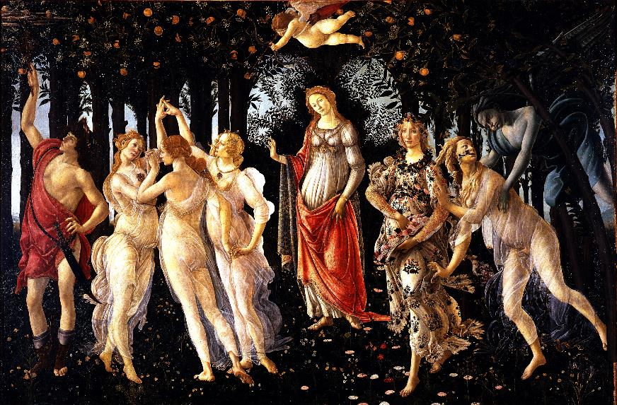
‘Primavera ’
Sandro Botticelli (1445 – 1510)
Wikimedia Commons
The snow has vanished, already the grass returns to the fields,
and the leaves to the branches:
earth alters its state, and the steadily lessening rivers
slide quietly past their banks:

The Grace, and the Nymphs, with both of her sisters, is daring enough,
leading her dancers, naked.
The year, and the hour that snatches the kindly day away, warn you:
don’t hope for undying things.

Winter gives way to the westerly winds, spring’s trampled to ruin
by summer, and in its turn
fruitful autumn pours out its harvest, barely a moment before
lifeless winter is back again.

Yet swift moons are always repairing celestial losses:
while, when we have descended
to virtuous Aeneas, to rich Tullus and Ancus, our kings,
we’re only dust and shadow.

Who knows whether the gods above will add tomorrow’s hours
to the total of today?
All those you devote to a friendly spirit will escape from
the grasping hands of your heirs.

When once you’re dead, my Torquatus, and Minos pronounces
his splendid judgement on you,
no family, no eloquence, no righteousness even,
can restore you again:
Diana can never free Hippolytus, chaste as he is,
from the shadow of darkness,
nor has Theseus, for his dear Pirithous, the power to
shatter those Lethean chains.

BkIV:VIII Poetry

I’d give bowls, generously, and pleasing bronzes,
to all of my comrades, my dear Censorinus,
I’d give tripods, the prizes that mighty Greeks gave,
and you wouldn’t be seeing the least of my gifts,
if I were, appropriately, rich in the works
Scopas produced, or Parrhasius created,
the latter in marble, the former in painting,
now expert in showing heroes, and now, a god.
But I’ve no such powers, and your spirit and state
don’t ask for any such kinds of amusement.
You delight in poetry, poetry we can
deliver, and establish the worth of the gift.
It’s not marble, carved out with public inscriptions,
and by which, after death, life and spirit return
to great generals, it’s not Hannibal’s rapid
retreat, once repulsed, with his threats turned against him,
nor is it the burning of impious Carthage,
that more gloriously declares all the praises
of him who winning a name from his African
conquest, came home, than the Calabrian Muses:
and you wouldn’t receive the reward for your deeds
if the books were silent. What would the child of Mars
and of Ilia be today, if mute envy
stood in the way of Romulus’s just merits?
The virtue, and favour, and speech of powerful
poets snatches Aeacus from Stygian streams,
immortalising him, in the Isles of the Blessed.
It’s the Muse who prevents the hero worth praising
from dying. The Muse gladdens heaven. So, tireless
Heracles shares the table of Jove he hoped for,
so the bright stars of the Twins, Tyndareus’ sons,
snatch storm-tossed ships out of the depths of the waters,
and Bacchus, his brow wreathed, in the green sprays of vine,
brings all of our prayers to a fortunate outcome.

BkIV:IX Lollius

Don’t think that the words I speak to accompany
the lyre ( I, born near thunderous Aufidus,
plying those skills not generally known
before) are destined to utterly die:

Though Maeonian Homer holds the first place,
Pindar’s Muse is not hidden, Simonides’
of Ceos, nor threatening Alcaeus’,
nor that of the stately Stesichorus:

time hasn’t erased what Anacreon once
played: and the love of the Lesbian girl still
breathes, all the passion that Sappho
committed to that Aeolian lyre.

Laconian Helen wasn’t the only one
inflamed by marvelling at an adulterer’s
elegant hair, or gold-spangled clothes,
his regal manners, and his companions,

Teucer wasn’t the first to fire an arrow
from a Cydonian bow, more than once great
Troy was troubled: Idomeneus
the mighty, and Sthenelus weren’t alone

in fighting wars sung by the Muses: Hector
the fierce and brave Deiophobus weren’t the first
to suffer the weight of heavy blows
for the sake of their chaste wives, and children.

Many brave men lived before Agamemnon:
but all are imprisoned in unending night,
all of them are unwept and unknown,
because of the lack of a sacred bard.

Courage that’s concealed in the tomb, is little
different to cowardice. Lollius I won’t
be silent about you in my verse,
(you’re celebrated) nor allow envious
oblivion to prey with impunity
on your many exploits. You’ve a mind that’s versed
in affairs, that’s just, in dubious
times, or in the most favourable ones,

punishing avaricious deceit, restrained
with money that draws everything to itself,
not a Consul of a single year,
but a judge often, one honest and true,

preferring honour to expediency,
with a noble look rejecting the criminal’s
bribe, a conqueror carrying arms
through the hostile ranks of the enemy.

It’s not right to call a man blessed because he
owns much: he more truly deserves a name for
being happy, who knows how to make
a wiser use of the gifts from the gods,

and how to endure the harshest poverty,
who’s a greater fear of dishonour than death:
he’s not afraid to die for the friends
that he loves, or to die for his country.

BkIV:X Age

O you who are cruel still, and a master of Venus’s gifts,
when a white, unexpected plumage surmounts all your arrogance,
and the tresses that wave on your shoulders have all been shorn away,
and the colour that now outshines the flower of the crimson rose
is transformed, my Ligurinus, and has changed into roughened skin:
whenever you look at your altered face in the mirror, you’ll say:
‘Why didn’t I have, when I was a youth, the mind I have today,
or why can’t those untouched cheeks return to visit this soul of mine?’

BkIV:XI Maecenas’ Birthday

I’ve a jar of Alban wine over nine years
old: and there’s parsley for weaving your garlands,
in the garden, Phyllis, and see, there’s a huge
amount of ivy,

with which you shine whenever it ties your hair:
the house gleams with silver: the altar is wreathed
with pure vervain, and waits to be stained with blood,
a sacrificed lamb:

All hands are scurrying: here and there, a crowd
of boys and girls are running, and see the flames
are flickering, sending the sooty smoke rolling
high up in the air.
And so that you know to what happiness you’re
invited, it’s the Ides that are the reason,
they’re the days that divide the month of April,
of sea-born Venus,

it’s truly a solemn day for me, and more
sacred to me almost than my own birthday,
because from that morning Maecenas reckons
the flow of his years.

A rich, an impudent, young girl has captured
Telephus, one you desire, and who’s above
your station, and holds him prisoner, fettered
with beautiful chains.

Scorched Phaethon’s a warning to hope’s ambition,
and winged Pegasus offered a harsh example
in refusing his back to Bellerephon,
his earthly rider:

always pursue what’s appropriate for you,
consider it wrong to hope for what isn’t
allowed, for someone who isn’t your equal.
Come now, my last love,

(since I’ll burn for no other woman after
you) learn verses you’ll repeat in your lovely
voice: the darkest of cares will be lessened
by means of your song.

BkIV:XII Spring

Now Spring’s companions, the Thracian northerlies,
that quieten the ocean, are swelling the canvas:
now fields are unfrozen, and rivers stop roaring
with their volumes of winter snow.

The sad swallow, tearfully mourning Itys, builds
her nest, she’s the House of Cecrops’ eternal shame,
avenging the barbarous lust of Tereus
with too savage a cruelty.

The shepherds, with indolent sheep, in the soft grass,
sing their songs to the sound of the pipes, and delight
great god, Pan, who is pleased with the flocks, and is pleased
by the dark hills of Arcady.

And, Virgil, the season has brought its thirst to us:
but if you’re eager to sip at a grape that was pressed
at Cales, you follower of noble youth, then
earn your wine with a gift of nard.

One small onyx box of nard elicits a jar
that’s lying there now in Sulpicius’ cellar,
sufficient for granting fresh hope, and effective
at washing away bitter care.

If you’re in a rush for pleasures like this, come quick
with your purchase: since I refuse to consider
dipping a gift-less you, in my wine, as if I’m
rich, my house filled with everything.

But abolish delay, and desire for profit,
and, remembering death’s sombre flames, while you can,
mix a little brief foolishness with your wisdom:
it’s sweet sometimes to play the fool.

BkIV:XIII You too, Lyce

Lyce, the gods have heard my prayers, the gods have
heard me, Lyce: you’re growing old, but still desire
the power of beauty, and still
you play, and drink quite shamelessly,

and, drunk, you urge dull Cupid on with tremulous
singing. He’s keeping watch on the beautiful cheeks
of Chia the young and fresh,
who’s expert at playing the harp.

For he flies disdainfully past the withered oak,
and he runs away from you, since you’re disfigured
by those now yellowing teeth,
those wrinkles, and that greying hair.

Now gowns of Coan purple, and those expensive
jewels, won’t bring back time, that the passage of days
has shut away, and buried,
a matter of public record.

Where’s Venus fled, alas, and beauty? And where now
are your graceful gestures? What is left of that girl,
that girl who once breathed of love,
who stole me away from myself,

happy when Cinara had vanished, and famous
for your looks and your charming ways? The Fates granted
Cinara the briefest years,
preserving Lyce, endlessly,

to suffer as long a life as an ancient crow,
so that the burning youths with many a ripple
of laughter, are here to gaze
at a fire that’s fallen to ashes.

BkIV:XIV Drusus and Tiberius

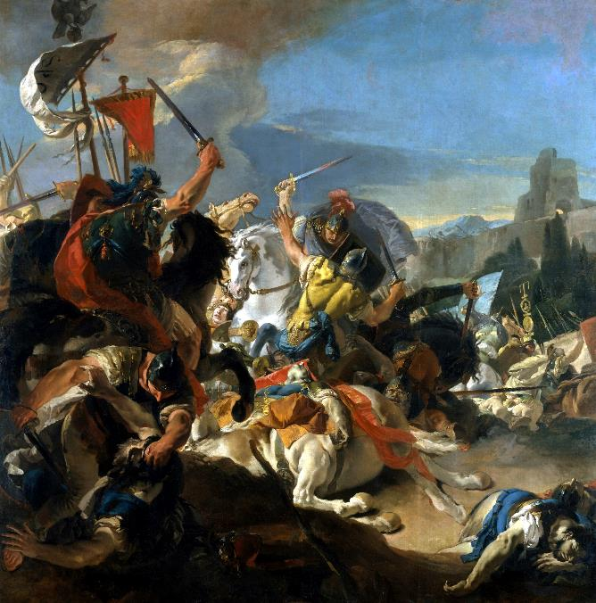
‘The Battle of Vercellae’
Giovanni Battista Tiepolo (1696 – 1770)
Wikimedia Commons

What care the Citizens and the Senators
shall take in immortalising your virtues,
granting you full honours, Augustus,
with titles and memorial plaques, O,
greatest of princes, wherever the sun shines
over the countries where people can live, you,
whose power in war the Vindelici
free of our Roman laws, till now, have learnt.

For, with your army, brave Drusus, demolished
the Genauni, that implacable race, in more
direct retaliation, the swift
Breuni, and their defences, established

on the formidable Alpine heights: and soon
Tiberius, the elder Nero, entered
that fierce fight, with his favourable
omens, defeating the wild Rhaetians:

it was wonderful to see with what destruction,
in contesting the war, he exhausted those minds
intent on the deaths of our freemen,
as the south wind, almost, when it troubles

the ungovernable waves, while the Pleiades’
constellation pierces the clouds, he was eager
to attack the hostile ranks, and drive
his neighing horse through the midst of their fire.

As, bull-like, the Aufidus rolls on, flowing
by the domains of Apulian Daunus,
when it rages and threatens fearful
destruction to their cultivated fields,
so Tiberius overwhelmed the armoured
ranks of barbarians, his fierce impetus
covering the earth, mowing down front
and rear, and conquering them without loss,

yours the troops, the strategy and the friendly
gods. For on that date when Alexandria
opened all its harbour, and empty
palaces to you, in supplication,

good Fortune, fifteen years later, delivered
a favourable outcome to the campaign,
and awarded fame, and the glory
hoped-for, to your imperial action.

The Spaniards, never conquered before, the Medes,
the Indians, marvel at you, the roving
Scythians, O eager protector
of Italy and Imperial Rome.

The Nile, that conceals its origin, hears you,
the Danube hears, and the swift-flowing Tigris,
the Ocean, filled with monsters, roaring
around the distant island of Britain,

and the regions of Gaul, unafraid of death,
and the stubborn Iberian land, hear you:
Sygambri, delighting in slaughter,
stand, with grounded weapons, worshipping you.

BkIV:XV To Augustus

Phoebus condemned my verse, when I tried to sing
of war and conquered cities, lest I unfurled
my tiny sail on Tyrrhenian
seas. Caesar, this age has restored rich crops

to the fields, and brought back the standards, at last,
to Jupiter, those that we’ve now recovered
from insolent Parthian pillars,
and closed the gates of Janus’ temple,

freed at last from all war, and tightened the rein
on lawlessness, straying beyond just limits,
and has driven out crime, and summoned
the ancient arts again, by which the name

of Rome and Italian power grew great,
and the fame and majesty of our empire,
were spread from the sun’s lair in the west,
to the regions where it rises at dawn.

With Caesar protecting the state, no civil
disturbance will banish the peace, no violence,
no anger that forges swords, and makes
mutual enemies of wretched towns.

The tribes who drink from the depths of the Danube,
will not break the Julian law, the Getae,
nor Seres, nor faithless Persians,
nor those who are born by the Don’s wide stream.

On working days, and the same on holy days,
among laughter-loving Bacchus’ gifts to us,
with our wives and our children we’ll pray,
at first, to the gods, in the rites laid down,

then, in the manner of our fathers, bravely,
in verse, that’s accompanied by Lydian flutes,
we’ll sing past leaders, we’ll sing of Troy,
Anchises, and the people of Venus.

Index of First Lines in Book IV

Venus now you’ve returned again 152
Iulus, whoever tries to rival Pindar, 153
Melpomene, Muse, one whom you 156
Like the winged agent of the bright lightning-bolt, 157
Son of the blessed gods, and greatest defender 161
God, whom Niobe’s children encountered, O 163
The snow has vanished, already the grass returns to the fields, 166
I’d give bowls, generously, and pleasing bronzes, 167
Don’t think that the words I speak to accompany 168
O you who are cruel still, and a master of Venus’s gifts, 171
I’ve a jar of Alban wine over nine years 171
Now Spring’s companions, the Thracian northerlies, 173
Lyce, the gods have heard my prayers, the gods have 174
What care the Citizens and the Senators 176
Phoebus condemned my verse, when I tried to sing 179

Metres Used in Book IV

T
he number of syllables most commonly employed in each standard line of the verse is given. This may vary slightly for effect (two beats substituted for three etc.) in a given line.

Alcaic Strophe: 11 (5+6) twice, 9, 10
used in Odes: 4, 9, 14, 15

Sapphic and Adonic: 11(5+6) three times, 5
Odes: 2,6,11

First Asclepiadean: 12 (6+6) all lines
Ode: 8

Second Asclepiadean: 8, 12 (6+6), alternating
Odes: 1,3

Third Asclepiadean: 12 (6+6) three times, 8
Odes 5,12

Fourth Asclepiadean: 12 (6+6) twice, 7, 8
Ode:13

Fifth Asclepiadean: 16 (6+4+6) all lines
Ode: 10

Alcmanic Strophe: 17 (7+10) or less, 11 or less, alternating
Odes: None in Book IV

First Archilochian: 17 (7+10) or less, 7 alternating
Ode: 7

Fourth Archilochian Strophe: 18 (7+11) or less, 11 (5+6) alternating
Odes: None in Book IV

Second Sapphic Strophe: 7, 15 (5+10) alternating
Odes: None in Book IV

Trochaic Strophe: 7, 11 alternating
Odes: None in Book IV

Ionic a Minore: 16 twice, 8
Ode: None in Book IV

About the Author

Q
uintus Horatius Flaccus (65–8 BC) was born at Venusia, on the border of Lucania and Apulia. His father, a freed slave and coactor (auctioneer and financier), invested heavily in his son's education, accompanying him to Rome to oversee his schooling. Horace subsequently enrolled at the Academy in Athens, where he studied Greek lyric poetry alongside Epicurean and Stoic philosophy.
The civil wars that followed Julius Caesar's assassination brought his education to an untimely close. Brutus recruited him in Athens, and Horace served as a military tribune at the Battle of Philippi in 42 BC. After the republican defeat, he accepted Octavian's amnesty and returned to Italy, where his father's estate had been confiscated for veteran settlements. He obtained a civil service post at the Treasury and began writing verse.
Through Virgil, Horace gained an introduction to Maecenas, Octavian's political lieutenant. Maecenas became his patron and gave him the Sabine farm that features prominently in his poetry. This relationship aligned Horace with the emerging Augustan regime — which scholars argue may have influenced the independence of his writing.
His works appeared over a period of roughly twenty-five years: two books of Satires (c. 35–30 BC), the Epodes (30 BC), Odes 1–3 (23 BC), Epistles 1 (c. 21 BC), the Carmen Saeculare (17 BC), Epistles 2, Odes 4 (c. 11 BC), and the Ars Poetica (c. 10–8 BC). Each collection adapted Greek and Roman models, including Archilochus, Lucilius, Alcaeus, and Sappho, to Roman conditions.
He died on 27 November 8 BC, shortly after Maecenas, and was buried near his patron's tomb. Both men bequeathed their property to Augustus.

About the Translator

A
nthony Kline lives in England. He graduated in Mathematics from the University of Manchester, and was Chief Information Officer (Systems Director) of a large UK Company, before dedicating himself to his literary work and interests. He was born in 1947. His work consists of translations of poetry; critical works, biographical history with poetry as a central theme; and his own original poetry. He has translated into English from Latin, Ancient Greek, Classical Chinese and the European languages. He also maintains a deep interest in developments in Mathematics and the Sciences.
He continues to write predominantly for the Internet, making all works available in download format, with an added focus on the rapidly developing area of electronic books. His most extensive works are complete translations of Ovid's Metamorphoses and Dante's Divine Comedy.

