Sir Orfeo

Translated from the Middle English

Author Anonymous (c.1300)

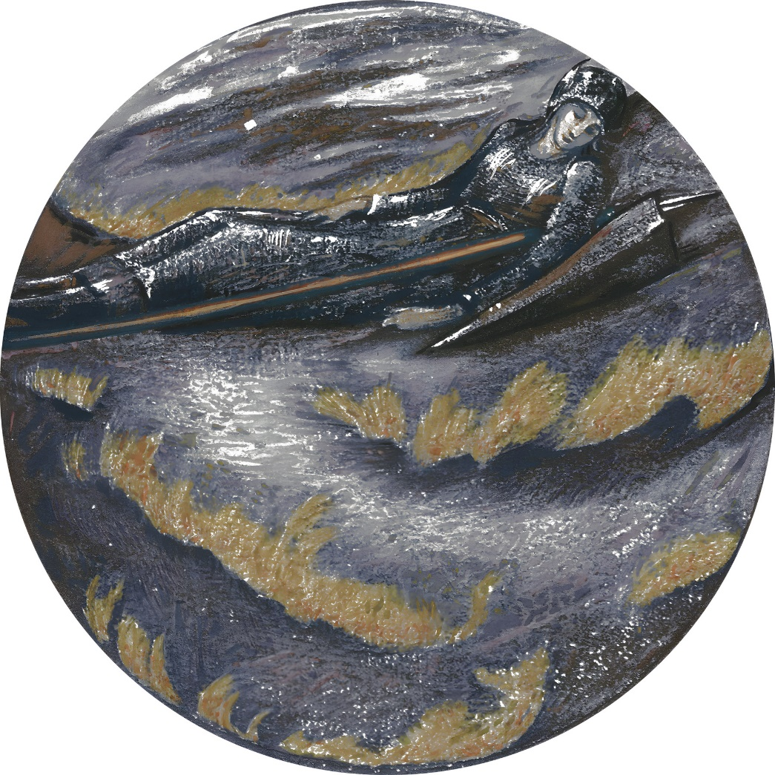

‘Flame Heath’ - Sir Edward Coley Burne-Jones (English, 1833 – 1898), Artvee

Translated and Modernised by A. S. Kline © 2025 All Rights Reserved.
This work may be freely reproduced, stored, and transmitted, electronically or otherwise, for any non-commercial purpose.
Contents

Translator’s Introduction 3
Sir Orfeo 3
The Poet’s Introduction 3
The Queen’s Affliction 4
The King Seeks to Aid Her 7
The Queen Replies 8
She Tells of Her Vision 8
The King of the Faeries 8
The Queen is Abducted 9
Orfeo Summons his Noblemen 10
He Flees to the Wilderness 11
He Sees the Faery Horde Out Hunting 14
And Recognises His Wife, Heurodis 15
Orfeo Pursues the Host of Ladies 16
He Enters the Castle 17
And Reaches the Great Hall 18
He Plays His Harp Before the King 19
And Asks for His Wife as His Reward 20
They Return to Winchester 21
He Enters the City in Minstrel Guise 22
The Steward Invites Him to the Castle 23
The Minstrel is Found to be Sir Orfeo 24

Translator’s Introduction

D
ating from the late 13th or early 14th century, Sir Orfeo, an anonymous Breton ‘lay’, written in Middle English, and based on the lost ‘Lai d’Orphey’, relates a tale derived from that of the Orpheus of Greek myth, here a royal hero who rescues his wife from the King of the Faeries. Celtic myth and folklore were also a source for the work, which was influenced by the Old French Breton ‘lais’ retold in Anglo-French by Marie de France and others. Three manuscripts survive, of which the oldest, the Auchinleck, dates from c1330. The folk song Orfeo (Roud 136, Child 19) is based on the poem.

Sir Orfeo

The Poet’s Introduction

We readeth oft, as clerks do write,
Who keep such works well in sight,
Lays that are both harped and sung,
Well-composed, to fit the tongue,
Telling some of war, some woe,
And some of joy and mirth also,
And some of treachery and guile,
Adventures old, lost many a while,
And some of jests and ribaldry,
While many of faery kingdoms be.
Of all the things that once befell,
Most of love, in truth, they tell.
In Brittany these lays were wrought,
There first, to light, were they brought,
Adventures sought in olden days,
Of which the Bretons made their ‘lais’.
When kings, as ever, wished to hear
Of each wonder that did appear,
Men took a harp, and sang that same,
And wrought a lay, and gave it name.
Of one adventure, that did befall,
Part I can tell, and yet not all.
But hearken, lordlings true, for lo,
I’ll sing that of ‘Sir Orfeo’.

The Queen’s Affliction

Orfeo, of most anything
Loved the harp, its every string,
And each good and skilful harpist,
Had much honour of him, I wist.
He himself the harp had learned,
Sharp of wit, its mastery earned,
And played so well, that in no place,
A finer harpist showed his face.
In all the world, no man was born
That before Orfeo, night or morn.
Might sit, and his playing hear,
But would think himself as near
To Paradise as a man could be,
So sweet that harpist’s melody.
Now Orfeo was a king, say I,
In England a great lord on high;
A stalwart man, and hardy too,
Generous, courteous, and true.
His father was a scion of Pluto,
And his mother of Queen Juno,
That, in times past, divine were thought,
For the deeds, all told, they wrought.
This king, his dwelling was in ‘Thrace’,
Noble, well-fortified, the place,
For Winchester was once named so,
‘Thrace’ it was, believe it or no.
A queen beyond all price was his,
And she was called Dame Heurodis,
The fairest lady ever known
Of mortal body, of flesh and bone,
Full of love, and of goodness too;
Her beauty none could grant its due.
Now, at the coming in of May,
When hot and pleasant is the day,
And fled are all the wintry showers,
And every field is full of flowers,
And blossom bright on every bough,
And all things wax merry enow,
Then the queen, Dame Heurodis,
With two choice maids, naught amiss,
In the late morn, made her way,
To an orchard by, to pass the day,
View the flowers that forth did spring,
And listen how the birds did sing.
They sat themselves down, all three,
Under a grafted, apple-tree,
And very swiftly this fair queen,
Fell asleep, there, upon the green.
Her maids their mistress dared not wake,
But let her lie, her rest to take.
So, she slept till the afternoon,
The morning past and gone full soon,
But then, as she began to wake,
A loathsome outcry she did make,
Rubbed at her hands and feet, tis said,
And scratched at her face till it bled;

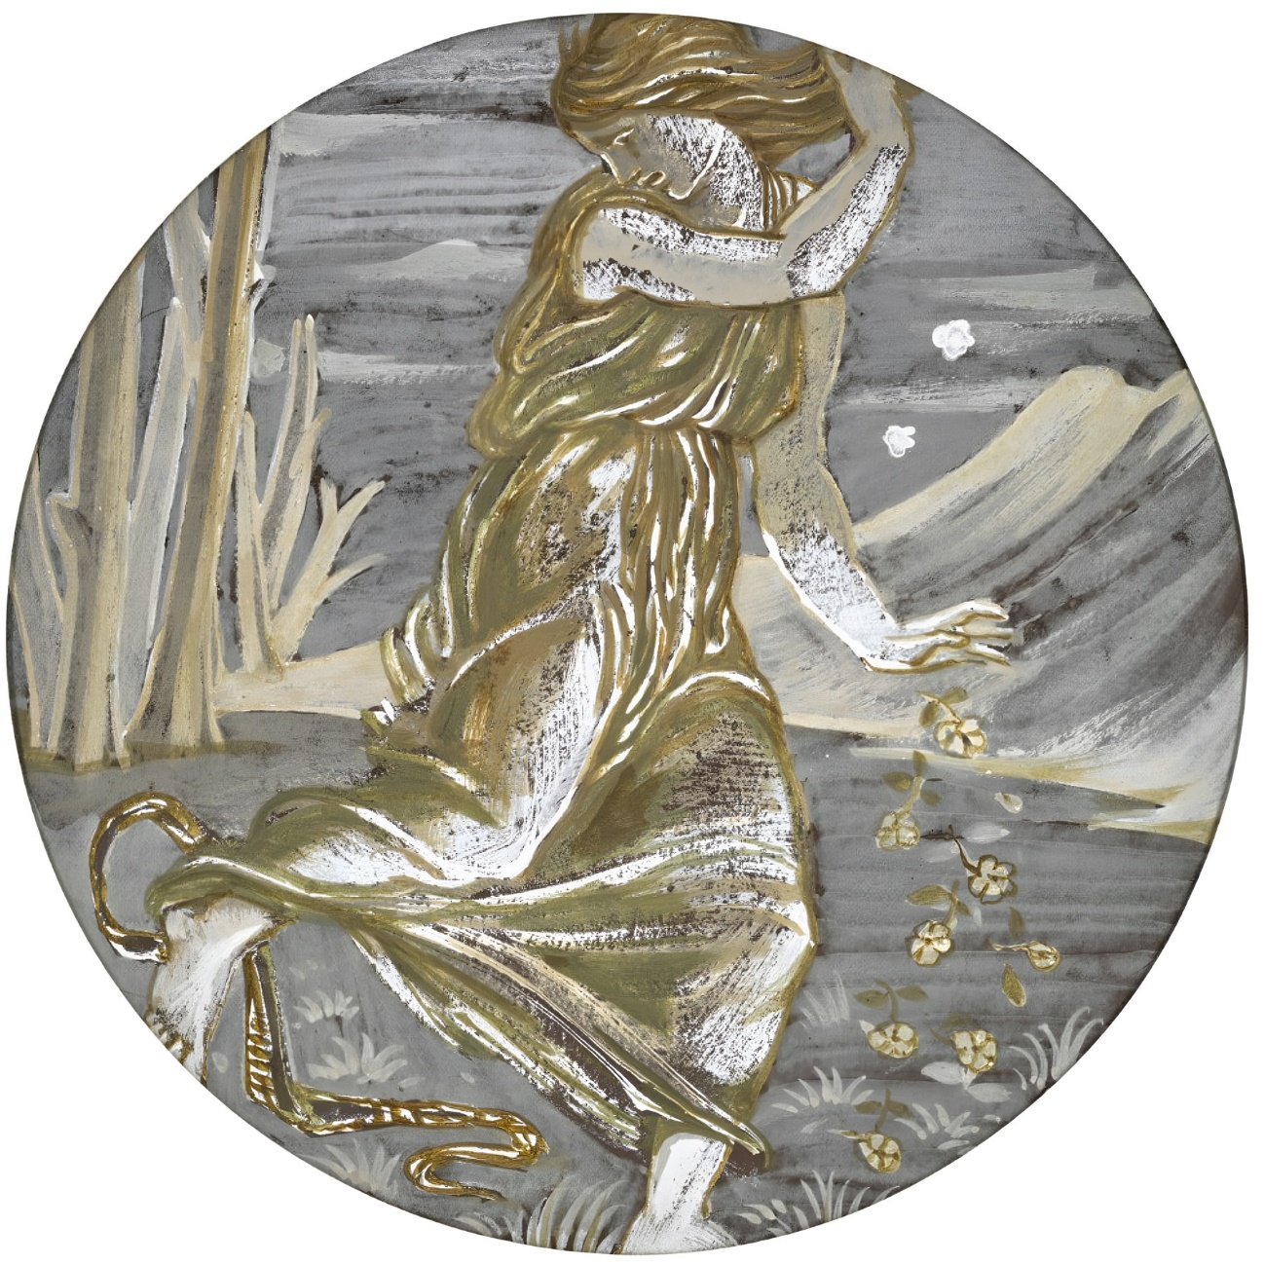

‘Eurydice Bitten by a Serpent’
Sir Edward Coley Burne-Jones (English, 1833 – 1898)
Artvee
Her rich robe she tore all to bits,
Driven, in truth, out of her wits.
The two maids who were by her side
Dared no more with her to abide,
But ran to the palace outright,
Crying, to every squire and knight,
That their queen had been driven mad;
And that they take her up they bade.
To her the knights and ladies flew,
And more than sixty damsels, too,
And in the orchard found the queen,
And so took her, their arms between,
And bore to her bed at last,
And held her there, good and fast.
Ever she held to the one cry;
Up and away from there would fly.

The King Seeks to Aid Her

Orfeo, at this ill-tiding,
Ne’er grieved more for anything.
With ten good knights, the king was seen
To hie to the chamber of the queen,
Behold her, and say, in his woe:
‘Dear heart of mine, what ails you so,
That ever have been calm and still,
Yet cry aloud now, wondrous shrill?
Your body so fine, white as dawn,
By your nails is so sadly torn;
Alas, your face, like a rose red,
Now all wan, as if you were dead;
Your slender fingers, to each nail,
Now they are all bloody and pale!
Your lovely eyes, alas and woe,
Look as a man does on his foe!
O, lady, grant mercy, say I,
Cease I beg your pitiful cry,
Tell me what ails you, and how,
With what aid, I may help you now.’

The Queen Replies

Then the queen she lay still at last,
And began to weep hard and fast,
And said to the king, in her woe,
‘Alas, my lord, Sir Orfeo,
We, since we were first together,
Never were wroth with each other,
But ever have I loved you true,
As my life, and the like have you,
But now we must part; be it so,
Do what is best, for I must go.’
‘Alas’ said he, ‘forlorn am I,
Where, and to whom, will you fly?
Whither you go, there I must be,
And whither I go, be you with me.’

She Tells of Her Vision

‘No, sir, you cannot, not in this,
For I shall tell you how it is:
As I this morning did abide,
Deep in sleep, by the orchard side,
A pair of fair knights came to me,
Well-armed, and armoured fittingly,
And bade me haste, for they would bring
Me to speak with their lord the king,
And I answered, in words full bold,
I dared not do so, for life nor gold.’

The King of the Faeries

‘Fast as they could, they spurred away,
Then came their king, as swift as they,
With a hundred knights and more,
And damsels there were, full five score,
All on snow white steeds they rode,
As white as milk their garments showed,
And never have I seen before,
Such fine, fair creatures, I am sure.
The king bore a crown on his head,
Not of red gold, silver instead,
Shining, as if of precious stone;
Bright as the sun it shone, I own.
As soon as to my side he came,
Whether I would or no, that same
Seized me and, after, made me ride,
Upon a palfrey by his side,
To his palace, far off it lay,
That was adorned in every way,
And showed me castles and towers
Rivers, forests, fields of flowers,
And his fine steeds, every one,
And brought me home, neath the sun,
Again, to our own orchard here,
And after he said to me full clear:
Dame, tomorrow, be sure to be
Here, neath this grafted apple-tree,
And then with me you shall go,
And evermore live with me also,
And if to hinder me you do aught,
Wherever you are, you will be sought,
And limb from limb, you will be torn,
And none can help you, no man born.’

The Queen is Abducted

When Orfeo heard what must pass,
‘O woe!’ cried he, ‘Alas! Alas!
I would choose to lose my life
Rather than lose the queen, my wife!’
He asks counsel of every man,
But none will help him or can.
The next day in the morning, late,
Orfeo, armed, was at the gate,
And a good thousand knights with him,
Likewise armed, all stout and grim,
And with the queen, at once went he,
And rode there to the grafted tree,
And ranked his men on either side,
And said that there they would abide,
And they would die there every one,
Before the queen from them be gone.
Yet, from amidst them, in broad day,
The queen was swiftly snatched away.
Taken up, through the faery’s power,
And none knew where she was that hour.

Orfeo Summons his Noblemen

Then was there crying, weeping, woe!
The king to his chamber did go;
Oft, he swooned to the floor of stone,
And gave such cries, made such moan,
That his life, it was well-nigh spent,
For no remedy brought him content.
He called his barons to aid the crown,
His earls, his lords of great renown,
And when they all had gathered near
‘Lordings,’ he said, ‘before you here,
My high steward I thus ordain,
To rule the kingdom; he shall reign
In my stead, your lord he’ll be,
To keep my lands secure for me.
From my side, has my queen been torn,
The fairest lady ever born.
Never more will I woman see,
Into the wilderness I’ll flee,
And there I will live ever more,
With wild beasts in woodland hoar.
And when you hear that I am spent,
Summon you then a parliament;
Choose for yourselves a new king.
Now, do your best in everything.’
Then was there weeping in the hall,
Loud were the cries among them all,
Scarce might the old, nor yet the young,
For weeping, to a word give tongue,
Then, as one, they knelt and were still,
And begged him, if it was his will,
Not to abandon them, and go,
‘Enough!’ he cried, ‘It shall be so!’

He Flees to the Wilderness

All his kingdom he did forsake,
But a pilgrim’s garb he did take;
He had neither tunic nor hood,
Shirt, nor aught else, tis understood,
His harp he took, at any rate,
And so passed, barefoot, through the gate.
No other man with him could go,
Alas! What weeping there was, and woe,
When a king that had worn a crown,
Went in poverty from the town.
O’er wood and heath, he made his way,
Into the wilderness, day by day.
Nothing he had of comfort there,
But, in distress, roamed everywhere.
He that had worn the vair and grey,
Purple the clothes on his bed alway,
Now on coarse heather he lay down,
Leaves and grass to wrap him round.
He that had both castles and towers,
Rivers, forests, and fields of flowers,
Now it begins to snow and freeze,
On a bed of moss, must take his ease.
He that had many a prized knight.
To kneel to him, and ladies bright,
Now sees nothing to please the eye,
Where snakes glide, as he passes by.
He that once had food in plenty,
Meat and drink, and many a dainty,
Now he might grub about all day
Ere he could fill his belly that way.
In summer he lived on wild fruit,
Small berries, and many a root,
In winter naught else could he find,
But roots and grasses, bark and rind.
All his body, it dwindled down,
From hardship, chapped foot to crown.
Lord! Who can tell the sorrow sore
That king suffered ten year and more?

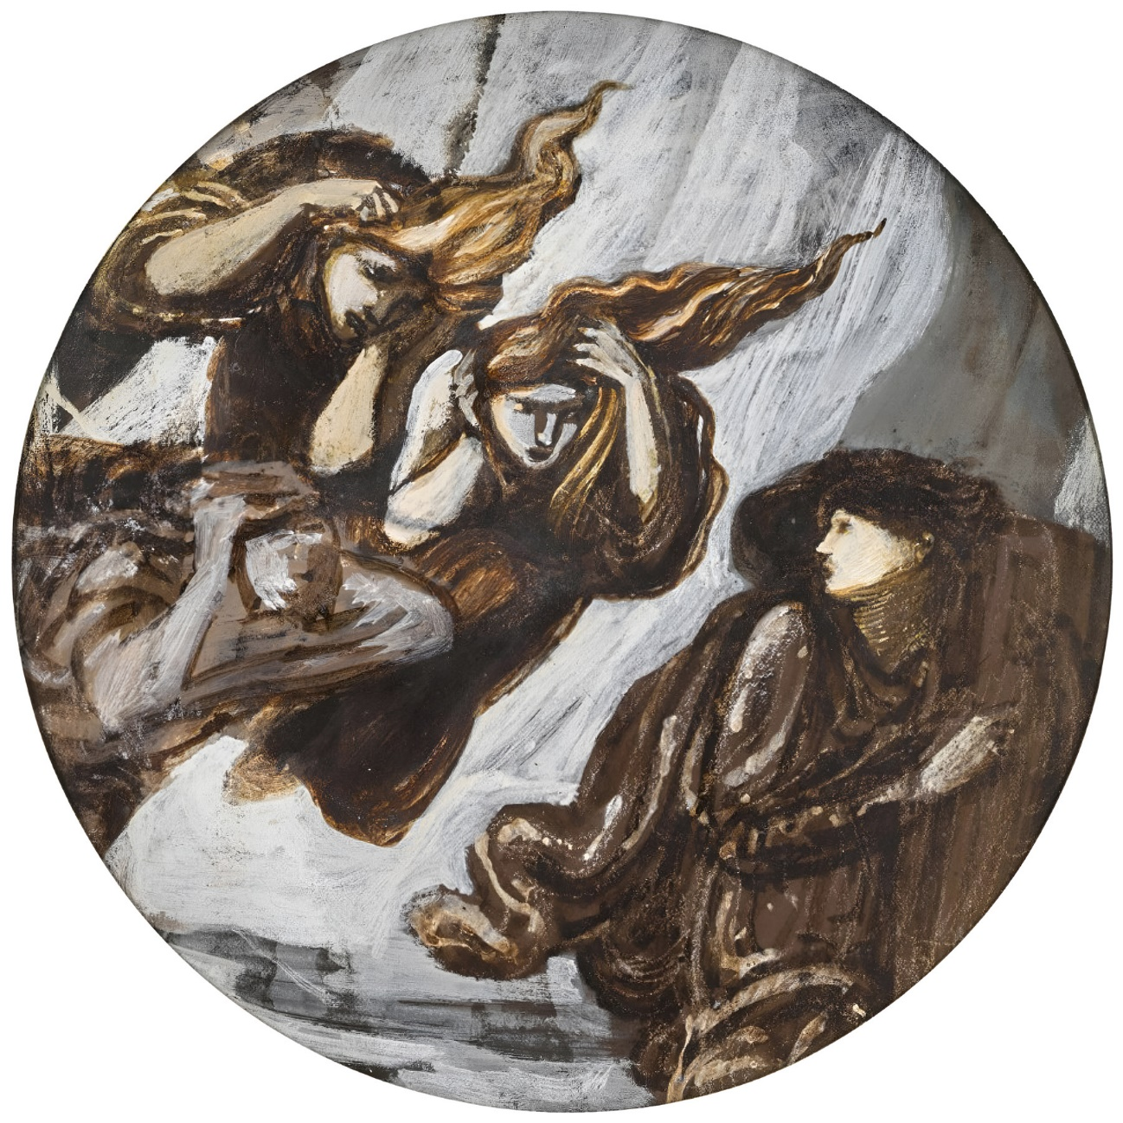

‘Orpheus Pursued by Furies’
Sir Edward Coley Burne-Jones (English, 1833 – 1898)
Artvee

His beard, that now was coarse and black,
Fell to his waist, comb he did lack.
A hollow tree he did employ
To hide his harp, now all his joy,
And when the sky was clear and bright,
He took his harp, and played aright,
Sounding it, of his own free will,
Till the wood with echoes did fill,
And all the wild beasts living there,
Gathered to him, from everywhere,
And all the birds about drew nigher,
And perched about, on every briar,
To hear the melodies so played.
Fine was the music that he made,
Yet when the sound of his harp died,
No creature did with him abide.

He Sees the Faery Horde Out Hunting

Oft of a morn, he would see nearby
When the sun was hot in the sky,
The King of Faery, with all his rout,
Come to hunt, in the woods about,
With far cries, their horns a-blowing,
Barking hounds before them going;
And yet they killed no creature there,
But vanished so, and none knew where.
At other times before his eye,
A mighty host went rushing by,
Well-attired, a thousand knights,
In full armour, a sight of sights,
In countenance all stout and fierce.
Many a banner the air did pierce,
Each man with drawn sword, although
Whither they went he ne’er did know.
At times, he saw another fair thing,
Bold knights, and fair ladies, dancing
In elegant clothes, and skilfully,
With gentle steps, most gracefully;
Or drums and trumpets passed him by,
Loud minstrelsy beneath the sky.
One fine morning he saw beside
Sixty ladies who there did ride,
Noble, lively as bird on bough,
Not a single man would they allow,
And each a falcon on her wrist
Hawking by the river, I wist,
Seeking the game-birds, where did haunt,
Mallard, heron, and cormorant.
The water-fowl rose in the air,
The falcons marking out their share.
Each killed its prey, each falcon proud,
Orfeo saw and laughed aloud:
‘By the faith,’ he cried, ‘here’s fair game,
Thither will I go, in God’s name,
For I am wont such sport to see!’
And so arose; and thither went he.

And Recognises His Wife, Heurodis

A lady he approached, full close,
And recognised her, midst the host,
Finding, by everything there is,
She was his queen, Dame Heurodis,
Glad to see her, and she him too,
Though never a word spoke those two.
From sadness, she for him did sigh,
That had been rich, and sat, on high,
Such that the tears fell from her eyes;
The other ladies saw her surprise,
And, turning about, away did ride.
She must with him no longer bide.
‘Alas!’ cried he, ‘to sorrow I bow.
Come Death, will you not slay me now?
Alas, poor wretch, that now I might
Die, having seen this woeful sight!
Alas! Too long extends this life,
When I dare say naught to my wife,
Nor she to me dare speak a word.
My heart must break, and we unheard.
By my faith,’ he cried, ‘come what may,
Wheresoever they course away,
Those lovely ladies, there go I,
Whether, in truth, I live or die.’

Orfeo Pursues the Host of Ladies

Swiftly he donned his pilgrim’s gown;
Slung at his back, his harp hung down.
Strong was his wish now to be gone,
O’er stump, o’er stone he hastened on.
Into a rock, that host did ride,
And he after those ladies hied.
When, midst the rock, the path he found
Three miles or more within had wound,
A fair country before him lay,
Bright as the sun on summer’s day.
Smooth and level, those meadows green,
Not a hill or dale, to be seen.
But a castle amidst all he did spy,
Rich, and royal and wondrous high.
Of that place, the outermost wall
Was clear and bright as crystal all,
With a hundred towers thereabout,
And wondrous its battlements stout.
The buttresses rose from the ditch,
Of red gold, high-arched, and rich.
Adorned was all the vaulting, too,
All kinds of enamelling on view.
And within were dwellings arrayed,
Of precious stones they were made.
The least pillar one might behold
In that place was of burnished gold.
That land was ever full of light,
For ever in the dark of night,
The rich stones shone, every one,
As bright as at noon shines the sun.
None may tell, nor frame the thought,
Of what rich work there was wrought;
To all intent, before his eyes,
Lay the proud court of Paradise.
Within, those ladies did alight,
And he would after them, if he might.

He Enters the Castle

Orfeo knocked upon the gate,
Where the porter yet did wait,
Who asked of him what he sought there.
‘Faith, I!’ said he, ‘am a minstrel fair,
Who would solace, with minstrelsy,
This castle’s lord, if his will it be.’
The porter opened the gate anon,
And into the castle he was gone,
Then Orfeo looked about him all,
And lying there beside the wall,
Folk, he saw, that were thither brought,
Alive, though dead one might have thought,
For some stood there without a head,
And some of them lacked arms instead,
And some had bodies pierced through,
And some were mad, and fettered too,
And some were armed upon a steed,
And some were choked, that did feed,
And some were drowned in water, there,
And some with fire scorched and bare.
Wives, they lay there in childbed,
Some of them maddened, some were dead,
And wondrous many there were beside
Sleeping the sleep of morningtide.
Each one named in this world had been
By faery magic brought thither, I mean.
There Orfeo saw his own wife,
Dame Heurodis, his dear life,
Asleep beneath a grafted tree;
By her clothes he knew it was she.

And Reaches the Great Hall

When he’d beheld these marvels all,
He entered then the king’s great hall,
And there he saw a seemly sight,
A tabernacle glowing bright.
Therein was the king its master’s seat,
And by him his queen, fair and sweet.
Her crown, her clothes, shone so bright,
Orfeo scarce could bear the light.
When he had gazed on all that thing,
He knelt him down before the king:
‘My lord,’ said he, ‘if your wish it be,
Come hearken to my minstrelsy.’
The king replied: ‘What man art thou,
That come hither, for, I avow,
Nor I, nor none that is with me,
Sent after you to summon thee.
Ne’er since my reign here began
Was there e’er so foolish a man,
That he hither his way did wend,
Except that after him I did send.’
‘My lord,’ quoth Orfeo, ‘then know,
I am but a poor minstrel fellow,
And, sire, tis our manner to roam,
Seeking many a great lord’s home,
And, though unwelcome we may be,
Yet we must offer our minstrelsy.’

He Plays His Harp Before the King

Before the king, he sat him down,
And took his harp so merry of sound,
Tempered his harp, well as one can,
And with such blissful notes began

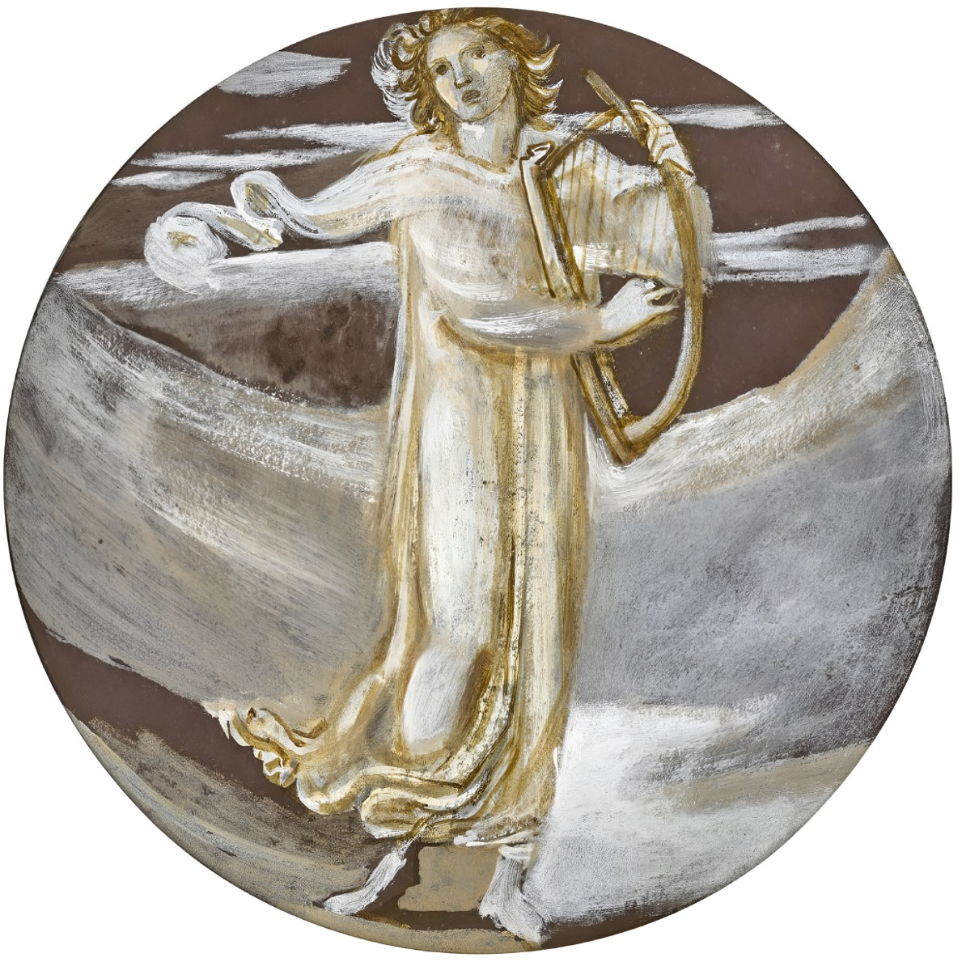

‘Orpheus and his Lute’
Sir Edward Coley Burne-Jones (English, 1833 – 1898)
Artvee
That all that were in the palace near
Gathered to him so they might hear,
And sat them down about his feet,
Thinking that melody so sweet.
The king hearkened and sat full still,
The notes he heard stirred his goodwill.
Great pleasure of that music had he,
As did the queen, both he and she.
When Orfeo had ceased his harping,
He was addressed thus by the king:
‘Minstrel, I like thy minstrelsy,
Now ask reward, whate’er it might be,
Generously, will I repay,
So, speak now, and win it you may.’

And Asks for His Wife as His Reward

‘Sire,’ he said, ‘then, I beseech thee,
Give but this single thing to me,
That lady, who is so fair to see,
Who sleeps beneath the grafted tree.’
‘Nay’ cried the king, ‘twill never take,
A sorry couple you two would make,
For you are lean, and coarse, and black,
While she is lovely, and naught doth lack;
And a loathsome thing that would be
To see you in her company.’
‘O sire,’ he answered, ‘gentle king,
Yet would it prove a fouler thing,
If from your lips did spring a lie,
For, sire, you said that aught that I
Might ask I should have and, of old,
A true king to his word must hold.’
The king replied: ‘Since that is so,
Then take her by the hand and go.
With her, I wish you may be happy.’
Orfeo knelt, and thanked him, swiftly.

They Return to Winchester

Then his wife he took by the hand
And they went quickly from that land,
Passing forth from out that same,
By the path on which they came.

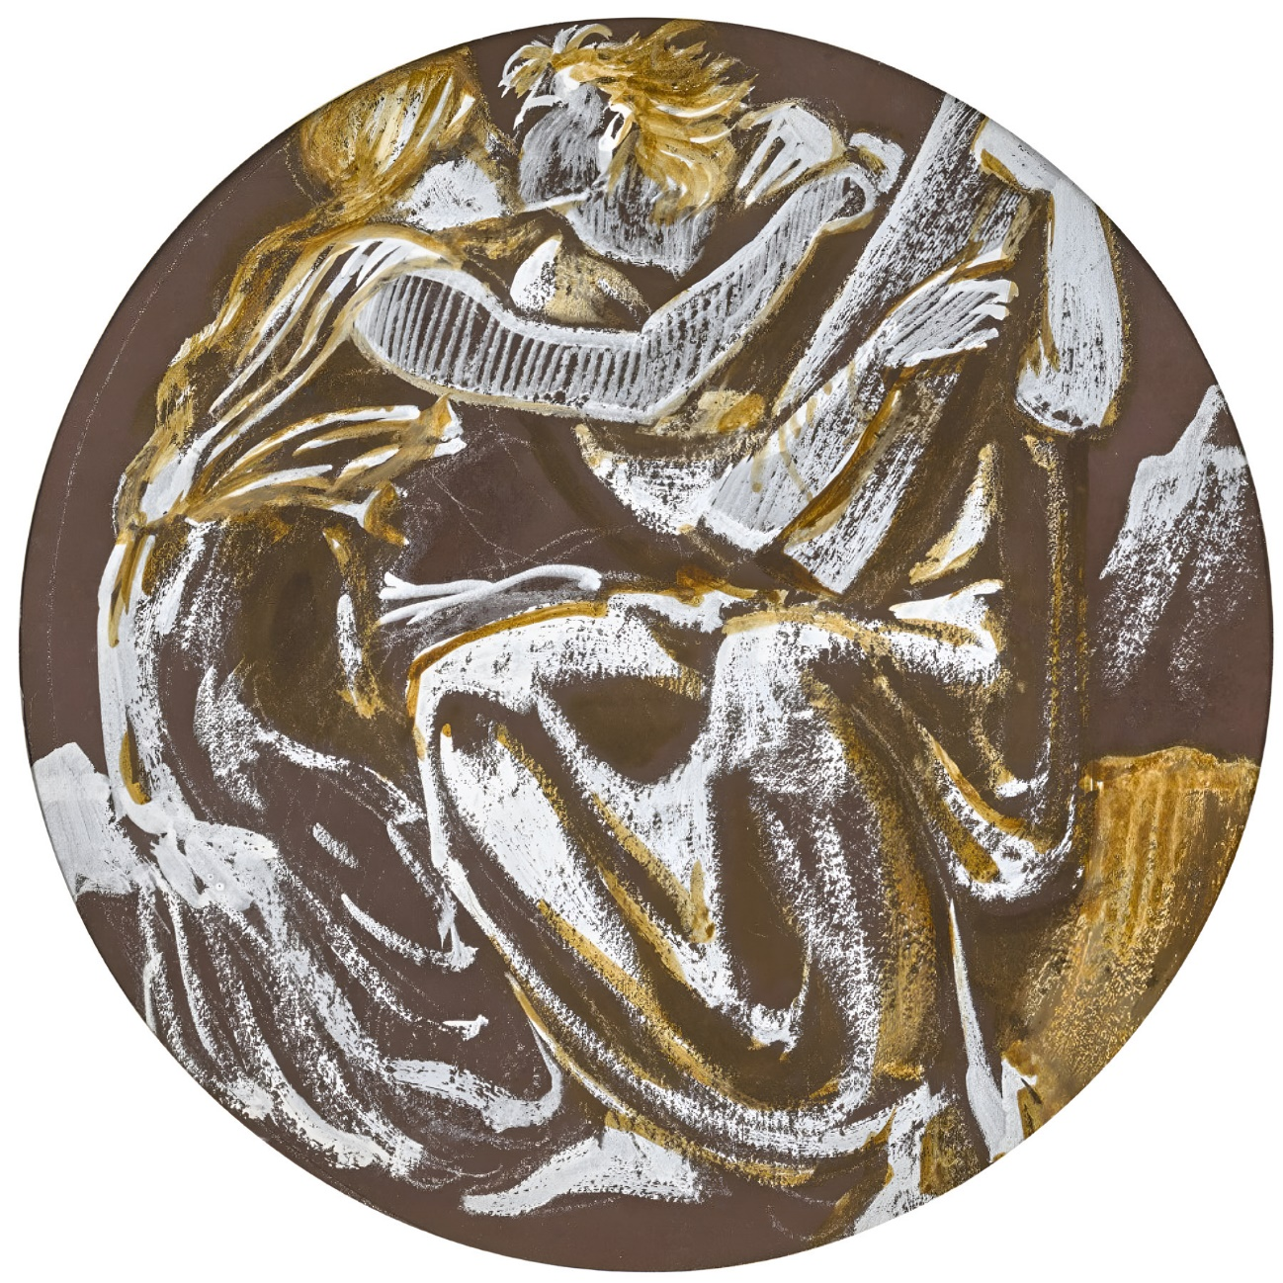

‘Orpheus and Eurydice Reunited’
Sir Edward Coley Burne-Jones (English, 1833 – 1898
Artvee
Long the journey, yet, once passed,
To Winchester they came at last,
That was, in truth, his own city,
Yet no man knew that it was he.
No further than the township’s end
Lest he be known, dared he wend,
But in a beggar’s narrow lodging,
He found a place, apt for resting,
For himself, and for his wife,
Fit for a minstrel’s humble life,
And asked the tidings in that land,
And who had the kingdom in hand.
The poor beggar, whose hut it was,
Told him all that had come to pass,
How their queen was stolen away,
Ten years past, by faery, one day,
How their king had to exile fled,
But none knew where he laid his head;
How the steward his land did hold,
And many another thing he told.

He Enters the City in Minstrel Guise

On the morrow, toward noontide,
He told his lady there to abide,
And dressed as if for minstrelsy,
His harp on his back for all to see,
Into Winchester, thus, he went;
That men beheld him, his intent.
Earls and Barons, brave and bold,
Burgesses, ladies, did him behold:
‘Lo, such a man, and in our town!
For see how his hair hangs down!
Look how his beard hangs to his knee!
He’s as gnarled as an old oak tree!’
And as he passed along the street,
His own steward he there did meet,
And, loudly, he gave forth a cry:
‘Sir Steward, mercy on such as I.
I am a harper from heathen land,
Aid me; in much distress I stand.’
The steward said: Come, then, with me,
Of all that I have, some shall you see.
Every good harper I welcome so,
For love of my lord, Sir Orfeo.’

The Steward Invites Him to the Castle

In the castle the steward sat to eat,
Many a lording beside his seat,
There were trumpeters, drummers too,
Of harpists, string-players, not a few,
And much melody made they all,
While Orfeo sat still in the hall,
And listened, and when they were still,
His harp he tempered to his will,
The loveliest notes sounding, clear,
To which ever a man gave ear.
Every man liked his minstrelsy.
The steward gazed at him carefully,
Both the man and the harp he eyed.
‘Minstrel, may you thrive’, he cried,
‘Whence had you this harp and how?
I pray of you, come tell me now.’
‘Lord,’ said he, ‘in a land unknown
I roamed the wilderness, alone,
And there, in a dale, a man I found,
All torn by lions, upon the ground,
Bitten by wolves, their teeth full sharp,
And beside him I found this harp;
And this was a good ten years ago.
‘Oh!’ cried the steward, ‘Here is woe,
For that was my lord, Sir Orfeo,
Wretched I am, to what must I go,
That such a lord I now must mourn?
O woe, that I was ever born!
That he should meet so harsh a fate;
So vile a death o’er-take him straight!’
In a swoon, he fell to the floor,
But his barons raised him once more,
All saying to him, with one breath,
‘There is no remedy for death!’

The Minstrel is Found to be Sir Orfeo

By this, King Orfeo well knew
His steward was his man, and true,
And that he loved him as he ought,
And so, he rose, amidst the Court.
‘Lo, steward,’ he said, ‘hear a thing:
If I were Orfeo the king,
And I had suffered, long ago,
In the wilds, full many a woe,
And had won my queen away,
Out of the land of faerie, say,
And did with that fair lady wend
My way here to the town’s end,
And with a beggar did her place,
And myself came hither apace,
In poverty’s guise attired still,
So as to witness your good will,
And I found you thus, full true,
Then this hour you ne’er would rue.
Surely, for love and all, I say,
You would be king, after my day,
But if at the news I was dead
You had rejoiced, exiled instead.’
Then all that were there, did know
That this, in truth, was King Orfeo,
For the steward recognised his lord,
And, rising, overturned the board,
And knelt down at his master’s feet,
As did all there, their lord to greet.
From them, as one, the cry did ring:
‘You are our lord, sire, and our king!’
That he yet lived all were happy.
They to his room led him, swiftly,
And bathed him, and shaved his beard.
Dressed as a king, he thus appeared,
And in procession then, they brought
The queen to the town, and the Court,
With all manner of minstrelsy;
Lord! Loud indeed the melody!
Tears of joy from all eyes did flow,
That both had returned, safely, so.
King Orfeo was crowned anew,
And his queen, Dame Heurodis too.
Thus, they reigned, for many a year,
And then the steward was king here.
Later, harpers in Brittany heard
The wondrous tale, every word,
And made a lay that joy did bring,
And named that lay after the king.
‘Orfeo’ tis called; in every throat,
Good is the lay, and sweet the note.
Thus came Orfeo out of his woe,
God grant us all to fare well so!
Amen!

The End of ‘Sir Orfeo’

