Heinrich Heine

The Harz Journey (Die Harzreise, 1824)

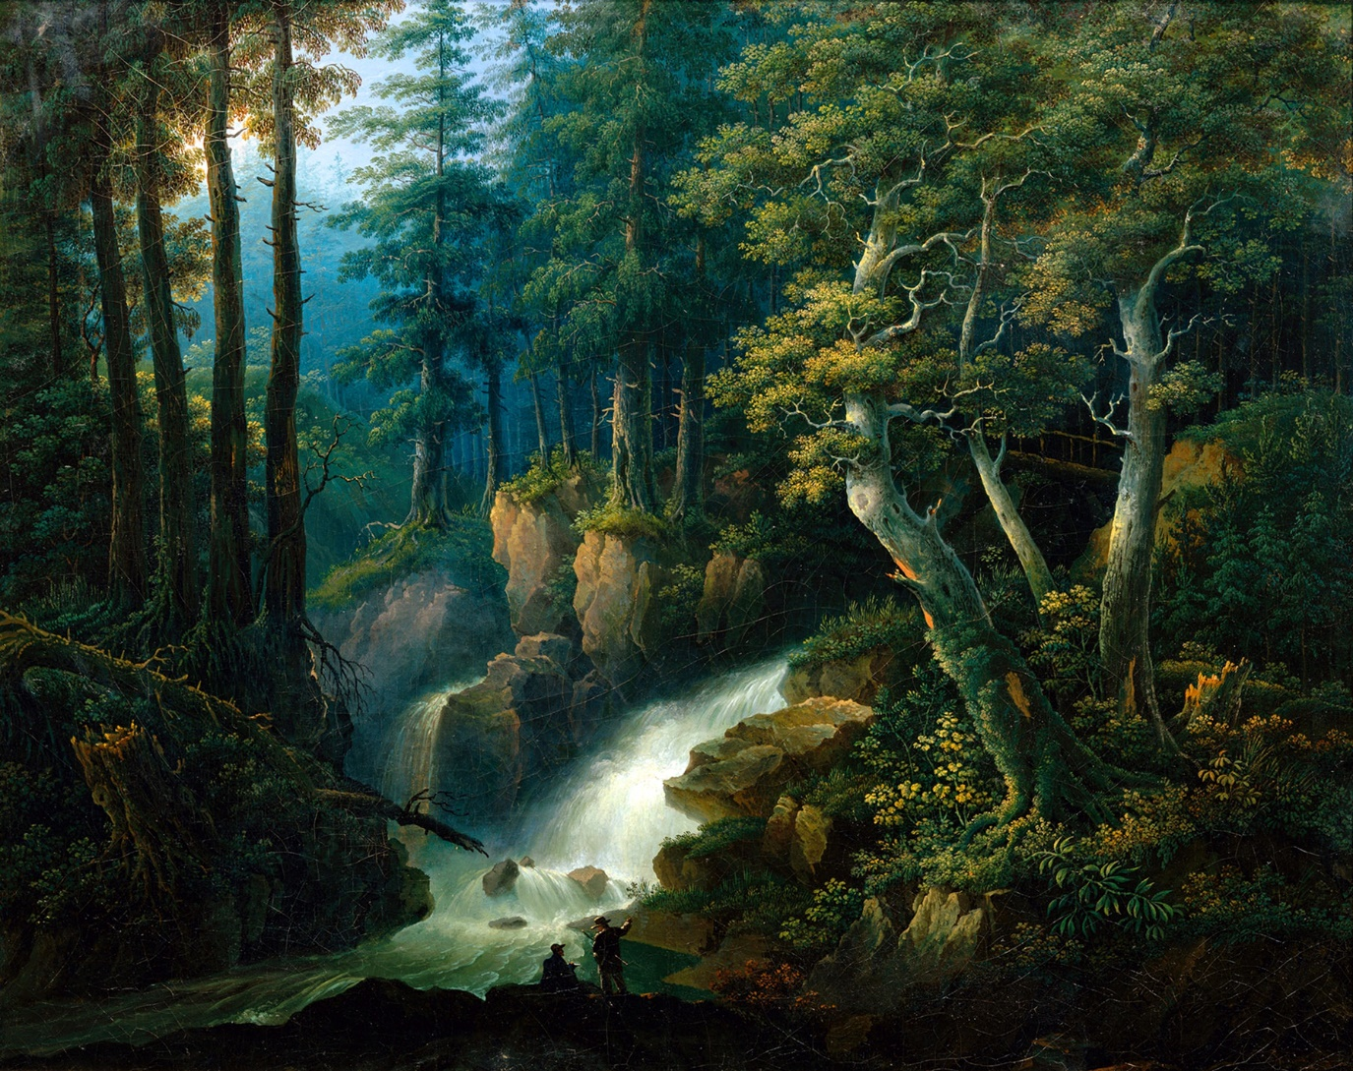
‘The Ilse Waterfall on the Brocken in the Harz Mountains (1830)’ Hermann Josef Neefe (German, 1790-1854)
Artvee

Part I
Part II
Part III
Part IV

Translated by A. S. Kline © Copyright 2026, All Rights Reserved.
This work may be freely reproduced, stored and transmitted, electronically or otherwise, for any non-commercial purpose. Conditions and Exceptions apply.

The Harz Journey (Die Harzreise, 1824): Part I

Contents

Translator’s Introduction.
I: Göttingen.
II. The Weender Gate, Near Rauschenwasser, Nörten.
III. Northeim.
IV: Osterode am Harz.
V: Lerbach, and Clausthal (Clausthal-Zellerfeld).

Translator’s Introduction
Christian Johann Heinrich Heine; born Harry Heine (1797 –1856) was a leading poet, author, and literary critic, of the German Romantic Movement. Known for his early lyric poems, frequently set to music in the form of Lieder by composers such as Schumann and Schubert, his later verse and prose (for example ‘Die Wintermärchen’ based on his brief visit to Germany in 1843) were notable for their satirical wit and irony. Heine emigrated to France, in 1831, due to the political conditions in Germany during the post-Napoleonic German Restoration period. In 1835, his works were banned with those of the other poets of ‘Young Germany’, and he spent the last twenty-five years of his life in Paris.
Heine, when a student in Göttingen, hiked through the Harz Mountains, in the autumn of 1824. ‘Die Harzreise’ his description of the journey, a mixture of lyricism and satire, was published in 1826, as part of a four-volume edition entitled Reisebilder, by Hoffmann & Campe, in Hamburg. It was Heine’s first major success with the public, and remains one of his most popular works.
Heine's route ran from Göttingen, through the Weender Gate, and across the Harz foreland to the Brocken, from which he descended the Ilse valley to Ilsenburg. Along the way he visited Nörten, Northeim, Osterode (with an overnight stay), the Osterode castle ruins, Lerbach, Clausthal (including a visit to the Dorothea and Karolina mines), and Zellerfeld (with an overnight stay at the Krone inn — note that Clausthal and Zellerfeld are now combined as Clausthal-Zellerfeld). He then continued to Goslar (an overnight stay), followed by a view of the Rammelsberg near the Harzburg, an overnight stay at the home of the Clausthal miner's brother near Goslar (the subject of a three-part poem), the Brocken (with an overnight stay in the Brockenhaus), and finally the Ilsenstein, passed during his descent of the Ilse valley to Ilsenburg.
There is now an established hiking trail, the Heinrich Heine Trail (Heinrich-Heine-Weg), which follows a section of the route of his 1824 journey, the descent from the Brocken towards Ilsenburg.
Alternatively, you may view a map of all locations detailed in the text, provided by uMap.
This enhanced edition has been designed to offer maximum compatibility with current search engines. Among other modifications, the proper names of people and places, and the titles given to works of art, have been fully researched, modernised, and expanded; comments in parentheses have been added here and there to provide a reference, or clarify meaning; and minor typographic or factual errors, for example incorrect attributions and dates, in the original text, have been eliminated from this new translation.

I: Göttingen
Black dresses, silk stockings,
Decorous white sleeves,
Soft lips, and embraces –
Are what the eye perceives.

Oh, if only they had hearts!
And those hearts were loving too –
Oh, I’ll die of their singing
Songs of love, and yet untrue.

I’ll climb the mountain heights,
Where honest cabins stand,
Where the lungs breathe freely,
Free, the air on either hand.

I’ll climb the mountain heights,
Where the dark fir-trees rise;
Streams flowing, birds calling,
High clouds sailing through the skies.

Farewell, you glittering halls, and men,
And women so beguiling!
I’ll climb the mountain heights,
Gazing down on you, and smiling.

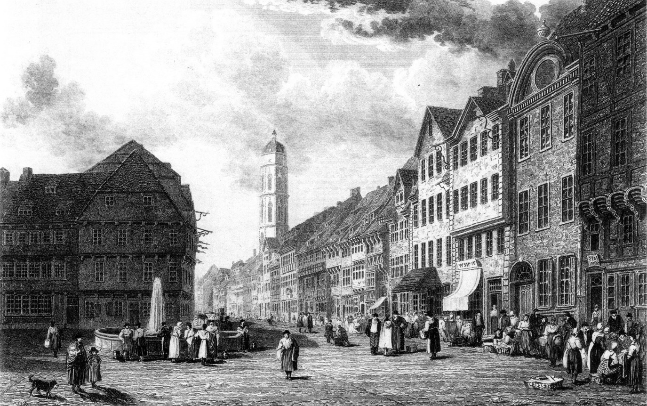
‘Goettingen Market, towards Weender Straße’ Captain Robert Batty, 1828
Artvee

The city of Göttingen, famous for its sausages, and its university, belongs to the King of Hanover, and contains nine hundred and ninety-nine hearths, sundry churches, a maternity hospital, an observatory, a prison, a library, and a Ratskeller where the beer is excellent. The river flowing by is called the Leine, and people bathe there in the summer; the water is very cold, and in some places so wide that Wilhelm Lüder (a student noted for his physical strength and agility) actually had to run at it in order to leap across. The city itself is beautiful, and is best viewed with one’s back to it. It must have been there for many a year, because I remember that when I matriculated there five years ago and, not long after, was advised to leave, it already had the same grey, aged appearance and was already completely furnished with college guards, beadles, dissertations, thé dansants (tea rooms with dance floors), washerwomen, compendiums, roast pigeons, Guelph Order medals, promotional carriages (used by doctoral students to make official visits to professors after matriculation), pipe-bowls, court-councillors, judicial councillors, disciplinary councillors, professors and confessors. Some even claim that the city was built during the Barbarian Invasions, and that every German tribe had left behind a raw proof of their existence, and thence came all the Vandals, Frisians, Swabians, Teutons, Saxons, Thuringians, etc., who even today, in Göttingen, march in hordes, each distinguished by the colour of their caps and the tassels on their pipes, along Weender Strasse; are forever fighting each other on the blood-stained duelling-grounds of Rasenmühle, Ritschenkrug, and Bovden; and, as regards customs and manners, still live as they did during the Migration Period, governed partly by their Duces (leaders) who are called ‘Chief Cocks’, and partly by their ancient code of law, which is called the ‘Comment’ and deserves a place in the leges barbarorum.
In general, the inhabitants of Göttingen are divided into students, professors, philistines, and cattle, these four classes being by no means wholly distinct. The class of cattle is the most significant. To list the names of all the students and all the regular and irregular professors here, would be too lengthy; moreover, I cannot recall all the students’ names at this moment, and among the professors there are some who as yet have no name at all. The number of Göttingen’s philistines must be as large as that of the particles of sand, or rather mud, in the sea. Truly, when I saw them of a morning, with their dirty faces and white ‘reckonings’, lined up before the gates of the Academic Court, I could barely comprehend how God could have created so many rascals.
More detailed information about the city of Göttingen can be easily found in Karl Friedrich Heinrich Marx’s topography (‘Göttingen from a medical, physical, and historical perspective’, 1824). Although I feel the most sacred obligation towards the author, who was my physician and showed me much affection, I cannot recommend his work unconditionally, and must criticise him for not contradicting, most vigorously, the false opinion he held that the women of Göttingen have excessively large feet. Indeed, I have occupied myself for years with a serious refutation of that opinion. I have, with that aim, studied comparative anatomy, extracted information from the rarest works in the library, and studied the feet of passing ladies for hours on Weender Strasse. In the fundamentally scholarly treatise that will contain the results of these studies, I speak firstly, of feet in general; secondly, about the feet of the ancients; thirdly, about elephants’ feet; fourthly, about the feet of the women of Göttingen; fifthly, I compile everything that has already been spoken with regard to these feet in Ulrich’s Beer-Garden (frequented by the students of Göttingen, and sited opposite the Albaner Tor, or Alban Gate, not extant), sixthly, I examine the feet, in context, and on this occasion also discuss calves, knees, etc., and finally, if I can find sheets of paper large enough, I will add some copperplate facsimiles of the feet of the women of Göttingen.

II. The Weender Gate, Near Rauschenwasser, Nörten
It was very early as yet when I left Göttingen, and the learned *** was certainly still in bed, dreaming as usual that he was wandering in a lovely garden, in whose flower-beds grew nothing but pieces of white paper covered with citations, which shone sweetly in the sunlight, and of which he plucked several here and there, laboriously transplanting them into fresh beds, while the nightingales, in their sweetest tones gladdened his old heart.
In front of the Weender Gate, I met two little local schoolboys, one of whom said to the other: ‘I prefer not to associate with Theodore anymore. He’s a scoundrel. Yesterday he couldn’t even recall the genitive form of mensa.’ As insignificant as the words sound, I am obliged to repeat them; indeed, I would like to have them inscribed above that gate as the town motto; for the young pipe as the old sing, and those words perfectly express the narrow-minded, dry, pedantic pride of the highly-learned Georgia Augusta (the Georg-August University).
Once on the road, in the fresh morning air, with the birds singing joyfully, I, too, gradually felt refreshed and joyous again. It was much needed. I had not had a break from my law-books recently; Roman casuists had wrapped my soul in grey cobwebs, my heart felt trapped amidst the iron clauses of individual legal systems; the constant echoes of ‘Tribonian, Justinian, Hermogenian, and Dumbedian’ still rang in my ears, and I even mistook a tender pair of lovers seated beneath a tree, their hands clasped, for an edition of ‘Corpus Juris Civilis’ (the Justinian Code of Laws). On the road to the country, things were already coming to life. Milkmaids passed by; also, donkey-drivers with their tawny charges. Beyond Weende, I met ‘the Shepherd’ (P.H Schäfer the head beadle) and ‘Doris’ (C.C. Dohrs, his junior). Not the idyllic couple of whom the poet Salomon Gessner sings, but a pair of rather well-paid university beadles whose vigilance ensures that students refrain from fighting duels in Bovden, and that new ideas, which must remain in quarantine for several decades before being admitted to Göttingen, are not smuggled in by some speculative itinerant lecturer. ‘The Shepherd’ greeted me in a very collegiate manner; for he, too, is a penman and has often mentioned me in his six-monthly reports; just as he has often summoned me before the University Court, and, not finding me at home, has always been so kind as to write the citation in chalk on my door. Now and then, a horse-drawn carriage rolled by, packed with students departing for the holidays, or forever. In a university town like Göttingen, there is constant to-ing and fro-ing; every three years, sees a new generation of students. It is a perpetual flow of people, where each semester, like an ocean-wave, sweeps away its predecessor, and only the old professors remain upright amidst the universal tide, unshakably firm, like the pyramids of Egypt — except that no legendary wisdom is buried in those pyramids of the university.
I saw two hopeful young men ride forth from a ‘myrtle grove’ near Rauschenwasser. A woman who plied her trade in the horizontal position, escorted them to the road, tapped the horses’ stringy legs with a practiced hand, and laughed aloud when one of the riders, with a spontaneous show of gallantry, delivered a few flicks of his whip to her behind. She then made her way toward Bovden. The young men, however, raced toward Nörten, hooting at their own wit, and singing à la Rossini: ‘Drink beer, dear Lise, dear!’ I heard their distant cries for a long time; but soon lost sight of the charming singers themselves, as they spurred and whipped on their horses, which seemed to possess the basic sober Germanic temperament, with dreadful force. Nowhere is the abuse of horses more prevalent than in Göttingen, and more than once, on seeing a lame, sweating beast tormented, by such folk as my knights of Rauschenwasser, merely to earn a little fodder, even having to pull an entire wagonload of students, I thought, ‘Ah, poor creature, your ancestors must surely have sinned, by eating forbidden oats in paradise!’
I met the two young men again, at the inn in Nörten. One was eating herring, with salad, and the other was chatting to the leathery, yellow-skinned maid, Fusia Canina (the ‘Lex Fufia Caninia’ regulated the freeing of slaves in testamentary wills), also known as the’ Kicking Bird’. He paid her a few polite compliments, and eventually they were hand in glove. To lighten my pack, I removed a pair of blue trousers, most interesting from a purely historical perspective, and gave them to the little waiter, whom they call the ‘Hummingbird’. Meanwhile, Bussenia, the old landlady, brought me a sandwich, and lamented over how rarely I visited these days, as she was very fond of me.

III. Northeim
Beyond Nörten, the sun was high in the sky. It was an honest sun, and warmed my brain, such that all the immature thoughts therein ripened fully. The beloved ‘Sun Inn’, at Northeim, is not to be despised; I stopped there and found lunch already prepared. All the dishes seemed appetising, and were more appealing to me than the tasteless university food, the saltless leathery cod, and tired cabbage, served in Göttingen. After I had eased my hunger somewhat, I noticed, in the same room of the inn, a gentleman and two ladies who were about to depart. The gentleman was dressed entirely in green, he even wore green spectacles that cast a verdigris-like gleam on his coopery-red nose, and possessed the appearance King Nebuchadnezzar may have owned to in his later years, when, according to legend, he ate nothing but grass, like a wild creature. The man in green asked me to recommend a hotel in Göttingen, and I advised him to seek directions to Brühbach’s Hotel (the beadle Brühbach ran the students’ gaol) from the first student he came across about. One of the two ladies was his wife, a very tall, expansive lady, with a red face a square mile in extent, with dimples in her cheeks that looked like spittoons for cupids, a long, drooping chin that seemed an imperfect continuation of her face, and a bosom piled high, surrounded by stiff lace and multi-pronged scalloped collars, as if by turrets and bastions, and resembling a fortress that would certainly be just as unable to withstand a donkey laden with gold as those other fortresses of which Philip of Macedon spoke (‘No fortress is impregnable so long as a donkey laden with gold can reach its gate’, cited by Cicero). The other lady, her sister, was her complete opposite. While the former descended from Pharaoh’s fat cows, the latter derived from the lean. Her face was nothing but a mouth between two ears, her chest as hopelessly desolate as the Lüneburg Heath; her whole dried-up figure resembling a charity table for impoverished theology students. Both ladies asked me simultaneously whether respectable people stayed at Brühbach’s Hotel. I answered in the affirmative, with a clear conscience, and as the charming trio drove away, I waved farewell repeatedly from the window. The innkeeper smiled slyly, no doubt knowing that the Göttingen students had so-named the students’ gaol.

IV: Osterode am Harz
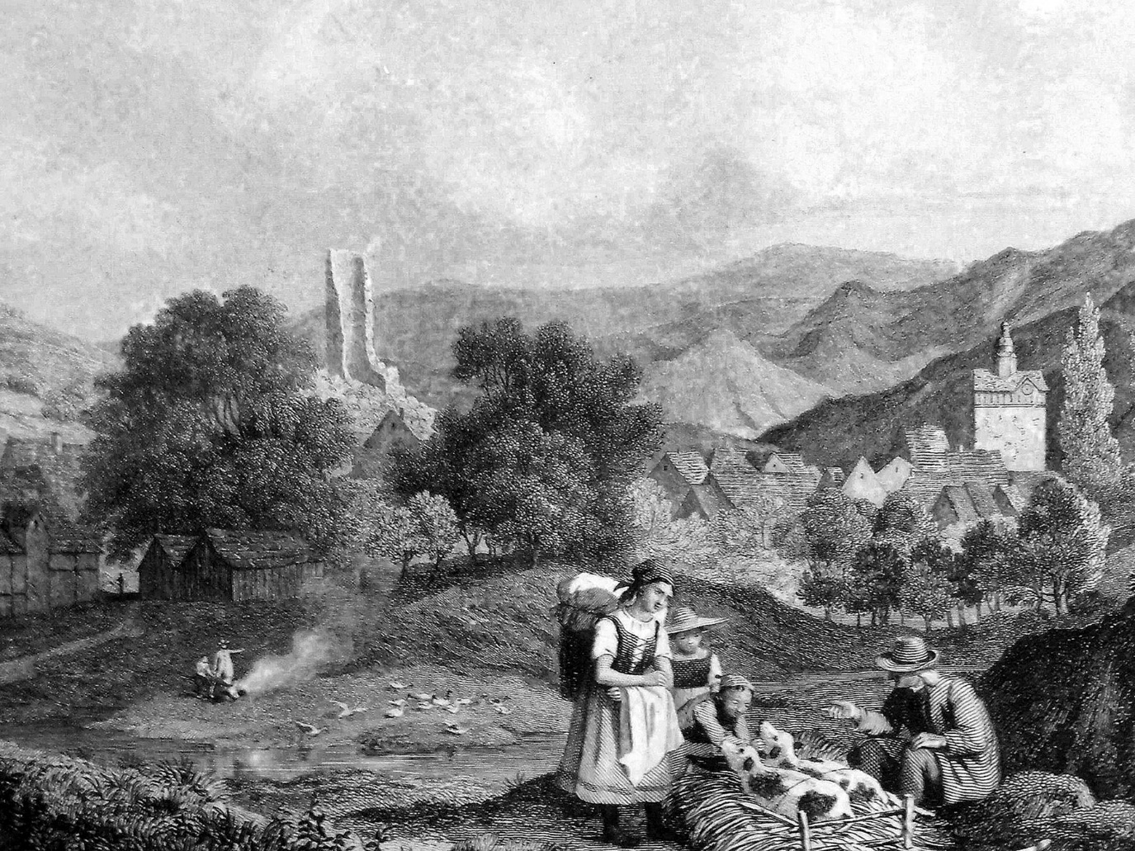
‘Osterode on the Harz’ Ludwig Richter (1838)
Picryl

Beyond Nordheim, the terrain becomes mountainous, with beautiful hilltops emerging here and there. Along the way, I mostly met shopkeepers heading for the Brunswick Fair, also a group of women, each carrying on her back a large, container almost the size of a house, and covered with white linen. Within them, there perched various species of captive songbirds, twittering and chirping incessantly, while the women hopped about and chattered merrily. A foolish thought came to me that one set of birds was carrying another to market.
I arrived in Osterode in pitch-darkness. I had no appetite for dinner, and went straight to bed. I was dog-tired and slept like a god. In dream, I returned to Göttingen, specifically to the library there. I stood in a corner of the Hall of Jurisprudence, rummaging through old dissertations, engrossed in my reading, and when I stopped, I noticed to my amazement that it was night, and crystal chandeliers lit the hall. The bell of the nearby church had just struck twelve, the hall door slowly opened, and in stepped a gigantic and superb female, escorted reverently by the members and adherents of the law faculty. The giantess, though already elderly, nevertheless bore a face whose features displayed a severe kind of beauty; every glance she gave betrayed the Titaness, the mighty Themis, whose sword and scales she held carelessly in one hand, while grasping, in the other, a roll of parchment; two young Doctores Juris carried the train of her faded grey robe; on her right, the lean Court Counsellor ‘Rusticus’ (the professor of criminal law Anton Bauer), the Lycurgus of Hanover, swayed windily back and forth, declaiming from his latest legal draft; on her left side her Cavaliere Servente, the Privy Counsellor ‘Cujacius’ (the jurist Gustav Hugo), hobbled along, gallantly and cheerfully, constantly cracking legal jokes, and laughing so heartily about them that even the severe goddess bent down to him several times, smiling, patted him on the shoulder with her large roll of parchment, and whispered in a friendly voice: ‘Careless little rascal, pruning the tree from the top down!’ (The reference is to a passage in the Corpus Juris Civilis, the subject of controversy at the time)
Each of the other gentlemen now also approached, each offering something to remark and smile about, some newly-concocted little system, or hypothesis, or a like aberration of their own petty minds. Through the open hall door, several other strange gentlemen entered, proclaiming themselves to be the rest of the great members of the illustrious order, mostly angular, furtive fellows, who immediately started on their definitions and distinctions, with extreme self-satisfaction, disputing every little tittle of some pandect or other. And new figures kept appearing, old scholars of the law, in outdated costumes, with long white wigs, their faces long-forgotten, who expressed great astonishment that they, the famous names of the past century, were not especially feted. They now joined, in their own way, in the general chatter, the trilling and screeching, which, like the ocean’s surf, roared about the high goddess ever more confusedly and ever louder, till she lost patience and, in a tone expressing the most vast and dreadful anguish, cried out, suddenly: ‘Silence! Silence! I hear the voice of my beloved, innocent Prometheus, whom the power of mockery and inarticulate violence, has chained to the rock of torment, while all your disputatious chatter cannot ease his wounds or break his bonds!’ So, cried the goddess, and streams of tears poured from her eyes; the entire assembly howled as if seized by mortal fear; the ceiling of the hall creaked; the books tumbled from their shelves; in vain, did old Münchhausen (Gerlach Adolf, Baron von Münchhausen the first curator of the University, whose picture hung in the hall) step from his frame to command silence, the rage and shrieking grew ever wilder, as, fleeing from the oppressive noise of that madhouse, I escaped into the Hall of History, that place of grace where the sacred images of the Belvedere Apollo and the Venus de Medici stand side by side, and fell at the feet of the goddess of Beauty, in sight of whom I forgot all those wild goings-on from which I had escaped, while my eyes absorbed, in rapture, the symmetry, and eternal loveliness, of her most blessed body. A Hellenic peace passed through my soul, as above my head, like a heavenly blessing, Phoebus Apollo poured out the sweetest melodies of his lyre.
When I awoke, I could still hear a friendly ringing sound. The herds were going forth to pasture, and it was the tinkling of their bells I heard. A lovely, golden sun shone through the window, lighting the paintings on the walls of my room. There were pictures from the Wars of Liberation (against Napoleon, 1813-1815), faithfully depicting us as heroes, as well as scenes from the French Revolution showing Louis XVI on the guillotine, and other like beheadings that one never gazes on without thanking God that one is lying peacefully in bed, drinking excellent coffee, with one’s head still sitting comfortably on one’s shoulders. Also hanging on the wall were Abelard and Héloise, and various examples of French youth, namely some vacant girls’ faces, beneath which were calligraphically inscribed: la prudence, la timidité, la pitié etc. and finally a Madonna so beautiful, so charming, so devotedly pious, that I wished to seek out the original model, wo had sat for the painter, so as to make her my wife. Of course, as soon as I had married that Madonna, I would have asked her to give up all further communication with the Holy Spirit, as I would not wish to have my head adorned with a halo, or any other decoration through my wife's intervention.
After drinking coffee, getting dressed, reading the inscriptions on the window panes, and setting things straight at the inn, I left Osterode.
The town has a specific number of houses, and a quantity of diverse inhabitants, among whom are several worthy souls, as can be read in more detail in Kaspar Friedrich Gottschalck’s ‘Handbook for Travelers in the Harz Mountains’ (‘Taschenbuch für Reisende in den Harz’, 1806). Before I took to the road, I climbed the ruins of ancient Osterode Castle. These consist of half of a large, solidly-walled tower, seemingly eaten away by disease. The path to Clausthal led me uphill again, and from one of the lower hills, I looked down once more into the valley, where Osterode, with its red roofs, peeks out from the green fir forests like a moss-rose. The sun cast a very sweet, innocently childlike light. From the intact half of the tower, one can see the ruins of the impressive rear.

V: Lerbach, and Clausthal (Clausthal-Zellerfeld)
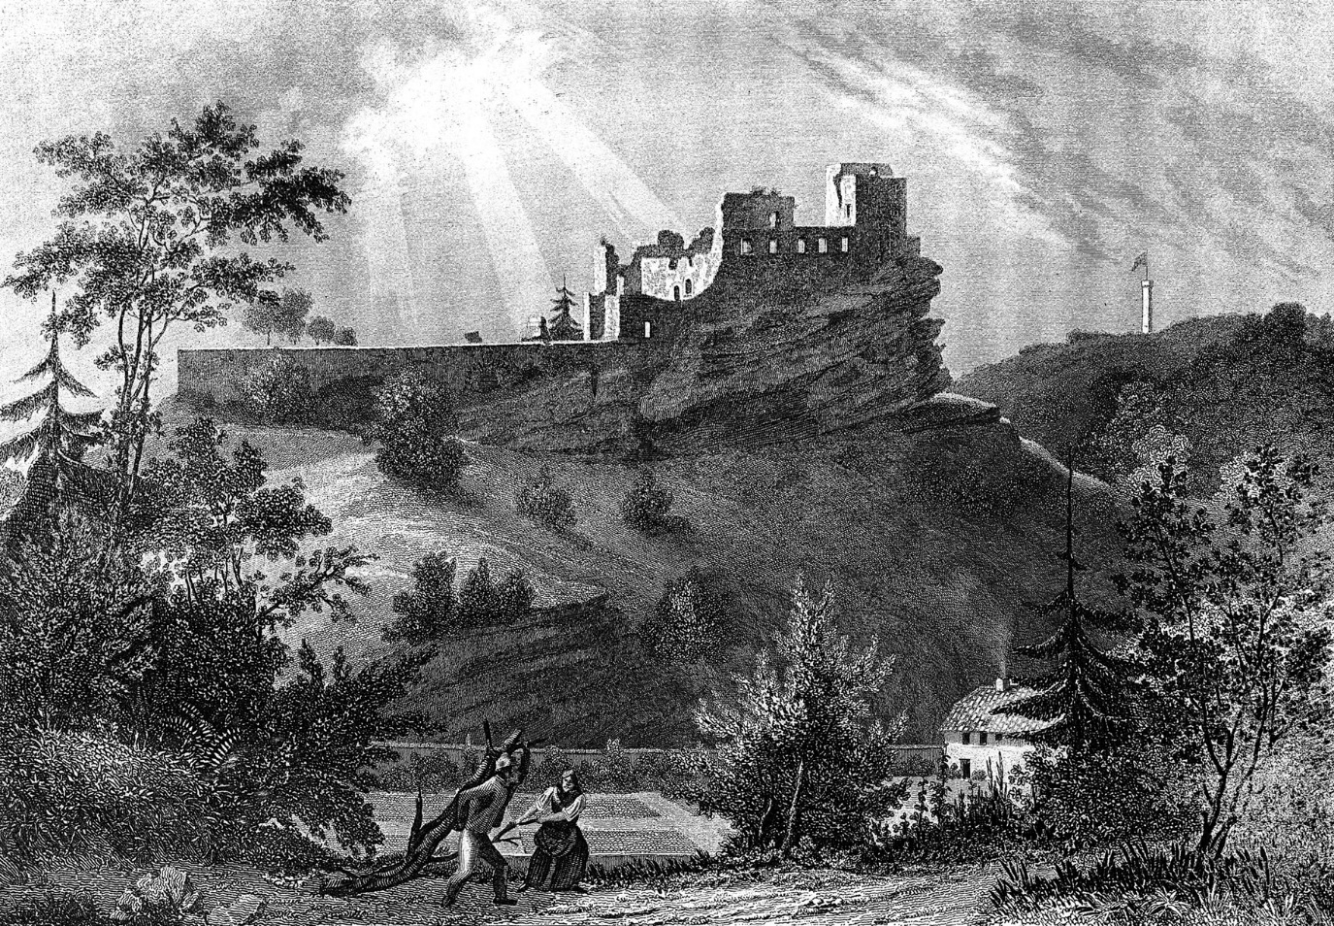
‘Hardenberg ruins near Nörten’ Friedrich Adolf Hornemann (1813–1890)
Artvee

There are many other ruined castles in the area. The Hardenberg near Nörten is the most beautiful. Even if one’s heart, as befits it, is on the left-hand side, the liberal side, of one’s body, one cannot resist all feelings of elegiac sentiment at the sight of the rock-bound nests of those privileged birds of prey, who pass to their feeble offspring only their violent appetites. And so, it was with me that morning. The greater my distance from Göttingen, the more my spirits gradually rose; as ever, I felt the Romantic impulse, and, as I wandered, I composed the following song:

Rise, my dreams, as of old!
Open wide, gates of the heart!
Joyous song, melancholy tears,
Flow forth, in wondrous art!

I shall wander midst the fir-trees,
Where the lively torrent springs,
Where the proud deer amble,
And the lovely song-thrush sings.

I will climb the mountain heights,
On some rugged peak alight,
Where the grey castle ruins
Stand, pale in the morning light.

There I shall seat myself,
Recalling olden days,
The generations flowering.
The lost glory of their ways.

Grass hides the field of tourney,
Where many a proud man fought,
Who overcame the best,
And won the prize at court.

Ivy climbs the balcony,
Where the noble lady stood,
Who overcame the conqueror,
With her eyes alone, for good.

Oh, the victor, the defeated
Death slew both, with his hand –
The lean knight’s gleaming scythe,
Stretches all upon the sand.

After walking for a while, I met a travelling tradesman, who had journeyed from Braunschweig and told me of a rumour there, that the young duke (Charles II of Brunswick and Lüneburg, who travelled to England, Switzerland, and Vienna in 1823) had been captured by the Turks on his way to the ‘Promised Land’, and could only be released in exchange for a mighty ransom. The duke’s extensive journey may have given rise to this legend. The people still preserve that traditional fable-loving mode of thought so sweetly expressed in their epic poem ‘Duke Ernst.’ (Ernst II of Swabia provided the material for this well-known Middle High German epic, and for many associated legends and dramatic pieces). The bearer of this news was a tailor’s apprentice, a neat little youth, so thin that the stars could have shone through him, as they did through Ossian’s misty spirits. Altogether, he was a folksy, if baroque, mixture of whimsy and melancholy, which was evidenced, in particular, by the droll and touching manner in which he sang that delightful folk song: ‘A beetle sat on the fence, buzz, buzz!’ That’s the thing about us Germans: none of us is so crazy that they can’t find someone even crazier who comprehends them. Only a German can empathise with that song, and laugh and cry themselves to death in the process. Here, too, I noticed how deeply Goethe’s poetry has penetrated the lives of the people. My lean companion also trilled to himself, occasionally: ‘Sorrowful or joyful, thoughts are free!’ (‘Leidvoll und freudvoll, gedanken sind frei!’ a corrupt version of Klärchen’s song from the third act of Goethe’s ‘Egmont’ beginning ‘Freudvoll und leidvoll, gedankenvoll sein’) Such mutilation of a text is common among the people. He also sang a song in which ‘Lotte mourns by the grave of her Werther.’ (Referencing Goethe’s ‘The Sorrows of Young Werther’) The tailor melted with sentimentality at the words: ‘I’m lonely by the rose-covered dell, where late the moon oft overheard us! Mourning, I wander by the silver spring that sped towards us and brought sweet bliss.’ (A slightly altered extract from the poem ‘Lotte at Werther’s Grave’, by Carl Ernst von Reitzenstein, 1775) But shortly afterward, he said, mischievously: ‘There’s a Prussian in the inn at Kassel who writes just such songs himself; he can’t sew a single stitch; if there’s a groschen in his pocket, he’s chasing two groschen, and when he’s drunk, he thinks the sky’s a blue camisole, weeps like the gutter on the roof, and sings a song with double-poetry!’ I desired an explanation of this last expression, but my little tailor, his legs thin as walking-sticks, hopped back and forth, constantly crying: ‘Double poetry is double poetry!’ Finally, I grasped that he had alternately rhymed poems, especially quatrains, in mind. Meanwhile, due to his excitement, and the adverse wind, this ‘knight of the needle’ had become extremely tired. He certainly made mighty preparations to advance, boasting: ‘Now I’m going to get the road beneath me!’ But soon he complained that he had blisters on his foot-soles and that the world was too spacious by far; and finally, he sank down, gently, near a tree trunk, moving his delicately-wrought little head like a sad lamb’s tail, and with a wistful smile, he cried: ‘Here I am, a poor little rascal, broken in two again!’
The slopes became even steeper here, the pine forests undulated below like a sea of green, while white clouds sailed through the blue sky above. The wildness of the region was, as it were, tamed by its unified nature, and its simplicity. Like a true poet, nature dislikes abrupt transitions. Clouds, however bizarrely-formed they sometimes appear, still possess a white, or at least muted, hue, corresponding harmoniously with the blue sky, and the green earth below, such that all the colours visible in a landscape melt into one another like tender music, and every natural view has a calming and soothing effect – the late Hoffmann would have ‘painted’ these clouds in variegated colours (referring to the landscape depictions of E. T. A. Hoffmann, who died in 1822). Like a great poet, Nature knows how to produce the greatest effects with the fewest means; with no more, in this case, than sun, trees, flowers, water, and her love. Of course, if love is lacking in the heart of the beholder, the whole may well appear an indifferent sight, in which the sun will merely be an object so many miles in diameter, the trees good for firewood, the flowers there to be classified according to their stamens, and the water decidedly wet.
A little lad, who was looking for brushwood in the forest on behalf of his uncle who was ill, showed me the village of Lerbach, whose little cabins with grey roofs stretched more than half an hour’s walking distance along the valley. ‘There,’ he said, ‘live idiots with goitre, and white Moors’— the latter being the name which the people endow upon albinos. The little fellow was in complete harmony with the trees; he greeted them like old acquaintances, and they seemed to return his greeting with a rustling sound. He whistled like a siskin, the other birds chirped a reply all around us and, before I knew it, he had bounded off, bare-footed, into the nearest thicket with his bundle of brushwood. Children, I thought, being younger than us, can still remember having been birds or trees, and are therefore still capable of understanding them; but we are too old, with too many worries and jumbled bits of jurisprudence, and far too many bad verses, in our heads. I recalled, quite vividly, the time when things were otherwise, on arriving in Clausthal. I reached this beautiful little mountain town, which you scarcely notice till you’re standing before it, just as the bell struck twelve and the children emerged, jubilantly, from school. Those delightful lads, almost all of them rosy-cheeked, blue-eyed, and flaxen-haired, leaping about and shouting, awakened in me the wistfully but happy memory of how, as a little boy in a dull-headed Catholic convent school in Düsseldorf, I was on one occasion not allowed to rise from my wooden bench all morning, and had to endure a great deal of Latin, blows from a cane, and much geography, and how I too, shouted and rejoiced, immoderately, when the old Franciscan bell finally rang twelve times. The children saw, on noticing my knapsack, that I was a stranger and greeted me very hospitably. One of the boys told me they had just received religious instruction, and showed me the Royal Hanoverian Catechism, from which text they were questioned about Christianity. This little book was very poorly printed, and I fear that the doctrines of the faith must have, instantly, made an unpleasant, blotting-paper impression on the children’s minds. I also found it terribly displeasing that the multiplication table, which seriously conflicts with the doctrine of the Holy Trinity, is printed in the Catechism itself, on the very last page, and that children can thus be led to sinful doubts at an early age. We in Prussia are much wiser in this regard, and in our zeal to convert those who are competent in arithmetic, we are careful not to have the multiplication table printed after the catechism.

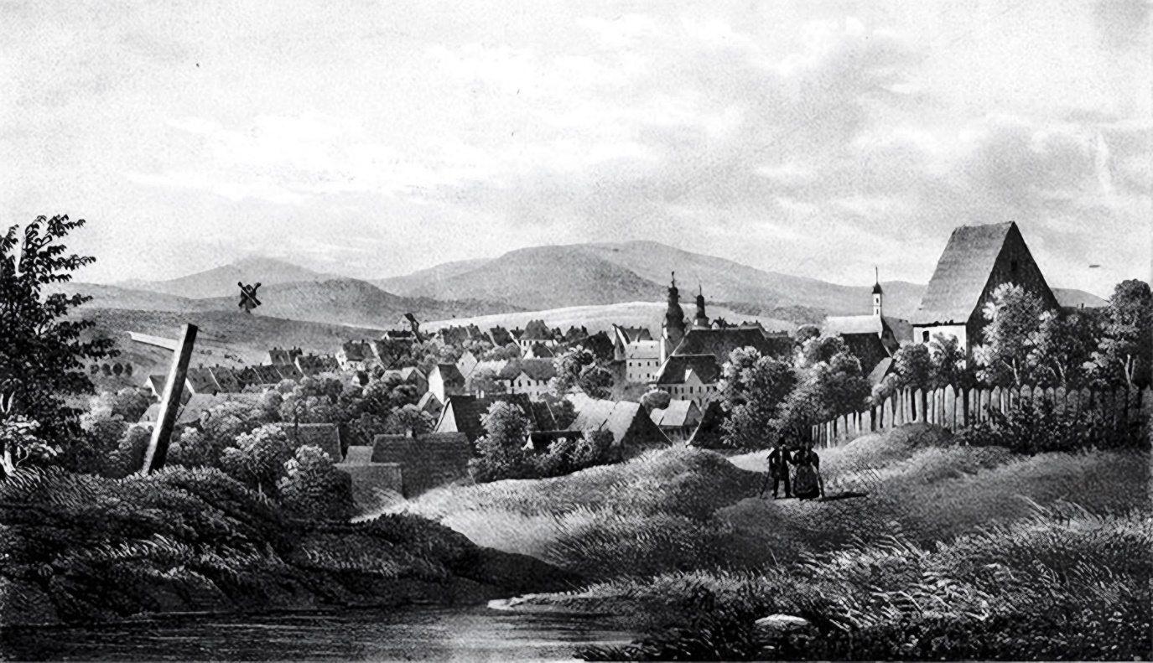
‘Clausthal’ 1841
Picryl

I had lunch at the ‘Krone’ (the ‘Golden Crown’, still extant at Kronenplatz 3) in Clausthal. I was served spring greens, parsley soup, violet-blue cabbage, a mound of roast veal as big as a miniature Chimborazo (the mountain in Ecuador), as well as a type of smoked herring called ‘buckling’, after its originator, Wilhelm Bückling, who died in 1447 and was so revered by the Emperor Charles V for his discovery that in 1556 he travelled from Middelburg to Biervliet, in Zeeland, simply to view the great man’s grave. How delicious such a dish tastes when you are aware of its history, and eating it yourself. However, my after-dinner coffee was spoiled when a young man sat down beside me, and chattered away so vigorously that the milk on the table turned sour. He was a young salesman wearing twenty-five colourful waistcoats, with just as many gold seals, rings, pins, etc. He looked like a monkey who had donned a red jacket, and was endlessly repeating to himself: ‘Clothes make the man’. He knew by heart a whole host of charades and anecdotes, which he constantly repeated whenever they were least appropriate. He asked me the news in Göttingen, and I told him that before my departure, a decree from the Academic Senate had been issued, forbidding the docking of dogs’ tails, the penalty being three thalers, since, during the dog days in summer, mad dogs run about with their tails between their legs, which distinguishes them from those dogs which are not mad, evidence which could not be observed if they had no tails at all. After dinner, I set out to visit the mines, the silver refinery, and the mint.

End of Part I of Heinrich Heine’s ‘Die Harzreise’

The Harz Journey (Die Harzreise, 1824): Part II

Contents

VI: The Dorothea and Karolina Mines.
VII: Goslar.

VI: The Dorothea and Karolina Mines
In the silver-refinery, as often in life, I missed seeing the silver. I did somewhat better at the Mint, where I could observe how money is made. I confess, I’ve never progressed any further. I have had the opportunity to observe the like on a number of occasions, but believe that if thalers rained from the sky, I would only collect holes in my head, while the Children of Israel would cheerfully gather the silver manna. With a feeling that was an amusing mixture of awe and emotion, I looked at the new-born, shiny thalers, set one fresh from the mint in my hand, and said to it: ‘Young Thaler! What a fate awaits you! What good and evil you’ll arouse! What vice you’ll hide, and virtue you’ll foster! What love you’ll receive, and curses you’ll suffer! What decadence, pandering, deceit, and murder you’ll assist in! What restless wandering you’ll endure, passing through clean hands and soiled hands for centuries, till at last, burdened with guilt and weary of sin, you’ll be gathered to your own people, in the bosom of Abraham, who will melt you down, purify you, and transform you into a new and finer thing, perhaps even an innocent teaspoon, with which my own great-grandchild will one day mash his beloved porridge!’
I found the exploration of the two most excellent Clausthal mines, the ‘Dorothea’ and the ‘Karolina,’ very interesting, and I must tell you all about it, in detail.
Half an hour’s walk from the town, you reach two large, blackish buildings. There, you are immediately greeted by the miners. They wear broad, dark and usually steel-blue, jackets that hang over the stomach, trousers of a similar colour, a leather apron tied at the back, and small green felt hats, completely brimless, like decapitated cones. The visitor is made to don similar clothing, but without the leather apron. A foreman, his guide, after lighting his miner’s lamp, leads him to a dark opening that looks like a chimney-hole, descends as far as his chest, gives the visitor instructions on how to manage the ladders, and asks him to follow without fear. The whole thing feels dangerous, yet is anything but; however, that you won’t believe, at first, if you know nothing about mining. There's a certain trepidation aroused in donning the dark delinquent’s garb. And then you have to clamber down, using hands and feet, and the dark hole is so very dark, and God knows how long the ladder is. You soon realise that there is not just a single ladder leading down into the blackness of eternity, but several ladders, each with fifteen to twenty rungs, and each leading to a small wooden platform on which you stand, and from which a new hole leads downwards equipped with another ladder. I first entered the Karolina; the dirtiest and most unpleasant Karolina I have ever met with. The rungs of the ladder were wet and muddy. From one ladder to the next one descends, with the foreman, as guide, going first, who constantly assures you there’s no danger at all, one just has to hold on tightly to the rungs with your hands, not look down at your feet, while avoiding vertigo or stepping on the side planking through which the whirring barrel-rope is now ascending, and from which a fortnight ago a careless person fell and sadly broke his neck. Below ground there is always a vague rushing and humming sound, you constantly bump into beams, and winding ropes hauling up barrels full of crushed ore and sinter. Sometimes, you come to a hewn-out passage, a gallery, where you can see the veins of ore, and where a solitary miner sits all day, laboriously knocking pieces out of the wall with his hammer. I failed to reach the lowest depths where, it is claimed, you can hear the folk in America shouting, ‘Hurrah, for Lafayette!’ Between ourselves, the level I had reached already seemed deep enough: with its constant rushing and roaring, eerie mechanical movement, the rippling of subterranean springs, water trickling from all sides, dusty vapour rising from the earth, and the miner’s lamp flickering on, ever dimmer, into the solitary night. It was truly deafening; breathing was difficult, and I could barely keep my grip on the slippery rungs of the ladders. I felt not a trace of what one terms ‘fear’, but, strangely enough, down there, in the depths, I recalled that the previous year, about this time, I had experienced a storm in the North Sea, which now seemed quite pleasant and cosy by comparison, the ship rocking back and forth, the wind trumpeting its tune, the cheerful shouts of the sailors ringing out in our midst, and everything bathed in the freshness of the Lord’s blessed, free air. Yes, air! Gasping for air, I ascended several dozen more ladders, till my guide led me through an extremely long and narrow passage hewn through the mountain, and into the Dorothea mine. There, it was airier and fresher, and the ladders were cleaner, but also longer and steeper than in the Karolina. There, I felt better too, especially on seeing traces of living people once more. In the depths, shifting glimmers of light appeared; miners with their lamps rose gradually to the surface, who, greeting me with cries of ‘Good luck, to you!’ and receiving the like from me, passed on by; and like a calm, friendly, yet at the same time tormentingly enigmatic memory, I was struck by the profoundly clear gaze of the solemn, pious, somewhat pale, faces of those men, young and old, mysteriously illuminated by the mining lamps, who had worked their dark, lonely mine shafts all day, and were now longing for the clear daylight and the faces of their wives and children.
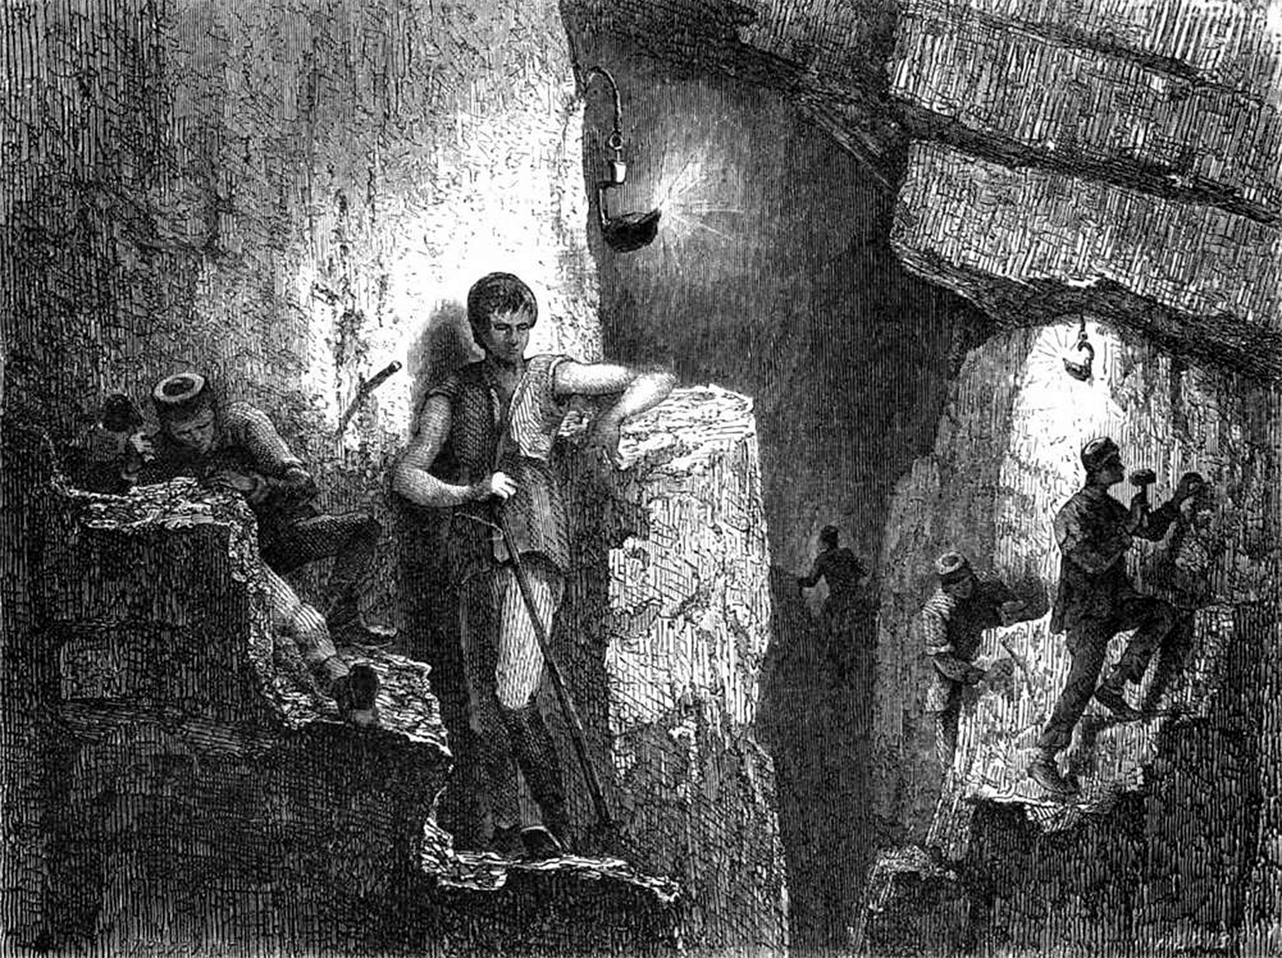
‘The Harz Miners’ 1863
Picryl

My guide himself was a thoroughly honest, biddable German. With a glow of joy, he showed me the spot where the Duke of Cambridge (Adolphus Frederick, youngest son of George III of England, Viceroy of Hanover in 1831) had dined with his entire entourage, while working the mine, and where the long wooden dining-table still stands, as well as the large bronze chair the duke occupied. ‘It will remain as a lasting memorial’, said the loyal miner, and he enthusiastically recounted the festivities that had taken place then, and spoke of how the entire tunnel had been decorated with lights, flowers, and foliage; how one miner had played the zither and sung; how the dear, fat Duke had cheerfully drunk many a toast; and how many miners, he himself in particular, would gladly allow themselves to be killed for the dear, fat Duke, and indeed the entire House of Hanover. I am deeply moved every time I witness such shows of allegiance being expressed in simple and natural words. It is a beautiful feeling! And a truly German one! The people of other nations may be more skilful, wittier, or more entertaining, but none are as loyal as the loyal German. If I was unaware that loyalty is as old as the world, I could easily believe a German heart invented it. German loyalty! It is not a modern cliché? At your courts, you German princes, that song should be sung and sung again, that of faithful Eckhart and the wicked Duke of Burgundy, who caused his sons to be slain and yet still found him true (see ‘Der Getreue Eckart’, by Ludwig Tieck, 1799). You rule the most loyal of peoples, and you are in error if you think that old, cautious, faithful hound has suddenly gone mad, and is snapping at your sacred calves.
Like German loyalty, the little minor’s lamp had now guided us quietly and safely, and with scarcely a flicker, through the labyrinth of shafts and tunnels; we emerged from the muffled darkness within the mountain, to the sun’s light shining its ‘Good luck to you!’
Most of the miners live in Clausthal, and the adjacent mining town of Zellerfeld. I visited several of these worthy people, observed their cosy homes, heard some of their songs, which they accompanied beautifully on the zither, their favourite instrument, and had them recite old mining tales and the prayers they usually say together before descending the dark mine-shaft, and I prayed many a good prayer along with them. One old foreman even suggested I should stay with them and become a miner; and when I, nonetheless, took my leave, he sent with me a message for his brother, who lived near Goslar, and many kisses for his dear niece.
However calm and uneventful the lives of these people may appear, they are nevertheless real. The ancient, quavering woman who sits behind the stove, opposite the large cupboard, may have been there for a quarter of a century, and her thoughts and feelings are doubtless intimately intertwined with every corner of the stove and every carving on the cupboard. And the cupboard and the stove are alive, for a person has infused them with a part of their soul.
Only through such a profound ‘immediacy,’ of perception, could the German fairy-tales emerge, the peculiarity of which lies in the fact that not only animals and plants, but also seemingly lifeless objects speak and act within them. To a thoughtful, gentle people in the quiet, enclosed privacy of their humble mountain or forest huts, the inner life of such objects had acquired an essential and consistent character, a sweet mixture of fantastic whimsy and purely human sentiment; and so in the fairy-tales, wondrously and yet, as it were, self-evidently: a needle and pin emerge from the tailor’s house and find themselves lost in the darkness; a piece of straw and a piece of coal wish to cross the stream, and meet with an accident; a shovel and a broom quarrel on the stairs, and wrestle each other; the mirror, on being consulted, reveals an image of the most beautiful woman; even drops of blood begin to speak, anxiously, their dark words of pity. That is why our life in childhood is so infinitely significant; during that time, everything is equally important to us; we hear all, we see all; there is a uniformity to all our impressions, whereas later we become more deliberate in our ways, deal more exclusively with individual tasks, exchange, laboriously, the bright gold of perception for the paper-money of literary description, and gain in breadth what we lose in depth. Once we are grown-up, distinguished people, we move to a new apartment; the maid tidies it daily, and rearranges the furniture as she sees fit, furniture which interests us little, for it is either new or belonged to Hans one day, and Isaac the next; even our clothes remain foreign to us; we scarcely know how many buttons there are on the coat we are currently wearing; we change our clothes as often as possible, none of which remain connected with our inner and outer history; we can hardly remember what the brown waistcoat looked like that once caused us so much laughter, and yet on whose broad stripes the dear hand of our beloved rested so sweetly!
The old woman, opposite the large cupboard behind the stove, was wearing a flowered skirt of ancient fabric, her late mother’s wedding dress. Her great-grandson, a blond, bright-eyed boy dressed as a miner, sat at her feet, counting the flowers on her skirt, and she may have already told him many little stories about that skirt, many serious, charming stories that the boy will certainly not soon forget, stories that he will often recall when, a mature adult, he is working alone in the midnight tunnels of the Karolina, and which he will perhaps recite in turn when his dear grandmother is long dead and he himself, a silver-haired, obsolete old fellow, sits amidst a circle of his grandchildren, opposite the large cupboard behind the stove.
I stayed the night at the ‘Krone’. Councillor B*** from Göttingen (Friedrich Bouterwek who had been Professor of Philosophy and Aesthetics, there) had also arrived. I had the pleasure of paying my respects to the old gentleman. When I signed the guest book and leafed through the month of July, I also found the much-loved name of Adalbert von Chamisso, the poet, and biographer of the immortal ‘Schlemihl’ (see his tale, ‘Peter Schlemihl, The Man Who Sold His Shadow’, 1813). The innkeeper told me that this gentleman had arrived in indescribably poor weather, and departed again in equally poor weather.

VII: Goslar
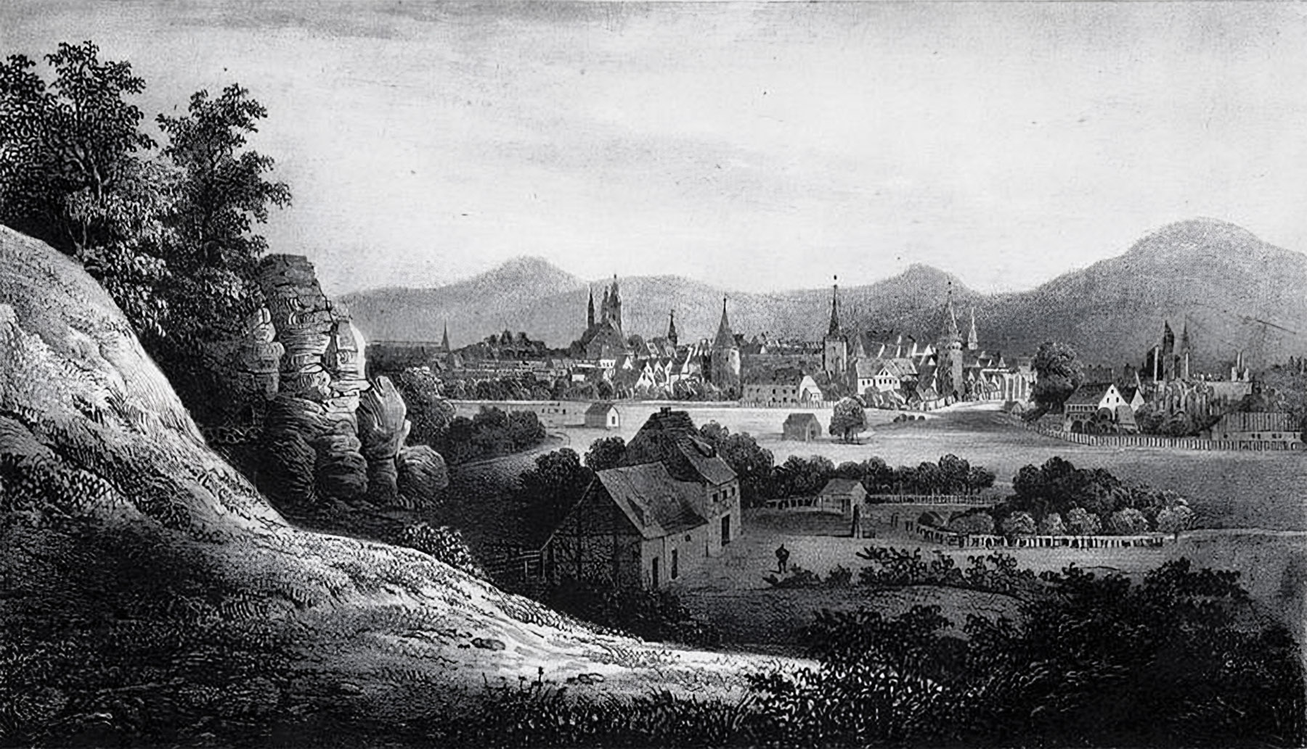
‘View of Goslar from the Klusfelsen rock’ 1842
Picryl

The following morning, I needed to lighten my pack again. I threw a pair of boots overboard, rose to my feet, and headed for Goslar. I arrived there without knowing how. This is all I can remember: I strolled uphill and downhill, gazing down into many a pretty meadow in the valley; silver waters roared, sweet woodland birds chirped, herd- bells rang, the varied green of the trees was bathed in golden sunlight, and above was the blue silk canopy of sky, so transparent that one could see deep into the Holy of Holies, where the angels sit at God’s feet and study the basso continuo visible in the features of his face. But I was still living the dream of the previous night, which I could not banish from my soul. It was of the old fairy tale about a knight descending into a deep well, where the most beautiful princess lies, frozen in enchanted sleep. I myself was the knight, and the well the dark Clausthal pit. Suddenly a host of lights appeared. From all the side-galleries rushed watchful little dwarves, making angry faces, slashing at me with their short swords, and blowing shrilly on their horns. More and more raced towards me, their large heads shaking horribly from side to side. As I struck at them, and the blood flowed I noticed, instantly, that they were in fact those red-flowered, long-bearded thistle-heads I had decapitated with my stick the day before along the way. They all immediately fled, and I entered a bright and magnificent hall. At its centre, veiled in white, rigid and motionless as a statue, stood my beloved. I kissed her mouth, and, by the living God, I felt the blissful warmth of her spirit, and the sweet trembling of her lovely lips. It seemed to me as if I heard God say, ‘Let there be light!’ An eternal dazzling ray shot down, but, in the same instant, night fell once more, and all was blended chaotically together, to form a wild, and desolate ocean. A wild, and desolate ocean, over whose churning waters, the ghosts of the deceased were anxiously racing, their white shrouds fluttering in the wind, while fast behind them, cracking his whip, ran a motley-coloured harlequin, who was myself – suddenly, from the dark waves, sea-monsters raised their misshapen heads, reaching for me, with outstretched claws, as I awoke in horror.
How often the most beautiful fairy tales are ruined! According to the tale, when the knight has found the sleeping princess, he has to snip a piece from her precious veil; and when, due to his boldness, her enchanted sleep is broken, and she is seated once more, in her palace, on her golden chair, the knight must approach her and say: ‘My most beautiful princess, do you know me?’ And then she will answer: ‘My bravest knight of all, I know you not.’ Then, he shows her the piece he has cut from her veil, which fits exactly, and they both embrace tenderly, and the trumpets sound, and their marriage is celebrated. It is my misfortune that my own dreams of love rarely have such a beautiful ending.
The name Goslar sounds so pleasing, and so many ancient Imperial memories are linked to it, that I expected to find an imposing, stately city. But it’s always the same, when one sees what is famous close to! I found it to be a nest of mostly narrow, labyrinthine, crooked streets, with a little river, probably the Gose, flat and gloomy, flowing through its centre, the paving of which was as bumpy as Berlin hexameters. Only the antiquities of the surrounding area, namely the remains of walls, towers, and battlements, grant the city a certain piquancy. One of these towers, called the Zwinger, has walls so thick that entire rooms have been carved into them. The square in front of the city, where the world-famous ‘Schützenfest’ (a rifle-shooting competition) is held, is a large and beautiful meadow, surrounded by high mountains. The market is small, with a fountain in the middle (still extant). The water flows into a large metal basin. When fires break out, it is struck several times; this produces a loud noise. Nothing is known about the origin of the metal basin. Some say the devil once set it down in the marketplace at night. Back then, the people were foolish, and the Devil was also foolish, and they exchanged gifts with one another.
The town hall in Goslar is a whitewashed police station. The adjacent guild hall has a finer appearance. At approximately the same distance from the ground as from the roof, stand statues of German emperors, smoke-black but partially gilded, each holding a sceptre in one hand and a globe in the other; they look like half-roasted university beadles. One of the emperors holds a sword instead of a sceptre. I have no idea what that signifies; and yet it certainly has some meaning, since we Germans possess the remarkable habit of reflecting on everything we do.
In Gottschalk’s ‘Handbook,’ I had read a lot about the ancient cathedral, and the famous Kaiserstuhl (Imperial throne) in Goslar. But on asking about both, I was told that the cathedral had been torn down, and the Kaiserstuhl had been taken to Berlin. We live in a momentous time: thousand-year-old cathedrals are being torn down, and Kaiserstuhls are being consigned to storage. (It is now back in the vaults of the Imperial Palace of Goslar. The sandstone plinth and enclosure with a replica of the bronze seat surrounds, are in the northern porch of St. Simon and Jude.)
Some memorials of the late cathedral, are now on display in St. Stephen’s Church. Beautiful stained-glass windows; some indifferent paintings, including one by Lucas Cranach; a wooden Christ on the Cross; and a pagan sacrificial altar of unknown metallic composition, which has the shape of an elongated, rectangular chest, and is supported by four caryatids, in a crouching position, who hold their hands above their heads, while grimacing in an unpleasant manner. Even more unpleasant, however, is the aforementioned large wooden crucifix which stands nearby. This head of Christ, with real hair and thorns, and a blood-stained face, certainly masterfully depicts the death of a human being, but not of a divinely born Saviour. Only material suffering is carved into that face, not the poetry of sacrifice. Such an image belongs more to an anatomy class than a church. The knowledgeable sexton who showed me around pointed out, as being especially rare, a black, polygonal, closely-planed, piece of wood covered with white numbers, hanging like a sign-board in the middle of the church. Oh, how brilliantly the inventive spirit of the Protestant Church is displayed here! For who would have thought it! The numbers on the piece of wood in question are the numbers of the day’s psalms, usually written in chalk on a blackboard and appearing somewhat austere to the aesthetic sense, but now, thanks to the above invention, serving as an ornament to the church and adequately replacing the Raphael paintings so often lacking. Such advances please me immensely, for I, a Protestant, and indeed a Lutheran, have always been deeply saddened when Catholic opponents choose to mock the empty, godforsaken appearance of Protestant churches.
I stayed in an inn near the market, where the lunch would have tasted even better had the innkeeper not sat down opposite, adding to the meal his long, superfluous face, and his tedious questions; fortunately, I was soon relieved of his presence by the arrival of another traveller, who had to endure the same questions in the self-same order: quis? quid? ubi? quibus auxiliis? cur? quomodo? quando? (Latin for Who? What? Where? By what means? Why? How? When?)
The stranger was an old, tired, worn-out fellow who, as was evident from his speech, had travelled the world, had lived a particularly long time in Batavia (then the capital of the Dutch East Indies), had acquired substantial wealth, and then lost it all again, and now, after a thirty-year absence, was returning to Quedlinburg, his hometown – ‘because,’ he added, ‘the family’s hereditary burial plot is there.’ The innkeeper made a most enlightened remark: that it was of no consequence to the soul where our body is buried. ‘Do you have that in writing?’ answered the stranger, and as he did so, uncannily-sly wrinkles formed around his puny lips and faded little eyes. ‘Though,’ he added nervously, and in a conciliatory tone, ‘I wouldn’t wish to suggest there is anything wrong with burial in a foreign land; the Turks bury their dead even more beautifully than we do; their churchyards are proper gardens, and they sit beside the white, turban-shaped gravestones, in the shade of a cypress, stroking their beards solemnly, and smoking their Turkish tobacco in their long Turkish pipes, quietly. And as for the Chinese, it’s a real pleasure to watch them hover respectfully about the resting places of their dead, praying, drinking tea, playing the lute, and decorating their dear ones’ graves very charmingly, with all kinds of gilded latticework, porcelain figurines, scraps of dyed silk, artificial flowers, and colourful lanterns — all very delightful. But, how far is Quedlinburg from here’
The churchyard in Goslar held little appeal for me. But I was more intrigued by the beautiful curly-haired girl who, on my arrival in the town, smiled at me from a high window overlooking a garden. After dinner, I sought that charming window again; but now only a vase of water with white bellflowers (campanula) stood there. I climbed up and took the pretty flowers from the glass, calmly setting them in my cap, and paying scant attention to the gaping mouths, petrified noses, and goggle eyes with which the people in the street, especially the old women, watched my blatant theft. An hour later, as I passed the house once more, the lovely girl was standing at the window, and when she saw the bellflowers on my cap, she blushed crimson, and drew back hurriedly. I had been able to observe her beautiful face more closely; it was a sweet, translucent embodiment of summer evening breezes, moonlight, the sound of nightingales, and the scent of roses. Later, when it had grown quite dark, she stepped out of the door. I arrived — I approached — she retreated, slowly, into the dark hallway. I took her by the hand and said: ‘I am a lover of beautiful flowers, and kisses, and what is not given me willingly, I steal.’ I snatched a kiss. And as she was about to flee, I whispered soothingly: ‘Tomorrow I’m leaving, and will probably never return.’ I felt the secret pressure of her lovely lips, and little hands. And smiling, I hurried away. Yes, I had to smile, on realising that I had unconsciously uttered the magic formula by means of which our red-coats and blue-coats, more often than by means of their mustachioed charm, conquer women’s hearts: ‘Tomorrow I’m leaving, and will probably never return!’
My lodgings offered a magnificent view of the Rammelsberg. It was a fine evening. Night galloped by on her black horse, its long mane fluttering in the wind. I stood at the window, and gazed at the moon. Is there really a man in the moon? The Slavs say his name is Kotar, and he causes the waxing moon to grow by pouring water on it. When I was very small, I was told that the moon was a fruit that, when ripe, was picked by God, and placed with the other full moons in a great cupboard at the end of the world, which is then boarded up with planks and nailed shut. As I grew older, I found that the world was not confined so narrowly, and that the human spirit had penetrated those planks and, with a giant key akin to Saint Peter’s, in other words the idea of ​​immortality, had unlocked all the seven heavens. Immortality! A beautiful thought! Who first conceived you? Was it a member of the Nuremberg bourgeoisie, seated before his front door on a warm summer evening, his white nightcap on his head, and a white clay pipe in his mouth, thinking, in a comfortably sort of way, how nice it would be if he could vegetate forever like that, his pipe and his little flame of life never failing! Or was it a young lover, who, in the arms of his beloved, conjured up the thought of immortality, conceiving it because he felt it, and could feel and think no other way? – Love! Immortality! My chest suddenly became so heated that I imagined the geographers had moved the equator and that it now ran right through my heart. And from that heart poured feelings of love, longingly poured into the vast night. The scent of the flowers in the garden below my window grew stronger. Fragrances are the feelings that flowers express, and just as the human heart feels itself stronger at night, when it believes it is alone and unobserved, so too the flowers, ashamed of the sensation, seem to wait for the darkness to envelop them before surrendering completely to those feelings, and breathing them out as sweet perfumes. Pour forth, perfumes of my heart, and seek, beyond the mountains, the beloved of my dreams! She is already asleep; angels kneel at her feet, and when she smiles, as she sleeps, it is a prayer the angels repeat; in her heart lies heaven with all its bliss, and when she breathes, my heart trembles, afar; the sun has set behind the silken eyelashes of her eyes, and when she opens her eyes again, it will be day, and the birds will be singing, and the herd-bells ringing, and the mountains shimmering in their emerald garments, and I will pack my knapsack and set forth.
Amidst these philosophical reflections and intimate feelings, I was surprised by a visit from Councillor B*** (Friedrich Bouterwek), who had also reached Goslar shortly before. At no other moment, could I have appreciated more deeply the benevolent friendliness of the man. I admired him for his acumen, and his success, but even more for his modesty. I found him uncommonly cheerful, refreshed, and vigorous. That he is certainly the latter, he recently demonstrated, with the publication of his new work: ‘The Religion of Reason’ (The Religion of Reason: Ideas for Accelerating the Progress of a Sustainable Philosophy of Religion, 1824), a book that has so delighted the rationalists, annoyed the mystics, and roused the general public. I myself am, at this moment, a mystic, for the sake of my health, since, according to my doctor’s instructions, I am to avoid all stimuli that provoke rational thought. Yet I do not underestimate the inestimable value of the rationalistic efforts of Heinrich Paulus, Johannes Gurlitt, Wilhelm Krug, Johann Eichhorn, Friedrich Bouterwek, Julius Wegscheider, etc. Incidentally, I myself find it very beneficial that these folk are sweeping away so many outdated evils, especially the old established church rubble, which harbours so many snakes and evil vapours. The atmosphere in Germany is becoming too close and hot, and I often fear being suffocated or smothered by my dear fellow mystics due to the warmth of their love. However, I will be more than angry with this fine school of rationalists if they cool the air a little too much. Essentially, Nature itself has set limits to rationalism; man cannot endure life in a vacuum chamber, or at the North Pole.
During the night I spent in Goslar, something very strange happened. I still cannot recall it without a pang of fear. I am not timid by nature and, God knows, I never felt any particular anxiety when a sharp blade, for example, attempted to make acquaintance with my nose, or when lost at night in a doubtful forest, or when a lieutenant’s wide yawn threatened to consume me during a concert — but I am almost as afraid of turbulent spirits as the ‘Austrian Observer’ (a reactionary daily paper, published in Vienna). What is fear? Does it derive from the intellect or the heart? I often debated this question with Doctor Saul Ascher (the Kantian idealistic philosopher, translator, and bookseller, who died in 1822. He was awarded a doctorate by the Friedrichs University of Halle) whenever we met, by chance, in Berlin at the Café Royal, where I lunched may a time. He always maintained that we fear something because we recognise through use of our Reason that it is something to be dreaded. Reason is the driving force, not the heart. While I ate and drank, he would continually demonstrate to me the virtues of Reason. Towards the end of his dissertation, he would consult his watch and conclude with the words: ‘Reason is the first principle!’ – Reason! When I hear that word now, I still see Doctor Saul Ascher with his ‘abstract’ legs, his tightly-fitting ‘transcendentally-grey’ coat, and his ‘angular’ craggy face, which could have served as a copperplate for a geometry textbook. A man in his mid-fifties, he was the personification of the straight line. In his pursuit of the positive, the poor man had philosophised away all the glorious things in life — sunlight, faith, the flowers — and nothing remained for him but a positively cold grave. He held a particular antipathy towards both the Apollo Belvedere and Christianity. He even wrote a pamphlet regarding the latter, proving it both unreasonable and untenable. He wrote a whole series of books in which Reason forever extolled its own excellence and, in all of them, the poor fellow doubtless meant to be taken seriously, and so deserves every respect, in that regard. But the ridiculousness of it all was precisely in his adopting such a serious, yet wholly foolish, face while being unable to grasp what every child does, precisely through being a child. I visited this proponent of Reason in his own home, several times, where I always found him in the company of some beautiful girl; since Reason did not forbid sensuality. On the last occasion, when I appeared, his servant told me: ‘The doctor has just died.’ I felt no more than if he had said: ‘The doctor has gone for a walk.’
But back to Goslar. ‘The first principle is Reason!’ I said soothingly to myself as I climbed into bed. However, it was of no help. I had just read, in Karl Varnhagen von Ense’s ‘German Tales’ (Deutsche Erzählungen, 1815), which I had brought with me from Clausthal, that horrific story of the son, who was about to murder his own father, but received a warning in the night, conveyed by the ghost of his dead mother. The whole atmosphere of this story caused a chill to traverse my veins as I read it. Ghost stories always produce an even more troubling effect when one reads them while travelling, especially at night, in a city, a house, a room one has never occupied before. One thinks, involuntarily: ‘How many dreadful things might once have happened on the very spot where I now lie?’ And then, the moon was illuminating my room in such an ambiguous manner, casting all kinds of unwelcome shadows on the wall, and, when I sat up in bed to glance about me, I saw —
Well, there’s nothing more eerie than the sight of one’s own face in the mirror, lit by moonlight. At that very moment, like a great yawn, a church clock struck, so heavily, lengthily, and ponderously slowly that after the twelfth stroke, I was certain a full twelve hours had passed by, and it would start striking twelve over all again. Between the penultimate and the last strokes, another clock struck, swiftly, almost naggingly, and perhaps annoyed at its godmother’s slowness. When both iron tongues had fallen silent, and a profound, deathly stillness reigned throughout the house, I thought I heard a shuffling sound, suddenly, in the corridor outside my room, like the footsteps of an old man of unsteady gait. Then, my door opened and, moving slowly, in walked the late Doctor Saul Ascher. A cold fever ran through my bones, I shivered like a leaf, and hardly dared to look at his ghost. He seemed the same as always: the same transcendentally-grey tunic, the same abstract legs, and the same angular mathematical face; only its colour was a bit yellower than before. His mouth, which had previously formed two angles of twenty-two and a half degrees, was also somewhat pinched, and his eyes had a larger radius. Swaying and leaning on his Malacca cane, he approached me, and spoke in his usual clipped but kindly manner: ‘Fear not, and refrain from thinking of me as a ghost. Your imagination deceives you, if you fancy you see a ghost. What is a ghost? Define a ghost? Deduce the conditions under which a ghost is possible? In what rational manner could such an appearance reasonably exist? Reason, I say reason.’ – And the ghost now proceeded to an analysis using pure Reason, quoting Kant’s ‘Critique’, part two, first section, third chapter, on the distinction between phenomena and noumena, then systemised the problem of a belief in ghosts, assembling one syllogism after another, and concluded with the logical proof that there can be no ghosts at all. Meanwhile, cold sweat ran down my back, my teeth chattered like castanets, and I nodded, agonisingly, in unconditional agreement with every sentence the ghostly doctor employed to prove the absurdity of my fear of ghosts. He demonstrated this so fervently that, on one occasion, in his distraction, he pulled a handful of graveyard worms from his vest pocket instead of his gold watch, and, realising his mistake, returned them to his pocket, in anxious and comical haste. ‘Reason is the highest…’ At that moment, the clock struck one, and the apparition vanished.
Leaving Goslar the next morning, I journeyed half at random, half intending to visit the Clausthal miner’s brother. Once again it was fine, the loveliest Sunday weather. I climbed hills and mountain-slopes, watched the sun chasing away the mists, and wandered joyfully through the breezy forest, while about my dreamy head bells were tinkling, the bellflowers of Goslar. The mountains were still in their white nightgowns; the fir-trees were shaking the sleep from their limbs while the fresh morning wind combed their green, drooping hair; the birds were at their prayers; the meadows glittered in the valley, like golden coverlets studded with diamonds; and the shepherd strode across them with his bell-ringing flock. I might well have gone astray. One always takes side-tracks and footpaths, believing they will bring one closer to one’s destination. As in life in general, so in the Harz Mountains. But there are always kindly souls who guide us back to the right path; they do it gladly, and on top of that, they take particular pleasure in telling us, with a self-satisfied expression, and a loudly benevolent voice, how great the detours are that we have made, and through what abysses and swamps we have passed, and how fortunate we are that we have met such knowledgeable people as themselves in the nick of time. I found such a guide not far from Harzburg. He was a well-fed citizen of Goslar, with a shiny, flabby, foolishly clever face; he looked as if he had invented the cattle plague. We walked a while together, and he told me all kinds of ghost stories, which might have sounded well if they hadn’t all boiled down to the fact, or its equivalent, that the ghost wasn’t really a ghost after all, that the pale figure was a poacher, and that the whimpering voices came from the newly born offspring of a wild sow, and the noise on the roof from the local cats. It is only when a person is ill, he added, that he thinks he sees ghosts; but as for himself, he was rarely ill, only occasionally suffered from skin ailments, and then always cured himself with common saliva. He also drew my attention to the practicality and usefulness of everything in Nature. Trees are green because green is soothing to the sight. I agreed with him and added that God created cattle because beef broth strengthens human-beings, that he created donkeys so that human beings could use them as analogies, and human beings themselves so that they would eat beef broth, and not act like donkeys. My companion was delighted to have found someone of like mind; his face shone with still greater joy, and he was greatly moved as we said our farewells.
As long as he was walking beside me, all of Nature seemed to lack enchantment; but as soon as he was gone, the trees found their voices again, the sun’s rays glittered, the meadow-flowers danced, and the azure sky embraced the green earth. Yes, I knew better: God created human beings to admire the world’s glories. Every author, no matter how great, desires that his work be praised. And in the Bible, God’s memoirs, it is explicitly stated that he created man for his glory and praise.
After a deal of wandering back and forth, I arrived at the home of my Clausthal friend’s brother, spent the night there, and was inspired to write the following fine poem:

I.

On the mountain, stands the cabin,
Where the aged miner dwells;
There the green fir-tree rustles,
The golden moon casts her spells.

In the cabin, stands an armchair,
Carved whimsically, and richly,
Whoever sits thereon is happy,
And that lucky man is me!

On her stool, sits a little girl,
Her arms against my knee;
Her eyes are like blue stars,
A rosebud mouth has she.

And those two bright blue stars
Gaze at me on high,
And a lily-white finger
Seals her lips, with a sigh.

No, the mother does not see us,
Busily spinning, on and on,
And her father plays his zither,
And he sings an old song.

And the little one whispers,
Quietly, in my ear;
Many an important secret
That she wishes me to hear.

‘Since my dear aunt is dead,
We can’t go and see the fair,
At the shooting-ground, in Goslar,
And it’s so lovely there.

Here, it’s always lonely,
So much colder than below,
And in winter we’re completely
Buried, deep in snow.

And I’m a timid creature
A child who fears the sight
Of those evil mountain spirits,
Who work bad things at night.’

Suddenly, she falls silent,
At her own words taking fright,
And her little hands cover
Those eyes that shine so bright.

Outside the fir-trees sound,
The spinning-wheel clicks and hums,
As the zither sounds between,
While its tune her father hums:

‘Don’t be afraid, dear child,
Of the power of evil sprights;
Angels will watch over you,
On dark and lonely nights.’

II.

A fir-tree’s long green fingers
Knock on the window glass,
And the yellow moon, listening,
Sheds her rays; within they pass.

Father, mother, sleep on quietly;
In their room they lie,
But we two, chatting happily,
Are wakeful still, nearby.

‘It’s hard to believe,’ she says,
‘That you often pray;
That twitching of your lips
Is not from prayer, I’d say.

That horrible, cold twitching –
Every time, it scares me so,
But your eyes’ gentle rays
Calm my fears. That you know

What true faith is, I doubt,
Nor belief in God the Father.
And the Son, and Holy Spirit;
Do you believe in either?’

‘Oh, my child, when yet a boy,
I believed, as one should,
In God the eternal Father,
The Lord, who’s great and good;

Who made all this lovely Earth,
And the lovely people here.
The sun, and moon, and planets
Their courses he made clear.

As I grew up, my child,
I understood far more,
Understood, and grew wiser,
And so, of the Son, I’m sure;

That dear Son, who lovingly
Revealed his Love to all,
And, as ever, his reward
Was crucifixion’s bitter gall.

Now that I’m an adult,
Well-travelled, and well-read,
I believe in the Holy Spirit,
My heart swells, by mystery fed.

It worked the miracles,
And does much greater things;
Shatters the tyrants’ castles,
And, to slaves, true freedom brings.

It heals our mortal wounds,
And renews the ancient law:
That all are born equal,
One true family, as before.

It drives away the evil mists
Dispels dark fantasies,
That mar our love and pleasure,
Day and night, and bring unease.

A thousand knights, well-armed,
The Holy Spirit’s chosen
To fulfil its every wish,
And with courage it inspires them.

Their precious swords are shining,
Their banners seem alight!
Oh, would you wish, my child,
To see so proud a knight?

Well, gaze at me, my child,
Kiss me, and believe it;
For I myself am such a knight
Of the Holy Spirit.’

III.

The moon now is hidden
Behind the green fir-tree,
And in the room our lamp,
Scarce aglow, shines fitfully.

But my azure stars
Shine with a brighter light,
That rosebud mouth glows,
As she tells me, in the night:

‘The little people, goblins,
Eat our bacon, steal our bread;
In the evening, it’s still here,
At dawn, with it they’ve fled.

The little people drink our milk,
Of our cream they take the best;
They leave the bowl uncovered,
So our cat drinks all the rest.

And our cat, she’s a witch,
She flies, at the midnight hour,
To the Mountain of Ghosts,
Where stands a ruined tower.

There a castle stood on high.
Full of life, in armour bright,
With his ladies, and his squires,
There danced many a knight.

The torch-dance they danced,
But an evil sorceress,
Cast a spell, and turned it all
To a ruin, where owls nest.

But my aunt, who’s dead, told me,
If I uttered the right word,
At the right hour of night,
In the right place, I’d be heard,

And those ruins will be turned
To a castle, once again.
Knights and ladies, and their squires,
Will dance yet, she’d maintain.

And whoever speaks that word,
The castle they will own,
Drum and trumpet will sound
The glory of their throne.’

From the little rosebud mouth,
Fairytale pictures rise,
And o’er the gloom is shed
The blue starlight of her eyes.

Her golden hair she wraps,
The child, about my hands,
Gives the fingers pretty names,
Dreaming of enchanted lands.

And all, in this quiet room,
Looks on, familiarly;
This table, cupboard too, I feel
Of old were known to me.

Gravely, but kindly, the clock ticks on,
And the zither, it would seem,
Sounds softly, by itself,
While I sit, as if in dream.

This moment is the time,
And this place is the place;
You’d be startled, dear child,
If I spoke the word of grace.

If I speak that word, it’s dawn,
And night trembles, on her way;
The streams and firs roar louder,
The old mountain wakes to day.

Zithers play; the dwarves’ song
Sounds where the mountain towers;
All blooms as if in Spring,
And the forest fills with flowers;

Flowers, bold and wondrous flowers;
Leaves upwards, outwards strive,
Fragrant, multi-coloured;
In an instant, all’s alive.

As if driven by some passion,
Roses, wild and red as fire,
Arise from out the tumult;
Lilies’ crystal hands aspire

To shoot heavenwards; huge stars,
Gaze downwards, from on high;
And in the lilies’ calyxes
Gleams starlight from the sky.

And we ourselves, my child,
Are transformed, even more;
Torchlight on gold and silk
Shimmers brightly, as before.

You’ve become a princess, now,
This hut a castle too,
And singing there, and dancing,
Knights and ladies fill the view.

And I? Why, I have won –
Yourself; all that’s here I own;
And drum and trumpet sound
The glory of my throne.’

End of Part II of Heinrich Heine’s ‘Die Harzreise’

The Harz Journey (Die Harzreise, 1824): Part III

Contents

VIII: The Brocken.

VIII: The Brocken
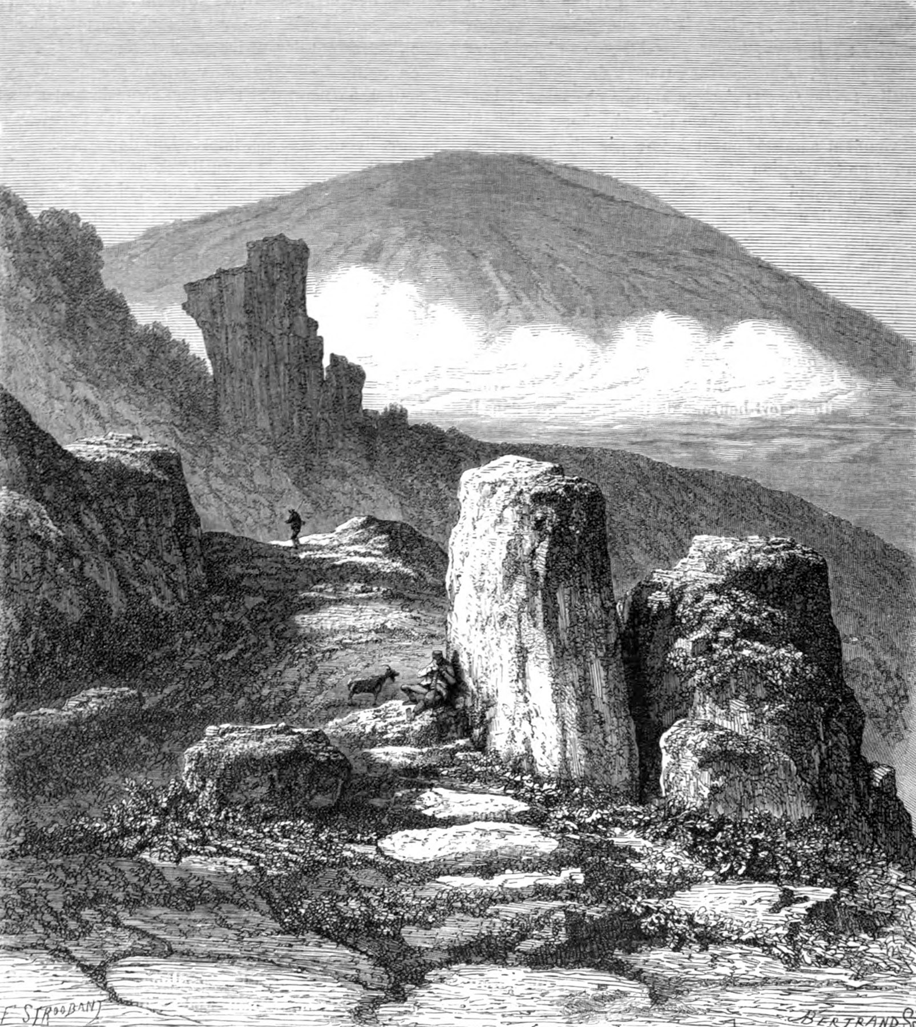
‘The Brocken’ 1879
Wikimedia Commons
The sun rose. The mists fled like ghosts, at the third cockcrow. I climbed, and descended again, and before me hovered the lovely sun, lighting scenes of ever greater beauty. The Spirit of the Mountains clearly favoured me; it knew well that poets know how to speak of beautiful things, and this morning it let me view its Harz Mountains, as they are certainly not viewed by everyone. But the Harz Mountains also viewed me, as few have seen me; on my eyelashes shimmered pearls as precious as those on the valley grasses. The morning dew of love moistened my cheeks, the rustling firs understood me, their branches parted, swaying up and down, like people silently expressing their joy by means of hand gestures, and far off there came a wonderfully mysterious sound, like the ringing of bells from a hidden woodland church; the sound, they say, of the herd-bells, which chime, in the Harz Mountains, in that lovely, clear, pure way.
According to the sun’s elevation, it was midday when I met with one such herd, and the herdsman, a friendly, blond young fellow, told me that the large mountain at the foot of which I was standing was the ancient, and famous Brocken. There were no houses for many a mile around, and I was pleased that the young man invited me to dine with him. We sat down to a déjeuner dinatoire (a buffet lunch) which consisted of cheese and bread; the sheep browsed the crumbs, while the pretty cows with gleaming hides jostled about us, tinkling their bells, archly, and mocking us with wide, contented eyes. We dined truly royally; in fact, my host seemed to me the true king, and since he is the only king who has, as yet, shared his bread with me, I will sing his praises royally too.

The shepherd boy is king,
A green hill his throne of old,
Above his head, the sun
Is his heavy, crown of gold.

The sheep lie at his feet,
Gentle flatterers, marked with red!
The knights are the calves;
With cloven feet they tread.

The court-players are the goats;
While every bird and cow
With its twittering, or its bell,
Is a king’s musician now.

They pipe and chime so sweetly,
So sweet their music deep,
Round the falls, and the fir-trees,
That the king falls asleep.

All the while, his sheepdog
As minister, must reign,
Its growling and barking
Echoing o’er the plain.

The young king babbles, sleepily:
‘To rule is hard, I ween,
Oh, I wish I were at home
In the arms of my queen!

In the arms of my queen,
My royal head, so softly, lies,
And there is all my kingdom,
Deep within her lovely eyes.’

We said our friendly farewells, and I climbed the mountain, cheerfully. Soon I was greeted by a grove of tall firs that reached the sky above, and for whom I felt every respect. These trees have not had an easy time of it, and have suffered hardships in their youth. The mountain hereabout is littered with numerous large granite boulders, and most of the trees have had to twine around the stones, or shatter them with their roots, laboriously searching for pockets of soil from which they might draw sustenance. Here and there, the stones sit on top of one another, forming a gateway, as it were, and on their summit stand the trees, their bare roots extending over that stony gate, and only at the foot of the pile grasping the ground, such that they seem to be growing in mid-air. And yet they have soared to a mighty height, and, clutching the stones as if nurtured together, they stand more firmly than their easy-going colleagues in the tame woodland soil of the plain. So too do great men stand who have strengthened and established themselves in life, by overcoming the constraints and obstacles of youth. Squirrels climbed the fir-branches, and roe deer ambled beneath them. When I see such gentle and noble creatures as the latter, I cannot understand how cultured people find pleasure in hunting and destroying them. It was a deer, more merciful than any human being, that according to legend nursed the languishing and sorrowful child of Saint Genevieve of Brabant.
The golden sunlight, piercing the dense fir-trees, is a thing of beauty. The tree-roots form a natural staircase. Everywhere are swollen banks of moss; the stones are covered, a foot deep, as if with light-green velvet cushions, amidst a cool freshness and the dreamy murmur of streams. Here and there, one sees silvery water trickling beneath the stones, lapping at the bare, fibrous tree-roots. If one bends down to observe more closely, one can eavesdrop, as it were, on the hidden evolutionary history of plants, and the quiet throb of the mountain’s heart. In some places the water bubbles more forcefully among the stones and roots, forming small cascades. It is pleasant to sit there. The murmuring water races downwards at an amazing speed; the birds give out broken cries of longing; the trees whisper as if with a thousand young girls’ tongues; mountain flowers with unknown names gaze as if from a thousand young girls’ eyes, and stretch out their wonderfully broad, oddly jagged leaves; sunbeams shimmer playfully; bright little herbs tell each other green-hued fairy-tales; everything is as if enchanted, its secrecy deepens, and an ancient dream comes to life; the beloved appears – oh, that she vanishes again so swiftly!
The higher you climb on the mountain, the shorter are the dwarf firs, seeming to shrink more and more, until one sees only bilberries, heathland shrubs, and alpine plants. It also becomes noticeably colder. Strange groups of granite boulders become clearly visible here, and are often of astonishing size. They may well be the playthings that evil spirits throw to one another on Walpurgis Night, when the witches fly there, on broomsticks and pitchforks, and their wild, wicked revelry begins, as one’s credulous nurse claimed, and as can be seen in Moritz Retzsch’s beautiful illustrations for Goethe’s ‘Faust’. Indeed, one young poet who passed the Brocken, on a journey from Berlin to Göttingen, on the first night of May (Heine himself, in 1824), even noticed some literary ladies there, who were holding an aesthetic tea party in an angle of the mountain, leisurely reading the Dresden ‘Abendzeitung’ (‘Evening Paper’) aloud to one another, praising the poetic billy-goats, who bleated and hopped around their tea-table, as universal geniuses, and passing final judgment on all the phenomena of German literature; but when they seized upon ‘William Ratcliff’ and ‘Almansor’ (plays by Heine, of 1821/22) and denied the author any trace of piety or Christianity, the young man’s hair stood on end, and horror seized him – ‘I’ spurred my horse, and galloped onwards!
In fact, when, on climbing the Brocken, one ascends beyond halfway, one cannot help but be reminded of the many delightful Blocksberg (an alternative name for the Brocken) legends, and especially of the great, mystical, German national tragedy of Doctor Faust. It seemed to me as if cloven hooves were scrabbling behind me, and someone in a mocking mood was catching their breath. I truly believe even Mephistopheles would struggle to do so while ascending his favourite mountain; the climb is extremely exhausting, and I was glad when I finally saw the long-awaited Brocken-House.
This building, which, as is known from numerous illustrations, consists only of a single floor and is located at the summit of the mountain, was constructed in 1800 by Count Christian Stolberg-Wernigerode, on whose behalf it is also managed as an inn. The walls were designed to be surprisingly thick, to resist the wind and the cold in winter; the roof is low, with a tower-like lookout in the middle (the tower was demolished in 1834). There are two small outbuildings next to the house, one of which once served as shelter for visitors to the Brocken in earlier times.

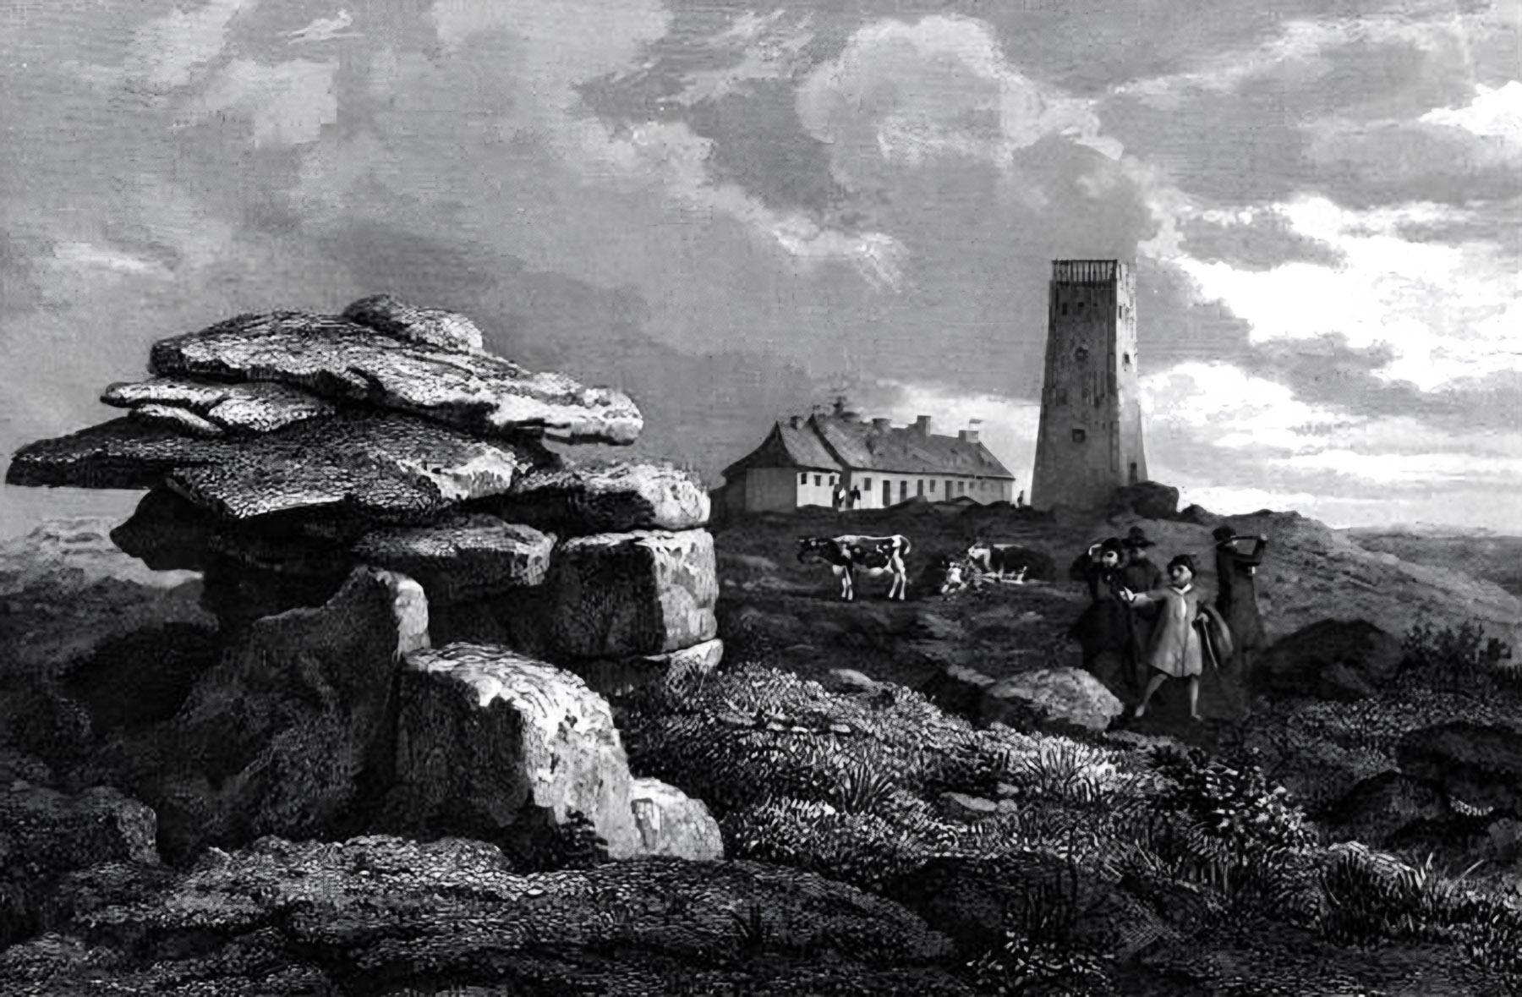
‘The Brocken-House’ Ludwig Richter, 1836
Picryl

Entering the Brocken-House produced in me a somewhat strange sensation, as if I were in legendary times. After a long, solitary ascent, amid rocks and fir-trees, one is suddenly transported to a house in the clouds; far below are townships, mountains, forests, while above one encounters an odd assortment of folk, half-curious and half-indifferent who, as is natural in such locations, welcome one almost as if one were expected. I found the house full of guests and, as befits a knowledgeable fellow, I already anticipated the discomfort of a bed of straw and an unpleasant night ahead. In a voice like that of a dying man, I immediately begged for tea, and the landlord was intelligent enough to understand that I, a sick person, needed a proper bed for the night. He provided this in the form of a cramped little room in which a young merchant, a tall ‘emetic’ in a brown overcoat, had established himself.
The public room I found to be an animated hive of activity. There were students there from various universities. Some had arrived shortly before, and were taking a rest, others were preparing to leave, packing their rucksacks, writing their names in the visitors’ book, and receiving Brocken bouquets (of flowering heather, moss, etc) from the housemaids. There was a deal of cheek-pinching, singing, leaping about, cheering, and the asking and answering of questions: ‘good luck’, ‘fine weather’, ‘good health’, ‘goodbye’. Some of those leaving were a little intoxicated, and were enjoying the beautiful view in duplicate, a drunk seeing everything double.
After I had recovered somewhat, I climbed the look-out tower, and there encountered a gentleman of modest height accompanying two ladies, one young, one elderly. The young lady was very beautiful. A superb figure, with a black satin hat like a helmet on her curly hair, the hat’s white feathers fluttering in the wind. Her slender limbs were so tightly wrapped in her black silk cloak that her noble form was outlined, while, with a free expression, she directed her wide eyes, serenely, upon the free world spread below.
When I was a boy, I thought of nothing but tales of enchantment and wonders, and every beautiful lady who wore ostrich feathers on her head I considered a faery-queen or, if I noticed that the train of her dress was damp, a water-nymph. Now I think otherwise, since I know from natural history that those symbolic feathers come from the most stupid of birds, and that the train of a woman’s dress can become damp in a perfectly natural manner. If, with the eyes of boyhood, I had seen the aforementioned young beauty in the aforementioned location on the Brocken, I would certainly have thought: ‘That must be the faery of the mountain, and it is she who has cast the spell that makes everything down there seem so miraculous.’ Indeed, everything does appear miraculous in the extreme when one first looks down from the Brocken’s summit. The mind receives new impressions at every moment, varied and even contradictory ones, which combine in one’s soul into one deep, as yet obscure and incomprehensible, feeling. If one succeeds in grasping this feeling in essence, one grasps the mountain’s innate character. This character is entirely German, both in its faults and its virtues. The Brocken is German. With German thoroughness, it reveals, clearly and distinctly, in a giant panorama, the many hundreds of cities, towns, and villages, located mostly to the north, and the mountains, forests, rivers, and expanses, all around it, to an infinite distance. But precisely because of this thoroughness, everything appears like a crisply-drawn, clearly-illuminated map; and nowhere is the eye delighted by truly beautiful effects of landscape. As always happens, we German compilers, because of our honest desire for precision in everything we present, never think of displaying individual features in a beautiful manner. The mountain has something calmly Germanic, sensible, and tolerant about it, precisely because it sees so far and so clearly. And when such a mountain opens its giant eyes, it may indeed see a little more than we dwarves who clamber about on its slopes, gazing from foolish little eyes. Many seek to claim that the Brocken is essentially philistine, and indeed Matthias Claudius wrote: ‘The Blocksberg is a tall gentlemanly Philistine!’ (See his ‘Rheinweinlied’)
But that is mere error. Displaying a bald head, sometimes hidden beneath a white cap of mist, it may give the appearance of philistinism; but, as with some other great Germans, it does so purely out of a sense of irony. It is a notorious fact that the Brocken has its youthful moments of fantasy, such as May Eve. Then it jubilantly throws it cap of mist into the air, and, like the rest of us, runs riot, in the spirit of true German Romanticism.
I immediately tried to engage the beautiful lady in conversation; for one only truly enjoys natural beauty when one is able to address it on the spot. She was not exactly witty, but was thoughtfully attentive. Her manner was truly noble, by which I mean not that commonplace, rigidly negative show of nobility that knows precisely what is to be avoided; but that rarer, freer, positive nobility that tells one exactly how far one may venture, and despite its impartiality, inspires in one the highest degree of social confidence. To my own astonishment, I suddenly developed a deep understanding of geographical detail, informing the interested beauty of the names of all the cities that lay far beneath us, searching for them and pointing them out to her on my map, which I spread on the stone slab of a table at the centre of the tower-room with the air of a knowledgeable man. I failed to find many a town, perhaps because I seemed to be searching for them more with my fingers than my eyes, which, meanwhile, had directed themselves towards the face of the lovely lady, finding therein locations more beautiful than ‘Schierke’ and ‘Elend.’ Her face was one of those that never charm, rarely delight, yet always please. I love such faces because their smiles calm my troubled heart. The lady was as yet unmarried, though already showing a maturity that sufficiently justified one’s speculation about her state. Yet this is a common occurrence; it is precisely the most beautiful girls who experience the most difficulty in finding a husband. Such was the case in ancient times, and, as is well known, all three Graces remained single.
I was unable to divine what relationship the gentleman possessed to the ladies he accompanied. His was a lean, oddish figure. A small head, sparsely covered with grey hairs and covering his low forehead, as far as his eyes of a dragonfly-green; a round prominently-protruding nose; and a mouth and chin drawn back precipitately toward the ears. His smallish face appeared as if made of delicate, yellowish clay, the kind sculptors employ when moulding their initial models; and when he pursed his thin lips, a thousand fine, semicircular wrinkles appeared on his cheeks. The little man spoke never a word, and only now and then, when the elderly lady whispered something amiable to him, did he smile like a chilly lapdog.
The older lady was the younger lady’s mother, and she, too, owned to the most refined features. Her eyes betrayed a morbidly dreamy profundity, her mouth had the set of strict piety, yet it seemed to me as if it had once been very beautiful, and had smiled a great deal, received many kisses, and returned many. Her face resembled a palimpsest, where, beneath the fresh blackness of some monk’s script, a text perhaps of some Father of the Church, lay half-obliterated lines inscribed by an ancient Greek love-poet. Both ladies had toured Italy that year with their companion, and told me all sorts of interesting things regarding Rome, Florence, and Venice. The mother spoke a great deal about the Raphael paintings in St. Peter’s (they were, and are, in fact, in the Vatican); the daughter spoke more about the opera at the Teatro La Fenice in Venice. Both were enchanted by the art of improvisation. Nuremberg was these ladies’ home town; but of its ancient splendour, they had little to say. Of the gracious art of the Meistersingers, of which the good Johann Christoph Wagenseil has informed us (see his ‘De Civitate Noribergensi Commentatio’, 1697), the last surviving notes have died, and the citizens of Nuremberg edify themselves with nonsensical Italian impromptus and castrato voices. O Saint Sebald, what a poor patron saint of Nuremberg you have proved to be!
As we spoke, dusk began to fall; the air grew even colder, the sun sank lower, and the tower’s platform filled with students, travelling tradesmen, and a few honest citizens with their wives and daughters, all of whom wished to view the sunset. It being a sublime sight that inspires the soul to prayer. For a full quarter of an hour, we all stood there in solemn silence, watching that beautiful fiery orb sink, gradually, in the west. Our faces were illuminated; hands were involuntarily clasped. It was as if we, a silent congregation, were standing in the nave of a gigantic cathedral, and the priest was now raising the ‘Body of Christ’, while Palestrina’s immortal chorale (his ‘Missa Papae Marcelli’ of 1562) was poured forth from the organ.
As I stood lost in contemplation, I heard someone next to me exclaim: ‘How beautiful nature often is!’ These words issued from the soulful heart of my roommate, the young merchant. They reinstated my everyday mood, and I was now able to utter a host of pleasant comments to the ladies regarding the sunset, and escort them calmly to their rooms as if nothing had occurred. They even allowed me to entertain them for a further hour. Like the Earth itself, our conversation revolved around the sun. The mother remarked that the sun sinking into the banks of mist looked like a glowing red rose flung, with celestial gallantry, into the wide, white bridal veil of its beloved Earth. The daughter remarked, with a smile, that frequent viewing of such natural phenomena weakens the impression they make. The mother corrected this false opinion with a quotation from Goethe’s travel letters (see, Goethe’s ‘Letters from Switzerland’; his letter of October 3, 1779), and asked me if I had read ‘Werther’? I believe we also spoke of Angora cats, Etruscan vases, Turkish shawls, macaroni, and Lord Byron, from whose poems the older lady recited some passages regarding sunsets, with a rather charming lisp, while sighing. To the younger lady, who knew no English and wished to read his poetry, I recommended the translations of Byron executed by my beautiful, and witty compatriot, Baroness Elise von Hohenhausen. On this occasion too, I did not neglect to rant about Byron’s godlessness, lovelessness, desolation, and heaven knows what else, which I customarily do when conversing with young ladies,
After this business, I went for a walk on the Brocken; since it is never completely dark there. The mist was not too dense, and I could see the outlines of the two hills known as the Witches’ Altar (Hexenaltar) and the Devil’s Pulpit (Teufelskanzel). I fired my pistol, but there was no trace of an echo. Suddenly, however, I heard familiar voices and found myself being embraced and kissed. Here were fellow-students of mine, who had left Göttingen four days later, and were most surprised to encounter me all alone on the Blocksberg. There was a great deal of talking and wonderment, of arranging to meet, of laughter and recollection, and it seemed as if, in spirit at least, we were back in our academic Siberia, where the refinement of manners is so great that ‘bears’ are bound (‘debts’ are contracted) in taverns, and the ‘sables’ (‘serving girls’) bid their pursuers good evening.

End of Part III of Heinrich Heine’s ‘Die Harzreise’

The Harz Journey (Die Harzreise, 1824): Part IV

Contents

IX: The Brocken-House.
X: The Ilse Valley.
XI: The Ilsenstein.
XII: Postscript.

IX: The Brocken-House
The evening meal was being consumed in the large room, containing a long table and two rows of hungry students. At the beginning, the conversation was commonplace university chatter: talk of duels, duels, and yet more duels. The company consisted mostly of residents of Halle, and Halle therefore became the main topic of conversation. Professor Christian Gottfried Schütz’s windows were exegetically illuminated. Next it was claimed that the last levee of the ‘King of Cyprus’ had been very splendid, that he had recognised a natural son of his, that he had married a Lichtenstein princess of inferior status, that his official mistress had abdicated her position, and that the entire ministry, deeply moved, had wept as required. I need hardly mention that this refers to one of Halle’s ‘beer’ kingdoms (established by the students in the taverns of local villages). The next subject of conversation was a pair of Chinese gentlemen who had appeared in Berlin two years ago, and who were now being trained in Halle to lecture privately on Chinese aesthetics. A great joke was made of this. A scenario was envisaged whereby a German was to be exhibited in China for financial gain, and to this end a notice was drawn up in which the mandarins Tsching-Tschang-Tschong and Hee-Ha-Ho declared that he was a true German, and listed the tricks he would perform which mainly consisted of philosophising, smoking tobacco, and exhibiting patience. It was noted finally that at noon, which was feeding time, no dogs were permitted entry, as they were in the habit of snatching the finest scraps from the poor German.
A young fraternity member, who had recently been to Berlin for purification (to be cleansed of his political views, and fraternity membership) spoke about that a great deal, but very one-sidedly. He had visited Wisotzki’s (the innkeeper of that name also ran a politically-outspoken puppet theatre at Stallschreibergasse 43), and the theatres; his judgement of both was erroneous. ‘Young people soon dispense with words,’ etc. and he even spoke of wardrobe expenses, and scandals involving actors and actresses etc. The youth was clearly ignorant of the fact that since, in Berlin, appearances are everything, as the common saying: ‘Man so duhn’ (‘One makes more of oneself, so’) sufficiently indicates, then illusion must of necessity flourish on the stage, and thus the management bears a major responsibility, as per the ‘colour of the beard, which also plays a role’, for the accuracy of the costumes, which are designed by historians who are on oath, and sewn by scientifically-trained tailors. And this is all quite necessary. For if Mary Stuart were to wear an apron belonging to the age of Queen Anne, the banker Christian Gumpel would certainly rightly complain that the illusion would be lost; and if Lord Burleigh accidentally donned Henry IV’s trousers, the Councillor of War von Steinzopf, née Lilientau, would certainly be irritated by the anachronism all evening. Such care for accuracy on the part of the management extends not only to aprons and trousers, but also to the people wearing them. Thus, in future, Othello is to be played by a real Moor, whom Professor Martin Lichtenstein (the professor who established the Berlin Zoo) has already brought from Africa for this purpose; in ‘Misanthropy and Repentance’ (or ‘The Stranger’, by August von Kotzebue), Eulalia is to be played by a real ‘lost woman’, Peter by a real idiot of a boy, and the Stranger by a real nameless cuckold, none of whom would need be brought from Africa. In ‘The Power of Circumstances,’ (by Ludwig Robert) a real writer, who has already received a few slaps in the face, is to play the role of the hero; in ‘The Ancestress,’ (by Franz Grillparzer) the artist who plays Jaromir is to have actually perpetrated a robbery, or at least stolen something; Lady Macbeth is to be played by a lady who, though most loving by nature, as Tieck demands, is nevertheless familiar to some extent with the blood-stained blade of assassination; and finally, a particularly shallow, mindless, vulgar fellow is to be engaged to play the great Wurm (the comic actor, Albert Wurm, who was involved with the banned anti-Semitic farce , ‘The Jewish School’ , written by Alexander Sessa, in 1813, and with its successor Carl von Brühl’s ‘Unser Verkehr’ ) on stage, the great Wurm who delights his fellow spirits every time he aspires to the height of greatness, higher, higher, yet ‘every inch a scoundrel!’ – If the above mentioned young man showed little grasp of the requirements of Berlin theatre, even less had he noticed that Gaspare Spontini’s Janissary Opera with its kettledrums, elephants, trumpets, and gongs, was a heroic means of strengthening our weakened people for war, a means which Plato and Cicero already slyly recommended. Least of all did this young man understand the diplomatic significance of ballet. With difficulty I demonstrated to him that there is more of politics in Michel-François Hoguet’s feet (Hoguet was the principal dancer of the Berlin State Opera) than in Paul Buchholz’s head (Bucholz was a writer on politics considered a fool by liberal thinkers), how all his dance moves signify diplomatic negotiations, how each of his gestures has a political interpretation, for example that he means our Cabinet when, leaning forward graspingly, he reaches out with both hands; that he means the Bundestag when he pirouettes a hundred times on one foot without moving from the spot; that he has the little princes in mind when he staggers around as if with his legs tied; that he signifies the balance of power in Europe when he sways back and forth like a drunk; that he indicates a Congress when he twines his bent arms together in a skein; and finally, that he represents our altogether too great friend in the East (Tsar Alexander I) when, gradually unfolding his limbs, he elevates himself, maintains position for a long while, and then suddenly launches into the most terrifying leaps. The scales fell from the young man's eyes, and he began to realise why dancers are better paid than great poets, why ballet is an inexhaustible topic of conversation among the diplomatic corps, and why a beautiful danseuse is often still supported privately by a minister, who surely toils day and night to render her receptive to his little ‘system’. By Apis! How large is the number of exoteric, and how small the number of esoteric, theatregoers! There stand the foolish people, gaping, admiring the leaps and turns, studying anatomy as revealed in the poses of Lemière (Marie Jeanne Desargus Lemière, prima ballerina of the Berlin Opera), applauding the entrechats of Röhnisch (C.F.W. Röhnisch, who danced in Spontini’s ‘Olympie’), and babbling about grace, harmony, and supple loins — and none of them notices that the fate of the German fatherland is before their eyes, in cipher-form, as a series of choreographed dance-steps.
While such conversations flew back and forth, more mundane things were not lost sight of, and the large bowls, filled with honest meat, potatoes, etc., were diligently devoured. However, the quality was poor. I mentioned this, casually, to my neighbour, who, with an accent that instantly betrayed him as Swiss, replied, quite rudely, that we Germans were ignorant not only of true freedom but also of true contentment. I shrugged my shoulders, and remarked that the servants to princes and the makers of delicacies are universally Swiss, and often termed so, and that in general, the contemporary Swiss heroes of freedom, who babble in so politically audacious a manner to the public, forever seem to me like hares that trigger the firing of pistols at public fairs, astonishing all the children and peasants with their bold action, and yet are still hares.
The son of the Alps assuredly meant no harm. ‘He was a fat man, therefore a good man,’ says Cervantes (‘Hombre que por ser muy gordo era muy pacifico: a man who, being very fat, was very peaceable’: Don Quixote, I. 2, referring to an innkeeper). But my neighbour on the other side, a man from Greifswald, was most offended by the remark; he insisted that German vigour and straightforwardness were not yet extinguished, beat his chest loudly, and emptied an enormous pint of wheat-beer. The Swiss placated him with a ‘Now! Now!’ But the more soothingly he said this, the more eagerly the man from Greifswald went to work. He was a fellow from the days when lice had their heyday, and barbers feared starvation. He had long, drooping locks, and wore a knightly sort of beret, a black old German coat, a dirty shirt that also served as a waistcoat, and beneath it a medallion with a tuft of hair from Field-Marshal Von Blücher’s grey horse. He seemed a full-grown fool. I like to get some exercise at dinner so I allowed him to engage me in patriotic argument. He was of the opinion that Germany should be divided into thirty-eight districts. I, on the other hand, maintained that it should be forty-eight, because then one could write a more systematic handbook about Germany, and it was necessary to mix feeling with science. My friend from Greifswald was also a German bard and, so he confided in me, he was working on a national epic poem glorifying Hermann (Arminius) and the Battle of the Teutoburg Forest. I gave him many useful hints for the creation of this epic tour de force. I pointed out to him that he could allude, onomatopoeically, to the swamps and rutted paths of the Teutoburg Forest in cloying and uneven verse, and that it would be a patriotic subtlety to have General Varus and the other Romans speak nonsense. I hope he will succeed in this, as successfully as the poets of Berlin, to the point of creating the most dubious of conjurations.
At our table, the conversation became increasingly louder and more intimate, wine replaced beer, punch bowls steamed, and people drank, swore brotherhood, and sang. The old ‘Father of the Nation’ (‘Landesvater’, 1782, written by the jurist August Niemann), and fine songs by Wilhelm Müller, Friedrich Rückert, Ludwig Uhland, and others rang out. And beautiful melodies composed by Albert Methfessel. Best of all, our own Arndt’s German verses sounded: ‘The God who created iron, never wished for slaves!’ (‘Der Gott, der Eisen wachsen liess’, 1813, from ‘Vaterlandslieds’ by Ernst Arndt) Meanwhile, outside the house, the wind roared as if the old mountain were singing along, and some friends even claimed, unsteadily, that it was shaking its bald head joyfully, and was rocking the room back and forth. The bottles grew emptier and the heads fuller. One fellow roared, another piped, a third declaimed from ‘Die Schuld’, (‘Guilt’, Adolf Müllner’s play of 1816) a fourth spoke Latin, a fifth preached about temperance, while a sixth stood on a chair and lectured us: ‘Gentlemen! The earth is a rounded cylinder, people are individual pins on its surface, seemingly scattered at random; but the cylinder turns, the pins strike here and there and sounds are produced, some frequently, others rarely, creating a wonderfully complex music, and this is called world-history. So, we speak first of music, then of the world, and finally of history; the latter, however, we divide into Positive and Spanish flies.’ — And so, he ran on, in a mixture of sense and nonsense.
A jovial Mecklenburger, who had his nose in a punch glass, and was smiling blissfully as he inhaled the steam, remarked that he felt as if he were standing in front of the theatre-buffet (famous for its punch) in Schwerin again. Another held his wine glass up to his eye like a lorgnette and seemed to be observing us attentively, while the red wine ran down his cheeks into his projecting mouth. The man from Greifswald, suddenly elated, threw himself on my chest and exulted: ‘Oh, if only you understood me, I am a lover, I am a happy man, I am loved in return, and, God damn me, she is an educated girl, for she has a full bosom, wears a white dress, and plays the piano!’ – But the Swiss merely wept, and tenderly kissed my hand, whimpering endlessly: ‘Oh, Bäbeli! Bäbeli!’ (A diminutive, often of the name Barbara, here used for comic effect)
Amidst this mayhem, where even the plates were learning how to dance, and the glasses how to fly, two young men sat opposite me, who were beautiful and pale as marble statues, one like Adonis, the other more like Apollo. The faint touch of redness the wine had brought to their cheeks was scarcely noticeable. They gazed at each other with infinite love, as if each could read the other’s soul in their eyes, and those eyes shone as if drops of light had fallen from a bowl full of burning love a pious angel above bore from star to star. They spoke softly, their voices trembling with longing, and the stories they told were sad ones, in which tones of wondrous pain resounded. ‘Lore too is dead, now!’ said the one, sighing. After a pause, he told the story of this girl from Halle who was in love with a student, and when the student left Halle, she refused to speak, ate little, wept day and night, and constantly gazed at the pet canary her lover had once given her. ‘The bird died and, not long after, Lore died as well!’ so ended the story, and the young man fell silent again, while both sighed as if their hearts would burst. Finally, the other spoke: ‘My soul is sad! Come forth with me into the darkness! I wish to breathe air from the clouded sky and the moonlight. Friend of my melancholy! I love you. Your words are like whispering reeds, like rippling streams, they echo in my breast, but my soul is sad!’
Then the young men rose, one wrapped his arm about the other’s neck, and they left the turbulent room. I followed, and saw them enter a dark chamber. One opened a large wardrobe, not the window, and they stood before it, arms outstretched longingly, and spoke alternately. ‘You, O twilight breezes!’ cried the first, ‘how refreshingly you cool my cheeks! How sweetly you toy with my fluttering curls! I stand on the mountain’s cloudy peak; below me the cities of men lie sleeping, and the blue waters glitter. Listen! Down there in the valley the fir-trees rustle! There over the hills, in misty shapes, the spirits of our fathers sweep by. Oh, if I could but race with you on a cloud-steed through the stormy night, over the rolling sea, and out to the stars! But alas, I am burdened with sorrow, and my soul is sad!’ The other youth, who had also stretched his arms longingly towards the wardrobe, tears streaming from his eyes, and towards the rear of a pair of yellow-leather trousers he mistook for the moon, now added, in a melancholy voice: ‘You are beautiful, O daughter of heaven! Blessed is the calm repose of your countenance! You tread sweetly! The stars in the east follow your blue path. At the sight of you, the clouds rejoice, and their gloomy forms rise on high. Who resembles you in the sky, one born of the night? The stars are ashamed in your presence and turn away their sparkling green eyes. When your face pales in the dawn light, where do you flee? Do you hold to your chamber like me? Do you dwell in the shadow of melancholy? Have your sisters fallen from heaven? Are they no more, those who joyfully travelled with you in the night? Yes, they fell, O lovely light, and you often hide yourself, so as to mourn them. But in time a night will come, when you, too, will pass away, leaving your blue path above. Then the stars, once ashamed of your presence, will raise their green heads, and rejoice. But now you are clothed in radiant splendour, gazing down from the gates of heaven. Tear the clouds apart, O wind, so that the offspring of night may shine forth, and the shaggy mountains may shine, and the sea’s foaming waves roll on in the light!’
A familiar, not so thin friend, who had drunk more than he ate, although this evening, as usual, he had devoured a portion of beef that would have fed six guards lieutenants and an innocent child, now came racing by, and in an excess of good humour, that is, like a complete pig, pushed the two elegiac friends somewhat roughly into the wardrobe, banged on the door, and made a murderous noise outside. The noise in the hall became increasingly confused and muffled. The two youths in the cupboard moaned and whimpered thinking that they were lying brokenly at the foot of the mountain; red wine flowed from their mouths, they drenched each other, and the one said to his companion: ‘Farewell! I feel I'm bleeding to death. Why do you wake me, Spring air? You choose to do so and say: ‘I will bathe you with drops of heavenly dew. But the time of my passing is near, the storm is near that will wither and scatter my leaves! Tomorrow the wanderer will come, who saw me in my beauty, his eye will seek for me in the meadow and will not find me.’ – But all this was drowned out by that familiar bass voice outside the wardrobe door, cursing and shouting, blasphemously, and complaining that there wasn’t a single lamp the whole dark length of Weenderstrasse, and one couldn’t even see whose windows had been smashed.
I can hold my drink — modesty won’t allow me to mention how many bottles — and I reached my bedroom in reasonably good condition. The young merchant was already in bed, wearing a chalk-white nightcap and a saffron-yellow jacket made of medically-approved flannel. He was not asleep as yet, and attempted to start a conversation with me. He was from Frankfurt-am-Main, and consequently he immediately spoke of the Jews who had lost, he said, all sense of nobility and beauty, and were selling English goods at twenty-five percent below German factory prices. I felt like teasing him a little; so, I told him I was a somnambulist, and must apologise in advance in case I disturbed him in his sleep. The poor fellow confessed to me next day, that he hadn’t slept a wink all night so worried was he that I might cause some mishap in my somnambulistic state, by firing my pistol, which was lying beside my bed. In truth, I had fared little better; I had slept badly indeed. A desolate and frightening fantasy had filled my dreams. A pianoforte score of Dante’s ‘Inferno’. In the end, I had even dreamed I was watching a performance of an opera on a legal theme, called ‘Falcidia’; its libretto, concerning the laws of inheritance, penned by Eduard Gans (the jurist), with music by Gaspare Spontini. A wild dream. The Roman forum shone in all its magnificence; Servius Asinius Göschenus (Johann Friedrich Ludwig Göschen, a legal scholar in Göttingen) as praetor, on his chair, his toga flung about him in proud folds, poured forth tumultuous recitatives; Marcus Tullius Elversus (Christian Friedrich Elvers an associate professor of jurisprudence in Göttingen) as prima Donna legataria, revealing all his delightful femininity, sang the love-meltingly bravura aria ‘Quicunque civis Romanus...’ (‘Whoever is a Roman citizen…’ a quotation from the Lex Falcidia). Probationers painted brick-red roared away in their role as a chorus composed of minors; private lecturers, dressed as genii in flesh-coloured leotards, danced a pre-Justinian ballet, and garlanded the Twelve Tables (which consolidated earlier unwritten codes into a written set of laws, stating the rights and duties of Roman citizens) with flowers, while amid thunder and lightning, the much-abused shade of ‘Roman Legislation’ rose from the earth; accompanied by trumpets, gongs, fiery rain, cum omni causa (and all the rest).
The Brocken innkeeper dragged me from the din, by waking me to watch the sunrise. I found a few people, already waiting, on the tower’s platform, rubbing their freezing hands; others, still sleepy-eyed, were staggering there, until, finally, the silent congregation of the previous night had assembled once more, and we watched as the small crimson globe rose on the horizon, spreading a wintry twilight, in which the mountains floated as if on a white, rolling sea, only their summits showing, so that one felt as if one was standing on a small hill in the midst of a flooded plain, from which only an occasional dry mound of earth protruded. In order to capture what I saw and felt, I composed the following poem:

It brightens now in the east.
Lit by the new sun’s glimmer,
Far and wide, each mountain peak
Is a mist-wrapped swimmer.

Had I my seven-league boots,
I’d race, by the wind beguiled,
Over those mountain peaks,
To the home of that dear child.

From the bed where she slumbers,
If I drew the curtains, now,
I could kiss her ruby mouth,
And her childlike brow.

I could whisper more quietly still,
Into her lily-like ear:
‘Dream that we love each other,
And ne’er lost each other here!’

However, my longing for breakfast was equally great, and after exchanging a few pleasantries with my two ladies, I hurried downstairs to drink coffee in the cosy parlour. It was needed; my stomach felt as empty as St. Stephen’s Church in Goslar. But a taste of that Arabian beverage, and the warmth of the East trickled through me; I was surrounded by the scent of Oriental roses, the bulbul’s (Persian nightingale’s) sweet song sounded, the students metamorphosed into camels, the Brocken-House serving girls with their fiery looks into houris, the noses of the philistines into minarets, and so on.
The book that lay beside me, however, was not the Koran. It certainly contained plenty of nonsense. It was the so-called Brocken-Book, in which all travellers who ascend the mountain write their names, while most also pen a few thoughts or, in the absence of any, their feelings. Many even express themselves in verse. In this book, one sees the horrors that arise when the vast host of Philistines, on familiar occasions such as here on the Brocken, decide to wax poetic. The Palace of the Prince of Palagonia (a villa with bizarre statues and furniture, constructed in Bagheria near Palermo, in the eighteenth century, by Ferdinando Francesco II Gravina Prince of Palagonia, and mentioned by Goethe in his ‘Italian Journey’) contains less absurdities than this book, where the gentlemen of the Excise Office, in particular, shine, with their mildewed elation, as do the young clerks with their pathetic outpourings of soulfulness, the old German revolutionary dilettantes with their platitudes born of the craze for gymnastics, the Berlin schoolteachers with their unfortunate attempts at rapture, and so on. All had wished to display themselves as authors on that occasion. Here, the majestic splendour of the sunrise is described; there, are written complaints about the poor weather, disappointed expectations, the mist that obscures the view. ‘Ascended in a fog, and descended in a fog!’ is a common joke, repeated a hundred times. A certain Karolina writes that she acquired wet feet while climbing the mountain. A naive Hannchen bore this complaint in mind, when writing laconically: ‘I, too, got wet during this saga.’ The whole book smells of cheese, beer, and tobacco; one feels one is reading a novel by Heinrich Clauren (the pseudonym of Carl Heun, H. Clauren being an anagram of his real name).
While I was drinking coffee and leafing through the Brocken-Book, the Swiss entered with bright red cheeks and, full of enthusiasm, recounted the sublime view he had enjoyed from the tower, when the pure, calm light of the sun, the symbol of truth, had fought with the night’s fog. It looked, it seems, like a battle between ghosts, where enraged giants wielded their longswords, armoured knights raced past on rearing steeds, and chariots, fluttering banners, and curious animalistic figures emerged from the wildest of melees, until finally everything, entwined and madly distorted, melted and became fainter and fainter, eventually vanishing without trace. I had neglected to view this natural phenomenon signifying the struggle for freedom and, on investigation, can swear that I have no remembrance of anything to do with it, except the taste of good dark coffee. Ah, it was his fault that I had forgotten my lovely lady, and there she was in the doorway, with her mother and companion, about to clamber into their carriage. I barely had time to hasten there, and warn her that it was a cold day. She seemed annoyed that I hadn't attended on her earlier; but I soon smoothed the sullen wrinkles from her beautiful brow by giving her an unusual flower I had plucked the day before, at great personal risk, from a steep cliff-face. The mother demanded to know the name of the flower, as if she found it improper that her daughter should pin an unusual and unknown flower to her breast — for the flower had indeed been granted that enviable location, something it had assuredly not dreamed of yesterday on its lonely height. The silent companion suddenly opened his mouth, having counted the flower’s stamens to establish to which floral class it should be assigned, and said quite dryly: ‘It belongs in the eighth class.’
It annoys me every time I see that the Lord’s beloved flowers have, like ourselves, been divided into castes, based on similar external characteristics, namely, the difference in the number of their stamens. If a classification is ever to be made, then let us follow Theophrastus’ suggestion, who wished to classify flowers more according to their souls, namely, their scents. As for me, I have my own system of natural science, and I divide all things, accordingly, into those which are edible and those which are not.
Yet the mysterious nature of flowers was anything but hidden from the elderly lady, and she remarked, involuntarily, that she was very pleased by flowers when they were growing in the garden or in a pot, but that a feeling of slight pain filled her chest, in a dreamlike and frightening manner, when she observed a flower broken from its stalk — since such a flower was in reality a corpse, and the delicate withered head of such a corpse droops sadly, like that of a dead child. The lady almost frightened herself with this gloomy reflection, and it became my duty to dispel it with a few lines from Voltaire. How a few words of French can instantly invoke a suitably complacent mood! We all laughed, hands were kissed, gracious smiles were exchanged, the horses neighed, and the carriage rattled its way slowly, and laboriously, down the hill.

X: The Ilse Valley
The students were also making preparations to leave. Their knapsacks were packed, their accounts, which turned out to be more reasonable than all expectations, were settled; the over-receptive serving girls, on whose faces traces of affection were visible, brought their Brocken bouquets, according to custom, and helped to fasten them on the students’ caps, to be rewarded with a few kisses or pence; and then we travellers descended the mountain, some, including the Swiss and my friend from Greifswald, taking the road to Schierke, while about twenty others, including my compatriots and I, led by a guide, descended via the so-called ‘snow holes’ to Ilsenburg. (The snow-holes path has been closed since 1960)
The idea was a complete disaster. Halle students march more quickly than the Austrian militia. Before I knew it, the bare slopes of the mountain with their scattered groups of stones were already behind us, and we were traversing a fir forest like the one I had seen the day before. The sun was already pouring forth its festive rays and shining on those merry colourfully-dressed lads as they pushed cheerfully through the thickets, disappearing here, to reappear there; ran along the tree trunks laid over swampy patches; climbed steep hollows by mean of intertwining roots; and trilled aloud in delightful tones, while receiving equally joyous responses from the twittering forest birds, the rustling fir-trees, secretive, bubbling springs, and in the form of a resounding echo. When joyous youth and lovely Nature meet together, they rejoice in one another.
The further we descended, the more sweetly the subterranean waters murmured. Only here and there, did they gleam, beneath rocks and undergrowth, seemingly listening, in hiding, for permission to emerge, until at last, a small rill issued resolutely forth. A familiar phenomenon followed: the boldest having made a move, a group of more timid ones were suddenly, much to their own astonishment, filled with courage, and hastened to join the first. A multitude of other springs now leapt hastily from their places of concealment, joining those which had first emerged, and together they quickly formed a considerable stream, rushing down the mountain valley over countless waterfalls, on oddly winding courses. This stream is the Ilse, the sweet and lovely Ilse. It runs through the charming Ilse Valley, which gradually deepens as it threads the mountains on either side. These heights, down to their feet, are mostly covered with beech, oak, and common deciduous shrubs, rather than evergreen fir-trees or spruce. The former, the deciduous, species, grow predominantly on the ‘Lower Harz,’ as the eastern side of the Brocken is called, in contrast to the western side, which is called the ‘Upper Harz,’ the latter being far higher, in fact, and therefore far more suitable for evergreen trees.
It is with indescribable joy, naivety, and grace that the Ilse plunges down over the bold rock formations encountered in her course; here the water hisses wildly or overflows in foam, and there it pours in pure arcs from a myriad of cracks in the rocks as if from full watering-cans, while down below it dances over the stones like a lively young girl. Yes, the legend is true, Ilse is indeed a princess who races down the mountain-side laughing and dancing. How her white foamy robe glitters in the sunshine! How the silvery ribbons at her breast flutter in the wind! How her diamantine drops sparkle and glitter! The tall beeches stand there like grave father figures, smiling furtively at the mischievous antics of this lovely child; the white birches sway with delight like an indulgent aunt, yet at the same time are anxious witnesses of her daring leaps. The proud oak-tree is like a morose uncle who has had to pay for all this fine weather; the birds of the air sing their approval, the flowers along the banks whisper tenderly: ‘Oh, take us with you, take us with you, dear sister! But the happy child leaps onward, inexorably, suddenly seizing the dreaming poet, while flowers rain down on me, in a shower of sounding rays, and radiant sounds, and my senses are dazed by the sheer splendour, till I hear only the one sweet, flute-like voice:

‘I am Princess Ilse,
I dwell in Ilsenstein;
Come, find within my castle,
Our happiness, yours and mine.

There, with my clear waters,
I’ll gently bathe your brow,
And you’ll forget your troubles,
My care-worn friend, I vow!

Clasped in my white arms,
In slumber, you’ll not fail,
Upon my white breast lying,
To dream Love’s fairy-tale.

I’d kiss you and caress you,
As I once kissed, of old,
My dear Emperor Henry,
Who now lies dead and cold.

And dead the dead remain,
Only the living – are alive;
My heart joys and trembles:
I am lovely, and I thrive,

And while my heart yet beats,
My crystal castle sounds,
The squires rejoice, the knights,
The ladies, dance their rounds.

Those silken trains rustle,
Those spurs clink night and morn,
While dwarves beat on the drum,
Play the fiddle, blow the horn.

As my arms clasped the emperor,
Tenderly, they’ll clasp you;
I closed his ears, gently,
When the note of warning blew.

We feel infinitely blissful when the world of appearances merges with our emotional world, when green trees, intimate thoughts, birdsong, melancholy, the blue sky, memories, and the scent of herbs intertwine in sweet arabesques. Women know that feeling best, and that is why a sweet, incredulous smile tends to hover on their lips when we boast, with a schoolboy’s pride, of our wholly logical actions, and of how we apportion what we experience neatly between the objective and the subjective ‘realms’, how we furnish our heads, much like a pharmacy, with a thousand little drawers; one contains reason, another understanding, a third wit, a fourth idle wit, and a fifth nothing at all — namely, the Idea.

XI: The Ilsenstein
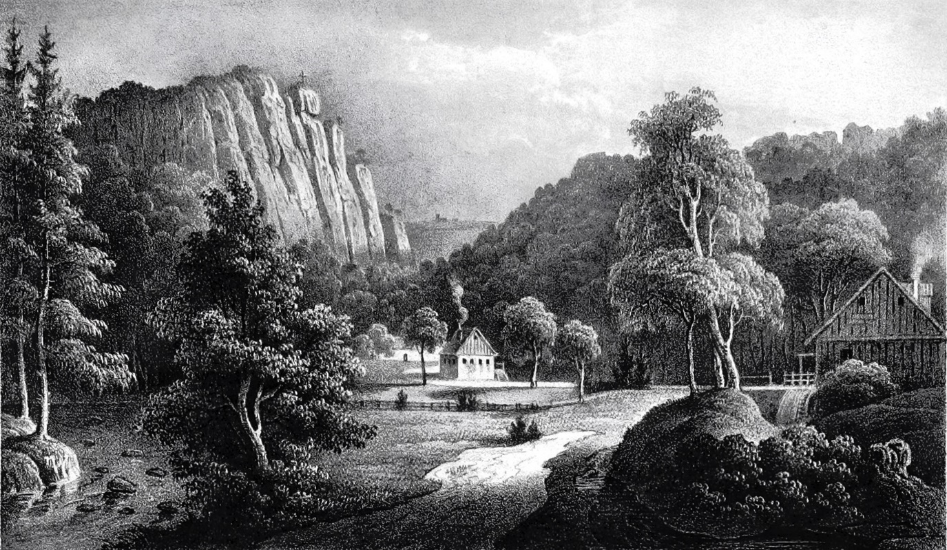
‘The Ilsenstein with the entrance to the Ilse Valley.’ 19th century
Wikimedia Commons

As if wandering in a dream, I almost failed to note that we were leaving the depths of the Ilse Valley, and climbing upwards once more. The ascent was steep and arduous, and many were out of breath. But like my late cousin (Till Eulenspiegel, the medieval ‘fool’) who is buried in Mölln, I anticipated the corresponding descent and was all the more pleased by it. Finally, we reached the Ilsestein.
This enormous granite rock rises boldly, and loftily, from the depths. It is surrounded on three sides by high, forest-clad mountains, but the fourth, the northern side, opens on a view of Ilsenburg and the Ilse River, far down below in the lowlands. On the tower-like summit of the rock stands a large iron cross, though there is still room for four human feet if needs be.
Just as Nature has endowed the Ilsenstein with great charm due to its location and form, legend too has cast a rosy glow over it. Gottschalk reports: ‘It is said that an enchanted castle once stood here, in which the rich and beautiful Princess Ilse lived, who still bathes in the Ilse every morning; and whoever is lucky enough to encounter her at the right moment will be led into the rock where her castle yet lies, and royally rewarded.’ Others tell a lovely story about the love of Ilse and the Knight of Westerberg, a variant of which one of our most famous poets (Karl Gottfried Theodor Winkler who wrote under the name ‘Theodor Hell’, i.e. ‘Theodor Bright’) romantically sang about in the Dresden ‘Abendzeitung’ (in September 1824). Others tell a different tale: it is the old Saxon Emperor Henry (Henry IV) who is said to have whiled away his imperial hours with Ilse, the beautiful water-faery, in her enchanted castle in the rock. More recently, a certain Ludwig Ferdinand Niemann, who has published a travel guide to the Harz Mountains (‘Handbuch für Harzreisende’, 1824) in which he has recorded the heights of mountains, the magnetic needle’s deviations, the debts of the various towns, and the like, with commendable diligence and arithmetic precision, claimed: ‘What is related concerning the beautiful Princess Ilse belongs to the realm of fable.’ So, say all those people, to whom a princess has never appeared, but I, who am especially favoured by beautiful ladies, know better. As did Emperor Henry. It was not for nothing that the old Saxon emperors were so attached to their native Harz. Just leaf through the pretty ‘Lüneburg Chronicle’, where those fine old gentlemen are portrayed in wonderfully faithful woodcuts, fully-armed, high on their armoured warhorses, the sacred imperial crown on each precious head, and sceptre and sword in hand; and one can clearly see on their charming, goatee-bearded faces how they often longed for the sweet affection of their Harz princesses and the cozy rustling of the Harz forest, when they were abroad, perhaps even when campaigning in the citrus-bearing, poison-rich Italy, to which they and their successors were so often drawn by the desire to be named as Roman emperors, a truly German addiction to titles which led to the downfall of emperor and empire.
But I advise anyone standing on the summit of the Ilsenstein to think neither of the emperor nor the empire, nor even of the beautiful Ilse, but only of their feet. For as I stood there, lost in thought, I suddenly seemed to hear subterranean music from that enchanted castle, and saw the mountains all around turn upside-down, the red-tiled roofs of Ilsenburg begin to dance, and the green trees fly about in the blue air, until everything before my eyes was blue and green, and I would surely have fallen, seized by vertigo, into the abyss, if I had not clung to the iron cross in spiritual distress. Surely no one will blame me for doing the latter, when in such a precarious position!

XII: Postscript
This ‘Harz Journey’ is, and will remain, a fragment, the colourful threads, woven so beautifully and harmoniously within the whole, have now been cut, as if by the scissors of a relentless Fate (Atropos, who cuts the thread of a life). Perhaps I will weave them together further in future songs, and what is now concealed in miserly manner will then be uttered fully. In the end, where and when one has expressed something is of little account, given that one has actually succeeded in expressing it. Let the individual pieces remain fragments, as long as when brought together they form a kind of whole. Through such a union, their imperfections may here and there be outweighed, harsh words counter-balanced, and the overly-harsh tempered. That would perhaps already be the case with the first pages of the ‘Harz Journey’, and they might well make less of a sour impression, if it had been revealed elsewhere that the displeasure I feel regarding Göttingen in general, though even greater than I have expressed, is by no means as great as the respect I feel for certain individuals there. And why should I be silent about them? I mean, in particular, that much-loved person who, as I have said earlier, took such a friendly interest in me; who, even then, instilled in me a deep love for the study of history; and who later strengthened my zeal for the subject, and so led my mind into calmer paths, directed my spirit in more wholesome directions, and generally provided those historical consolations without which I would never be able to endure the painful events of the day. I am speaking of Georg Friedrich Sartorius, that great historian and human being, whose eye is a bright star in our dark times, and whose hospitable heart is open to all the sorrows and joys of others, to all that concerns beggars or kings, and to the last sighs of vanishing nations and their gods.
I cannot help but note here that the Upper Harz, the section I have described as far as the beginning of the Ilse Valley, is by no means as pleasing a sight as the romantically picturesque Lower Harz and, in its wild, rugged, pine-clad beauty, contrasts sharply with it. Likewise, the three valleys of the Lower Harz, formed by the Ilse, the Bode, and the Selke, contrast gracefully with one another, if one knows how to personify the character of each valley. They are three female figures, of whom it is not easy to distinguish which is the most beautiful.
Of dear Ilse, and how sweetly and lovingly she welcomed me, I have already spoken and sung. The gloomier beauty, Bode, failed to receive me as graciously, and when I first saw her in the village of forge-darkened Rübeland, she seemed quite sullen, and wrapped herself in a silver-grey veil of rain. But as a hastily-contrived sign of love, she cast her veil away as I reached the granite summit of the Rosstrappe. Her face shone upon me in sunniest splendour, a vast tenderness breathed from her every feature, and from that rocky breast, now conquered, emerged what seemed like sighs of longing, and melting tones of melancholy. Less tender, but more cheerful, appeared to me the beautiful Selke, a lovely, amiable lady, whose noble simplicity, and calm serenity keep sentimental familiarity at bay, but who nevertheless betrays her mocking spirit by a half-hidden smile. I would like to attribute to that spirit, the fact that many small mishaps befell me in the Selke Valley: that, as I tried to leap the stream, I plunged straight into its midst; that later, after I had exchanged my wet shoes for slippers, one of them came off, or rather, fell off; that a gust of wind stole my cap; that thorns sadly tore at my legs, and so on. But I gladly forgive the beautiful lady for all my misfortunes, for she is beautiful. And even now she stands before the gates of my imagination with all her quiet charm, seeming to say: ‘Even though I laugh, I mean well by you; so, I beg of you, sing my praises!’ The cordial Bode also emerges from memory, and her dark eyes say: ‘You resemble me in your pride and pain, and I wish you to love me.’ The beautiful Ilse too comes leaping by, dainty and enchanting in countenance, form, and movement. She is exactly like the lovely creature who fills my dreams and, exactly as she does, looks at me with unconquerable indifference, yet at the same time is so intimately, eternally, transparently true. – Well, I am lord Paris; the three goddesses stand before me; and I hand the apple to the lovely Ilse.
Today is the first of May, Spring, like an ocean, floods the earth with ​​life; white foaming blossom clings to the trees; a wide, warm, misty glow spreads everywhere, and in the city the window-panes of the houses are sparkling joyfully; the sparrows are building their nests in the eaves once more; people are walking in the streets and are surprised that their feeling of joy is so strong, and that they themselves feel so strange; the colourful Vierländer girls (Vierlände is an area in the Hamburg region) appear with bouquets of violets; the illegitimate, orphaned lads in their blue jackets with their sweet, faces walk down the Jungfernstieg (a promenade in Hamburg) and are as happy as if they were about to meet their fathers this very day; the beggar on the bridge looks as pleased as if he had won the lottery, and even the grimy, still as yet unhanged, pedlar who wanders about there with his mischievous ‘manufactured-goods’ face on, is illuminated by the sun with its most tolerant of rays – I wish to take a stroll beyond the town gate.
It is the first of May, and I think of you, lovely Ilse – or should I call you ‘Amalie,’ since that is the name I like most of all? (The name being that of his cousin, Amalie Heine, for whom he felt a lifelong unrequited love) – I think of you, and would like to see you once more, gleaming as you race down the mountain. But most of all, I would like to stand below in the valley so as to catch you in my arms. It’s a fine day! Everywhere I see the colour green, the colour of hope. Everywhere, like lovely miracles, the flowers bloom, and my heart longs to bloom again. This heart of mine is a flower too, though a very strange one. It is no humble violet, no smiling rose, neither a pure lily nor any other flower that charms a girl’s senses with its delightful, graceful sweetness, and can be set prettily against a pretty bosom, but one that wilts today and blooms again tomorrow. This heart of mine is more like that curious, weighty flower from the forests of Brazil, which, according to legend, blooms only once every hundred years. I remember seeing such a flower as a boy. We heard a sound like a pistol-shot in the night, and the following morning the neighbours’ children told me that it was their ‘aloe’ that had blossomed suddenly and produced that loud bang. They led me into their garden, and there, to my amazement, I saw that the tough little plant with foolishly-broad, sharply-serrated leaves, which could easily injure one, had now raised itself in the air and, like a golden crown, bore the most magnificent blossom at the top. We children were not tall enough to see, and old, grinning Christian, who loved us, built a wooden staircase round the flower, and we clambered up like cats, to peer, full of curiosity, into that open calyx, from which yellow threads like rays of sunlight, and utterly strange fragrances, issued forth in incredible splendour.
Yes, Amalie, this heart of mine, does not bloom readily or often; as far as I can remember, it has bloomed only once, and that must have been a long time ago, certainly a hundred years at least. I believe that, however magnificently its blossom unfolded then, it must have withered, sadly, from lack of sunshine and warmth, if it has not been violently ruined by a dark winter storm. But now it stirs again and presses against my breast, and if you suddenly hear that pistol-shot — lovely girl, fear not! I have not killed myself, but my love has burst its bud, and shoots upwards in radiant song, in eternal dithyrambs, in joyous poetic abundance
But if this elevated form of love is too much for you, dear girl, then, at your ease, climb those wooden steps, and look down from there into my blossoming heart.
It is still early in the day, the sun has barely completed half its journey, and my heart already breathes its perfume so powerfully that it rises to my head, and I no longer know where irony ends and heaven begins; so powerfully, that I populate the air with my sighs, while I myself long to dissolve into sweet atoms, into the uncreated Divinity – how will things be when night falls, and the stars appear in the sky, ‘the ill-omened stars that possess the power to tell you…’
It’s May Day, the most pathetic little shop-boy has the right to be sentimental today, and would you deny a poet the same?

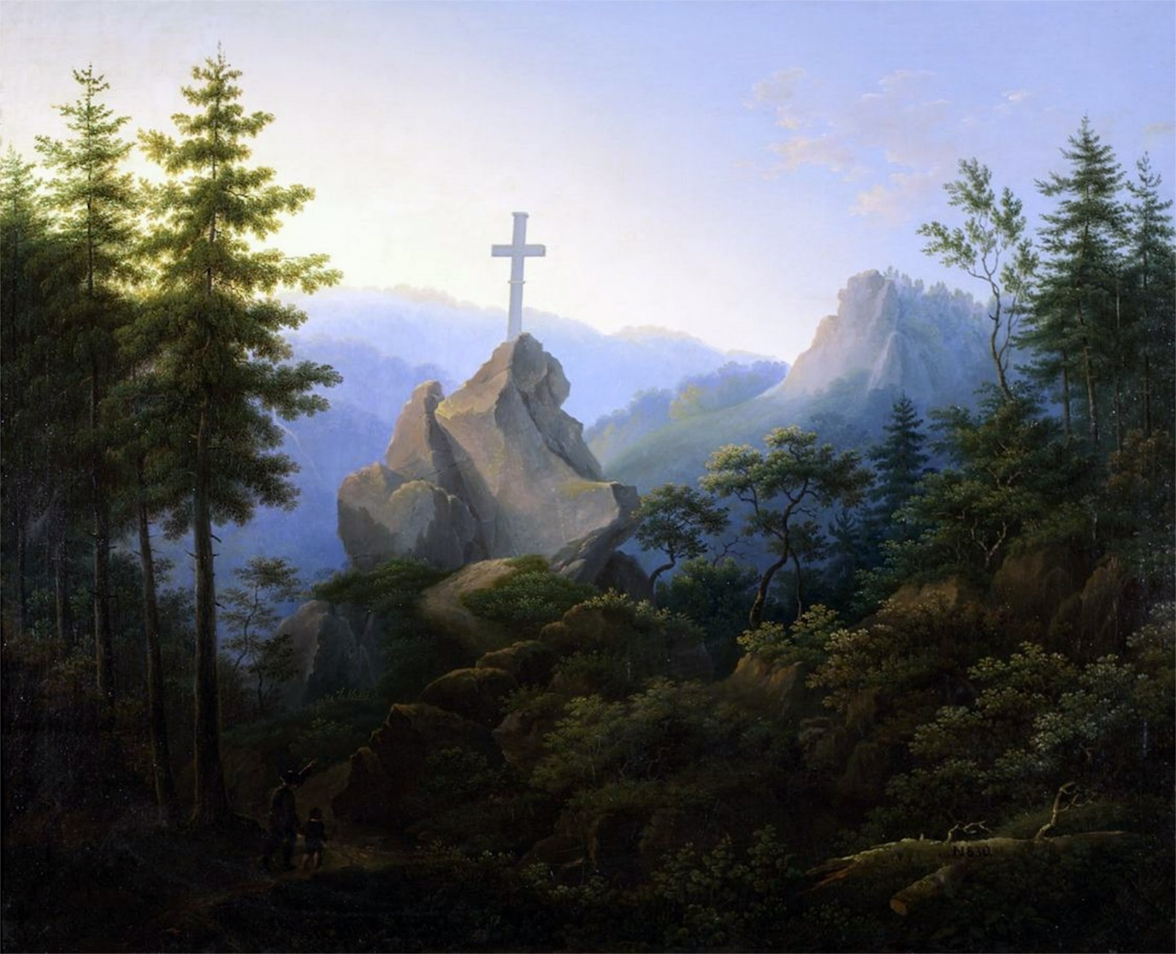
‘Ilsenstein at the foot of the Brocken in the Harz Mountains (1830)’ Hermann Joseph Neefe (1790–1854)
Wikimedia Commons

End of Part IV and of Heinrich Heine’s ‘Die Harzreise’

