Théophile Gautier

A Tour in Belgium

(Un Tour en Belgique, 1836, 1846)

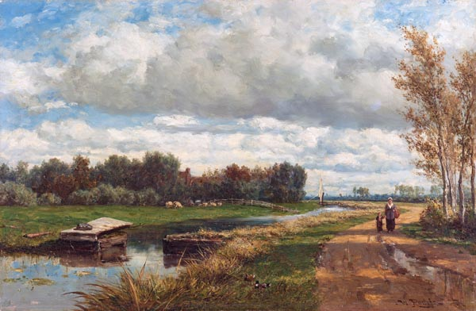

Landscape in the Environs of The Hague
Willem Roelofs (I) (c. 1870 - c. 1875)

Translated by A. S. Kline © 2025 All Rights Reserved.
This work may be freely reproduced, stored, and transmitted, electronically or otherwise, for any non-commercial purpose.

Contents

Translator’s Introduction 3
A Tour in Belgium 5
Part I: 1836 5
Chapter I: Paris to Gournay 5
Chapter II: Gournay to Péronne 13
Chapter III: Cambrai to Valenciennes 19
Chapter IV: Mons to Brussels 30
Chapter V: Brussels 37
Chapter VI: The Railway, and Antwerp 47
Part II: 1846 59
Chapter VII: Antwerp to Amsterdam 59
Chapter VIII: Rembrandt, and Rotterdam 69

Translator’s Introduction

Théophile Gautier (1811-1872) was born in Tarbes, in the Hautes-Pyrénées region of south-west France, his family moving to Paris in 1814. He was a friend, at school, of the poet Gérard de Nerval, who introduced him to Victor Hugo. Gautier contributed to various journals, including La Presse, throughout his life, which offered opportunities for travel in Spain, Algeria, Italy, Russia, and Egypt. He was a devotee of the ballet, writing a number of scenarios including that of Giselle. At the time of the 1848 Revolution, he expressed strong support for the ideals of the second Republic, a support which he maintained for the rest of his life.
A successor to the first wave of Romantic writers, including Chateaubriand and Lamartine, he directed the Revue de Paris from 1851 to 1856, worked as a journalist for La Presse and Le Moniteur universel, and in 1856 became editor of L’Artiste, in which he published numerous editorials asserting his doctrine of ‘Art for art’s sake’. Saint-Beuve secured him critical acclaim; he became chairman of the Société Nationale des Beaux-Arts in 1862, and in 1868 was granted the sinecure of librarian to Princess Mathilde Bonaparte, a cousin of Napoleon III, having been introduced to her salon.
Gautier remained in Paris during the Franco-Prussian War of 1870-71, and the aftermath of the 1871 Commune, dying of heart disease at the age of sixty-one in 1872.
Though ostensibly a Romantic poet, Gautier may be seen as a forerunner to, or point of reference for, a number of divergent poetic movements including Symbolism and Modernism.
On Gautier’s visit to Belgium in 1836, from July to September, he was accompanied by his friend Gérard de Nerval, nicknamed Fritz. They crossed the border on foot. Ten years later, in 1846, Gautier travelled by train to Belgium, Germany and the Netherlands. He combined his notes on the journeys into this travel-piece, published in his collection Zigzags.
This enhanced translation of Un Tour en Belgique has been designed to offer maximum compatibility with current search engines. Among other modifications, the proper names of people and places, and the titles given to works of art, have been fully researched, modernised, and expanded; comments in parentheses have been added here and there to provide a reference, or clarify meaning; and minor typographic or factual errors, for example incorrect attributions and dates, in the original text, have been eliminated from this new translation.

A Tour in Belgium

Part I: 1836

Chapter I: Paris to Gournay

Before beginning the triumphant tale of my expedition, I believe I should tell the world that it will find here neither lofty political considerations, nor theories regarding the railways, nor complaints with regard to the pirating of books, nor dithyrambic tirades in honour of the millions of folk employed in every enterprise of that happy country of Belgium, a true industrial Eldorado; my account will cover only what I saw with my own eyes, that is to say, through my binoculars, and opera glasses too, since I feared my eyes might deceive me. My account will owe nothing to traveller’s guides, nor volumes on geography or history, and that is a merit rare enough to deserve the reader’s gratitude.
This journey was the first I had ever made outside of France, and I have returned with the following conviction, namely, that travel writers have never set foot in the countries they describe, or if they have, like the Abbé de Vertot their ‘siege’ was written in advance (René-Aubert Vertot wrote a number of histories. When offered additional information regarding the Ottoman siege of Malta in 1565, he replied that his siege was ‘already over’, interpreted as a disregard for historical accuracy.) Various descriptions of Belgium which I have read since my return have singularly astonished me in regard to the vast, and poetic, expenditure of imagination involved. Certainly, I failed to recognise the country or the people I had just visited.
Now, if the curious wish to know why I went to Belgium rather than elsewhere, I will gladly tell them, since I have nothing to hide from so respectable a being as a reader. It is an idea which came to me in the Louvre, while walking in the Rubens gallery. The sight of those lovely women with plump forms, those fine bodies so full of health, all those mountains of pink flesh over which fall torrents of golden hair, inspired me with the desire to confront the reality. Moreover, the heroine of my next novel was to be blonde in the extreme, so I would be killing two birds with one stone, as they say. These are the motives, then, which pushed an honest and naive Parisian to commit a brief infidelity as regards his beloved Rue Saint-Honoré. I did not seek the East, like Père Enfantin, to find the ‘free’ woman (see ‘Père Enfantin’ no. 2 in the series ‘Portraits Historiques au Dix-Neuvième Siècle’, by Hippolyte Castille. Barthélemy-Prosper Enfantin was one of the founders of Saint-Simonianism a form of utopian socialism. He supported the Suez Canal engineering project after travelling to the Near East. He wore a badge with the title of Père, declared himself the ‘chosen of God’, and searched for a woman predestined to be the ‘female Messiah’ and mother of a new saviour), I sought the North and the ‘blonde’ woman; I succeeded little better than did the venerable Enfantin, ex-deity, and now an engineer.
You know the difficulty with which a Parisian tears himself away from Paris, and how deeply the human plant drives it roots into cracks in the pavement. It took me three months to decide on this fifteen-day journey. My trunk was packed and unpacked a dozen times, and a seat in every diligence reserved; I had said farewell, I know not how many times, to the three or four people I thought likely to note my absence; my feelings suffered greatly from the repetition of these pathetic scenes, and my stomach began to ache, from drinking stirrup-cups; eventually, one fine morning, having exchanged a fairly large pile of hundred-sou pieces (écus, worth five francs each) for a much smaller pile of louis (twenty-franc coins), I gripped myself by the collar and threw myself from the house, ordering my companion whom I left there to shoot me like a rabid wolf if I appeared again before the three weeks were up, and headed for the fateful Rue du Bouloi (near the Palais-Royal) where the stagecoach awaited.
It is clear that the departure of a friend must painfully affect sensitive souls; and yet, if you remain, after having announced a trip, something that looks much like discontent begins to appear among your entourage; it seems you are no longer entitled to cross the Pont des Arts for a sou, or the Pont de Neuf for nothing. Your doorman when you seek to enter, draws back the rope, reluctantly; Paris, grasping you by the shoulders, pushes you away, and your own room regards you as an intruder. That is what happened to me through having said I was leaving for Antwerp. The divinity whom I worship, while agreeing that these three weeks would seem very long to her, pointed out that I should have left some while before.
If you visit Belgium, and you have literary friends, the inconvenience is twofold: ‘Bring me my latest novel, or volume of poetry, a Hugo, a Lamartine, an Alfred de Musset, a Manuel du Libraire (Jacques-Charles Brunet’s ‘Bookseller’s and Book-Lover’s Handbook’), four volumes in octavo, pardon my asking.’ Make sure the pages are cut, or they’ll be seized by Customs; and what have we here, a three-page list of items, longer than Don Juan’s! ‘Sono Mille e trè’ (‘There’s a thousand and three’, Leporello’s catalogue aria from Mozart’s opera), and yet no one thinks to offer you a full purse or an empty trunk to bring back all that baggage.
My father, who accompanied me to the stagecoach, behaved very well in this supreme situation; he declined to press me to his heart, and avoided giving me his blessing, yet gave me nothing else. My conduct was also very manly: I did not cry; I did not kiss the soil of this fair France that I was about to leave, and I even hummed quite gaily and as tunelessly as usual a little air which is my lillibulerro and my tirily; but all my courage abandoned me when I saw my two female companions arrive, or rather my two travelling companions: they were between twenty-nine and sixty years old, with extravagant hats, outrageous sleeves, disproportionate curls, unsociable noses, and the most cannibalistic and most odiously garish of all the green and red parrots that ever made an honest man, imprisoned in a carriage, despair. At the sight, my eyebrow:

‘Prit l’effroyable aspect d’un accent circonflexe,’

‘Took on the fearful appearance of a circumflex accent’

(See Alfred de Musset’s poem ‘Les Secrètes Pensées de Rafaël, verse 2’)

and I felt a sadness, like to death, in my heart. Fortunately, I, as well as my brave comrade Fritz, of whom I have not yet spoken to you and of whom I will speak to you more than once, because he is the best fellow in the world found another seat inside. The coach departed, and, having arrived at the Barrière de la Villette, I was able to say, with Jean-Jacques Rousseau: ‘Adieu then, Paris, famed city of noise, smoke, and mud (see Rousseau’s ‘Émile’, the end of Book IV)
How wretched the surroundings to the Queen of Cities are! There is nothing more poverty-stricken in the world than those houses whose sides, laid bare due to the demolition of neighbouring buildings, still retain the black imprints of chimney-pipes, shredded-paper, and the remains of half-effaced paint, or those wastelands pocked by puddles of water, and heaped with mounds of filth, which one views near the barriers: the degradation and filth were especially noticeable to me on my return, accustomed as I was to the cleanliness and excellent maintenance of Flemish cities.
True to my role as a picturesque traveller, I stuck my nose out of the window, to right and left, to see how Nature bore herself. I first observed a large number of tree trunks, which I will refrain from describing one by one, since that might prove a little monotonous in the long run: these trunks, whose foliage I could not see, galloped by at the speed of the horses, and fled like an army of routed wooden posts. Through this kind of moving grille appeared ploughed fields, crops of different hues, a few little houses with wisps of smoke rising, processions of poplars, orchards of fruit trees, and, at the very edge, a blue horizon, two fingers high; then, above, large banks of dappled grey cloud with, at certain places in the heavens, streaks of greenish azure, and piles of snowy flakes like melting ice in one of the polar seas. The sky was very beautiful, richly painted in broad, proud strokes; as for the ground, I found that much less successful; the lines were cold, the colours dry and garish: I failed to understand how Nature could seem so unnatural, or look so much like a tasteless dining-room tapestry. I am not sure whether the habit of viewing pictures has distorted my eyes and judgment or no, but I have quite often experienced a singular sensation when faced with reality; the real landscape seemed to me to be painted and to be, after all, only a clumsy imitation of the landscapes of Louis-Nicholas Cabat, or Jacob von Ruisdael. This idea struck me more than once on seeing those interminable ribbons of chocolate-coloured earth, and those rows of trees of the most delectable spinach-green that one can imagine, unfold beyond the window.
Surely a painter who would risk such foliage, and such soil, would be accused by all of not being true to nature; all this was outlined as if with a metal punch, with an inconceivable crudeness, harshness, and lack of aerial perspective: the stage-sets of the Gymnase (Le Théâtre du Gymnase, on Boulevard Bonne-Nouvelle, Paris), wherein one beholds large lawns in the manner of billiard tables, with café-au-lait paths, and houses which seem to have donned Nankeen trousers, resemble nature much more than one might think.
So much for the colour; as for the form, imagine I know not how many leagues of narrow strips, in the style of those wide drawings lithographed by Louis-Jules Arnout, which represent the quays or the boulevards; there is no more apt comparison.
On a fairly steep descent, I noted a certain number of small crosses of a rather sinister appearance, at the sides of the road, and was told that these marked the sites where unfortunate postilions had been killed in falling from their horses, and where the diligence had overturned with a great loss of commercial travellers and other useful objects; an explanation which caused a woman of sorts, of a disagreeable age, adorned with two soot-coloured eyes, a modestly red nose and, as her principal means of seduction, thirty-two teeth of yellowish ivory as long and broad as knife handles, and of the most formidable appearance in the world, to cry out. This interesting young person, who displayed profound strategic knowledge, and seemed to know the entire French army intimately, crouched in a corner of the carriage, surrounded by all sorts of bags and pouches containing unknown dishes which made strange noises at each jolt of the carriage. Every ten minutes she vanished beneath them, with a regularity which would have done honour to the most well-regulated watch.
As I have sketched the scene, and so that the gathering is complete, I will give a brief description here of the rest of the carriage. First, a tall old man, as thin as a lizard that has fasted for six months, and mummified so to speak, so dry in fact that if he had snuffed out a candle with his fingers, he would have infallibly caught alight. His wrinkled forehead had more ditches and counterscarps than a city fortified in the manner of Vauban. His withered cheeks, crossed with scarlet fibrils, resembled vine leaves scorched by frost; and the blackened mouth in his earthy face represented, quite closely, the slot in a money-box. This witness of ancient days, this contemporary of the fossil world, whose white hair was long past turning grey, indulged in the most anacreontic facetiousness, and recounted his good fortune in the remote era when it seems he had flourished; he never stopped talking;

‘Près de lui, non, Hercules
Et Jupiter n’étaient que des fats ridicules’

‘Next to him, why, Hercules
and Jupiter were merely ridiculous fops’

(A modification of the lines from Victor Hugo’s ‘Le Roi S’Amuse, Act I’)

His chief tale concerned the love he had felt, during the Revolution, for a ‘Goddess of Liberty’, who was quite the libertine; a play on words he seemed most fond of, since he repeated it five or six times in five or six different ways. I think scant truth was to be found in any of the versions.
Secondly: a certain eccentric and mysterious being to whom I failed, at first, to assign a profession: he was dressed in a peculiar way: his pretentiously cut frock-coat, of a shiny material, gave off very singular metallic gleams; one would have said that he was fresh from the river, or had just had a shower. A little cap, all curled up waddled about, without losing its balance, on his little pate, which was all humped and full of protuberances. His trousers were of no great note, but his boots seemed doubtful to me, not to say suspicious. I have never seen a more comical physiognomy; one hooked eyebrow, set much higher than the other, gave him something of a fearful and extravagant air, the comic effect of which can only be rendered with difficulty. His nose seemed like a wedge that had been driven into the midst of his face; his chin had been carved out with an axe by negligent Nature, and from the centre of his neck, left exposed by a very low cravat, an enormous cartilage projected which would have made old wives say that a quarter of the famed and fatal apple had caught in his throat, a piece which he could not help but swallow. Nervous tics shook his face from time to time; he rolled his eyes exorbitantly, and scrunched up his lips like a monkey, while saying his paternosters in a low voice. The fellow had certainly posed for the first nutcracker made in Nuremberg: as for the rest, he said not a word. I might have thought him a poet who was looking for rhymes for triumph and uncle, so deeply occupied he seemed. But the shape of his hands did not allow me to dwell on this purely gratuitous supposition. — We will see who he was, later; this droll character who seemed to have escaped from a fantastic tale by Ernst Hoffmann (see E. T. A. Hoffman’s tale, ‘The Nutcracker and The Mouse King’ ‘Nussknacker und Mausekönig’, 1816), and who, in fact, would have played his role there very well.
I will not give you the topography of my illustrious comrade, for fear of offending his modesty and violating his incognito. You lose a lot by it, because, in this happy expedition in search of the jester, the most buffoonish thing I saw was most certainly him; I will only tell you that he did not once cast his eyes on the country he was crossing, and that he spent all his time reading La Nouvelle Héloïse (by Jean-Jacques Rousseau), or La Fleur des Histoires (a universal history with moral examples, by Jean Mansel, c1456), an occupation that could not have been more edifying.
Near the border of the Seine department, the door of our menagerie was opened, and a new creature was thrust within: I had never seen one like him: he was an agreeable-looking Walloon wearing the national blouse and matching cap; this fellow had under his arm an object made of tin, oblong in shape, whose contents were hidden. He squeezed in between me and the old man of few words, and took from his pocket a prodigious disk that, at first, I took for a table fit for twelve place-settings, or a millstone, but which was in fact a snuffbox whose two hinges uttered, as they turned on themselves, cries more terrible than those of twenty cats flayed alive. Robert Macaire's snuffbox is a harmonica in comparison (Macaire was a character created by the playwright Benjamin Antier, and brought to life on-stage by Fréderick Lémaitre). The Walloon drew handfuls of powder from this ‘crater’ with which he stuffed his ‘trunk’, snorting with a formidable noise, like Leviathan or Behemoth when they sneeze; but let us not anticipate the passage of events.
The coach rolled along and we soon arrived at a village, a hamlet or a town, I am profoundly incapable of telling you which, whose houses, without a single exception, bore upon their foreheads, in characters of all sizes, and with all possible and impossible errors in its spelling, the enticing and deceitful inscription: ‘The Celebrated Ratafia’ (a fruit liqueur flavoured with almond). While changing horses in this place, we descended from our perch and, as conscientious tourists, went off to verify the assertion. We began with the food-sellers on the left, and ended with those on the right and, I swear, by Triple-faced Hecate and the impassable Styx, the drink is dreadfully disappointing: imagine something bitter and insipid, with an abominable aftertaste of molasses, like soured blackcurrant. O overconfident traveller, never drink ratafia at Louvres; may our misfortune render a service to humanity! — In the same place, we viewed, in compensation, a Gothic Hôtel-Dieu (hospital), with diamond-pointed ogives of a rather fine character, and beggars so well-dressed and of such good bearing, that we were tempted to ask them for alms.
Senlis, once left behind, seemed to pursue us, the great finger of its bell-tower pointing to the sky, who were thinking less of the sky than of the table d’hôte, for, alas, hunger, malesuada, was raging furiously, and we were beginning to eye each other closely, with dreadful expressions, as Ugolino looked on his sons in the tower (see Dante’s ‘Inferno, Canto 33’): and if we had not arrived at Gournay (Gournay-sur-Aronde), where lunch was to be had, we would surely have drawn lots to determine who would be eaten by the rest.

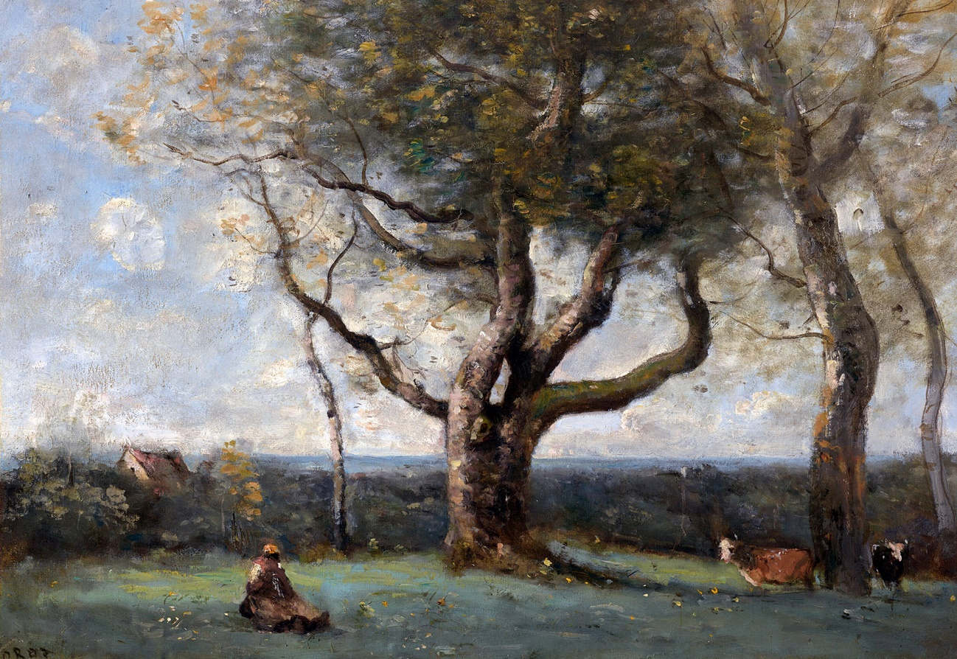

The Large Tree (near Gournay) (1865–1870)
Jean-Baptiste-Camille Corot (French, 1796 - 1875)
Artvee

Let the reader not feel regret as regards the time I have taken to describe the temporary inhabitants of this little four-wheeled abode called a diligence; the view was not exactly interesting, Nature continued to mock me, and to retain its air of a washed-out drawing; there were poplars still, like fish-bones, multi-coloured field-strips like the samples in a tailor’s sample book, vegetation like painted tin, sawdust-coloured soil, trees, earth, and sky as always; not the meanest little viewpoint, not the smallest Romantic or picturesque location.
I will halt here, and let the reader’s imagination dwell on a cheerful scene: picture to yourself a large table, where a constellations of dishes and garnished plates shone on a beautiful white tablecloth; add, two enthusiastic young fellows, alongside a dozen other eager travellers who, with napkins tucked about our necks, possessed the air of Greek heroes each in a marble chlamys (short cloak), a resemblance which was further confirmed by the bellicose attitude with which they brandished their offensive weapons.

Chapter II: Gournay to Péronne

O deceitful innkeepers! You, to whom one can apply as justly as to women the words of Shakespeare: ‘Perfidious as the wave’ (see Victor Hugo’s translation of ‘Othello Act V, Scene II. Othello in the English text says: ‘She was false as water’); you Machiavellian Palforios (Palforio is the innkeeper in Alfred de Musset’s play ‘Les Marrons du Feu’). O, two-faced hosts, do you think that, despite my apparent candour, I have not noticed your diabolical scheme, to ensure that unfortunate folk dying of hunger lose ten of the precious twenty minutes allowed by the implacable coach-driver in which to take their meal?
I denounce to the ambulatory world of travellers this execrable ruse, all the more deceitful, because it comes in the form of a beautiful porcelain soup-tureen, opaque with threads of blue, filled with a soup, cheerful enough to at first remove all suspicion; but this broth which has more eyes than Argus (the hundred-eyed guard of Io, in the Greek myth), was doubtless made in the Devil’s cauldron, with a volcano to heat it, because it exceeds by several degrees the temperature of molten lead, and is still boiling when served.
My acolyte Fritz, resolutely plunging his shiny head into the whirlwind of warm vapour rising from this insidious mixture, took a huge spoonful; from the midst of the thick fog a cry was heard, and soon the worthy Fritz was seen grimacing horribly, and holding in his fingers the first two layers of his tongue, like a glove turned inside-out.
Warned by this dreadful experience, we were forced, despite our more than canine hunger, to wait till our soup cools, since to tolerate such a temperature, one would have to have a palate lined, nailed, and studded with copper. Innkeepers know this well, and they calculate accordingly; the soup maintained so skilfully at a hundred and fifty degrees centigrade (!), spares them the preparation of three or four chickens, and completely saves them the dessert. The delay was all the more painful, since the most mocking of cuckoos, gazing at us from the cuckoo-clock through the two holes like pupils by means of which it was wound, seemed to despise us infinitely, and pursue us with its ironic ticking, which told us in clock language: ‘Time passes, but the soup’s still too hot’. I appeal to all ancient and modern civilisations, was there ever anything crueller?
Another inconvenience presented itself. Though my friend and I had tried not to sit next to a lady at table, for fear of having to appear honest and gallant, a most annoying thing when one wishes to dine seriously, we could not avoid the one seated on our right. — I confess that nothing in the world displeases me more than offering a stranger, built in such a way as to make you consider yourself lucky never to have met her, the only part of a chicken I find edible, that is to say a wing or a piece of breast. Fritz, who shared my pain, cleverly surmounted the difficulty, by seizing from the plate, as it passed by, all the wings a chicken could have. By this clever manoeuvre, I could offer the lady neither wing nor breast, Fritz having confiscated them, on his own authority; I took a small piece of grilled skin for appearance’s sake, while the disappointed lady for her part received only a thigh, stringy and dry as herself: then, the magnanimous Fritz, pretending to have had eyes bigger than his stomach, passed me half of his catch: in this way I received a wing, while not seeming dishonest, and with the fair sex aboard the diligence yet retaining a favourable opinion of me.
Such actions are retained in the memory, and lead to the formation of indissoluble friendships: Orestes and Pylades, Aeneas and Achates, Theseus and Pirithous, doubtless rendered similar services to each other at the table d'hôte. O Friendship! Though Alexandre Dumas calls you in his play Antony (Act III, Scene III) a false and bastard sentiment, I proclaim you here a most agreeable thing, and superior to love, as regards chicken wings.
This battle between innkeepers and travellers, which is called dinner, having ended without too much disadvantage to us, thanks to our expeditious ferocity, we were ordered into our cage again, and the coach set off at full gallop.
The eccentric little fellow, nodding his head more vigorously than usual, muttered between his teeth: ‘Vile dinner, oh, vile indeed!’ Then returned to his reverie. After a few nervous grimaces, each more fantastic than the last, he plunged his bony hand into one of the pockets of his frock-coat, and withdrew a wallet too bulky to be that of an elegiac poet or a vaudevillian. He opened this, and took from one of the folds something black, which he began to observe with an air of indefinable satisfaction. ‘Well!’ I said to myself, ‘It’s a lock of his mistress’s hair: it seems that he’s a lover, despite his comical nose and singular boots.’
I love lovers, being one myself, and I looked at him in a more benevolent way, no doubt, for he handed me the little black bundle he held in his hand, as if to someone judged worthy of understanding him; then remained silent, in his corner, fixing upon me eyes whose pupils were completely surrounded by white, with the corners of his lips about to meet behind his head in a superhuman smile, and his forehead illuminated with the most radiant pride, waiting in silence for an explosion of astonishment on my part.
Dear reader, even if you were Oedipus (pronounced Eedipus, as Kean, the actor, is pronounced Keen), you would never guess what the little motley gentleman, inside the stagecoach from Paris to Brussels, had handed me to examine.
When I had turned the thing over, in all the senses of the phrase, and with the air of a monkey gripping a watch, that astonishing being in the shiny frock-coat said to me, in a tone of deep and restrained jubilation:
— ‘Well, sir, what do you find there?’
— ‘It’s a tiny brown coat of cloth, sewn with white thread by the mischievous Scribbler (‘Gribouille’, a folk character), that is what I find here, sir, and nothing more. I have no idea what one means by such a garment. Are you, by chance, the leader of the learned cockchafers?’
The individual shook his head.
— ‘So, you are Gulliver, back from Lilliput with the clothes of some native of the place; do you also have his breeches?’
— ‘I am not Gulliver, nor know of him; I come from Paris, where I have sold fourteen of these little suits for a hundred francs each, and like you I travel to Brussels, where we shall arrive, please the Lord and the post, tomorrow evening; but look carefully at the clothes once more, especially how they are sewn.’
I began the examination again; but saw no more clearly than at first what was so interesting about this outfit suitable for a puppet, apart from its excessive smallness.
— ‘You see nothing?’ said the little creature after giving me time to collect my thoughts.
— ‘No, upon my word!’ I replied, ‘Set me, if you like, among the class of web-footed birds, or any class of the Institute de France you like, but I can make nothing of it.’
And I gave him the little suit, which he passed on to the other people in the car, who performed no more intelligently than I had.
Then, with the majesty of a mystagogue, or an Orphic poet unveiling an allegory, he explained to his astonished audience how it was a model for a garment, sewn from a single piece of cloth and with a single seam; a technique not known till that day. The thread was white, so that the eye could readily follow the meanderings of the unique and all-conquering seam.
— ‘Yes, there’s not two sous’ worth of cloth in there, and a mere centime’s worth of thread: yet it sells for a hundred francs, though it’s the method of doing so that brings the reward.’
I replied that a seamless garment would be a superior invention and the garment was worth two hundred francs, be it half the size.
— ‘Certainly,’ he replied after a moment of deep thought, ‘but that would only be possible using rubber.’
I thought it necessary, seeing the violent interest he took in it, to grant excessive praise to this wonderful discovery, praise which so roused his self-esteem that he could no longer remain incognito.
— ‘Who do you think invented that, sir? Perhaps you think it was someone else? No! It was I! I have a famous mind, indeed! — I’m a tailor!’ He said this with an expression of happy arrogance, very difficult to render, and in exactly the tone in which one might say: ‘I’m a prince’, or ‘I’m a virtuoso’: then he added in a more human tone: ‘a tailor to civilians and the military, Rue d’Or, Brussels.’
‘The Devil!’ I said to myself — ‘The adventurer’s a prince, the idiot a spirit in disguise, the sleeping cat’s a cat on watch, and my elegiac poet an estimable tailor.’
Finding that I seemed taciturn, he began to speak of his profession, with a transcendental lyricism which reminded me more than once of the enthusiastic little wigmaker whom Ernst Hoffmann so well depicted in The Devil’s Elixirs (his novel, of 1815) — But his inventive spirit was not limited to the making of clothes; he had recently discovered a method for deploying water-mills on the tops of the highest mountains; a discovery as useful as that of establishing windmills at the bottom of wells. He explained the mechanism to me so perfectly, that I confess to my shame that the thing seemed not only possible, but easy, and if I refrain from giving a description of it here it is for fear that some engineer might profit from the process invented by my ‘Friend of the Needle’ and his associate the carpenter; he intended, however, to apply for a patent.
During all this conversation, the trees were still spinning by, to right and left; the pink hues of the horizon were turning to violet; the landscape had dimmed, and the sun, in the mist, looked like a fried egg; which is humiliating for a star about which the poet Jacques Clinchamps de Malfilâtre composed an ode (‘Le Soleil fixe au milieu des planètes’) that Jean le Rond d’Alembert found admirable.
The difference in temperature and the coolness of the onset of night caused a copious, pearly moisture to trickle down the windows, which prevented me from distinguishing the objects without, already blurred by the shadows; a gust of icy breeze making me draw my head back inside each time I advanced it, like a snail whose horns are touched; I therefore renounced my role as observer, and settled down in my corner in the least uncomfortable manner possible. As for Fritz, he thought of a means to encourage sleep, which another might have used to keep awake: he tied both ends of his scarf to the cowl of the carriage, passed his head through this kind of halter, and wa soon drinking in deep gulps from the black cup of sleep. What greatly surprised me was that he failed to actually choke himself; apparently God, always good, always paternal, wanted to spare him the pain of hanging.
All were soon sleeping the sleep of the just in the stagecoach, except the Anacreontic centenarian, who emitted loose words of triple meaning and courted, assiduously, the woman with thirty-two yellowing teeth, whose bag of dishes gave off more and more disturbing noises; Death’s pale brother (in Greek mythology, the gods of Sleep, Hypnos, and Death, Thanatos, are twin brothers) against whom I had been struggling for two hours, at last threw sufficient sand into my eyes, that I was forced to close them, like the rest of the company. There is necessarily, therefore, a gap here in my description of events; I ask the reader’s pardon, but it was impossible for me not to yield to Nature, having resisted her all the previous night in favour of Friendship, to whom I was bidding farewell.
A violent enough jolt woke me, and I heard the carriage wheels rolling, dully, as if over a kind of floor; I lowered the window, and distinguished in the darkness another darkness, opaque and deeper still, like a piece of black velvet on a black cloth: it was Péronne, the outskirts of which we had been traversing for the past half hour, passing through a maze of portals and drawbridges that were quite discouraging, and which help greatly to explain the intact nature of the aforementioned Péronne. As we crossed a sort of square, I caught a glimpse, by the light of two or three stars that had stuck their heads through the cloudy skylight, of a vaguely-outlined four-sided tower. — That was all I could distinguish. After driving through a few more narrow streets, whose houses trembled at the passage of the heavy diligence, we departed through as many portals as on entry.

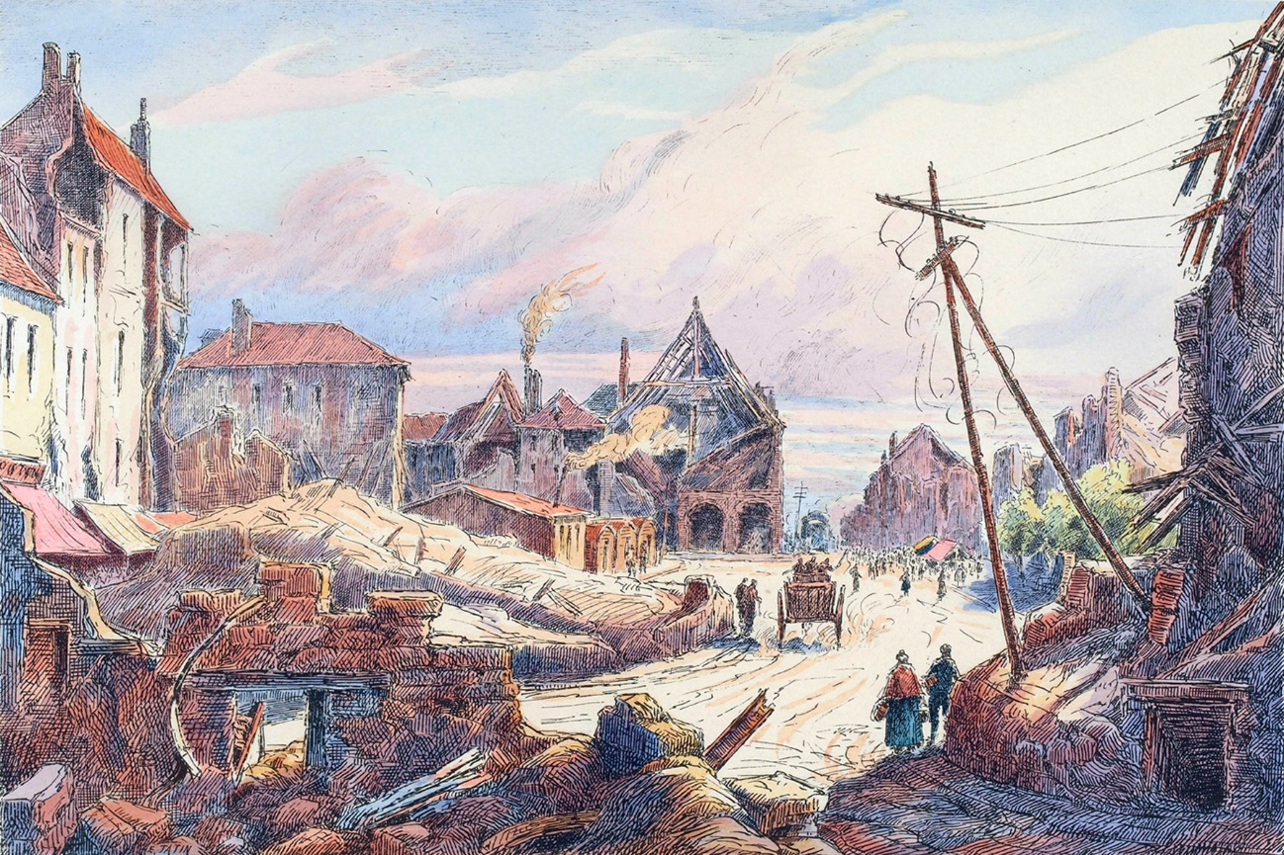

Péronne – Town Hall Square (1920)
E. Tatin (French, 19th/20th century)
Artvee

After traversing Péronne, I fell asleep once more; when I opened my eyes again, day was beginning to break. Dawn had the charming paleness of a young bride, and indeed I think she had not slept that night, lying in her old husband’s bed. (Aurora, the dawn, was in Greek myth, the wife of the mortal Tithonus, who aged while she remained ageless) As for the Sun who was malingering, I think that he had spent the night drinking in some tavern, playing brelan (a card-game somewhat like poker) in the house of Madame Thetis (Thetis was a Greek sea goddess; the sun sinking into the sea, her house, at sunset), because his one open eye was quite red.
We were not far from Cambrai. The aspect of the countryside had changed completely. The temperature had falling considerably, and I expected at any moment to see polar bears appear and ice floes float by. It was only at that latitude I realised I was no longer at Pantin or Bagnolet (suburbs of Paris): the French facial type gives way to the Flemish; it is also near there that the use of stockings and shoes begins to fade, and that so much care is taken in cleaning their houses that people never clean their faces.

Chapter III: Cambrai to Valenciennes

What shall I say of Cambrai, except that it is a fortified town of which François Salignac de La Mothe-Fénélon was once archbishop, which earned him the title of the ‘Swan of Cambrai’, in opposition to the ‘Eagle of Meaux’ (Jacques-Bénigne Bossuet, Fénélon’s chief theological and political adversary was so called); as regards swans though, when I passed through, I saw only a magnificent flock of geese; some white, others speckled with grey.

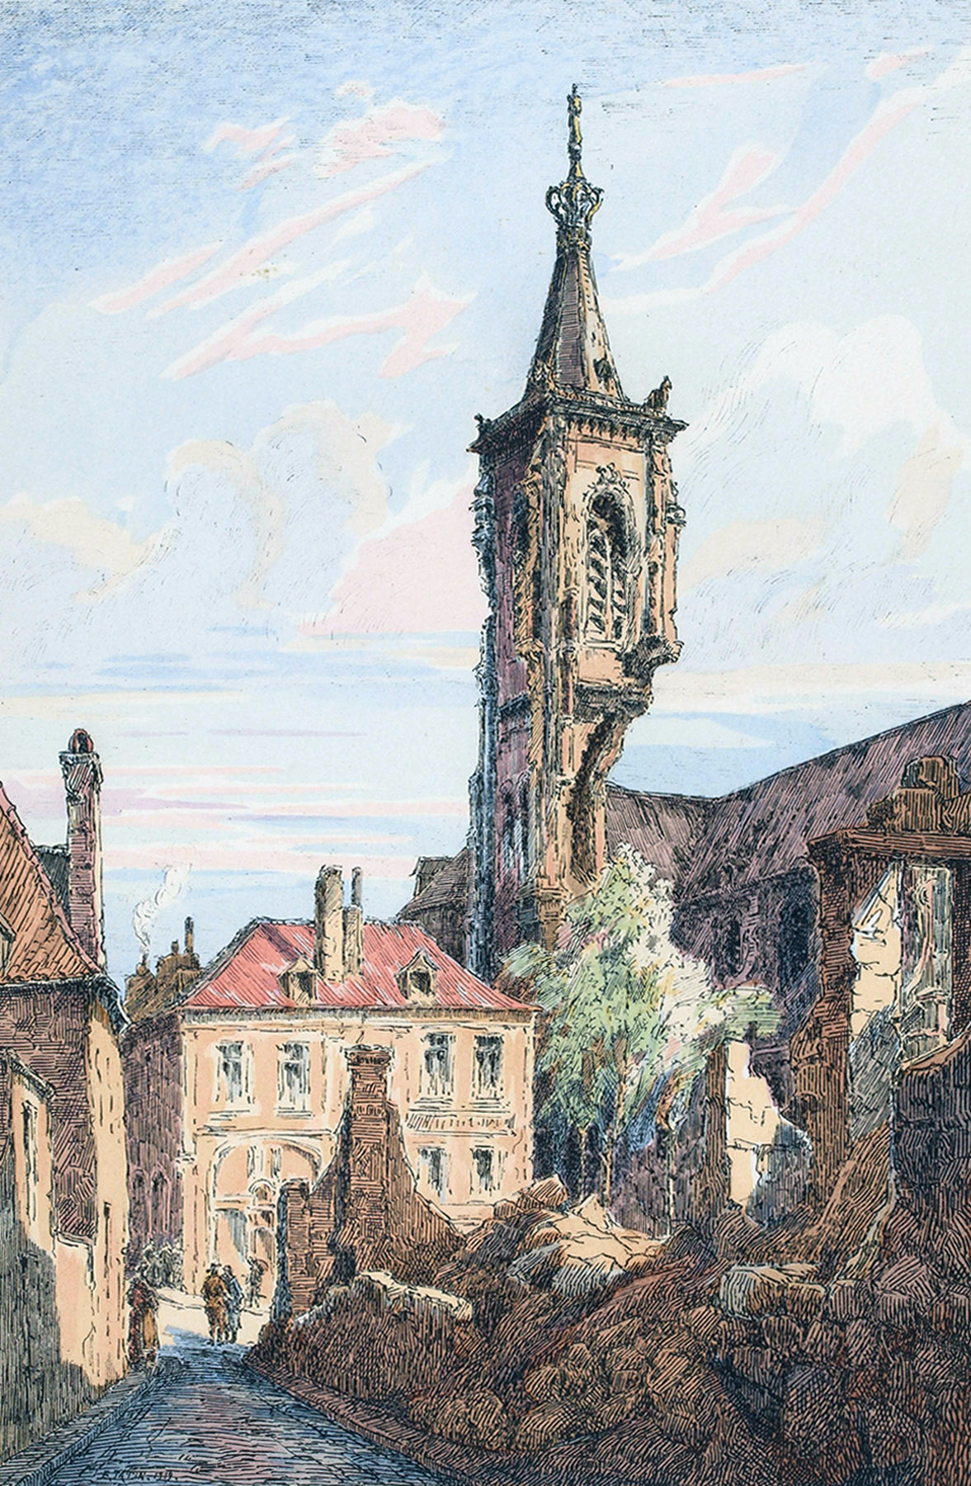

Cambrai – The Cathedral (1920)
E. Tatin (French, 19th/20th century)
Artvee
A fortified city, yet again in the Vauban style, that is to say all one can imagine of the ugliest and saddest architecture in the world. — Imagine three walls of brick making endless zigzags, separated by ditches filled with reeds, rushes, water-lilies, potatoes, and everything in general, except water of course; three walls with no other ornamentation than embrasures for cannon with shutters painted in green, and all three exactly alike. — The soft pink colour of the brick, and the peaceful green of these shutters which are opened every morning to let the cannon get some air, are of the most singular and pastoral effect in the world.
I flatter myself that I am wholly ignorant where military architecture and strategy are concerned; and I confess that these much-vaunted fortifications seem to me to be more suitable for training vines or espalier peach-trees than for defending a city.
I need dungeons, round towers and square towers, superimposed ramparts, machicolations, barbicans, drawbridges, portcullises and all the apparatus of ancient fortresses; lunettes, basins, casemates, bastions, counterscarps and half-moons are less agreeable: I am like Mascarille (a character in Moliere’s play ‘Les Précieuses Ridicules’, once played on-stage by Moliere himself), I believe in full moons.
What is the use of a fortified town, if not to be taken? If there were no fortified towns, there would be no sieges, and I cannot see what prevents us from by-passing these fortresses so virginally entrenched behind their brick skirts and stone farthingales.
Fortified towns seem to me, in truth, despite their prudish air, to be blatant coquettes quite capable of allowing the god Mars (the god of war) to ruffle their battlemented collars, and quicker to untie their girdle of towers, and enter the bed of the conqueror, than one might believe from their wild and fierce reputations. Every possible facility is provided for the enemy to enter by agreement, via an infinity of little paths all strewn with roses (see Moliere’s ‘Les Femmes Savants’, Act III, Scene 2) and very carefully maintained; the embankments and the glacis form gentle slopes that invite those who least enjoy a climb.
In Cambrai, where we dined, I saw nothing remarkable except a gigantic poster from La Presse, and another of more modest dimensions, which informed the worthy inhabitants of the place that the superb play Edward in Scotland (‘Édouard en Écosse’ by Alexandre-Vincent Pineux Duval, 1801), generally admired in Paris, and performed by the leading artistes, was to be enacted that evening at the town’s theatre: and then, a rather fine tower on the right of the road, which I did not have time to examine.
One thing that struck me was that all the streets were covered with bluish dust; three or four coal-carts that I saw passing, which scattered an impalpable powder as they progressed, explained the cause. I had already taken up my pencil to write in my notebook: ‘In these remote and as yet undescribed regions, through some strange phenomenon, the earth is blue.’ Many a traveller’s observations are no better founded.
Here then, to complete the picture of Cambrai, is the appearance of the place which I freely offer to lovers of local colour. — Blue earth, a leaden eau-de-Nil sky, houses the colour of dried rose-leaves, roofs the colour of a bishop’s violet robes, pumpkin-hued men, and straw-coloured women. — Cambrai is an excellent city in which to set an intimate novel; if I were to indulge in that genre, I would sketch out a plot, and involve two pairs of more or less adulterous and consumptive heroes and heroines, which would achieve the finest of effects.
After Cambrai, the countryside took on a character quite different to that which I had seen so far. I was already sensible of our northerly advance, and icy gusts of wind reached my face. I had left Paris the day before, in my shirt, and a temperature of twenty-six degrees; I found after twenty hours’ travel that my virtue alone was an insufficient garment, and carefully wrapped myself in my cloak.
I have never seen anything fresher or more elegant, than the picture which unfolded before my eyes as I left that ugly old town, all soot-stained and black with coal.
The sky was a very light blue, which turned to pale lilac as it approached the region of rosy light with which the rising sun had bathed the horizon. The ground undulated gently, relieving the often monotonous flatness of the landscape, and the view on either side of the path terminated in little strips of harmonious blue; immense fields of poppies all beaded with dew, shivered gently beneath the breath of morning, like a young girl’s shoulders on her leaving the ball; the poppy-flower takes on a delicate blue almost like the flower of the iris, where the white variety reigns; those great azured sheets looked like pieces of sky that a divine washerwoman had spread on the ground to dry. Or the sky resembled a square of inverted poppies, if the comparison pleases you better; one might have thought of Turner’s most limpid watercolours in seeking to describe its transparency, delicacy, and lightness of tone; there were only two dominant tints, moreover, pale blue and pale lilac; here and there a few bands of that prasine green that painters call Veronese green; two or three streaks of ochre and pale yellow on a few distant clumps of trees; that was all; nothing in the world was more charming, these are the effects that one must forego painting or describing, and which are felt rather than seen.
As the coach advanced, the view widened, new perspectives opened on all sides. Little brick houses, buried in foliage, and red as Lady apples (a cultivar, pomme d’api, originating in Brittany) set in moss, advanced between two branches, curious to see us pass. I saw water shimmering beneath the oblique rays of sunlight, or the slate roof of some bell-tower suddenly gleaming like a flake of silver: large gaps allowed the eye to penetrate meadowland of the most amorously spring-like green of which one could dream, and revealed a thousand small, calm and peaceful views, of a most Flemish intimacy and touching charm.
There were especially little paths, real truants, which met the main road, after running along some fence or hawthorn hedge, with the most engagingly uncultivated and wild air in the world, and which delighted me greatly. I would have liked to be able to leave the coach, and plunge at random into one of those paths, which, surely, must lead to the most pleasant and picturesquely rural corners. One cannot imagine how many idylls in the style of Salomon Gessner (painter and poet) those little paths have led me to compose; into what oceans of cream my reverie has plunged on account of them; and how much sugared spinach I have chopped, in imagination!
We often passed through hamlets, villages, and towns, built entirely of brick, charmingly clean, and so neatly built in comparison with the hideous cottages around Paris that I could scarcely overcome my surprise.
All these houses, striped in white and red, gaudily decorated with designs formed by different methods of laying the bricks, with painted and varnished shutters, projecting cornices, purple slate roofs, and sentry-box wells festooned with hop-vines or Virginia creeper, yield the effect of those little towns in coloured wood sent from Nuremberg in pine boxes as children’s New Year gifts. The proportions are necessarily larger, but they look much the same. One of these villages could well have been given to young Gargantua to serve as a toy.
One might expect such houses to contain plump, clean, well-dressed inhabitants, but one would be wrong to judge the snail by its shell. One would willingly place against these lead-glazed windows framed by climbing plants, some misted profile of a young blonde girl, turning about at the sound of the horses, or working at her little spinning wheel:

‘Oeuvre de patience et de mélancolie.’

‘The work of patience and melancholy.’

(see Alfred de Musset’s play: ‘La Coupe et les Lèvres’ Act V, Scene 3)

One imagines some young mother standing on her doorstep with her infant on her arm, highlighted, pure and glowing, against the dark, bituminous front of the lower room, a large dog gazing at her tenderly and barking softly, as if to express that he is taking part in this joyful domestic peace.
Instead, here were ugly creatures, as tanned as if they have been on African campaign, so ugly that the youngest looked sixty years old. These young women, for the most part, kneaded the raw lumps of mud with large flat feet that only lacked webbing, and let the upper fold of their dresses float free, most carelessly. If this was coquetry, it was received badly, for the exhibition was not at all engaging; but I believe they meant no harm by it.
Add to the scene a few snotty-nosed little children, in shirts much shorter in front than back, without shoes or stockings, whose bare legs, red with cold, resembled forked carrots, battling each other with clods of earth at the edge of the ditches, or playing on the doorsteps, and you will have a fairly accurate picture of the population of those delightful little houses.
Victor Hugo somewhere (see his ‘En Voyage: France et Belgique: Brittany’) calls the inhabitants of a wonderful little town in Brittany (Fougères), ‘the bedbugs of these magnificent abodes’. This is true of all places except capital cities; the criticism has appeared excessive to Bretons and even to some Parisians; but it is the only one that seems adequate, when one is on the spot. — Man is superfluous almost everywhere, and the inhabitants are almost never worthy of the landscape.
Every time the stagecoach passed through a village, there would suddenly rise up, from the depths of the ditches, from behind the hedges, from the manure of the farmyards, a pack of little albino boys, with long locks of blond-coloured hair straggling over their eyes, who would follow it to the far end, doing cartwheels, and squealing in a plaintive tone the lone monosyllable cents, cents, the dread meaning of which I understood only later. These little boys, several of whom turned out to be little girls who performed cartwheels as nimbly as the rest, fulfil the role of stray dogs, which is to bark at carriages and bite the horses’ hocks. To be employed as a dog is, in that country, a real sinecure; except that the dogs are better attired, less dirty, and never demand cents: a triple advantage.
Apropos of dogs, I must here record this important remark, that they become rarer and rarer, as one progresses towards the polar regions and the Arctic zone; cats are also very few in number, I saw only five in the whole of my journey; they were of a tawny-grey coat, striped with a few black bands. These poor animals had the air of not dining every day, and to eat little but seldom, contrary to the precept of the Medical School of Salerno (which advised ‘little and often’ see the poem ‘The Flower of Medicine,’ or ‘Flos medicinae’, also known as ‘The Salernitan Rule of Health’). To conclude as regards zoology, I saw two white butterflies only, which traversed the field of view of my telescope between noon and one o’clock; on the other hand, I saw many Walloons in blouses and caps. The windmills (a customary sight and not to be neglected) vary singularly in their form. Here no longer is the classic mill, square, and turning on a pivot, but an elegant tower, of which only the roof and sails are mobile; some wear a collar of wood about the neck, to most picturesque effect. If my brief description is not enough for you, I refer you to a charming little painting by Camille Roqueplan, shown at the last salon, where you will see a collection of windmills, the oddest and most Flemish in all the world. — I will add here, because you would not find an example of it in the painting I mention, that I even noticed one furnished with a single sail, which was moving in the most wild and comical manner one might see. I recommend it to Godefroy Jadin, the Raphael of windmills.
I shall say nothing regarding Bouchain, which is so well-fortified a town that I passed by without seeing it. If you will allow me, I shall skip a few post-stations, and we will be in Valenciennes.
It was around this town that a bad joke began which lasted us throughout our journey: every quarter of an hour, we crossed watercourses and provincial rivers and, as ignorant and conscientious travellers, asked some more or less dense Walloon:
— ‘Sir, the name of the river?’
— ‘It's the Scheldt, sir.’
— ‘Ah! Very good.’
Further on, a fresh river, a further question:
— ‘And this, dear Walloon, would you be so kind as to tell me what waterway it is?’
— ‘Certainly, sir; it is the Scheldt canal.’
— ‘Sir, I am most pleased; I like canals; they are a blessing of civilisation; we should not abuse them, however.’
The Walloon maintained the calm and simple attitude befitting a pure conscience; he did not seem to understand the majestic intent of the last part of the sentence.
- ‘And over there, where I see vessels with red sails and apple-green rudders?’
- ‘The Scheldt, sir, the Scheldt itself’.
We had become so accustomed to this answer, that when we arrived at the coast, at Ostend, my comrade Fritz refused to admit that it was the ocean, and maintained mordicus unguibus et rostro (obstinately, fighting tooth and nail) that it was still the Scheldt canal. I had all the trouble in the world weaning him off the idea; and though he drank the bitter wave like Telemachus, son of Ulysses, (see Fénélon’s ‘Les Aventures de Télémaque: Book V’) he is not yet quite certain of the fact.

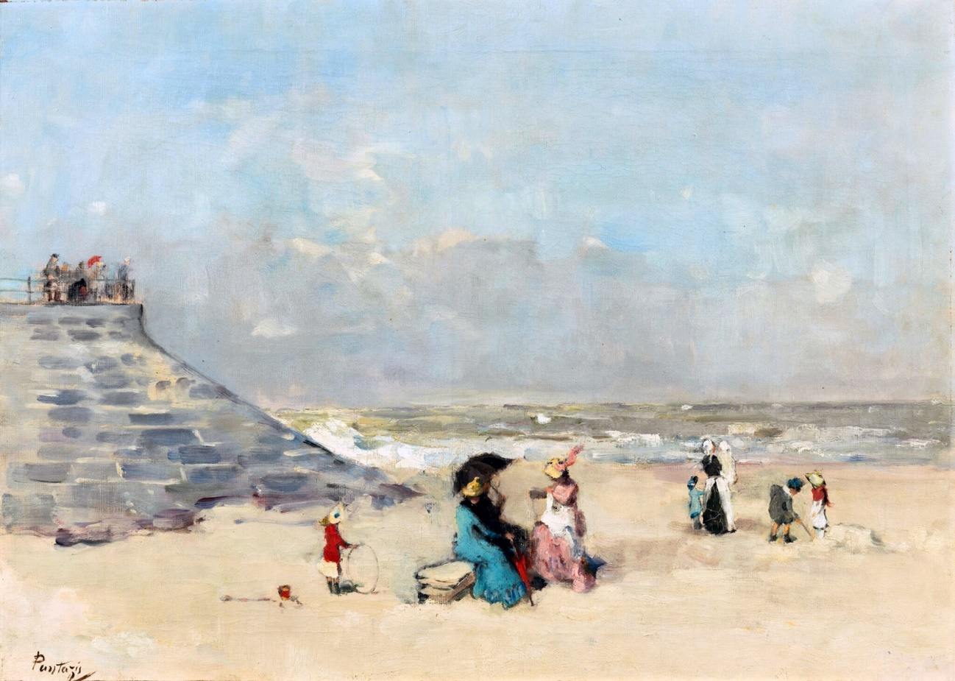

At the beach, Ostend
Pericles Pantazis (Greek, 1864-1871)
Artvee

I entered Valenciennes with the idea that never left me of finding endless embroidery and lace. This expectation was renewed in Malines (Mechelen, Flanders): I would have liked the whole town to be adorned and festooned likewise, and I was disagreeably surprised to see little of the female Valenciennes. All these towns famous, for some particular product, have always had this effect on me. I can imagine Nérac only in the form of a terrine, likewise Angoulême; Chartres is to my imagination only an immense pile of pâtés; Bordeaux a cellar full of bottles with elongated necks; Brussels a large patch of little cabbages, named Brussels sprouts; Ostend an oyster-bed, and so on. How many disappointments such prejudices expose the honest tourist to!
Valenciennes is, however, a pretty little town, with a few Renaissance houses, a town hall from the reign of Louis XIII, and a church in the Florentine style. It was in Valenciennes that I first saw that formidable inscription on the wall, invariably reproduced every ten houses till the end of my marvellous odyssey: ‘Verkoopt men dranken’, which means in loyal Flemish ‘Ici l’on vend à boire’ (Here drink is sold), or in Belgian French: ‘Ici l’on van de boison’ (sic). It was also in Valenciennes that I was given, in change, I know not what fabulous little heaps of cents, lead coins marked with a crowned W (Willem I, Netherlands one cent pieces, issued 1817-1837), which the Devil himself would not have known what to do with, and was also given a hemp-straw match, instead of a wooden one, to light my cigar.
In the main street of Valenciennes, I caught sight of the first and only Peter Rubens model I had seen on my journey in search of blond hair and undulating contours; she was a plump kitchen maid, with enormous hips and a prodigious avalanche of charms, who was innocently sweeping the gutter, without suspecting in the least that she was a truly authentic Rubens. This encounter gave me hope: a deceptive hope!
Valenciennes was the last French city; only a few leagues remained before we reached the border. I carefully cleaned my telescope so as not to miss any of the astonishing things I was doubtless about to see. As for Fritz, he pocketed ‘The Flowers of Examples’ (‘Les Fleurs des Exemples’, a devotional text by Antoine d’Averoult: ‘The Flowers of Examples or Historical Catechism containing miracles and fine speeches, drawn both from the Holy Scriptures, from the Holy Fathers and ancient Doctors of the Church, and from other famous, trustworthy and true Authors, mainly sacred and well approved,’ 1603. Translated into Latin as ‘Flores Exemplorum’, 1614).
Large factory chimneys, made of pink bricks, give to this whole portion of the country a very un-Flemish, Egyptian air. Many houses, also in red brick, are scattered along the road; they all bear the date of the year in which they were built; the oldest not before 1811. To the right and left, bell-towers frequently rise above the forest of chimneys, marking the grey canvas of the horizon.
We passed several vehicles of an unusual configuration, with very long, flared sides, entirely painted in that sky-blue formerly reserved for wigmakers’ shops. The horses were not as well-harnessed as those drawing our carts; they bore only a collar, and were otherwise completely bare of trappings.
Finally, we arrived at a place where we were made to descend from the coach, and where our luggage was carried into a kind of shed to be inspected. We were no longer in France. I was very surprised not to experience a violent sensation. I thought that a well-behaved heart should deliver twenty more beats per minute, at least, on leaving the adored soil of the motherland; I found that this was not the case. I also believed that the frontier would be marked with small dots, and illuminated in a blue or red tint, as one sees on geographical maps; I was again mistaken.
A café, named Café de France and decorated with a rooster that looked like a camel, marked the place where French territory ended. A tavern, with the sign of the Lion of Belgium, indicated the place where the possessions of his majesty King Leopold II began. The tavern sign gave no particularly elevated idea of ​​the current state of the arts in this blessed country of literary pirates. General idea: ‘Do you wish to paint a Belgian lion? Ignore the lion; take an adolescent poodle, put a pair of nankeen breeches on it, a tow wig, and place a pipe in its mouth, and you will have a Belgian lion, which will produce an excellent effect when mounted above the inscription: Verkoopt men dranken.’
I gave myself the pleasure, while the customs officers were searching my suitcase, of repeating the journey from France to Belgium and Belgium to France several times. On one occasion, I even stood with one foot in France and the other in Belgium. The right foot, which rested on French territory, felt, I confess to my shame, not the slightest patriotic tingle. Fritz approached and asked if I would not like to kiss the soil of the motherland before getting back into the stagecoach. We searched in vain for a suitable place to perform this pious duty; but it was devilishly muddy, and we were forced to renounce that indispensable formality. Besides, another difficulty presented itself, namely: whether a cobblestone could pass for the native land, as we had only cobblestones to kiss!
While waiting for the inspection to be over, we threw ourselves, thirsty for local colour and absolutely dying of thirst, into the triumphant inn of the Belgian Lion, where we poured more beer into our bodies than they could reasonably hold. It was a deluge of Faro, Lambic, and white beer (witbier) from Louvain, enough to set Noah’s Ark afloat. We also imbibed Belgian coffee, Belgian gin, and Belgian tobacco, and assimilated Belgium by every possible means.
Having returned to the Customs shed, I witnessed the opening of the trunks belonging to the two ladies in the coupé whose company, and parrot, I had so subtly avoided. They held a singular collection of fancy clothes, yellow china, pots of pomade, and other more or less incongruous items. One of these ladies, most respectable due to their great age, was a Parisian milliner on her way to Russia; the other, a Portuguese singer who was travelling to England. As I was occupied in gazing at these intimate trinkets, for an open trunk is often the revelation of a person’s entire life, I felt myself kissed on the hand from behind. I turned quickly to view the divinity in whom I had inspired such sudden passion, and which augured well for my future good fortune in a foreign country, and saw a youngish man in a blue blouse, of an equivocal appearance, who smiled at me foolishly, by means of the large maw which served as his mouth.
I failed to grasp the point of this comedy; a customs officer told me the truth: here was an idiotic female beggar who dressed as a man, and sometimes helped to unload the luggage, and who sought for alms in this way. I quickly threw her a sou to rid myself of her attentions. Fritz granted her two, and she kissed his boot very tenderly. I know not what she would have kissed for three.

Chapter IV: Mons to Brussels

I am quite as eager as you, dear reader, to reach the end of my journey; I am dying to be in Brussels, as much as if I had committed a fraud and were fleeing bankruptcy; but though I spur my pen, launched at a great gallop down this road of white paper, which has to be lined with black ruts, I fail to advance. I am unable to follow that large stagecoach loaded with luggage and Walloons, and drawn for several hours by horses which are also Walloons. It would take me less time to tour all Belgium than write those four miserable chapters.
Like a young mouse emerging for the first time from its hole, I am inclined to take molehills for mountains, and to relate as if they were strange and marvellous the simplest events in the world. I have had to make, and will doubtless make, observations of the greatest ingenuousness. My remarks will be somewhat in the style of those of the Chinaman who visited Paris, and who, among other singular things, wrote on his tablets that he had seen houses so tall one could touch the stars with one’s hand from their roofs; women who trimmed their nails; and young men, of twenty years at the most, who read all kinds of books fluently. Or, again, in the style of that Englishman who was greatly astonished to find that very young children in Italy spoke excellent Italian.
I would like to describe the paving stones one by one, count the leaves on the trees, render the appearance of objects, and even note from hour to hour the colour and shape of the clouds, and were I not restrained by a virginal feeling of shame, I would write things like this:
‘The sky is much bigger than I thought (the largest stretch of sky I have ever seen is the one that serves to roof the Place de la Concorde); the men are not sky-blue and the horses canary-yellow; there is, then, something beyond the suburbs, and no lack of ground under my feet! There are, then, people who do not inhabit Paris, have never seen Paris, and never will see Paris!’
I had known, though quite vaguely, that there were said to be various other parts of the world, named Europe, Asia, America and Africa; but, to tell the truth, had little faith in them, and had thought deep down they were the products of mere rumour.
I entered Mons with this wild idea, like to the one provincial folk have on visiting the Royal Library... ‘Would a lifetime suffice to read all these books?’ ... ‘Could one ever meet all those people who inhabit all the houses of all these towns, that succeed each other so quickly?’ I felt, I know not why, a prodigious desire to be the intimate friend of the peaceful inhabitants of Mons, city of war (from 1572 to 1814, the city frequently changed hands in warfare).
It is truly a fearful thing for a heart that is expansive and of somewhat lofty ambition to discover how many people there are in the world who know nothing of your existence; whose ears one’s name, however famous it might be, will never reach: it seems to me one must return from any journey humbler than before, and with a much truer idea of ​​the relative importance of things. One is liable to misjudge the noise one makes, and the place one occupies in the world. Because there are a dozen people at home who speak of you, you believe yourself to be the pivot on which the earth turns: there is a salutary lesson in viewing the radiance of one’s glory from the depths of a foreign country. How many, anxious to retain their incognito, take endless precautions on departure, who would willingly write on their hat on their return:

‘C’est moi qui suis Guillot, gardien de ce troupeau,’

‘It is I, Guillot, the guardian of this flock,’

(See La Fontaine’s ‘Fables III, 3: The Wolf who Played Shepherd’)

and would be no more recognized for having done so!
All in all, the impression made by travel is a painful one. We discover how easily we can do without those we thought we loved the most, and how simple and natural a transition from temporary to absolute absence would be; we feel, instinctively, that the corner we once occupied in a few lives has already been filled, or is about to be so. We realise that we can live elsewhere than in our own country, our city, our street, and with other than our parents, our friends, our dog, or our mistress; and I am convinced that the thought is an evil one. The fable of the Wandering Jew is more profound than we think. Nothing is sadder than to view each day things one will never see again. Anyone who travels incessantly is of necessity an egoist.
Let us return to Mons. — Mons is a truly Flemish city. The streets there are cleaner than the parquet floors of France; one might think they had been waxed and varnished. The houses are, without exception, painted from top to bottom in extravagant colours. They are in white, ash-blue, buff, pink, apple-green, mouse-grey, and every sort of bright hue unknown to France. Stepped gables are frequently seen there. The roof of the Théâtre de l’Ambigu-Comique (on Boulevard du Temple, Paris) may give Parisians, who are in general less than cosmopolitan, a fairly clear idea of ​​this form of construction: it produces an odd, but rather agreeable, effect.
I barely caught a glimpse, at the end of a street, of the vague outline of the cathedral, which, to me, seemed lacking in beauty. On the other hand, the coach having halted, I had plenty of time to examine a charming church, in the lightest and happiest of styles, with a crowd of bell towers, spires, and little pot-bellied minarets, quite Muscovite in form: it looked as if a number of cup-and-ball holders, and pepper-shakers, or perhaps large apples threaded on spits, had been symmetrically arranged on the roof. A grotesque image, but conceive of something delightfully capricious, and most picturesque in appearance: a joyful, triumphant church, more suited to weddings than funerals, and decorated, wildly, in the most unbridled, flowery, most hunchbacked Louis XIII style, a building at once substantial and slender, heavy in its lightness, and light in its heaviness, producing the finest of effects.
This church, if I am not mistaken, is dedicated to Saint Elizabeth, unless it is to Saint Peter or Saint Jude, which is equally possible; but what is certain is that it is on the right of the high street, on the road from Paris.
In Mons, I bought some of the local cakes; they are small rounds of firm dough or shortcrust pastry, very liberally sweetened, and quite similar to Italian pasta frolla, but less fine and fragrant. In general, I noticed that, in Belgium, bread and pastry are never sufficiently risen; their puff-pastry never succeeds: is it the fault of the bakers, the water, the yeast, or the flour? I am not knowledgeable enough as regards baking to resolve the question, but such is the fact. While philosophising about pastry, I drank a large quantity of gin to wash the cakes down, and ate a large quantity of cakes to help the gin down. To this magnificent repast, I had invited the eccentric tailor, he of the little suit sewn with white thread, which completed the process of gaining his friendship, and subsequently earned me two good stories, and several useful pieces of information.
At that northerly latitude, a serious anxiety gripped me. The reader has doubtless not forgotten the reasons for my excursion into these polar and arctic regions, and that, like a second Jason, I had set out to conquer the Golden Fleece or, to speak in a more modest manner, to seek the fair-haired woman, and the Rubens type; an innocent and laudable aim if ever there was one. I had not yet seen a single blonde, though I had my telescope constantly trained, and my friend Fritz looked on the left, while I explored the right side of the road, for fear of allowing, in a moment of distraction or negligence, some unframed Rubens in the form of an honest Flemish woman to pass by.
I communicated my fears to the worthy Fritz, who, with that beautiful composure which characterises him in all the difficult events of life, replied to me that I should not lose courage yet; that Rubens was from Antwerp, and that it was more probably in Antwerp that the models for his paintings might be found; but that if in Antwerp (in Flemish, Antwerpen) I failed to meet with a blonde, not only would he permit me to despair, but he would also engage to do his best not to deny me the pleasure of throwing myself into the Escaut, canalised or not, at my choice.
According to him, I had no right, as yet, to blondes; the most I could hope for were brunettes.
I yielded to a process of reasoning so full of eloquence and wisdom, and promised myself not to ask for a blonde until thirty leagues (seventy miles) or so, further on.
The planes of the landscape became flatter and flatter, and took on the most Flemish, most desperate horizontality in the world; one might have likened it to a billiard table, and if it had not been for a comb’s teeth of steeples set transversely at the sky’s edge, biting into the blue hair of the ether with gusto, earth and sky would have been wholly confused; one would not have been able to judge of their boundary, exactly as if one were on the open sea.
From time to time the smoking obelisks of factories replaced the bell-towers; a few rows of poplars bristled amidst the countryside like a row of exclamation points !!!! making it look like a pathetic page from some fashionable book.
Hop-vines, the grape-vines of the north, began to appear more frequently. The hop is a very pretty plant which climbs, in festoons, around tall stakes, with the false air of vine-stems about a thyrsus. Iacchus (a Greek god associated with the Eleusinian Mysteries, sometimes identified with Dionysus-Bacchus god of the vine), that gentle father of joy, might have been evident from a league away; but a traveller with short sight, and most ignorant of botany, can easily prove mistaken.
Creatures, whom I am obliged to call women, for want of another word, continued, however, to pass on the road from time to time. I must declare loudly here, even if I should be accused of paradox, that I have never seen anything more burnt, more roasted, more ridiculously brown than these women. Blondes must surely be numerous in Abyssinia and Ethiopia since Belgium so abounds in dark-haired women.
The further you go, the more you sense a vague scent of a Catholicity totally unknown in France, in the air; in almost every house there is a Virgin or saint in a niche, and not a saint or Virgin with a broken nose and odd fingers missing, as at home, for all are equipped with a nose, and very few are one-armed. In many villages the Virgins are dressed in silk robes and adorned with crowns, tinsel, and necklaces made from beads of hollowed-out elder; they have a lamp before them as in Spain or Italy; the churches are also adorned with an affected and amorous coquetry quite southern in nature.
Not far from Brussels, the droll tailor of the Rue d’Or pointed out, to the right of the road and close to some factory chimneys, two rows of small perfectly uniform buildings composed of a ground and first floor, plus, a dozen or so square metres of land, like a small garden.
He told me that all these little houses, neatly divided into individual rooms, belonged to a family of Belgian industrialists, who employed it to house a kind of commune, or working-men’s monastery.
A room is allocated to each worker, who can only leave the establishment by express permission, which in turn is granted grudgingly, and only in extreme circumstances; a workman who is absent twice without exeat (leave) is irrevocably dismissed. — In order that the workers lack plausible reason to leave the factory, there is a tavern or canteen managed by the administration, to which only working men are admitted. The paternal leanings of the administration do not stop there; a special ‘harem’ is maintained for the use of these industrial monks, so that the owners find a way to take from them little by little the wages previously granted. Thus, with a good supper, fire, lodgings and all the rest, the folk there live like rats in straw, and are not to be pitied materially. But morality and self-worth are offended at seeing men reduced to the functions of a steam engine, and existing as little more than cogs in a machine instead of being creatures of God. — It was clear to me they would be neither so well housed, nor well-fed, nor well-clothed in France; however, it must be a dreadfully sad life, this life of barracks and monastery without a ready escape: I would be little surprised if the administration was not often obliged to provide these poor devils, so happy in appearance, with a few fathoms of rope to hang themselves, and a few bushels of coal to asphyxiate themselves.
Further on, the Hoffmanesque tailor, my inventor of water mills on mountain-tops and windmills at the bottom of wells, who had decidedly set himself up as my guide, told me that a small illuminated statue, which I had just glimpsed in a niche, at the corner of a house, was the effigy of a very famous and very influential saint of that country; this courageous girl, during the Prussian war, climbed the ramparts to stop cannonballs in flight, and caught them in her apron, which had earned her canonisation. Up to this point the story was quite straightforward, one finds a thousand like it in the Golden Legend (the 13th century book of hagiographies by Jacobus de Voragine), and the miracle seemed not excessively miraculous as miracles go. But the beauty of it, is that the number of cannonballs found in the sculpture’s stone apron is never identical. There are sometimes five, sometimes seven, or nine; the experiment has been tried a thousand times, and the count is never the same. I give you this fable for what it is worth, though many a serious tale has less authentic foundations.
In the same place, I saw: a church whose ridged roof was crenellated in the most delicate way; a pink pig, like the one in August Charles de la Berge’s painting (see his ‘Diligence Traversing a Village’, in the Château de Compiègne collection); a young girl, very blonde, but on the other hand very thin and ugly; and a sign conceived thus: ‘So-and-so (spelt with all the W’s, K’s and H’s possible), Pork Butcher and Bootmaker, stocks Rouennerie (printed cottons) and fabrics’; and this, mind you, without prejudice to the inevitable ‘Verkoopt men dranken’.
Speaking of signs and stores, I will note that everyone there is a grocer, and that one travels from Paris to Brussels between twin hedges of grocery stores which are also tobacconists, displaying the ‘Coq Gaulois’ or the ‘Lion Belge’.
Who the devil can buy all this pepper and molasses? Or is the grocer’s profession so delightful that it is pursued for pleasure alone? I am inclined to think so.
Rain streaked the sky with thin lines but soon degenerated to a cataract, so that it became necessary to draw one’s head back into the shell, and listen again to the tailor’s stories. He related two: one concerning a penitent knight whom the prior sent to the Holy Land with a snuffbox, in which the grains had been counted; the other, about a beautiful embroiderer of his Rue d’Or, in Brussels; a most complicated story involving occult sympathies and magnetism (the little tailor being affiliated to a sect of mesmerists), and full of astonishing and incomprehensible things, very good to listen to in a stagecoach, on a grey day of mist and rain.
As we entered Brussels, rainwater was pouring from the roofs in such abundance

‘Que les chiens altérés pouvaient boire debout.’

‘That thirsty dogs could drink with their heads upright.’

(See Mathurin Regnier: ‘Satire X’, quoted by Victor Hugo in ‘Han d’Islande’)

Here are the notes I made that evening, relating exclusively to the house-windows: the lower windowpanes are adorned with pieces of tulle of equal dimensions, stretched as neatly as possible, with a large bouquet embroidered by hand at their centre; or else small shutters made of densely woven Chinese bamboo, on which are represented landscapes, birds or fruits; these shutters, opaque on the street side, allow the people inside to view what is occurring outside without being seen, an occupation facilitated by a combination of concentric mirrors, arranged outside in such a way as to reflect all the people who pass at either end of the street in a mirror placed on a table, or in a steel ball suspended from the ceiling. The espagnolettes (window-locks) are also not arranged like ours; they open and close more easily and more precisely, with the help of a handle that turns on a small toothed-wheel mechanism. I noticed, moreover, that all the houses were painted with oil-based paint, and varnished, for the most part, which is quite unpleasing to the eye.
The weather being unsuitable for sight-seeing, we will halt, if you please, at the Hôtel Morian, to rest a little and wait for the rain to pass.

Chapter V: Brussels

The Hôtel Morian, where we stayed, is situated on the Rue d’Or (Rue de Marais, Broekstraat), very close to a square where there is a building that looks to outdo the Madeleine (the church in Paris, on Place de la Madeleine). — This hotel is a large and beautiful house, maintained in the English style. The ceilings of the carriage entrance and the hall are decorated with frescoes, representing a wholly Chinese, but imaginary, landscape. There are cockerels bigger than houses, ships sailing over ploughland, forests that look like vast piles of oyster shells, rocks one might take for plates of soiled meringues, fishermen catching birds on their lines, and shepherds kneeling before beautiful princesses whom the turn of the wall prevents them seeing. — I greatly liked these paintings: they were amusingly absurd, and, yet, quite charming to look at; I rank them second only to the decorations on Japanese pottery and lacquered-screens.
The hotelier of the Morian is a sort of big jovial barrel, with a splendidly crimson face, a scarlet visage of noble lineage (haute graine) as Master Alcofribas Nasier (François Rabelais’ pen-name, an anagram of his given name) would say; a nose like an elephant’s trunk, bristling with little flower-buds, glowing and dappled with the blush of spring; nostrils apart like a hunting-dog’s snout, and bristling with long, rough, white hairs, like a hippopotamus’ muzzle; a triple cascade of chins flowing widely over his enormous chest and almost touching his belly: in other words a true Palforio, a Falstaff, a young Lepeintre (Emmanuel Lepeintre, a comic actor notable for his obesity), a human elephant. I describe this character with some care, because he was the only fat creature I saw in Flanders; I note it here, as one of the rarities of that country, and it gave rise to an unrealised hope,.
We naturally demanded dinner of this worthy lord, who hastened to grant our request. Seeking local colour as ever, while awaiting the outcome of my quest for a Rubens blonde, I asked for Brussels sprouts. This vegetable product seemed totally unknown to the huge monster in bombasin jacket and cotton cap.
— ‘Monsieur, would you like Spanish cardoons (similar to artichokes), cooked in lemon-juice or butter?’
— ‘I want Brussels sprouts, not Spanish cardoons… for heaven's sake, we are not in Madrid!’
— ‘Excuse me, I did not understand. Very well! Waiter, bring Monsieur some sauerkraut.’
If there had been any lifting gear (‘crics’, ‘chevres’ and ‘bigues’ in the French text are all forms of such), to hand, I would have cheerfully dropped the innkeeper out of his own window; but I had none, and it was not within the power of mortals to shift such a mass.
The waiter brought some green petit-pois, which were indeed very green and very small, unlike the peas customarily so-named, and which present themselves, especially at the end of August, in a large yellow form and are sliced like melons.
Following Jules Janin’s (a theatre critic known for his capricious humour) advice, in order to gain the esteem of the hotelier, beside whom I looked as large as my travel bag did to me, we had a bottle of Bordeaux wine brought to us, the quality of which would have proved less than equal to a ride in a cabriolet (a two-wheeled carriage drawn by a single horse) drawn by a half-bred horse. We did not dare risk it, given the thinness of our trousers, the Lafite here representing the equipage complete. It would have proved too mythologically extreme.
Having grazed, we set our noses to the window to gain knowledge of the street’s layout, and surroundings. We saw before us a house pierced with large windows, a group of young girls leaning on its balcony, some ugly, others dark-haired, rather thin, and ugly. The place was probably an embroidery workshop or something like that: only one was blonde and pretty, but, alas, she weighed less than eighty pounds, and was as white as virgin wax; she held, however, a strangely graceful pose: she was seated on the balcony, her back leaning against the balustrade, and her head thrown back towards the street, so that her hair, scarcely restrained by her comb, hung down outside the rail. She was singing I know not what song, while nodding her head, with a little nervous tic that could not have been more charming.
These girls, having noticed that we were looking at them, examined us more closely, and the result was that, with the exception of the pale blonde, who was still swaying to and fro and singing her song, they all burst into laughter, and seemed to think us very comical, not only myself in particular, on account of my long hair, but Fritz also, for a reason that I have not quite discovered, for he is nothing but majestic in himself, and his appearance that evening was most becoming.
We soon set out, at random, to view the town, like two wild boars exiting a thicket. Fritz, who has a peculiar movement of his arm, like that of a wing, which makes him seem to walk while flying and fly while walking, like an ostrich, was in front; I lagged behind, puffing like a mastiff who has swallowed a spoon while licking a cooking-pot, and all the more anxious because I had forgotten the name of the street where the hotel stood. What reassured me a little regarding the fear I had of losing my friend Fritz was that I was carrying the purse, a circumstance which would necessarily have led him to find me, even in the depths of hell, or at the very top of the Magdalena-Straas (Rue de la Madeleine).
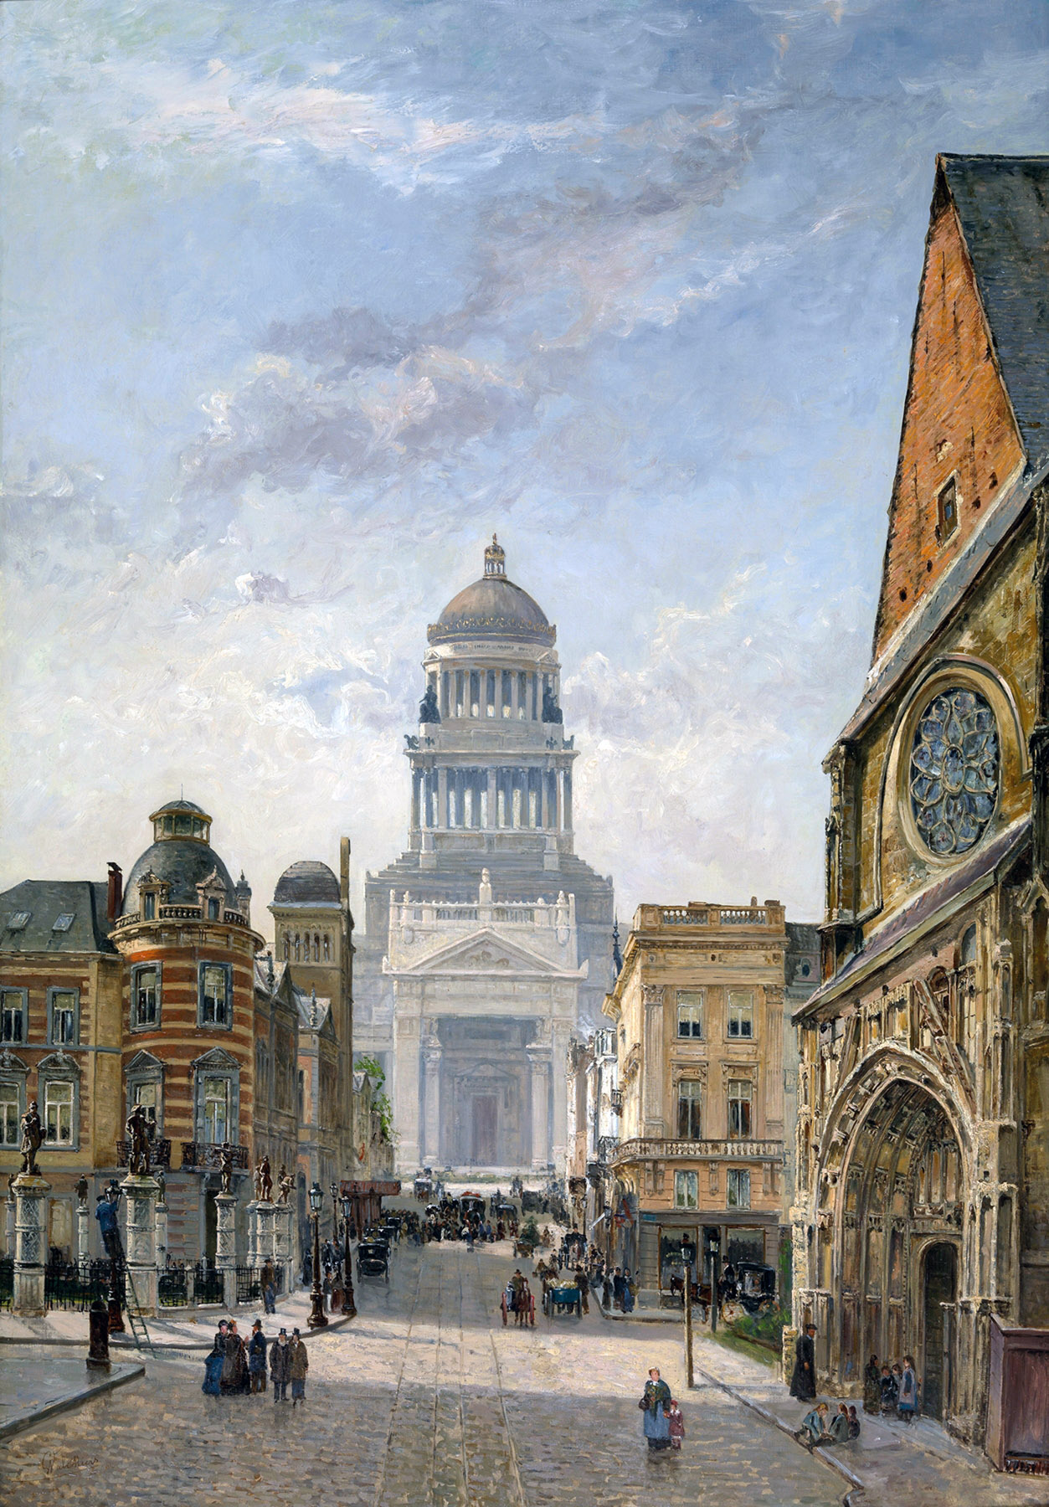

Regentschapstraat in Brussels
Gustave Walckiers (Belgian, 1831-1891)
Artvee
After traversing an infinity of streets, lined with houses with stepped roofs, we suddenly came out onto the Square in front of the Hôtel-de-Ville, which provided the most vivid surprise in my entire journey. It seemed to me that I was entering another era, and that a ghostly scene from the Middle Ages had suddenly opened before me; I had thought such effects only existed in dioramas and English engravings.

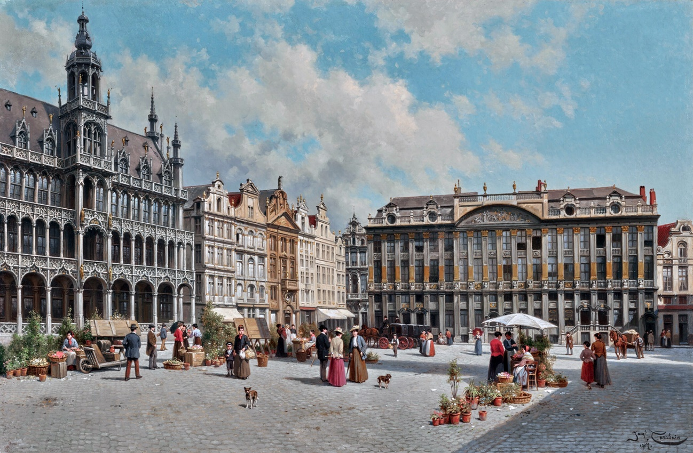

La Grand Place, Brussels (1907)
Jacques François Carabain (Belgian, 1834-1933)
Artvee

Imagine a large square (the Grand-Place/Grote Markt), one side of which is occupied by the Hôtel-de-Ville (Brussels Town Hall), a miraculous building with a row of arches like those of the Ducal Palace in Venice, bell-towers surrounded by small balconies with carved balustrades, a tall roof replete with decorative dormer windows, and then a pierced spire of the most audacious height and slenderness, so delicate that the wind seems to tilt it, and on the very top, a golden archangel, wings open and sword in hand.
On the right, facing the Hôtel de Ville, a series of houses that are real gems, stone jewels, their originals chiselled by the wondrous hand of the Renaissance (they had been destroyed in 1695 during the French assault but subsequently restored). One could not find anything more charmingly pretty; there are little spiral columns, overhanging floors, balconies supported by slender-necked women whose lower bodies end in foliage or perhaps serpent tails, medallions with wide elaborate frames, mythological bas-reliefs, allegorical figures supporting armorial shields, everything that the architectural coquetry of that age thought most attractive and most amusing to the eye. All these houses are now admirably maintained, not a stone is missing; the tri-coloured coating that covers them preserves them as if in an ornamental case.
The opposite side of the square is occupied by buildings of a completely different character. These are hotels in the Florentine style with vermiculated bossages, squat columns, balusters, sculpted garlands, vases with flames in stone, and near the summit large stone scrolls, volutes coiled several times upon themselves, whose technical name I do not know, and which have the signature look of the period; add to this that almost all the projecting ornaments, such as the capitals of the columns, the interior of the fluting, the frames of the cartouches, and the flames of the cassolettes are gilded, and you have something strange and magnificent to the eyes, in particular, of a poor Parisian who only knows the houses, stained with dirt to the third storey, of his hellish capital.
That side of the square is a real gallery of architecture, where all the nuances of Spanish and Italian Rococo, and that of the French, from Louis XIII to Louis XV, are represented by authentic and best-chosen samples. I use the word Rococo here for want of another, without intending any detrimental meaning, to designate a period of art which is neither antiquity, nor the Middle Ages, nor the Renaissance, but which, in its own way is quite as original and admirable.
Opposite the Town Hall, and completing the square, stands a large Gothic palace, a kind of votive residence, built by I no longer know which princess, following I no longer know what events, having lost the small strip of paper on which I copied the Latin inscription written on the facade; since though I possess a good memory, I have a limited ability to recall inscriptions in the lapidary style, particularly when I have the inscription in my pocket, or think so. But the inscription adds little to the medal itself.
This votive mansion now serves as a meeting place for a dining, smoking, dancing or literary society, and the brightly illuminated interior made the stained glass windows of the blackened face of the old building blaze, buried as it was in shadow, for the moon was rising behind it, and beginning to cast its veil of lilac crepe glazed with silver over the other houses in the square; all this looked so unnatural and improbable, that I seemed to stand before a theatre-set, executed by artists even more admirable than Leon Feuchère, Edouard Desplechin, Charles Séchan and Jules Diéterle, those scene-painters of the Paris Opéra. Fritz even claimed to have heard the triple-knock sounded by the stage manager, and the bell, too, summoning the actors for their entrance.
In truth, it looked like the set for the first act of a Victor Hugo play, Lucrezia Borgia or Angelo Tyrant of Padua — a great palace, lit as required, radiating joy in the gloom and melancholy of night; in the background the dark silhouette of Padua in the Middle Ages, outlined against a horizon of spires and bell-towers. We expected Gubetta (Lucrezia’s male servant) to emerge from behind his pillar, for Marie Dorval (the well-known actress, in the role of Lucrezia) to descend the steps of the flamboyant palace, followed by the jealous podestà, Angelo, and for Homodei (a guitar-playing character) to rise from his bench, with his guitar. But as none of them appeared, we chose to leave, though Fritz wanted to ask for his money back at the door, and attempted to sell his pass-out ticket to some Walloon. Since there would be no performance, we decided to go and partake of a cup of coffee, something which seemed to us an easy thing to achieve, but which cost us infinite trouble.
Having seen an establishment over which was written: Estaminet (Café), we entered boldly, side by side so as to appear more respectable. Alas! We might as well have found ourselves fallen into an antheap or a boiling pot; there was a fog so thick it was impossible for a man of average height to see his feet beneath him. However, thanks to the gaping door which we had failed to close, the tobacco smoke having somewhat dissipated in consequence, we made out a polished counter laden with glass measures, pewter pots resplendently polished, and something in the middle which bore a distant resemblance to a woman. We asked for coffee, with the simple and natural air of people who believe they are seeking something not, in itself, wildly ridiculous.
Then, from the depths of the cloud, amidst which we were beginning to distinguish, here and there, the heads of a few Walloons, and the backs of women leaning on tables, arose a universal clamour, a gigantic hurrah, a burst of laughter more than Homeric in nature, interspersed with: ‘Ho, ho! The Fransquillons! Ha, ha!’ And other grunts in the French of that place, which is less intelligible than simple Flemish or double Dutch (any language twice as hard to comprehend as Dutch). — Greatly alarmed by this unfriendly reception on the part of a people to whom, it is said, we are intimately allied, I made a prodigious somersault backwards, which put me almost in the middle of the street, at a fairly pleasant distance from this damned capharnaum. Half a second, a third, a fraction of a second later, I received Fritz, who was beating a hasty retreat, in my stomach, though he maintained that he had retired with battle honours. For my part, I frankly admit I could not rid myself of the thought of ​​being quartered, and eaten raw, by the Walloons, and had heroically escaped first, counting on the killing, flaying, and scalping of my intimate friend granting me time to reach civilised terrain.
Despite our failure, Fritz, who insisted on coffee, tried to prove to me, by reasoning more brilliant than well-founded, that we were not yet quite among the Eskimos, and that in the end we ran little risk other than having a certain quantity of tin pots thrown at our heads, an excellent opportunity to test the specific hardness of our skulls, and one which might never occur again.
Seduced by his golden sophisms, I ventured with him into several other places, where the same colossal hoots of laughter greeted us, and ever the refrain of: ‘Ho, ho! The Fransquillons!’ For a moment I thought myself in Constantinople; the only thing missing were the cries of ‘Christian dog!’ and ‘Giaour!’
At last, after several more or less unsuccessful attempts, we found a place where we were served coffee, without hurrahs, and with proper seriousness.
After the coffee, it was time to return to the Hôtel du Morian. We traversed about twenty-five leagues (!) before finding the blessed hotel again, the malicious directions given by various Walloons helping to lead us astray. However, having followed a very long street by chance, it turned out to be the Rue d’Or, the one we were looking for. Oh, unexpected happiness!
We were shown to our rooms, and to our beds, which we desperately needed. Belgian beds are not made like French beds; there is no bolster, merely two large pillows placed side by side. The covers are cotton, with little knots and embroidery of a very pretty nature. The sheets are linen, the mattress-covers are damask, similar to that of tablecloths: the candlesticks are also not the same shape as ours; they stand on a very wide base, and resemble those of the days of Louis XV. The floor is made of firwood boards close-scraped, which are a pale salmon colour, instead of the inlaid squares on floors at home. They are scrubbed every week with boiling water and sandstone. All this may seem somewhat uninteresting, but nevertheless it is all these little details which constitute the difference between one country and another.
As for Belgian slumber, it is exactly similar to the Parisian. Only, Fritz dreamt that he was bathing in the Yellow River in China, and that he had indigestion due to eating swallow-nest soup, after dining with a mandarin whose fingernails were eight inches long. This was the most remarkable thing that occurred that night.
In the morning, we breakfasted like a pair of lions who had been fasting for a fortnight, and from modesty I dare not say how much beer we infiltrated into our bodies; after that, we felt a pronounced need to roll the barrels of faro and lambic now concealed in our bellies through the streets.
Brussels is a city which appears more English than French in the more modern areas, and more Spanish than Flemish in the older parts. There are few churches of note, except Saint Gudule (Saint Michael and Saint Gudula Cathedral), on the Rue de la Montagne. The stained-glass windows, confessionals, and pulpit of Saint Gudule are of great beauty. When I visited it, it was being scraped, restored, and whitewashed, the rage for whitewashing being even more vehement in Belgium than in France. In this church I noticed for the first time the Christianity idolatry prevalent in Belgium, whose effect on me was quite new only being acquainted with the Voltairean churches of France: here was a profusion of tinsel, crowns, ex-votos, candles, vases, embroidered banners, orange-trees in boxes, and a thousand other devout inventions.
A notable feature of Brussels is that all the shops bear the inscription: ‘So-and-so, Court shoemaker; so-and-so, Court seed-merchant; so-and-so, Court match-supplier, and so on, incessantly, in connection with trades which do not seem in the least to have anything to do with the Court itself. The apothecaries’ shops bear large and natural deer-antlers as signs, though they cast no aspersions as to the marital status of any of those gentlemen. As for the taverns, there are almost half as many of them as there are houses.
By dint of crawling along Magdalena-Strass, we arrived at a large and beautiful square, which is called the Place Royale (Koningsplein), where stands a church (Église Saint-Jacques-sur-Coudenberg/Sint-Jacob-op-Koudenbergkerk) with a pediment where there is, in the midst of a glory in bas relief, a sculpted eye (‘The Eye of Conscience’, not extant) which appears like a gigantic eye looking down on all the city’s children. The Royal Palace is close by. It is a fairly large building of mediocre architecture, painted white with an oil-based paint, and which must be a comfortable and convenient dwelling. Art is wholly lacking. The park, which is fairly small, offers nothing of special note; there is a little fountain and various groups of ponds, and statues on plinths, also painted with oil-based paint and varnished; the trees of this garden seemed to me of an admirable greenness, even for a country of beautiful verdure, and a great air of freshness reigns there.
Our tour of the park completed, we visited the publishers of pirated editions: I bought the complete poems of Alfred de Musset, in one volume, and Madame de Sommerville, by Jules Sandeau; I also wanted to buy a copy of Mademoiselle de Maupin, a recent novel by yours truly; but I confess that this was impossible, as it was nowhere to be found. It was all the more mortifying, since editions of Le Bibliophile Francais, and works by Alphonse Brot, Hippolyte-Julien Lucas, and other illustrious people of my acquaintance, were wonderfully done, and I confess, with all the humility that characterises me, that till now I had believed myself the equal of those gentlemen. My journey has undeceived me, and made me abandon so foolish a presumption. Le Bibliophile especially enjoys such a great reputation in that country, that the Mauvais Garçons by Alphonse Royer and Auguste Barbier, and Victor Hugo’s Notre-Dame de Paris (‘The Hunchback of Notre Dame’), the two best novels that the Middle Ages have inspired, are printed there under its name.
The prose volumes of Un Spectacle Dans Un Fauteuil, by Alfred de Musset, are unknown to Belgium, and the publisher of pirated editions from whom I requested them seemed quite surprised, and wrote immediately to his correspondent to send them to him. This does little honour to the powers of advertising of the Revue des Deux Mondes, or to the literary tastes of Belgian booksellers.
On leaving the booksellers’ shops, we took a fiacre, and were borne off to the Porte de Laeken (The Laeken Gate) to view the railway. Belgian horse-drawn cabs are very fine, and in no way resemble our sapins; they travel swiftly, when drawn by the appropriate horses. The one we occupied was a kind of landau lined with white velvet, which would have seemed a very magnificent carriage at home; but while they are twice as beautiful as ours, they are also twice as expensive. They usually draw up in ranks on the Place Royale; about forty or so at a time.
The railway is now an object of too great importance and too alive with actuality for me to devote to it only the last paragraph of this chapter; that would be especially frivolous on my part, I who am in a delicate situation with regard to the railway, and who have spoken of it many times in somewhat unmeasured terms. The railway from Brussels to Antwerp, O magnanimous reader, will therefore be the subject of the following chapter, along with a very fine bird’s eye view of Antwerp, which I am holding in reserve for the final crescendo of my symphony.

Chapter VI: The Railway, and Antwerp

The railway is now in fashion: it is a mania, a craze, the rage! To speak ill of the railway is to seek to expose oneself to the pleasant light-hearted invective of the champions of utility and progress; it lays one open to being termed a retrograde fossil, a partisan of the old regime and of barbarism, and passing for a man devoted to tyranny and obscurantism. But were one to apply to me the well-known line by François Andrieux:

‘Au char de la raison attelé par derrière’

‘Harnessed behind the chariot of reason’

(See Andrieux: ‘La Perfectibilité de l’Homme’ 1825)

I would state, boldly, that the railway is a rather foolish invention. In appearance, the railway displays nothing picturesque in itself. Imagine narrow rails (tracks) laid flat on logs (sleepers), with which mesh hollow wheels of a moderate diameter, about the size of the front wheels of a stagecoach. Then, a long line of carriages, luggage vans, and wagons, linked to each other by chains, and separated by large leather buffers, to reduce friction and accidental shocks. At the head, an engine, a kind of rolling forge, from which showers of sparks escape, and which resembles, with its raised funnel, an elephant progressing with its trunk in the air. The perpetual snorting of this machine, which, while operating, spits out a black vapour, with a sound like that which a sea-monster with a cold in the head would make in blowing salt water through its vents, is certainly the most unbearable and most unpleasant thing imaginable; the smell of coal must also be counted among the benefits of this means of travel.
I had imagined to myself that there would be no jolting or rattling on those polished tracks; that was a mistake: the carriages when pulled by the engine oscillate to and fro, a kind of horizontal yawing which makes one feel dull and seasick. This is no upwards jolt like that caused by the unevenness of an ordinary road; it is a movement similar to that of a sliding drawer opened and closed several times in a row, in haste. The engine fires up, the first car tugs at the second which strikes the buffers of the next at intervals, and so on to the end of the line; these dull counter-blows are something dreadful, especially when the engine halts — a ceremony which is performed to the unpleasant music of scrap metal.
As to speed, it is quite quick; however, it did not seem to me to exceed that of a post-chaise. True, I was told, that the engine could be driven much faster, and the pace of its progress doubled. After which, there is the minor matter of leaping in the air and being sent to meet the aerolites, a journey amidst the shooting stars which would not be without a certain charm.
I confess I prefer the old carriages drawn by horses, to all these mechanisms of less than reassuring complexity. A good sedan with three strong horses, and a postilion only half-drunk, who cracks his whip cheerfully, and strikes at the aery imps with all his might, displays something more lively and joyful than those rows of hearses sliding silently along their groove with the asthmatic noise of a cooking-pot. Good horses, prancing and neighing, with long manes, satiny rumps, red pompoms, and bells, ringing out with their hooves that beautiful line from Virgil:

‘Quadrupe/dante pu/trem soni/tu quatit/ungula/campum,’ (scanning syllable length)

‘Quadrupedante putrem sonitu quatit ungula campum,’ (marking the stresses)

‘And with the thunder of their hooves shake the broken ground’

(See Virgil: Aeneid Book VIII, 596)
are certainly preferable as poetry, and in their versatility; one can veer right or left, travel this way or that, instead of imperturbably following a straight line, which of all lines most displeases people who lack the good fortune of being mathematicians or candle-makers, and who have retained in a corner of their soul a feeling for beauty — which, as we know, from the use of curves and zigzags, is a truth well-known to school-children.
If the railway was to put an end to horses and coachmen, that alone should be enough, in my opinion, to prevent its adoption. I would quite willingly abandon the coachmen for whom I have a mediocre regard; but I would be sorry if the superb animal which provided Job (see the Bible, Job 39: 19-25) and Jacques Delille (translator of Virgil’s ‘Georgics’ and ‘Aeneid’) with the subject of such a beautiful description disappeared from the face of the globe: and truly, at the rate at which the utilitarians are travelling, I greatly fear that we will soon be exhibiting the last horse, in the manner of that caricature (‘The Knacker’s Yard or the Horse’s Last Home’, in the British Museum) by George Cruikshank, set between a cage full of Humanitarians, and Papuans from the South Seas. In a few hundred years from now, some Georges Cuvier or Geoffroy Saint-Hilaire of the time will succeed, through comparative anatomy, in reconstructing the skeletons of horses buried within the layers of tuff, limestone or marl, and will offer endless descriptions of them, capable of demonstrating that the beast called Hippotherium, which lived before the great renewal of the world brought about by steam, should not be confused with the cockchafer or the rhinoceros; and that it was no fish either, as some scholars previously claimed.
We have not yet reached the level of madness of the Americans, who build railways everywhere: underground, underwater, in attics, in cellars, and from one corner of a room to another. We have too much common sense to give way to such reveries, and France will certainly be the last country crisscrossed by railways. Railways are much like omnibuses, which transport goods at low cost, travel over large areas, and carry large numbers of people. They never go where one needs to be: that is what makes the first street that comes along, and a vehicle, say a cabriolet, always infinitely better. A railway, or an omnibus route, terminates without exception in a quagmire, a barred gate, or a sewer under construction; so that to get to the place where one wants to go, one must forever hire a standard carriage and horse.
Everything that was truly useful to man was invented in the beginning. Those who inherited have scoured their imagination to find something new: they have wrought differently, but they have not wrought better. Change is not progress, far from it; it has not yet been proven that steamboats are superior to sailing ships, or railways with their locomotives to ordinary roads and horse-drawn carriages; and I believe that we will end by returning to the old methods, which are always the best. A friend of mine, a man of science and intellect, is busy replicating animal flesh by passing an electric current through egg white; I think it is simpler to buy a pound of meat from the butcher, since my honourable friend’s beefsteaks resemble, whatever he may say, failed omelettes; and even if his operation were to succeed perfectly, what would be the result? Since Adam, of happy memory, we have supplied ourselves with meat without galvanism, an electric current, or egg white. I also know of another young man who discovered an alchemical powder which would change base metal to gold; he spent twenty-two thousand francs to produce a louis’ worth of the latter, and burnt down the house which contained his laboratory, due to the intensity and duration of the process. A fine profit, indeed! That resembles to some degree the history of the railway.
The railway carriages are of various types: berlins, diligences, covered charabancs, and simple wagons. In the berlin, the seats are ranged like theatre stalls, and one sits in small armchairs; the diligence is absolutely the same as an ordinary diligence; the price of seats varies between a franc and four francs ten sous; there are several departures per day.
The locomotive, the steam-engine which replaces the horses, after groaning horribly for fifteen minutes, began to snort more loudly, and blow smoke more actively; it began to move, and we rolled forward, at first slowly, then more swiftly, and finally at quite a high speed.
The countryside we traversed was perfectly flat and perfectly green; here and there the white houses of Laeken blossomed like daisies on the rich emerald carpets, specked with great oxen bathing in grass up to their bellies. English gardens with yellow paths, sleepy rivers their waters of pewter and quicksilver, Chinese bridges alight with brilliant colours, passed to right and left; tall, slender poplars paraded by at the gallop; bell-towers rose on the horizon; vast puddles of water, like the scattered scales of a gigantic fish, shimmered from time to time, surrounded by brown earth; among the numerous hollows which lined the road, a few contained taverns with their ‘Verkoopt men dranken’ signs, in letters a foot long, smiling peaceably from the depths of their little hop gardens, making a thousand advances to the travellers, encouraging them to descend and drink a good glass of strong Flemish beer, and smoke a pipe of patriotic Belgian tobacco; vain advances, since on board a train one cannot stop even to drink, which is one of the most serious disadvantages of the railway, in my opinion.
Painted wooden barriers, managed by little boys, barred all the cross-roads until after the wagons had passed; and at intervals, frail huts of straw and mortar sheltered workmen, charged with ensuring that no stones were found on the rails.
The train, having reached its highest speed, produced a similar effect to that of a boat, whereby the river-banks seem to flow past while you yourself seem motionless. The starry fields of golden colza flowers (rapeseed or canola) sped by with strange velocity, appearing as yellow stripes in which one could no longer distinguish the specific crop; the brown track, studded with small chalky white pebbles, looked like the backside of a guinea fowl being drawn violently from beneath us; perpendicular lines became horizontals, and if the landscape had been better laid out and more uneven, it would have produced a singular mirage. The silhouette of Mechelen, dominated mainly by a large square tower, passed by so swiftly that, when I nudged my friend Fritz to show it to him, it was already beyond our reach. Our speed could not be maintained, either because there was a shortage of coal, or because the need to set passengers down at various stations en route forced them to regulate the steam. However, we were approaching Antwerp, and as the railway does not pass through it directly, a crowd of omnibuses of various shapes and colours had gathered at the nearest station. These omnibuses cost six sous a trip like ours; they are lined with painted and waxed canvas, have an imperial (a light wooden cage) surrounded by wire mesh on top to hold the luggage, and are harnessed to three horses abreast, as the omnibuses of Paris were, originally. The horses, more handsome and better fed than the miserable nags used for public transport there, have as harness only a light collar and are otherwise bare of trappings.
One enters Antwerp through a stone arch, decorated with bosses, coats of arms, and trophies, the effect not lacking in majesty; pink, apple-green and mouse-grey houses abounded there, as expected; I even saw two or three in wood of a delightful tarry hue; but what astonished me most was the vast number of Madonnas, painted and decorated with glass beads like the Virgins of the Middle Ages, seen on every street corner. Calvaries are no less numerous; the seven instruments of the Passion, the cross, lance, ladder, hammer, nails, sponge and crown of thorns, gathered together in a bundle, cover almost all the walls; large statues of Christ, of completely sinister appearance, tinged with a livid flesh colour, and furrowed by long crimson filaments, rise at the crossroads and at the corners of the squares; lanterns serve for their haloes, and all bear an inscription conceived more or less thus: Ex Christo splendor (From Christ, radiance) or Christus dat lucem (Christ brings light), but with every possible variation; one cannot conceive of the fantastic effect of these life-size figures in the moonlight, amidst the evening mist, each with their reddish lantern, which seems like the open eye of a Cyclops, in the night.
I had seen in Roger de Beauvoir’s album a very fanciful drawing by Alphonse Royer, depicting an immense ink blot, with the solemn inscription: Antwerp at Night. There was nothing to prevent it from being a picture of Constantinople, or Masulipatnam (Machilipatnam, or Bandar, in India). Because of this misleading drawing, I had retained the idea of ​​Antwerp being a place of darkness, and nothing surprised me more than to be able to see clearly there, even at night, thanks to the Christ lanterns. Nothing is less bituminous, medieval, or cluttered than the city of Antwerp; not a stagnant gutter, not an unpaved street, nothing in short of that picturesque tangle which renders Rouen such an attractive city for artists. Eugène Isabey, Eugène Poitevin (also, Lepoittevin), and other lords of the crowded, jumbled, and ‘soiled’ (pardon the word), would not, in Antwerp, find the slightest subject for a sketch; everything there is broad vast, well-aired, and of a fabulous cleanliness; everything is thrice painted, even the cathedral, which is coloured a rather bright and facetious pistachio.
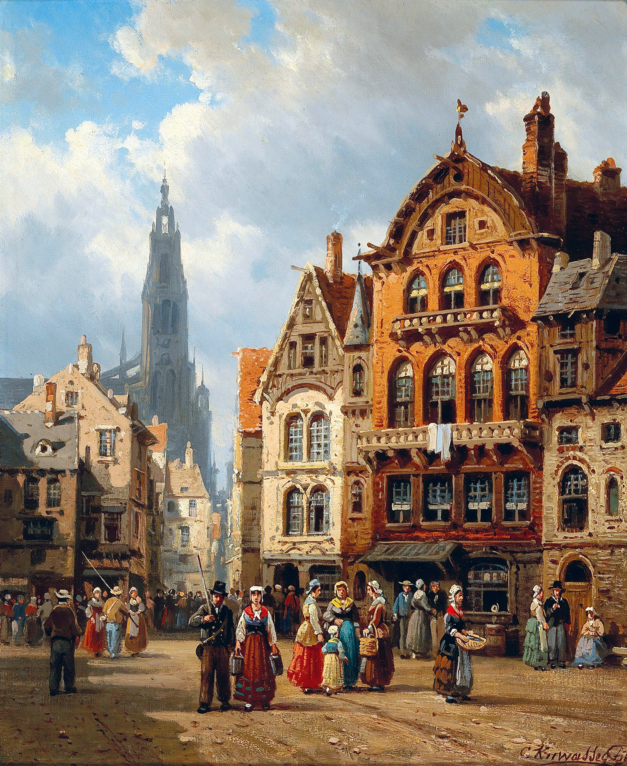

Antwerp
Charles Euphrasie Kuwasseg (French, 1833-1904)
Artvee

We went off to the Place Verte (Groenplaats) with the laudable design of dining well; in which we succeeded only imperfectly; but the good Lord, who only takes account of our intentions, will, I hope forgive us. The Hôtel de l’Union had been pointed out to us as a place where we could pleasantly attend to the repair of ‘the place below the nose’ (the phrase is from Rabelais); so, we headed for the Restauration of the Hôtel de l’Union, since, in Belgian French, a restaurant is called a restauration. It was a very tall building of a white tending towards sky-blue, with large windows, cast-iron bollards, and of appropriate appearance. We drank a certain white wine from the Rhine which was not too bad. As for the cooking, it was banal, and lacking the least character. Fritz, who has a mania for exotic ingredients, could not find a single strange or incongruous item on the menu, though he had the patience to read it from end to end, except a compote of ginger from China. The confitures Pantagruel sent to King Anarchus were nothing compared to it (see Rabelais’: ‘Pantagruel, Chapter XXVIII: How Pantagruel got the victory very strangely over the Dipsodes and the Giants’). Imagine cantharides (Spanish fly, a substance extracted from blister beetles) marinated in nitric acid, vitriolic chili pepper, everything you can imagine that is most devilishly hot and spicy in taste, a mixture that makes your tongue tingle as if you had licked nettles, and you will have a faint idea of ​​this Chinese stew’s exorbitant flavour.
As soon as we had swallowed two mouthfuls of the abominable liquid, we began to cry out: ‘Ah! Ah! My throats burning! A glass of water!’, but the fire was not quenched for all that, and we were obliged to rise from the table with flaming volcanoes in our chests.
Next to us were dining two theatrical friends of mine whose names I forget... To visit Flanders to seek out blonde Flemish women, only to find vaudevillians from Paris there: oh, the mockery of it! The vaudevillians went east, while we sought the west; I have not met them since.
As it was still quite light, we visited the cathedral (the Cathedral of Our Lady): it contains three miraculous Rubens: ‘The Descent from the Cross’, ‘The Elevation of the Cross’ and ‘The Assumption of the Virgin’; the first two with side-panels by the same hand, making an additional four. Six pages of Oh’s Ah’s, and exclamation points could only faintly represent the stupor of admiration with which I was seized at the sight of these prodigies; instead of a chapter, I would need an octavo volume to describe them. The wooden pulpit, carved by Michiel I van der Voort, is of the greatest beauty. The subject represents Adam and Eve, and the balustrade, covered with vines and foliage, is burdened with all sorts of birds, amongst others a turkey fanning its tail. Was this a malicious allusion of the artist to the preacher’s flock, or to the preacher himself? I dare not answer so delicate a question. What elegance and clarity, what sharp and vigorous lines, what smooth and abundant curves! How burgeoning, luxuriant, and full of invention and interest are the details. What a robust company those artists of the sixteenth century made! The church also contains some fine pictures by Jean-Erasme Quellyn, Otto Van Veen who was Rubens’ master, Anthony van Dyck, and several others. The only thing that saddens the visitor is that this beautiful cathedral, painted in a pistachio colour on the outside, is daubed inside with an execrable canary yellow, applied in several layers with the greatest care in the world.

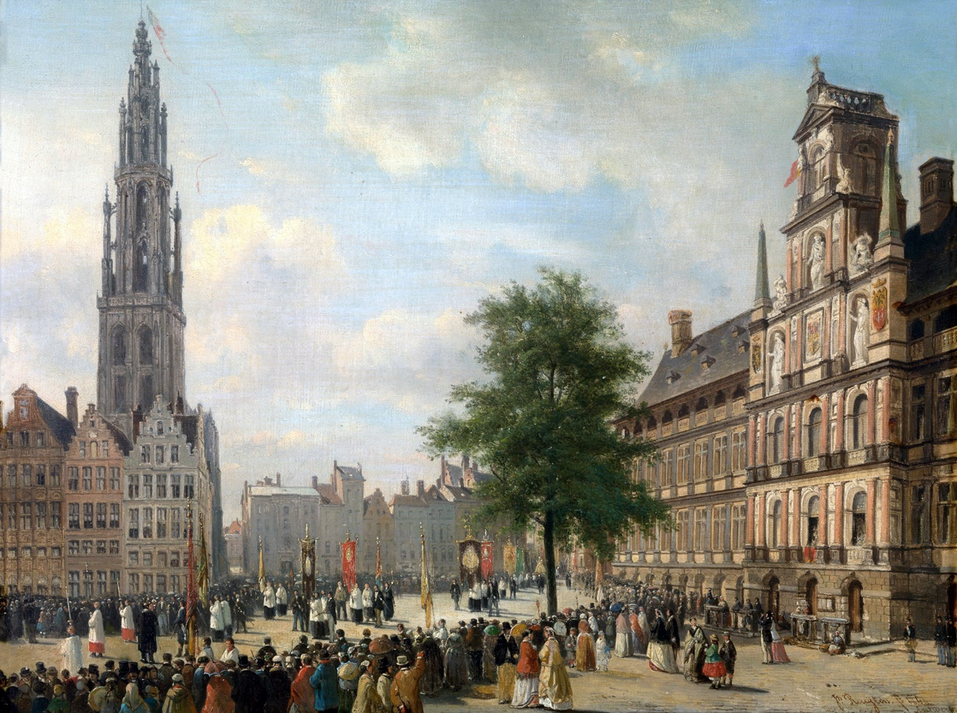

Procession on the Grote Markt in Antwerp (1848)
Jan Michiel Ruyten (Belgian, 1813-1881)
Artvee
Having visited the interior, we conceived the idea of climbing the bell-tower; it cost us three francs, which is rather a steep price for visiting a bell-tower. One could climb the towers of Notre-Dame for six sous, before Victor Hugo’s novel ‘(Notre-Dame de Paris’) was published and made the old cathedral fashionable; it costs eight sous now, still quite a reasonable price.
There are six hundred and twenty-two steps from the pavement to the base of the cross which surmounts the spire; one ascends a small winding staircase, whose narrow barbicans barely allow a dubious light to filter through. The darkness is intense at first, because of the shade cast by the neighbouring buildings; but as one climbs, the daylight increases, as if in symbolic augmentation, to give one the impression that one is leaving the earth beneath, that the darkness is slowly dissipating, and the true light is from above. Halfway through the ascent one reaches the housing for the bells, those monstrous birds that perch and sing in the stony foliage of cathedrals, and chambers in which chipped fleurons are repaired with mastic cement, and projecting ornaments are made as substitutes for those that time or warfare incessantly shaves from the old church. To do the Belgians justice, they care for their monuments with almost filial love: a stone has no sooner fallen than it is replaced; a hole opened than it is filled; they would cheerfully encase them in glass, and it is a truly pleasant situation to be a monument in that country. Only they show themselves infinitely too prodigal with apple-green, lemon-yellow, and other not very Gothic whitewashes. The town hall of Alost (Aalst), which we passed on our return, is an interesting example of the genre: the background colour of the wall is a green tending towards prasin (leek-green), with thin white lines indicating the joints in the stonework; the columns are slate blue, the statues and sculptures varnished in silver-white; it appears very clownish, like a painted toy from Germany.
After many detours in the darkened belly of that immense tube, we finally emerged on the platform. A vast panorama unfolded before our eyes; one could scarcely imagine a more magnificent spectacle: immense waves of air bathed our faces, and the fresh breeze dried the sweat from our damp foreheads that the effort of the ascent had beaded there; clouds of doves passed by from time to time, and strewed the balustrade like white flakes of snow, a balustrade carved with cloverleaves so frail that I dared not lean there, for fear of hurling it and myself into the abyss. The whole city was gathered at the foot of the cathedral, like a flock of sheep at the shepherd’s feet; the tallest houses barely reached its ankles, and the stepped roofs produced a singular effect from above: it was as if the inhabitants had tried to build stairways to storm the cathedral, but had stopped after a dozen or so steps, on realising the futility of their efforts. All these roofs, burdened thus with staircases that lead nowhere, looked like a bunch of unfinished little towers of Babel.
The city, seen in bird’s eye view, displays the shape of a taut bow with the Scheldt forming the bowstring: its roofs of bright red and violet-blue still shone in bright flakes against the evening mist, which was starting to rise. The Scheldt gleamed in places like a blade of polished steel: elsewhere, it had the dull sheen of a mirror’s tinfoil backing; on the other side of the river, one could see the Tête-de-Flanders and, beyond, immense meadows of a velvety-green amidst which the waters of the Scheldt, with its many sinuosities, sparkled from time to time. Koffs (Dutch, two-masted merchant ships) with red sails progressed slowly, their slender wakes scoring the dull surface of ribbon-like stretches akin to molten lead. Often, where the flatness of the perspective did not allow one to see the river itself, the boats seemed to be sailing across open ground, like ploughs with sails. The keeper pointed out to us, close to the skyline, four small, black, almost imperceptible dots. These were four Dutch vessels guarding the roads. In that direction (to the north) lay Bergen-op-Zoom; but I scoured the horizon in vain with my telescope, unable to distinguish anything among the purple tones of the distance that had the slightest resemblance to that city. If my great desire to see Bergen-op-Zoom astonishes you, well, a grandfather of mine was the first to mount the assault on Bergen-op-Zoom (during the French siege of 1747), receiving a silver sword of honour for a fine feat of arms. As it was a most triumphant moment of history as regards my family, I should not have been sorry to catch a glimpse, even from a vast distance, of a place where one of my ancestors had shown such great courage. — but that satisfaction was denied me.
Great banks of reddish cloud, piled one on top of another, glowed copper and bronze, like gigantic pieces of some Titan’s armour emerging from the furnace. There were clefts and landslips, huge masses interspersed with fiery light, like a collapsing volcano, and to sublime effect.
The sun, an immense shield of fire on the arm of a destructive archangel, shone, sinisterly, amidst those russet hues: a large cloud, in the shape of such a warrior seated on an island, which floated in a sea of ​​flame, completed the illusion. This phantasmagorical effect lasted for no more than a few minutes. The wind blew violently, the outline of the cloud faded, and the archangel melted into mist.
When we had contemplated this spectacle sufficiently, the guard pointed out that we were not yet quite at the top, and that there were still a hundred and twenty steps to climb, and showed us a small staircase two handbreadths wide while instructing us to advance. Imagine to yourself a very sharp, thin needle, hollow inside, fearfully pierced and windowed, as high as Chimborazo and constantly narrowing. Fritz, on this occasion, allowed me to go first, an honour I scarcely aspired to; I found him far too polite. As soon as I had inserted myself into that abominable chimney, it seemed to me that I had swelled to an enormous size. I was afraid of not being able to descend, and of being obliged to stay there till the end of my life, like that lighthouse keeper’s wife, who had grown so fat in her aerial nest, that she could no longer traverse the narrow staircase she had climbed so nimbly, as a slender young girl. I felt heavier than a war-elephant, with a castle on its back. The wooden steps bent beneath my feet, and my elbows made the sides of the walls bulge like a piece of compressed cardboard. Through the evil piercings of that infernal needle, as frail as the paper lace placed around sweets and candied fruits, one could see streaks of bluish air or the paving stones of the square, which looked as small as an average-sized chessboard, the men like cockchafers, and the dogs like flies, a most pleasing scene!
For added pleasure, there was a sharp wind, a wind that would knock the horns off an ox, and everything was dancing in this devil of a bell tower, like plates on a dresser when a carriage goes by.
I turned to see if Fritz was following me, and poked him in the eye, which will give you a sufficient idea of ​​the less than gentle slope of the stairway; at last, we reached a small skylight opening on the void, near the ball beneath the cross. The ascent was over. We seated ourselves on the last step for a few moments so as to rest a little. While I was sitting there, the ingenious idea struck me, that one day or other a cathedral steeple must necessarily collapse, and that it was perhaps on this day, at this very moment, that the spire of Our Lady of Antwerp would bend its granite legs and strike its nose on the pavement. It would have been rather unpleasant to find ourselves at the exact summit of the parabola. I communicated this reflection to Fritz, who found it salient, and we began to tumble down the spiral staircase, our ears laid back like hares being hunted.
As we reached the first platform, the sun, staggering like a man overcome with drink, took a false step and stumbled into a gulf of mist. Now and then an intermittent glow, like that of a furnace being rekindled with bellows, escaped the black bars of cloud. It was magnificent; beyond pen and palette to describe. The most transcendent gibberish would have seemed feeble beside it.
In the opposite direction, there were only cold blues, icy violets, and vaporous greys; there, night had already fallen. Mechelen’s bell-tower (of St. Rumbold’s Cathedral) with the four dials of its clock (the clock and its dials are no longer extant), was illuminated by a single orange shaft of light, and stood out sharply against the background of zebra-striped crops in different shades. The vague silhouette of Brussels barely topped the last visible fringe of horizon; the locomotive, with its tail of carriages, and plume of smoke, crawled along the track like a strange animal; and a few country houses, their lamps already lit, dotted the broad, gradually darkening, shadows with bright points of light.
The sun vanished completely. Fritz, who is a well-bred young man, claiming that one should never be dishonest, even with regard to the stars, removed his hat most graciously, saluted the sun, and said to him: ‘Good night, old friend; till tomorrow…’

Part II: 1846

Chapter VII: Antwerp to Amsterdam

‘You will doubtless remember, my dear Fritz, that when we visited Antwerp together some ten years ago, railways were in their infancy, and there was, as yet, no other stretch of rail on the continent (carrying public passenger trains) than that section in Belgium, of about five leagues in length (the Brussels to Mechelen line, thirteen miles in total, was completed in May 1835). — Surely you remember those pretty houses, like the toy ones from Germany, which we would have liked to pack in pinewood boxes to give as gifts to the children we knew; those apple-green, pink, sky-blue, lemon, doe-belly yellow, and lilac facades, enhanced by thin white stripes, which looked so cheerful, so clean, so coquettish? Well, all that has changed. Those houses with stepped roofs which we so admired, are uniformly coated with the dreadful, sticky, yellow wash with which in the Middle Ages they smeared the houses of traitors, which was the vilest punishment those ‘colourist’ centuries could conjure.
Probably for secular betrayals only, a chocolate-coloured stripe was added to the base of walls thus dishonoured. Don’t accuse the Anversois, or Antwerpians (I don’t know which term is most used) of bad taste, dear Fritz; they ask no more than to brighten the walls of their dwellings with charming hues. It is the authorities who force them to commit so anti-picturesque a crime: a municipal ruling condemns an innocent town to deck itself with a pumpkin-coloured robe, and don the livery of infamy. It is but a public service to condemn the main promoter of this ridiculous measure to the hatred of painters and the maledictions of poets; his name is Gérard le Grelle (the Mayor of Antwerp). At the Town Hall they hold samples of the various shades that the house painters can use; a range of tones false enough to make Rubens turn in his grave. One would need the freedom of language exercised in the days of the Regency to describe certain of these shades: they run from leaden white to putrid yellow. The dolphin and the goose once baptised two of them, which I will speak of no more; one could not imagine anything more purulent or sickening to the eye. Such is the state of Antwerp. I will also tell you that ribbed fabrics (faille), those memories of the Spanish mantilla, have almost completely vanished.
The lantern-bearing Christs and illuminated Madonnas at the corners of crossroads seemed far less numerous to me than before. The three Rubens paintings in the cathedral blazed less brightly in my eyes than on the first trip. Is this due to the dimming of my vision this last ten years, or have those noble canvases too submitted to the alterations imposed by time? I congratulate myself on having entered the world at a time when the masterpieces of Rubens, Raphael, and Titian were still visible, and cannot pretend otherwise to please posterity, which will only know them through engravings. Our descendants will be deprived of that serene joy of admiring a sublime thought framed in a divine form.
The distance by rail from Antwerp to Liège is but eighty kilometres, a mere step today. Also, my companion and I could not resist our desire to see the preparations for the grand Jubilee which was soon to take place. So, we both left for Liège, which is named Lüttich in German. At the station where we lunched, a very pretty serving-girl consented to bring us a beer. I note the occasion, because it was the only time that we were able to obtain one throughout the journey.
You will no doubt recall, Fritz, ‘my old friend, my old accomplice’ (see Hugo’s ‘Lucrezia Borgia’, Act I, Scene II’), the abundant and numerous libations that formerly we made to the Bacchus of the North, crowned with hops and ears of barley, who though not the equal of his brother of the South is, however not, devoid of a certain local merit. Your throat will have retained some memory of our studies of faro, lambic, the white-beer of Louvain and the many varieties of those bitter but nourishing beverages; now you would be unable to find a bottle of beer in a single tavern. At the Hôtel de Suisse, in Brussels, a superb, well-kept establishment, I asked the waiter for a mug of faro. That honest servant blushed, turned pale and showed signs of the greatest embarrassment; he gazed at his napkin, stroked the points of his shirt collar, and ended by saying, in a tone filled with horror: ‘Oh, Monsieur it is not possible! But, as I insisted, he went to seek the owner.
The host, to whom I reiterated my request, seemed deeply dismayed. ‘What have I done to deserve such humiliation?’ he muttered in a voice broken with sighs. Is not my hotel in the latest taste, as it is known in Paris and London?
— ‘Do you fear, venerable hotelier, my not spending enough? I’ll pay you for the beer at the price of the dearest Bordeaux wine or Rhine wine. It is a whim of mine. I drink nothing else, I tell you, for I like to indulge my tastes and not those of you innkeepers, and if offered only water I shall prove hydrophobic and bite you.’
— No; even if you pay me 20 francs a schoppe (mugful). Belgian beer here! At the Hôtel de Suède! I would die of shame and sorrow. What an idea! I’ll give you Scottish ale, or porter, English beer; it is not dishonourable; and then,’ he added in a whisper, ‘if you hold to your yearning for ​​faro, I’ll bring some to your room, tonight, on the condition that you tell no one.’
This charade was repeated throughout the journey. I have never understood what crime Belgian beer has committed in the recent past, to cause the mere pronunciation of its name alone to make waiters flee, producing an effect similar to ‘mene, tekel, upharsin’ (‘numbered, weighed, and found wanting’ see the Bible: Daniel, 5, 25)
Instead of that good brown liquor which so joyfully crowned with froth those measures, in gleaming tin cups, they serve dreadful sulphurous vinegar, in bottles shaped like skittles, on the pretext of it being wine from Moselle or the Rhine; and alcoholic blackberry syrups in rum flasks, posing as France’s most celebrated vintages; — they seem delightful to the English and Germans who, at heart, only like brandy.
Describing a countryside that you know perfectly well is quite useless; and besides, what can one see, dragged along by that hippogriff of iron and steel called a locomotive? One travels amidst sensations of dizziness and bedazzlement; trees flee by like a routed army; belltowers, pointing at the heavens, soar past. You scarcely have time to discern a few brown or white patches, which are herds and flocks in the verdant meadows, and a few scaly roofs which are villages.
After a few hours, we reached Liège, the western entry to which is charming, a pleasant mixture of ponds, trees, and houses; my vigilante (the name for a fiacre in this country) was travelling slowly enough for me to inspect
the signs and posters, as if I occupied the position (as court orthographer) requested by Caritidès in Moliere’s ‘Les Fâcheux’; on an old blackened monument, I read this inscription: ‘Church for sale, for demolition or otherwise’.
The city was preoccupied with preparations for the Jubilee procession. The stopping-places and triumphal arches, decorated with the figures of angels and the theological virtues on painted canvas; the oriflammes (scarlet banners), the coats of arms of the guilds and the neighbouring towns, cluttered the streets all black with cassocks: twenty-nine archbishops and bishops were to attend the ceremony, the stalls selling rosaries, Agnus Dei figures (lambs bearing a cross or flag), and medals that had been blessed, were established beneath the church porches, and their owners seemed to prosper.
It was a singular spectacle for a Frenchman unused to external manifestations of worship, this blossoming of the church beyond its walls, Catholicism invading and mingling with the life of the public streets. Liège thus festooned, decked, and garlanded, reminded me of the old Corpus Christi festivals, one of the liveliest memories of my childhood.
Such were my thoughts while visiting the Town Hall courtyard, decorated with granite columns of a fantastic architectural order, none of which resembled another, and the pretty church of Saint-Jacques, fronted by an early Renaissance portico.
A few miles from Liège, Seraing smokes and bubbles, the site of John Cockerill’s factories. The forges of Lemnos, with their three wretched Cyclopes, would have been nothing beside this immense establishment, always blackened with coal, and red with flames, where metal flows in torrents, where they puddle (convert pig iron to wrought iron) and hammer iron, and fabricate the enormous steel bones of steam engines; there, industry rises to the level of poetry and leaves mythological invention far behind.
From Liège to Verviers, the railway, piqued no doubt on hearing itself reproached for its love of the plains, and its disdain for picturesque sites, has chosen, as if taking the former road, a more uneven path; a little river the Vesdre Weser, finds amusement, mutinously and obstinately, in blocking the passage of the railway. At every moment, it has to be crossed by a bridge. The bridge once crossed, a hill presents itself, soon a tunnel, and so on, in alternation. The countryside traversed is delightful; with small wooded areas, enough high cliffs to appear rural but not rugged, and a scattering of villages, châteaux, and country houses. The Vesdre always in the background, winds through willows, alders and poplars, to charming effect.
A branch line heads for Aix-la-Chapelle (Aachen), Charlemagne’s ancient royal city. At one of the stations, a singularly-clad soldier, wearing a helm of the Middle Ages, in black leather enhanced by yellow copper trappings and surmounted by a pointed tip of the same metal, and dressed in a short, narrow surcoat of blue cloth, like a knight
about to depart on crusade, asked for my passport. I presented it to the eyes of this warrior in a completely civil manner. It was the first time the item had been of service. In time, the railway will lead to the abolition of passports. Try asking two thousand travellers for them, folk who traverse a city as the crow flies, and halt there for less than a few hours. The Customs offices will soon be affected likewise, given the impossibility of checking the travellers’ luggage. In ten years from now, nothing will stop the spread of whole populations from one end of Europe to the other.
To describe Aix-la-Chapelle after the illustrious author of The Rhine (‘Le Rhin’ by Victor Hugo, 1842), is an effrontery I refuse to commit. He has listed the wonders of the treasury, and spoken of the gigantic bones of Charlemagne in a style that is his alone. The thing that drove me to visit the cathedral of Aix-la-Chapelle, was Charles V’s monologue in Hernani (see Hugo’s play ‘Hernani: Act IV, Scene II’), the lines of which revisited my memory in droves.
Aix-la-Chapelle, the German Aachen, is a clean, well-laid-out city, surrounded by beautiful walks, the one named Borcette (Burtscheid) being particularly pretty. Those who, based on various impressions, anticipate a Gothic city, its houses covered in interesting works of sculpture, will find they have fallen victim to a grand deception.
The most striking feature as far as tourists are concerned are the soldiers’ sentry-boxes, their barriers and posts diagonally striped with white and black.
The theatre, adorned with an Apollo Musagetes (‘Leader of the Muses’), and in the Odéon style one finds everywhere, was closed; this confirmed us in our resolution to leave for Cologne that evening.
Have you ever owned a box of Jean-Marie Farina’s authentic bottles of Eau de Cologne? Examine the picture on the lid, and you will gain a fair idea of the city of Cologne.
The cathedral surprises because they are still at work there; a Gothic church filled with modern masons, seems an inconsistency, and yet nothing is more natural.
The square is surrounded by little shops where they sell views of the cathedral, in its current state and as it is intended to look in the future; rosaries; pictures; and devotional books.
The old woman from whom I bought some engravings, doubtless to show herself as supremely civilised, felt obliged to display a Voltairean skepticism as regards the objects of her trade. A stall-keeper who sells crosses, missals, and books of legends, filled with the spirit of the Middle Ages, concerning the Emperor Augustus, ‘Pierre and Maguelone’ (‘Pierre de Provençe et la Belle Maguelone’, a fourteenth century tale), ‘Geneviève de Brabant’ (her tale is told in ‘The Golden Legend’), and ‘Grisélidis’ (a medieval folktale retold by Boccaccio), yet believes in none of it, is that not hideous?
One of my dreams was of viewing the famous painting by Rembrandt, known as ‘The Night Watch’. Thus, travelling downriver on the Rhine on one of those steamboats, with an orchestra on board, that happily travel the route, I disembarked upstream at Emmerich, the steam boat continuing on to Nijmegen.
A branch of the railway, which allows one to join it at Arnhem, would enable me to reach the gates of Amsterdam that evening. A post-carriage bore me across the intervening space at a quite moderate trot, which allowed me to admire all the beauties of the landscape in detail. The Dutch postilions are eminently phlegmatic; their horses seem little disposed to speed, discouraged, as are the horses of other countries, by the invasion of the railway; those sad quadrupeds tacitly acknowledge their defeat by the locomotive, and content themselves with travelling at five miles an hour when one is obliged to use them.
As soon as one has passed the black and white striped border of Rhenish Prussia, the appearance of the country changes. A few turns of the wheels transport you to a new world. The villages have an air of cleanliness and prosperity; the houses are like those in paintings by Jan Van der Heyden, or Adriaen van de Velde; the roofs are steep, tall and stepped. Wheels, fixed on masts, serve as nests for storks. Red brick is happily employed for the facades, above rows of white lintels.
Large trees, with vigorous foliage, soak their feet in puddles of brown water over which ducks, in squadrons, manoeuvre; in passing, the eye plunges deep into calm, restful interiors, vaguely distinguishing some scene of domestic intimacy. On each side of the road, almost always beyond an embankment, one discovers, stretching to the far distance, meadows transected by ditches and planted with clumps of trees, where, half-drowned in grass, herds of these beautiful cattle wander, that are the glory of the art of Paulus Potter.
From Arnhem, to the degree that the scene, already darkening, and the speed of the train allowed me to see, the country takes on a strange appearance, the fields are barer, and turn to moorland and steppe; the vegetation becomes poorer, eaten away by saline exhalations; one nears the dunes, weak barriers of sand opposing the anger of
the Ocean. All this horizon, indented here and there by the profile of some tree or other, does not lack a certain grandeur, when seen through the veil of a violet evening.
It had been dark for quite a time, when the train reached the terminus. Then all the carriagefuls of Dutch folk, belying their proverbial reputation for gravity and composure, seized their luggage with a more than southern vivacity and began running at full speed to the city side of the station; the local cab drivers whipped their horses to the gallop and drove them over the ground; it was as if a routed army was being pursued at sword-point. The matter was soon explained: a wide door, one of whose leaves closed on us so firmly we were almost caught between the pair of them, was the cause of this precipitate action; the bell had sounded for closing the city gates.
My vehicle quickly took me to the hotel which had been indicated to me in advance, and I attempted, by leaning out of the door to snatch a view of the city, unknown to me, that I was traversing.
Amsterdam, seen by night, offers a most bizarre and striking spectacle. Its avenues of tall trees; its rows of houses with sharp ridges; its canals whose black, oily, slumbering waters reflect, in long glittering streaks, the lights of house-windows and shops; its bridges and locks in silhouette; its masts and rigging, illuminated suddenly by some stray shaft of light, form to the foreigner a mysterious and magical whole, which suggests a dream rather than a reality; nor does the effect vanish by day; Amsterdam is one of the most singular of cities. Situated on the Zuiderzee, on the banks of an arm of the Ijmeer, the Dutch Venice is crescent-shaped. A line of canals transects its houses granting it a most particular appearance.
Looking at the city from the harbour, the perspective is generally composed thus; a canal, sinking out of sight
between two rows of centuries-old trees and houses with pointed or scrolled roofs; in the background, a mill powered by a waterwheel, a bell tower with a bizarre bulge, Muscovite in style and reminiscent of the turrets of the Kremlin; in the foreground, a footbridge; a drawbridge whose beams take on different gallows-like shapes; various koffs (sailboats) with red sails, tarred at the stern and enhanced by a strip of that pretty apple-green whose nuances Camille Roqueplan and William Wyld capture so well; and a swarm of sailors, fishermen, peasant-women, and porters bearing bales.
As it was still too early for the museum to have opened, I took myself off for a walk, at random, through the city, and found everywhere the same stamp of originality, a host of garden fences made of boards laid transversely and painted with bitumen. A ditch covered with these small lentil-shaped plants which glaze the still waters in tones of verdigris, ran the length of those houses not overlooking a canal. The delightful dwellings I looked at in passing combined Chinese caprice with Dutch rectitude in charming proportions.
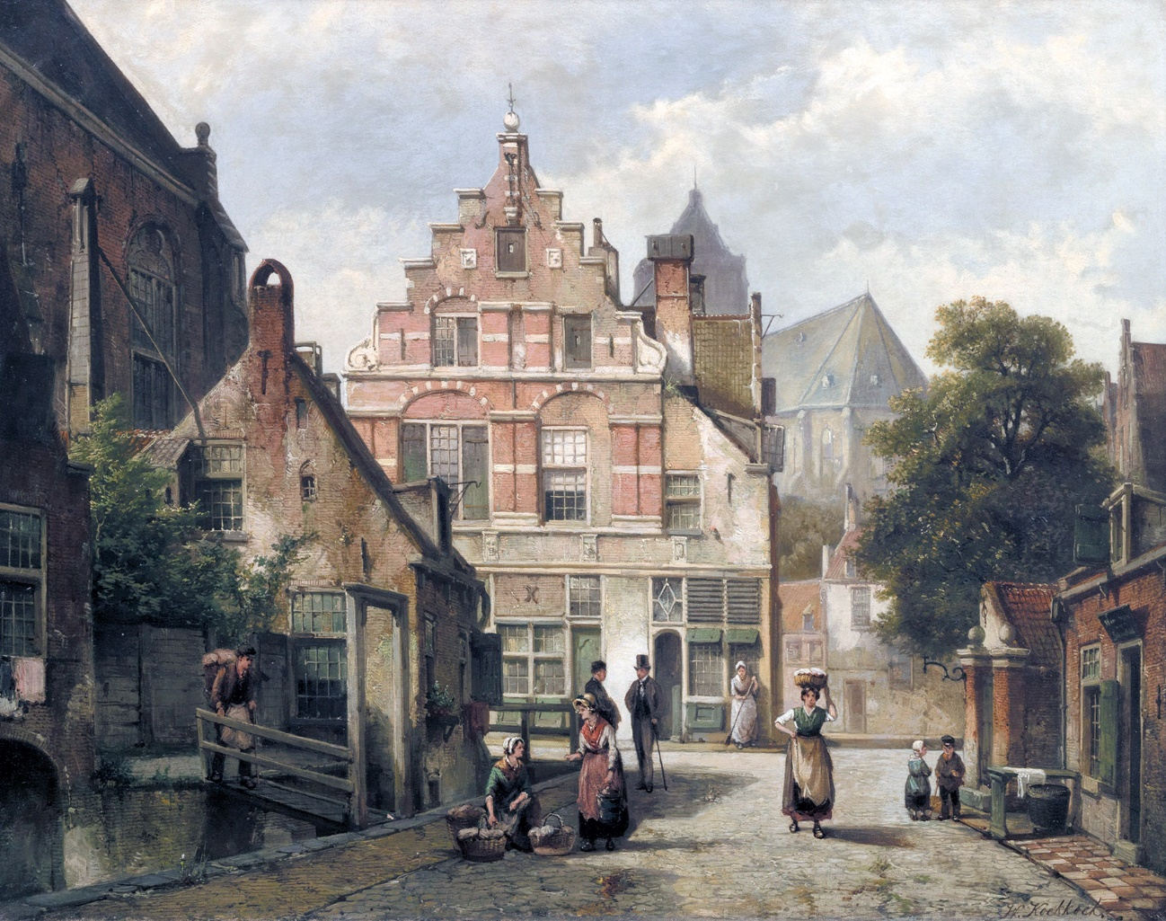

Amsterdam
Willem Koekkoek (Dutch, 1839 – 1885)
Artvee

I sometimes surprised myself, astonished at the Javanese appearance of some particular pavilion, but quickly acknowledged that Amsterdam had long since made its fortune in Batavia (the capital of the Dutch East Indies, modern Jakarta). By their love of porcelain, lacquer, and varnish, their meticulous propriety, their patient approach, their taste for flowers, painting and bric-a-brac, the Dutch established a depth of rapport with the inhabitants of the Celestial Empire; it is from Holland that the Chinese today acquire the crackled celadons, warty bronzes, spider-webbed ivories, jade idols, and screens with designs in relief whose secret they have lost; all the porcelain fired over two centuries in Peking (Beijing) is to be found in Amsterdam.
During my perambulations, I noticed a multitude of garlands, embellished with gold paper and tinsel, from which were suspended small, painted, tinplate fish; I was told they were to celebrate the arrival of the herring fleet. Herring are, indeed, one of the riches of Holland, and the city had reason to be joyful. What a singular thing is the migration of these fish, shoals of them leaving the polar regions at a fixed time, and ending up piled beneath layers of salt in barrels belonging to all the nations bordering the North Sea.
The manner of dress of the bourgeoisie of Amsterdam differs in little or nothing from that of a Parisian or an inhabitant of London; middle class women have nothing characteristic about them but a camisole that is worn long forming a sort of shortened frock-coat. This camisole is almost always of lilac-hued Indian cotton. Lilac seemed, indeed, to be the shade favoured by the fair sex of the Pays-Bas (The Low Countries): one might even believe to the exclusion of every other colour, if a few pink exceptions, very few in number it is true, did not go to prove that a degree of caprice is allowed in the matter of camisoles. One remark, if a little puerile, is that all the women display the same shape of nose, long, white, and slightly upturned at the tip, with very broad nostrils. A mould could not turn out examples any more similar. I note this physiognomic fact for the benefit of future travellers. The women are, moreover, quite pretty, and recall the type consecrated by Gérard Dow (Gerrit Dou); of a chubby whiteness and sweet sadness.
Some peasant women from the small islands and provinces of the Zuider Zee (the Frisian Isles and Friesland) who are a little behind the new fashions in circulation, wear splendid headgear, worthy of some queen from the Middle Ages, composed of silvery lace secured by gold plated ornaments at the temples Nothing is nobler or more graceful.
One thing that may surprise the traveller is the carriage without wheels, whose Dutch name escapes me, set on a sled as are quartants (barrels holding eight and a half English gallons) of beer, in France. These unique vehicles are becoming rarer, and soon will vanish altogether.
I was also struck by the enormous size and strange shape of the draft horses, shod with skates of a sort, which elevate their hooves several inches. Their hooked noses, monstrous rumps, necks like pigeon’s throats, feet bristling with large tufts of hair, dishevelled manes, and long-haired tails, made me think of Anthony van Dyck’s equestrian portraits, the battle scenes of Adam Frans Van der Meulen, and those pictures of the chase by Charles Parrocel and Philippe Jacques de Loutherberg. In France one no longer encounters those strong and heavy breeds, Friesians and Mecklenburgers.
In a bookseller’s window, I saw a translation into Dutch of Une Fille de Régent (‘The Regent’s Daughter’, 1846) by Alexander Dumas. It is flattering to be translated into a language so bristling with consonants... ten o’clock sounded; the museum was open, and in a few minutes time I would be contemplating a great artist’s radiant masterpiece.

Chapter VIII: Rembrandt, and Rotterdam

The first object that catches the eye when ascending the stairs of the museum in Amsterdam (the Trippenhuis, then housing the Dutch Academy of Sciences.) is a painting of a gigantic swan, with wings outstretched, feathers outspread, and beak half-open, in an attitude both alarmed and protective. It lacks the appearance of an incarnation of Jupiter about to seduce Leda, though a divine soul breathes beneath the whiteness of that noble bird. The painter, Jan Asselijn, wished to symbolise, in the shape of this emblem, the vigilance of the Grand-Pensionary of Holland, Johan de Witt; the guide-book so informed me, I would not have not discovered the fact on my own. Neither Frans Snyders nor Jan Weenix ever produced a more beautiful work. (The painting is now in the Rijksmuseum, as is Rembrandt’s ‘The Night Watch’)
The Night Watch, Rembrandt’s most famous painting, occupies almost the entire side of a room. One could wish for better lighting; but to obviate this disadvantage, the canvas is held by a kind of mechanism that allows it to be swung out from the wall until one can gain a good view.
Before entering on an appreciation of this marvel, it may be helpful to speak of the circumstances in which it was created and the theme that the artist treated.
If anything confirms the theory I have put forward and supported more than once, namely that the subject is relatively unimportant to the true artist, it is undoubtedly that prodigious painting in the Amsterdam Museum.
That title, The Night Watch or Guard, by which it is habitually designated, might induce those who have not seen it to dream of some mysterious scene from phantasy, some nightmare full of shadows and dread, the like of which Rembrandt unquestionably knew how to draw; the painting is, however, of no such poetic matter, but rather of a simple convocation of the National Guard of his day.
Indeed, if we refer to Jan Wagenaar’s history of Amsterdam (‘Vaderlandsche historie, 1749-59’), on May 4, 1642, Rembrandt was commanded by the militia to be ready for a review which was to take place at seven in the evening, under penalty of a twenty-five guilder fine levied on absentees. The occasion was the reception of William II of Orange accompanied by the daughter (Mary) of Charles I of England whom he had recently married.
Surely, one could not offer an artist a more insignificant or prosaic motif for a painting, and one knows, from the recent examples one has seen, the results such a subject would produce today.
Add to this, the obligation to show the important members of the militia in a good light, and produce a fair likeness of each of them, since most of the figures depicted are true portraits, and the baroque names of the main characters represented have been preserved. The captain is Frans Banninck Cocq, Lord of Purmerland and Ilpendam; his lieutenant, Willem van Ruytenburch van Vlaardingen, Lord of Vlaardingen; their ensign-bearer, Jan Visscher Cornelissen; the sergeants, Rombout Kemp and Reijnier Engelen; and the militia, Barent Harmanszn, Elbert Willemzen Swedenrijck, Jan Pieterson Bronchorst, Jacob Dirckszn de Roy, Jan Brughman, Jan Adriaenzen Keijser, Jan Ockersen, Harman Jacobzen Wormskerck, Walich Schellingwou, and four others possessing names bristling with no less barbarous letters (Claes van Cruysbergen, Jan van der Heede, Jan Claesen Leijdeckers, and Paulus van Schoonhoven. The drummer has been identified as Jacob Joriszn. The list of names of the militia members is given on a cartouche added by a later artist; the drummer’s name is the result of modern research).
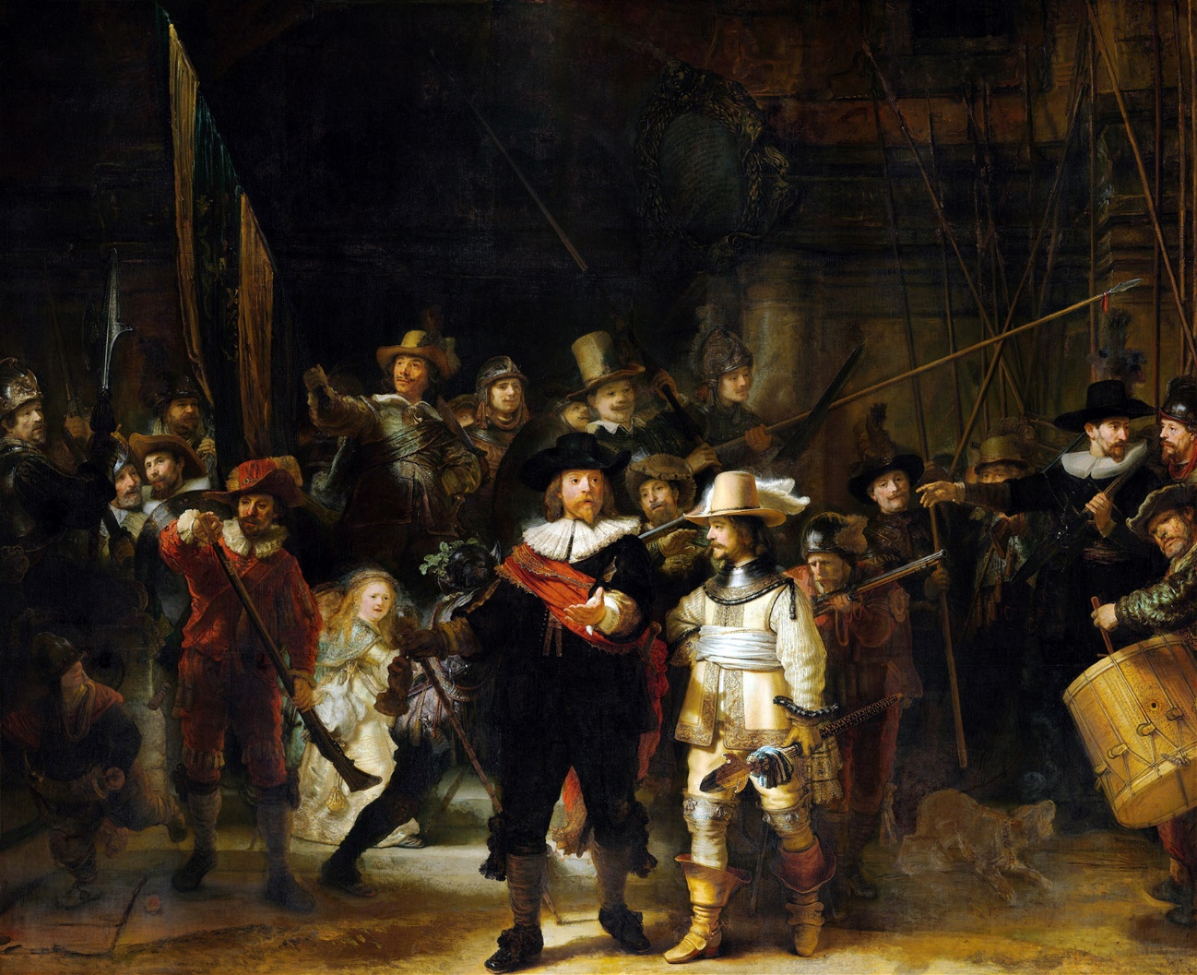

Night Watch, Militia Company of District II under the Command of Captain Frans Banninck Cocq (1642)
Rembrandt van Rijn (Dutch, 1606-1669)
Artvee

It is obvious that all these brave soldiers had not received a service order, or that the use of them was unknown to the good city of Amsterdam, because the summons on the drum seems to have surprised them in the middle of whatever they were about, and they are hastening to attend, as if a minute’s delay will render them subject to a twenty-five gilder fine; they are half dressed; one is still buttoning his doublet, another puts on his leather gloves while walking. Throughout the scene there is movement, disorder, a widespread liveliness.
Leonidas’s Spartans hastening to arm themselves for the defence of Thermopylae advanced no more courageously than these honest and good-natured Dutch bourgeois to serve their Prince of Orange.
You are aware how fancifully the son of the miller of Leiden dressed the figures in his painting; well, never has he shown himself more wildly bizarre than in this inoffensive gathering of militiamen.
It is true that the costumes of the time were somewhat more picturesque than ours. Those leather doublets, braided aiguilettes, funnel-shaped boots, sallet helmets, breastplates, gorgets, wide baldrics, elaborate sword-guards,
all of it, even borne by a national guardsman, can act as content for the skilful painter’s art.
What Rembrandt derives from it, is truly prodigious; never was vigorous execution pushed further; there is boldness in the brushstrokes, a madness of impasto, of which the most energetic sketches of Alexandre-Gabriel Decamps give not even a distant idea; gold embroideries are modelled in full relief, foreshortened fingers dismissed with a stroke of the brush. Certain noses positively leap from the canvas! Yet what is strange, and what reveals Rembrandt’s genius, is that the incredibly brutal execution of his art is at the same time extremely delicate; it shows great finesse; finesse delivered by blows of the fist, yet in such a way that the most forceful of them never land; from this chaos of violent brushstrokes, this tumult of light and shade, these splashes of colour applied as if by chance, a sovereign harmony results.
Rembrandt, who is surely the artist least interested in Greek and Roman art, and whose powerful love of the commonplace shrinks from none of Nature’s miseries, is not however, in consequence, devoid of style, or as distant from the ideal, as one might think: through the singular emphasis he gives to even the most faithfully depicted objects, the romantic oddity of detail, the profound and thoughtful expressions with which he endows those faces most condemned to ugliness, he manages to achieve a certain monstrous beauty that one feels more deeply than one can describe. The formidable character of his painting elevates it to the level exhibited by all past masterpieces. The fanciful yet masterful way in which he distributes shadow and light, the sublime effects of chiaroscuro, render him as poetic an artist as ever lived. To trouble you, and set you dreaming for a whole day, one old man upright in his armchair, and a gleam of sunlight on a black background suffices.
Beneath his paintbrush, these good Dutchmen have acquired handlebar-moustaches, artichoke-leaf beards, raised eyebrows, turns of the hip, arch gestures, and an aggressive manner. Never did, condottiere (Italian mercenaries, later simply military leaders), lansquenets (landskenechts, German mercenaries), or stratiori (Balkan mercenaries) possess a more forbidding appearance; the brigands Salvator Rosa painted seem like honest people alongside these worthy militiamen. Jacob Joriszn, the drummer, in particular, beats his box with fierce determination, and an expression fit to make nature tremble; on the other hand, nothing is more charming, or adorned with a more golden glow, than the little blonde girl dressed in yellow, seen through an extricable barrier of arms and legs.
This painting, according to the historian Jan Wagenaar, adorned, in 1764, the room allotted to the Disciplinary Council of the said militia. What a pleasure it must have been then to no longer be on guard duty. One was cited by the Disciplinary Council, but whilst being judged, one could gaze at this wonderful painting hung behind the tribunal. How times have changed. What military court, these days, would think of ​​commissioning a painting from Delacroix to hang in their courtroom?
This gleaming canvas is assigned to 1642; Rembrandt’s skill as a painter of talent was now fully mature. It is interesting to note that the artist’s early paintings are of quiet, polished and neat execution; in clear, bright colours, and calm in their effect; as he ages, instead of cooling, he grows warmer; instead of rigidifying, he frees himself more; instead of attenuating, he magnifies. Once he has mastered his medium completely, he abandons himself to imagination; he further develops his original approach which he accentuates year by year; he scrapes his lion’s nails over the bitumen with inconceivable ferocity; his mane becomes wilder, more glowing, more tangled; no cavern, however profound its darkness scares him now; he plunges, boldly, into its depths, certain of lighting its darkness with a single touch.
It is a beautiful spectacle, that of a master to whom the years add all that he lacked before. Happy the artist who does not listen to the harmful advice of the prudent but redoubles the audaciousness of his efforts, at an age when the most passionate become wise and, sustained by an unshakeable conviction, furthers his originality, even to the point of fury and extravagance; no painter, no poet has ever spoken his last word. Strong and glorious are those who seek, in their obstinacy, to reject in their nature everything vague or commonplace, and develop their unique qualities without concern for the clamour of criticism or the displeasure of the bourgeoisie.
There is another painting by Rembrandt in this museum, The Syndics of the Drapers’ Guild (De Staalmeesters, 1662, now in the Rijksmuseum) a canvas of the first order, created with a superb pride of touch which one could gaze at for a whole day were it not for the dread company of The Night Watch which dims the rest of the gallery and limits one’s power and desire to view any other painting.
In the evening, still dazed by this masterpiece, I wandered along one of the broad canals which lead to the port, and there I encountered a canvas sentry-box wandering along; the owner of the local Punchinello theatre, who had doubtless failed to gather an audience, was returning, sadly, to his home. The impresario’s wife accompanied the booth, and guided him on his way. I signalled for them to stop, and by means of a sustained pantomime of laying out coins, expressed my wish for a personal and immediate performance of that immortal drama no poet has equalled.
The Dutch Punchinello is not of the type generally accepted under that name; he has a black moustache, few or no humps, and a certain roguish air of his own. He beats his wife, his friend, his neighbours, passers-by, the coal-seller, and the knife-grinder; he defies the Devil, the police, and the executioner; in less than no time, the edge of the booth is littered with a pile of dead and injured. So far nothing out of the ordinary as regards a Punchinello show; but now the drama takes on frightening proportions and a depth worthy of the second part of Faust (the more Classical part of Goethe’s poetic work). Punchinello the victor is parading about the battlefield with the furious joy and unbounded gestures usual to triumphant heroes, when a little doll-like puppet suddenly appears, glittering with gauze and tinsel, who begins to dance the polka, and with the tip of her foot strikes Punchinello so hard that he instantly falls, lifelessly, on the bodies of his victims. With Punchinello slain, the polka-dancer starts a waltz at prodigious speed, rises from the ground, and whirls away through the sky.
Thus, mighty Punchinello, you who feared neither woman, nor the police, nor the executioner, nor the Devil, a mere polka has defeated you; a little doll has proved greater than all the powers of heaven and earth.
After The Night Watch, it was essential for me to view The Anatomy Lesson of Doctor Nicolaes Tulp (Rembrandt’s painting of 1632), which is in the museum (Mauritshuis) in The Hague. An enticing sketch, done by my friend Paul Chenavard, not to mention the engraving reproduced everywhere, had inspired me with a strong desire to know the original; so, I took the train that ran to the Hague, along the kind of inland gulf that they call the Sea of Haarlem.
One could not imagine anything more cheerful, coquettish, neater, or better-maintained than all the little houses with bright red-tiled roofs that gleam amidst the garden greenery, like Lady apples (a cultivar from Brittany) in moss. One cries involuntarily: ‘I long to end my days in one of those charming houses’; it seeming quite impossible not to be happy there; forgetting that the water undermines all those pretty domains won from it with great rows of piles, and that a feverish breath is exhaled by those green and undulating pastures, cloaked by a velvet layer of muddy soil and alluvium.
The Hague, at which I arrived the same evening, is extremely picturesque: the trees, canals and houses are arranged as ordered for the pleasure of watercolourists: there are channels bordered by gardens, planted capriciously to charming effect. The palace (Noordeinde) around which I was shown, is notable only for its simplicity. Among the paintings, mostly modern, that it contains, my attention was drawn to those created by a prince from some island in Polynesia, who was sent to Europe to study, named Raden Saleh (Raden Saleh Sjarif Boestaman, from the Dutch East Indies, of Arab-Javanese ethnicity, painted in the Romantic style); in particular a very characteristic military portrait, and a canvas entitled Fight Between an African Buffalo and Two Lions (not extant). I was really surprised by the vigour and boldness of touch.
Opposite this palace stands a kind of modern Gothic castle, in front of which stands a bronze statue of William the Silent (William of Orange) by the Count van Nieuwerkerke (Alfred Émilien O’Hara). This equestrian statue showed to better effect in The Hague than in Paris. — The courtyard of the Neo-Gothic building, is full of Senegal cranes, tufted herons, and other rare birds.
Galleries opening late in the morning in Holland too, I went to visit the park which surrounds the royal summer residence (Huis ten Bosch) despite the weather which was turning to rain.
Imagine enormous trees, mostly beech and ash, whose roots are almost always bathed in water, whose masses of vigorous foliage hang above ponds, lakes, and rivers whose surface calm reflects them in sombre manner: duckweed, green algae, water lilies, the whole cold family of dense marsh plants, fills the ditches beside the paths; a fresh humidity permeates the air even in the warmest weather, and gives the vegetation’s growth an extraordinary impetus. At each group of picturesquely contorted tree-trunks, at every bluish break in the opacity of foliage, at each clump of plants bowed by the dew, I said to myself: ‘Ah! If only the French landscape gardener, who knew how to create those wonderful landscapes at Saint-Cloud, were here!’
The residence is the most delightful dwelling of which a poet could dream. Unfortunately, poets never realise their dreams. There is especially a certain living room decked with Chinese wall-hangings of exquisite and fabulous beauty, which have as their subject the four seasons, represented by the various agricultural tasks they demand. There is really no need to travel to China with Louis-Jean-Francois Lagrénée, the artist. These tapestries will tell you as much as, and more than, such a voyage. In another room, there are birds, embroidered in relief on a background of white satin. No fey could have plied a lighter or more delicate hand; their mad arabesques, and a use of unscientific perspective of which the wise Chinese alone possess the secret, imitate Nature.
The hall, decorated from the forty-feet high ceiling to the floor with allegories in honour of the House of Nassau, by Jacob Jordaens and the school of Rubens, is unique of its kind. There are avalanches of blonde hair, pink and white flesh, and acres of female nudity to revolt the ethical school of Johann Friedrich Overbeck; when the Flemish painters of this era set their hands to depicting theological virtues and emblematic figures they did so with abandon. What, beneath their sensual brushstrokes, became of Prudence, Chastity, Temperance, Justice and those other nouns personified for the pleasure of princes who decorated their palaces is truly something both droll and exorbitant. Fortunately, they deployed all the resources of their palettes, and the beauty of execution leaves no time to ponder the ethics of their art.
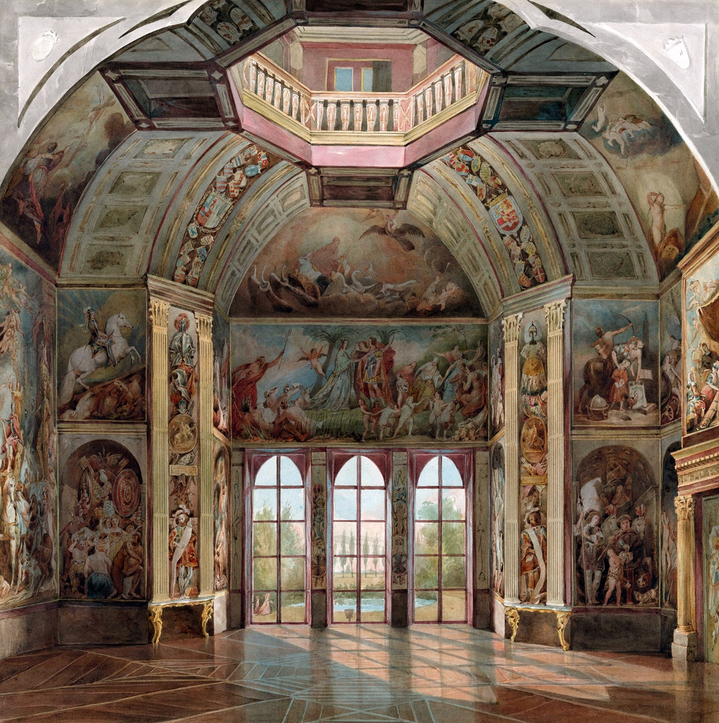

South Wall of the Oranjezaal, Huis Ten Bosch, The Hague (ca. 1860)
Tieleman Cato Bruining (Dutch, 1801-1877)
Artvee

The main work is a triumphal entry of I no longer recall which prince of the dynasty (Frederick Henry, Prince of Orange), painted by Jordaens (in 1652), manu propria (signed by his own hand), and is truly the most astonishing melee of naked women, lions, horses, that was ever hurled across a peaceful wall: this torrent of satin flesh, golden manes, bluish rumps, cheeks as crimson as if they have taken fire, produces the strangest effect in all the world. I admit fancy without restriction; but it is difficult to distinguish amidst this anything that resembles a prince of Nassau or Orange. It is true that the execution is admirable, which deprives my criticism of value.
The rain that had been threatening since the morning began to fall first in drops, then in buckets, then in sheets, and finally in cataracts; lines of toads crawled happily over the soggy sand, and water seemed to leap from the ground to meet the rain. I found temporary shelter in a small café, located in the middle of the park, waiting for someone to find me a carriage. I gazed at beautiful emerald leaves cleansed of the dust of June by this salutary shower; I admired tree-trunks, pale and polished like columns, striped here and there with pretty streaks of moss, with all the more astonishment, in that I had just been told that this park vast and shady as a forest, was planted over a parquet floor, the ground being so marshy, so inconstant, so drowned by inundations, that it had to be strengthened by a wooden paving, covered with topsoil.
The carriage arrived, and a quarter of an hour later I was standing before The Anatomy Lesson of Doctor Nicolaes Tulp. It is a canvas so completely different in appearance to the Night Watch, that at first one might believe it to be from the hand of another master. When he created it, Rembrandt was only twenty-six years old! It is a masterpiece, and an accomplished masterpiece.
Hung in the amphitheatre of the surgery school, the painting remained there until 1828, the year when the medical men of the day decided to sell it at auction, for the benefit of some relief fund. The day of the auction was announced, and the masterpiece would probably have been lost to Holland, if the king had not opposed the sale, granted the surgeons thirty-two thousand florins, and had the radiant canvas re-hung in a place of honour in the Mauritshuis.
Doctor Nicolaes Tulp, who seems to have gifted the Anatomy Lesson to the school, is surrounded by seven distinguished personages of the time: Jacob Block, Hartman Hartmanz, Adrean Salbran, Jacob de Witt, Mathijs Kalkoen, Jacob Koolvelt, and Frans van Loenen, who are following the learned professor’s lesson with admirably intense attention.
Nothing is simpler or, at the same time, more striking than this composition, which is scarcely one. A corpse
foreshortened, the chest illuminated, legs bathed in shadow, is lying on a table. The professor, standing beside him, lifts with surgical scissors the exposed muscles of the left arm of which he is doubtless giving a description. This dead body, bloodless white, surrounded by these serious-looking individuals, dressed in black, with blond beards, their expressions intelligent and gentle, despite their sinister occupation, engraves itself on the memory in an indelible manner.
Here the painter’s style is sober, contained, precise; no impasto, no highlighting, not a brushstroke visible. Everything is soft, molten, polished; grey and silver tones abound. You will not find in the painting the warm vaporous shadows which gild and darken other of the master’s works; but what confidence already, what profound knowledge, what restrained power!
Doctor Tulp’s Anatomy Lesson seems to me one of those masterpieces the study of which would prove most profitable for young colourists. Through art’s wondrous magic, its hideous subject, which in reality would repel any other than a medical man, detains you, and holds you entirely captive for hours, and yet no detail is avoided, nothing is concealed; horror’s franchise could be pursued no further.
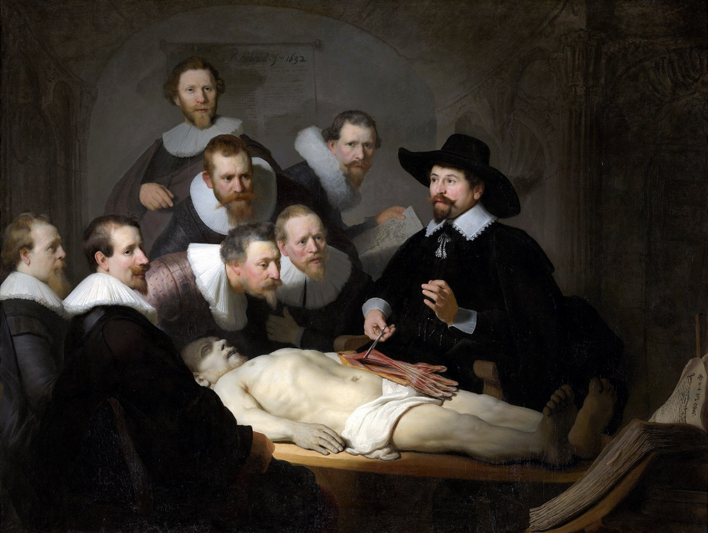

The Anatomy Lesson of Dr Nicolaes Tulp (1632)
Rembrandt van Rijn (Dutch, 1606-1669)
Artvee

Let me not forget a little Susanna Bathing, a sketch for, or a copy in miniature with some minor amendments of, that magnificent Susanna, nearer life-size, exhibited for a while at Susse Frères’ gallery, and acquired by Paul-Casimir Périer (sold as ‘Susanna in the Bath’ in 1843, correctly ‘Bathsheba with King David’s Letter’, now in the Louvre).
Paulus Potter’s large painting depicting a bull, a work which has acquired a colossal reputation, failed to make the desired impression on me; I saw such proud and handsome bulls in Spain, that this heavy characterless beast pleased me only marginally. A Garden of Eden, the background painted by Jan Breughel the Elder, the Adam and Eve by Rubens, and two female portraits by that great painter, are works that one cannot help but gaze at, even when one has resolved, as I had, to study only one painting by each chosen master.
The ground floor of the Mauritshuis houses an immense collection of Chinoiserie, barbarous weaponry, and other oddities. One can find everything there, even authentic mermaids and fauns.
From The Hague I travelled to Rotterdam, via Delft and Schiedam, to take the packet-boat which would me carry me to England, descending the Meuse to the sea, and eventually ascending the Thames: it took a little matter of some thirty hours; but I had seen The Night Watch and The Anatomy Lesson of Doctor Tulp and, in this world, everything has its price; as Napoleon said…’

The End of Gautier’s ‘A Tour in Belgium’

